**Name: …………………………………………………………… Index No. ……………………………**

**School: …………………………………………………………. Candidate’s Sign. …………...............**

**Date: ………………………………….**

**232/2**

**PHYSICS**

**PAPER 2**

**TIME: 2 HOURS**

**MWAKICAN JOINT EXAMINATION 2016**

***Kenya Certificate of Secondary Education (K.C.S.E.)***

**232/2**

**Physics**

**Paper 2**

**TIME: 2 HOURS**

**INSTRUCTIONS TO CANDIDATES:**

* *Write your* ***name*** *and* ***index number*** *in the spaces provided above*
* *This paper consists of* ***two*** *sections* ***A*** *and* ***B.***
* *Answer* ***all*** *questions in section* ***A*** *and* ***B*** *in the spaces provided.*
* *All working* ***must*** *be clearly shown in the spaces provided.*
* *Scientific calculators and KNEC Mathematical tables may be used.*
* *This paper consists of 10 printed pages. Candidates should check to ascertain that all pages are printed as indicated and that no questions are missing.*

**FOR EXAMINER’S USE ONLY:**

|  |  |  |  |
| --- | --- | --- | --- |
| **Section** | **Question** | **Maximum Score** | **Candidate’s Score** |
| **A** | **1 – 14** | **25** |  |
|  | **15** | **11** |  |
|  | **16** | **11** |  |
| **B** | **17** | **11** |  |
|  | **18** | **11** |  |
|  | **19** | **11** |  |
| **Total Score** | | **80** |  |

**SECTION A – 25 MARKS**

1. The figure below represents an object O placed infront of a plane mirror M.

0 •

E

Using ray diagram, locate the position of the image as seen by the eye E. (2 Marks)

1. State one way in which local action reduces current in a simple cell. (1 Mark)

………………………………………………………………………………………………………………

………………………………………………………………………………………………………………

1. Explain why the image formed in a plane mirror is virtual. (2 Marks)

………………………………………………………………………………………………………………

………………………………………………………………………………………………………………

1. Give one advantage of an alkaline cell over a lead acid cell. (1 Mark)

………………………………………………………………………………………………………………

………………………………………………………………………………………………………………

1. Identify the polarity marked X on the magnetic material shown when K is closed. (1 Mark)

X

Y

Soft iron

Switch

1. In the circuit diagram below, the ammeter has negligible resistance; when switch S is closed, the ammeter reads 0.12A. Determine the internal resistance of the cell. (3 Marks)

10Ω

A

1.5V

………………………………………………………………………………………………………………

………………………………………………………………………………………………………………

………………………………………………………………………………………………………………

………………………………………………………………………………………………………………

1. State two conditions for total internal reflection to occur. (2 Marks)

………………………………………………………………………………………………………………

………………………………………………………………………………………………………………

………………………………………………………………………………………………………………

1. A metallic body shaped as shown in the figure below was positively charged and insulated from the ground as shown below.

Metallic body

Ground

Show on the figure, the charge distribution. (1 Mark)

………………………………………………………………………………………………………………

………………………………………………………………………………………………………………

1. An immersion heater of resistance 1600Ω operates at 240V mains supply. Determine the power rating.

(2 Marks)

………………………………………………………………………………………………………………

………………………………………………………………………………………………………………

………………………………………………………………………………………………………………

………………………………………………………………………………………………………………

1. Calculate the effective capacitance across X and Y.

60μF

30μF

20μF

X

Y

………………………………………………………………………………………………………………

………………………………………………………………………………………………………………

………………………………………………………………………………………………………………

………………………………………………………………………………………………………………

1. Draw a circuit diagram to show how you would use a voltmeter, ammeter, variable resistor, cells and connecting wires to find the resistance of a lamp. (2 marks)

………………………………………………………………………………………………………………

………………………………………………………………………………………………………………

………………………………………………………………………………………………………………

………………………………………………………………………………………………………………

1. The figure below shows two parallel current carrying conductors A and B placed close to each other. Current flows in the opposite direction. Sketch on the figure the magnetic field pattern formed by the conductors. (2 Marks)

X

A B

1. The figure below shows an object O infront of a concave mirror. Draw a ray diagram to locate the image formed. (2 Marks)

C

F

O

1. The figure below shows a circuit used to measure resistivity of wire of diameter 1.15mm and length 50m.

V

A1

I1

V = 3.0V

I1 = 0.1A

Calculate the resistivity of the wire. (2 Marks)

………………………………………………………………………………………………………………

………………………………………………………………………………………………………………

………………………………………………………………………………………………………………

………………………………………………………………………………………………………………

**SECTION B – 55 MARKS**

1. In an experiment to study the variation of charge stored on a 0.03F capacitor and the potential difference allowed, the following results were obtained.

|  |  |  |  |  |  |  |
| --- | --- | --- | --- | --- | --- | --- |
| Charge (C) | 0.06 | 0.12 | 0.18 | 0.24 | 0.30 | 0.42 |
| P.D (V) | 2.0 | 4.0 | 6.0 | 8.0 | 10.0 | 14.0 |

(i) On the graph paper provided, plot a graph of charge Q against p.d. (5 Marks)



(ii) Determine the gradient of the graph. (2 Marks)

………………………………………………………………………………………………………………

………………………………………………………………………………………………………………

(iii) Define the quantity represented by the gradient in (ii) above. (1 Mark)

………………………………………………………………………………………………………………

………………………………………………………………………………………………………………

………………………………………………………………………………………………………………

(iv) From the graph determine the work done in joules to increase the charge stored in the capacitor from

0.1C to 0.3C. (3 Marks)

………………………………………………………………………………………………………………

………………………………………………………………………………………………………………

………………………………………………………………………………………………………………

………………………………………………………………………………………………………………

1. (a) Define the following

(i) Frequency (1 Mark)

………………………………………………………………………………………………………………

………………………………………………………………………………………………………………

(ii) Wavelength (1 Mark)

………………………………………………………………………………………………………………

………………………………………………………………………………………………………………

(b) On the axis provided below, sketch a graph showing the variation of frequency against wavelength at

a constant velocity. (1 Mark)

Frequency (H2)

Wavelength (m)

(c) The figure below shows circular waves approaching a straight reflector.

Show on same diagram the reflected wave. (1 Mark)

(d) State three conditions necessary for two progressive waves travelling in the opposite direction to

form stationary waves. (3 Marks)

………………………………………………………………………………………………………………

………………………………………………………………………………………………………………

(e) The sketch below shows wave front.

-0.2

0.2

0.2

0.3

0.5

Displacement (m)

t(s)

Determine

(i) Amplitude (1 Mark)

………………………………………………………………………………………………………………

………………………………………………………………………………………………………………

(ii) Frequency of the wave (1 Mark)

………………………………………………………………………………………………………………

………………………………………………………………………………………………………………

………………………………………………………………………………………………………………

(f) The speed of light in air is 3.0 x 108m/s. Find the speed of light in diamond if the refractive index of

diamond is 2.42. (2marks)

………………………………………………………………………………………………………………

………………………………………………………………………………………………………………

………………………………………………………………………………………………………………

………………………………………………………………………………………………………………

1. (a) State Ohm’s law. (1 Mark)

………………………………………………………………………………………………………………

………………………………………………………………………………………………………………

(b) The graph below shows the voltage current relationship for a certain conductor.

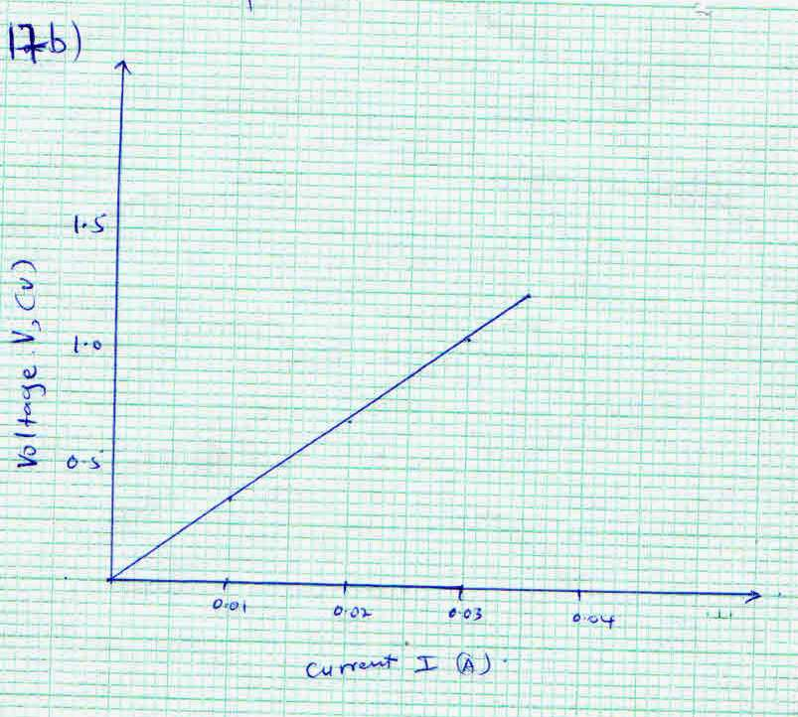

Voltage V, (v)

Current I (A)

(i) Determine the resistance of the conductor. (3 Marks)

………………………………………………………………………………………………………………

………………………………………………………………………………………………………………

………………………………………………………………………………………………………………

………………………………………………………………………………………………………………

(ii) State with a reason whether the conductor obeys Ohm’s law or not. (2 Marks)

………………………………………………………………………………………………………………

………………………………………………………………………………………………………………

(iii) Give three factors that affect the resistance of conductor. (3 Marks)

………………………………………………………………………………………………………………

………………………………………………………………………………………………………………

………………………………………………………………………………………………………………

………………………………………………………………………………………………………………

(iv) A starter coil has current of 6A passing through it. If across it is 12V, determine the resistance of the

starter coil. (2marks)

………………………………………………………………………………………………………………

………………………………………………………………………………………………………………

………………………………………………………………………………………………………………

………………………………………………………………………………………………………………

………………………………………………………………………………………………………………

………………………………………………………………………………………………………………

1. (a) Define a fuse. (1 Mark)

………………………………………………………………………………………………………………

………………………………………………………………………………………………………………

(b) What property does a fuse have? (1 Mark)

………………………………………………………………………………………………………………

………………………………………………………………………………………………………………

(c) Define power as applied in electric circuits (1 Mark)

………………………………………………………………………………………………………………

………………………………………………………………………………………………………………

(d) A light bulb is found to have a resistance of 950Ω when operating normally on 240V mains, Find:

(i) The power rating of the bulb (3 Marks)

………………………………………………………………………………………………………………

………………………………………………………………………………………………………………

………………………………………………………………………………………………………………

………………………………………………………………………………………………………………

………………………………………………………………………………………………………………

(ii) The current it draws from the mains when working normally. (3 Marks)

………………………………………………………………………………………………………………

………………………………………………………………………………………………………………

………………………………………………………………………………………………………………

………………………………………………………………………………………………………………

(e) Explain why the heater in an electric kettle is fitted at the bottom of the container (2 Marks)

………………………………………………………………………………………………………………

………………………………………………………………………………………………………………

………………………………………………………………………………………………………………

………………………………………………………………………………………………………………

1. (a) Define a magnet (1 Mark)

………………………………………………………………………………………………………………

………………………………………………………………………………………………………………

(b) State two properties of a magnet. (2 Marks)

………………………………………………………………………………………………………………

………………………………………………………………………………………………………………

(c) Differentiate between hard and soft magnet materials. (2 Marks)

………………………………………………………………………………………………………………

………………………………………………………………………………………………………………

(d) The figure below shows two magnets placed parallel to each other and a ring made of soft iron metal

placed between them.

Sketch the magnetic field pattern between the two magnets. (2 marks)

S

N

(e) The graphs below shows two magnetic materials.

Strength of magnet

Magnetizing force

A

B

(i) Which material is easier to magnetize? (1 Mark)

………………………………………………………………………………………………………………

………………………………………………………………………………………………………………

(ii) Which material forms a stronger magnet? (1 Mark)

………………………………………………………………………………………………………………

………………………………………………………………………………………………………………

(iii) State one application of each. (2 Marks)

………………………………………………………………………………………………………………

………………………………………………………………………………………………………………

………………………………………………………………………………………………………………