MWAKICAN JOINT EXAMINATION 2016
PHYSICS PAPER 232/2
MARKING SCHEME
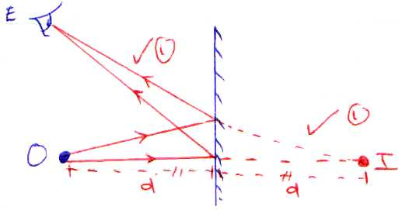

- Reduces the size of the zinc plate. 1
- Cannot be formed on the screen. 1
- (i) Requires less attention.
(ii) They are light and easily portable.
(iii) Large currents can be drawn from them
(iv) They can be kept in a discharged condition for a very long time before the cells are ruined.
Any 1 (1 mark)
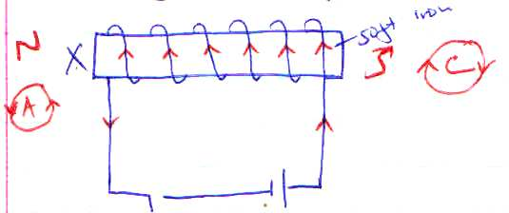

- V = IR 1
1.5 = (10 + r) x 0.12
1.5 = 1.2 + 0.12r
$\frac{0.12r}{0.12}$ = $\frac{0.3}{0.12}$ 1
$r$= 2.5Ω
- (i) Critical angle must be exceeded 1
(ii) Light should be moving from a more denser to a less denser medium.
+
+
+
+
+
+
+
+
+
+
Metallic body
Ground
+
+
+
+
+
+

- P = $\frac{V^{2}}{R}$ = $\frac{240 x 240}{1600}$ = 36W
- 20μF + $\frac{30 x 60}{60 x 30}$ = 40μF
½

½
½
V
A

½

X
1
Attraction 1

½
1

O
F
C

14. R = $\frac{30}{1}$ = 30
R = $\frac{e x L}{A}$ = ∴$\frac{e x 50}{\frac{1.15}{2}x{10}^{-3}x \frac{22}{7}}$ = $\frac{50e}{1.807x{10}^{-3}}$
50e = $\frac{30x1.807x{10}^{-3}}{50}$
e = 1.08 x 10⁻³
15.(i) Scan

(ii) $\frac{0.3-0}{10-0}$ = $\frac{0.3}{10}$ = 0.03c/v
(iii) Capacitance – Ability of a capacitor to store charge.
(iv) Work done = Area under the graph for 0.1 to 0.3C
$\frac{1}{2}$ x 6.4 x 0.2
$=0.64J$
16. (a) (i) Frequency – The number of oscillations per second 1
(ii) Wavelength – Distance between two successive crests or troughs.
(b)
Frequency (Hz)

1

Wavelength
(c) 1

(d) Equal speed 1
Equal amplitude 1
Same frequency 1

(e) (i) 0.2m
(ii) T = 0.4 seconds
f = $\frac{1}{T}$ ½
= $\frac{1}{0.4}$ = 25Hz ½
(f) 2.42 = $\frac{3x{10}^{5}}{V}$,
V = $\frac{3x{102.}^{8}}{2.42}$ 1, V = 1.24 x 10⁸m/s
17. (a)V=IR→ The current flowing through a conductor is directly proportional to the potential different
across it provided temperature and other physical conditions are kept constant.
(b)(i) R= $\frac{V}{t}$ = $\frac{1.25-0}{0.035-0}$
= 35.71Ω
(ii)Since the graph is a straight line¹ the conductor obeys Ohm’s law¹
(iii)
- Length of conductor.
- Nature of material.
- Cross –sectional area of the conductor.
- Temperature difference between the ends of a conductor.
Any 3(1mark each)
(iv) V = IR, R = $\frac{V}{I}$ = $\frac{12}{6}$ 1= 2Ω 1
18 (a) A device used for regulating excess current in a circuit.¹
(b)Has low melting point¹
(c)Power is the energy change rate of 1 joule¹ per second or power is the flow of energy per second.
(d) (i) P = $\frac{V^{2}}{R}$ 1= $\frac{240X 240}{950}$ = 60.63 1W
(ii) P = VI, I = $\frac{P}{V}$ 1 = $\frac{60.63}{240}$ 1 = 0.25A
(e)So that the liquid being heated totally covers the heater hence energy absorbed by the liquid is distributed throughout the liquid by convection.¹¹
19(a)A form of iron ore which attracts some materials when they are brought near it.¹
(b)
- Directional property.¹
- Magnetic poles¹
(c)Hard magnetic materials are hard to magnetise but retain magnetism for long once magnetised.¹
Soft magnetic materials are easily magnetized and also lose magnetism easily.¹
(d)
N
S

e) i) A
ii) B
iii) A – Can be used to make cores of electromagnets
B – Can be used to make permanent magnets used in loud speakers

