Name____________________________________Class______________Adm No:_____________
Date__________________________________________Sign_______________

END OF TERM ONE EXAMINATION

FORM TWO

PHYSICS

2 HOURS

INSTRUCTIONS TO LEARNERS
1. This paper has two sections A and B. Answer all the questions in both sections.
2. Show your calculations in the spaces provided.
3. Take g = 10N/kg where needed to use it.

SECTION | QUESTION | MAXIMUM SCORE | CANDIDATES SCORE
A | 1 - 12 | 25
 | 13 | 7
 | 14 | 4
 | 15 | 6
B | 16 | 7
 | 17 | 10
 | 18 | 7
 | 19 | 8
 | 20 | 8
 | TOTAL  SCORE | 80

SECTION A ( 25 MARKS )
1. State the basic law of magnetism ( 1 mk )
………………………………………………………………………………………………………………………………………………………………………………………………………………………………………………………………………………………………………………………………………
2. The figure below shows a micrometer screw gauge being used to measure the diameter of a ball
Bearing

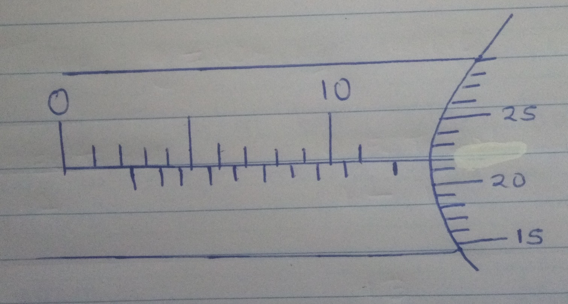
The thimble scale has 50 divisions. What is the reading? ( 2 mks )
………………………………………………………………………………………………………………………………………………………………………………………………………………………………………………………………………………………………………………………………………

3. The figure below shows a uniform metal rod balanced at its centre by different force.

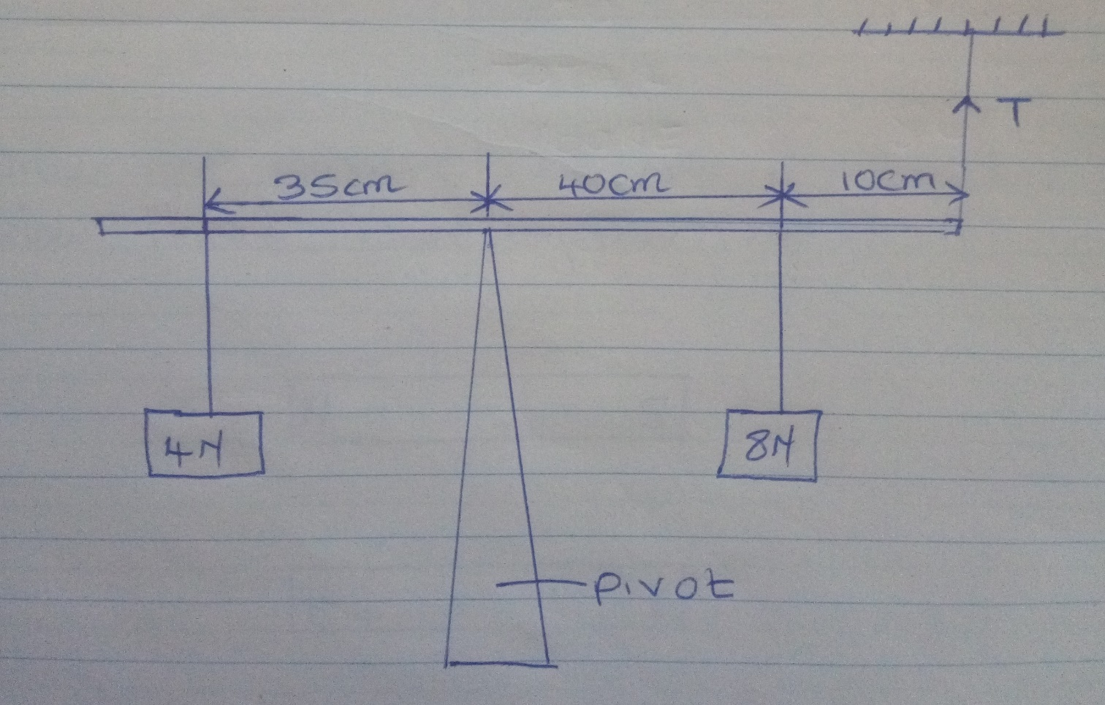

Determine the value of T (3mks)
………………………………………………………………………………………………………………………………………………………………………………………………………………………………………………………………………………………………………………………………………
4. Give two reasons why when alighting from a moving bus a person has to spread out his legs.(2mks )

……………………………………………………………………………………………………………………………………………………………………………………………………………………………………………………………………………………………………………………………………………………………………………………………………………………………………………………
5. A uniform metal bar, 100 cm long balances at 20 cm mark when a mass of 1.5kg is attached at 0 cm mark.
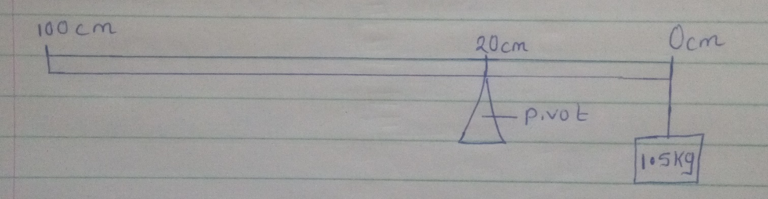
Calculate the weight of the bar ( g = 10 N/kg ) (3mks )

………………………………………………………………………………………………………………………………………………………………………………………………………………………………………………………………………………………………………………………………………
6. Draw the magnetic field pattern of the two magnets below placed close together. (2 mks)
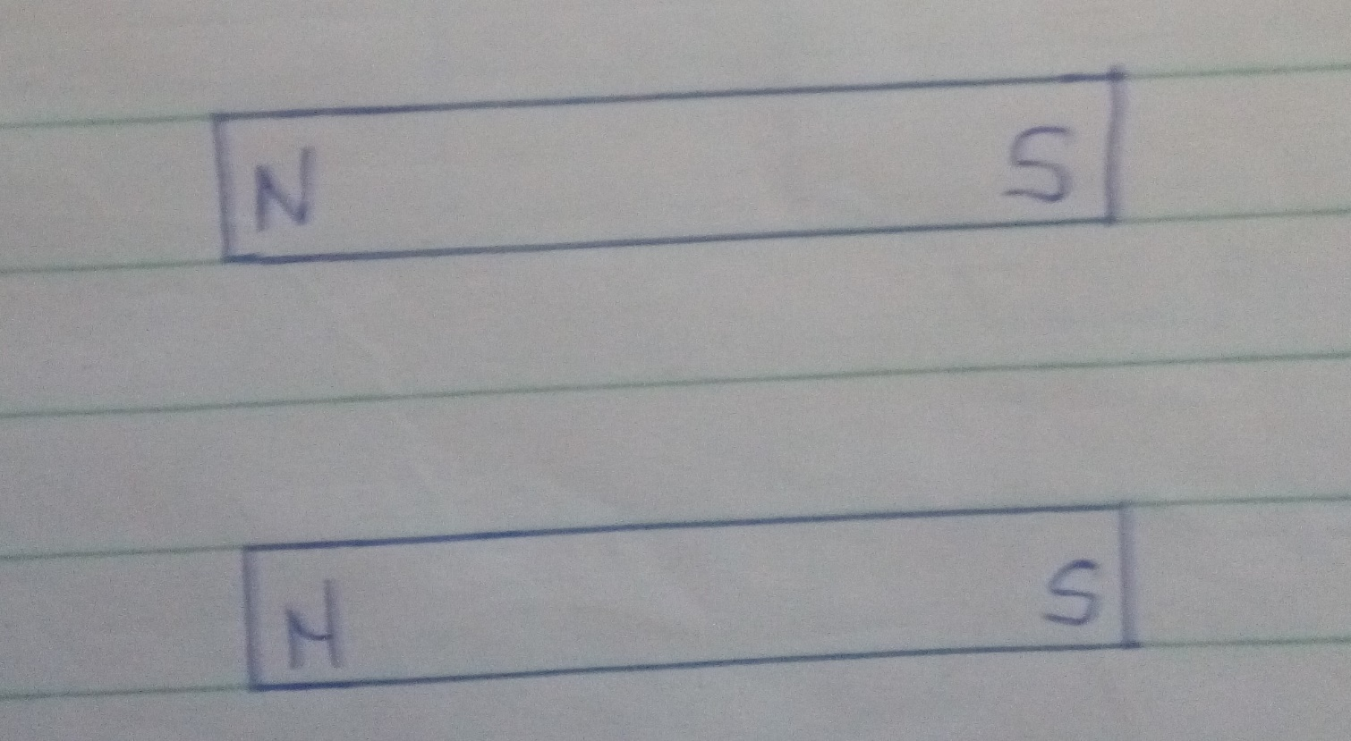

7. Define polarization (1 mk)
………………………………………………………………………………………………………………………………………………………………………………………………………………………………………………………………………………………………………………………………………
8. Give 2 uses of an electroscope. (2 mks)
………………………………………………………………………………………………………………………………………………………………………………………………………………………………………………………………………………………………………………………………………
9. At what angle would two mirrors be inclined to form 17 images. (2 mks)
………………………………………………………………………………………………………………………………………………………………………………………………………………………………………………………………………………………………………………………………………
10. What does formation of shadows show about light? ( 1 mk )
………………………………………………………………………………………………………………………………………………………………………………………………………………………………………………………………………………………………………………………………………
11. Explain why soft –board ceiling is better than concrete ceiling. (1 mk )
………………………………………………………………………………………………………………………………………………………………………………………………………………………………………………………………………………………………………………………………………

12. The figure below shows water in a flask
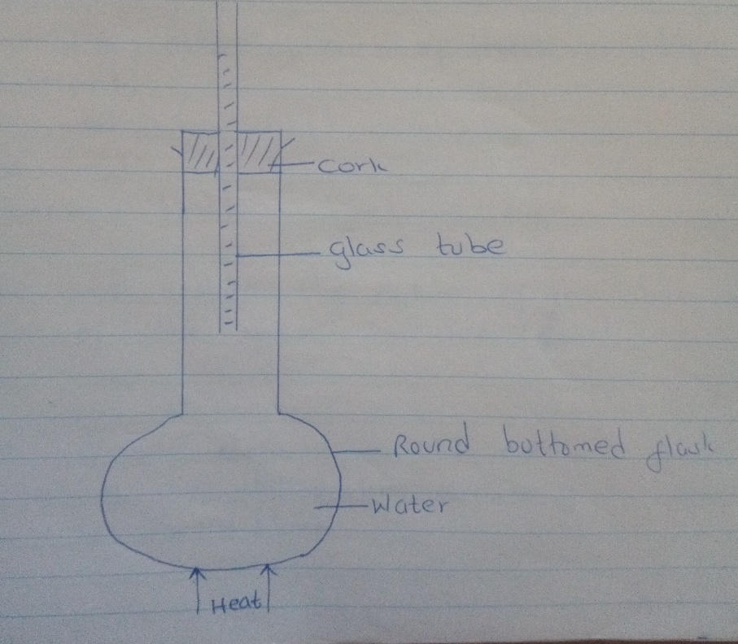
As it is heated, it is observed that the level of water in the glass tube falls slightly first then later starts
Rising.Explain ( 2 mks )
………………………………………………………………………………………………………………………………………………………………………………………………………………………………………………………………………………………………………………………………………
SECTION B ( 55 MARKS )

13. A) State the kinetic theory of matter ( 1 mk )
………………………………………………………………………………………………………………………………………………………………………………………………………………………………………………………………………………………………………………………………………
b) Brownian motion of smoke particles can be studied by using the apparatus shown in the figure below.
To observe the motion some smoke is closed in the smoke cell and then observed through the
Microscope.

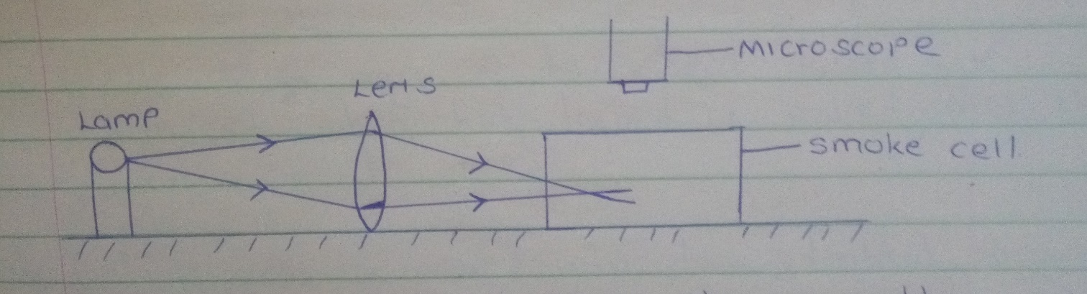

Explain the role of each of these in the experiment.
i) Smoke particle ( 1 mk ) ………………………………………………………………………………………………………………………………………………………………………………………………………………………………………………………………………………………………………………………………………
ii) Lens ( 1 mk ) ………………………………………………………………………………………………………………………………………………………………………………………………………………………………………………………………………………………………………………………………………
iii) microscope ( 1 mk ) ………………………………………………………………………………………………………………………………………………………………………………………………………………………………………………………………………………………………………………………………………
c) State and explain the nature of the observed motion of the smoke particles. ( 2 mks )
………………………………………………………………………………………………………………………………………………………………………………………………………………………………………………………………………………………………………………………………………

d) What will be observed on the motion of smoke particles if the temperature surrounding the
smoke cell is raised. ( 1 mk )
………………………………………………………………………………………………………………………………………………………………………………………………………………………………………………………………………………………………………………………………………
14. The figure below shows a cross section of a vacuum flask.
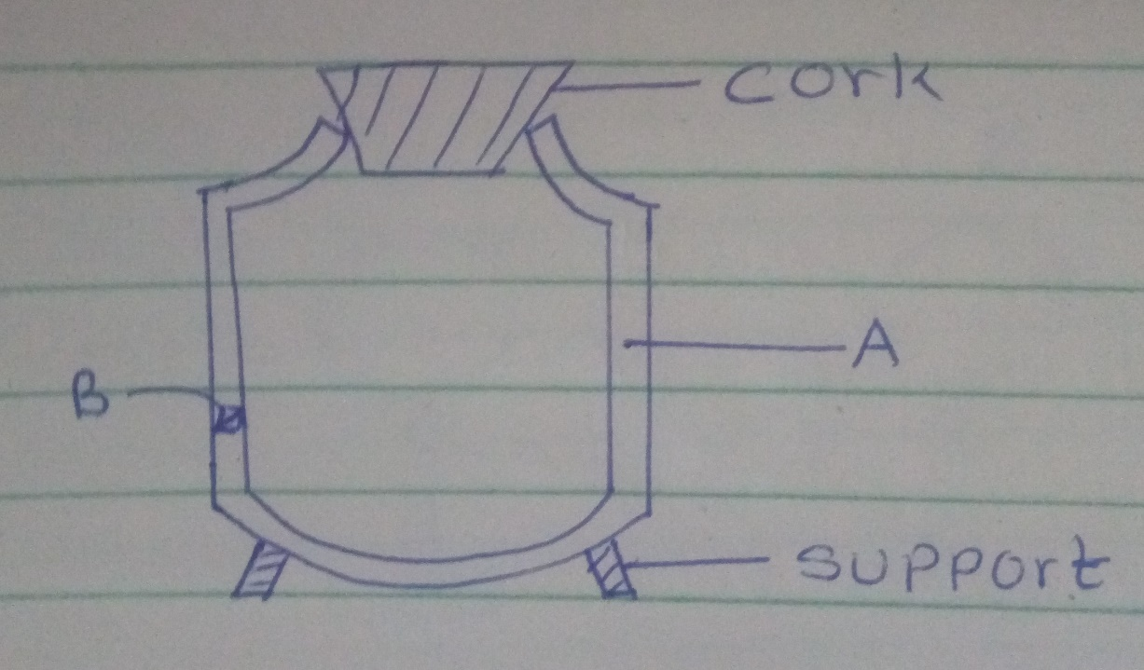
a) Name parts, labeled. ( 2 mks )
A.......................................................................................

B......................................................................................
B) Boiling water is poured into two identical vacuum flasks A and B. Flasks A is partially filled while Flask
B is completely filled. Both are closed tightly. State with reasons the flask in which water is likely to have a higher temperature eight hours later. ( 2 mks )

………………………………………………………………………………………………………………………………………………………………………………………………………………………………………………………………………………………………………………………………………
15. a) An uncharged metal rod brought close but not touvhing the cap of a charged electroscope causes a decrease in the divergence of the leaf. Explain. ( 2 mks )
………………………………………………………………………………………………………………………………………………………………………………………………………………………………………………………………………………………………………………………………………………………………………………………………………………………………………………………………………………………………………………………………………………………………………………………………………………………………………………………………………………
b) A positively charged rod is brought close to two spheres A and B, held by insulated handles as
shown below.
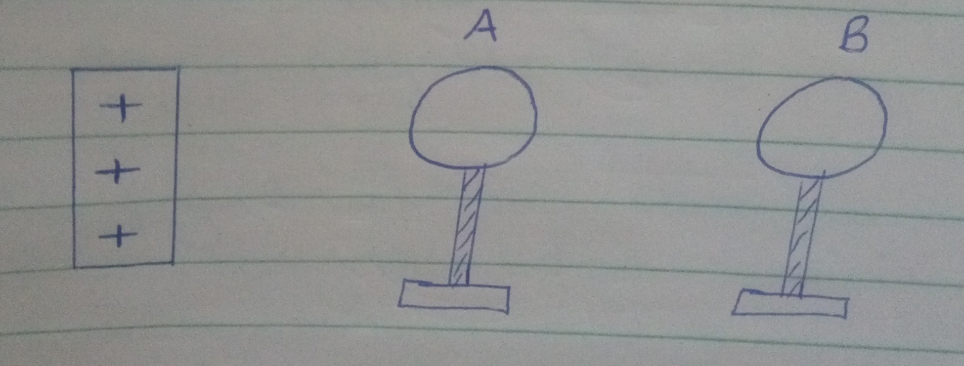
Indicate the charge on sphere A and B. ( 2 mks )

c) The figure below shows a highly positively charged rod being moved slowly downwards towards the cap of a negatively charged leaf electroscope. It is observed that the leaf initially falls then rises.
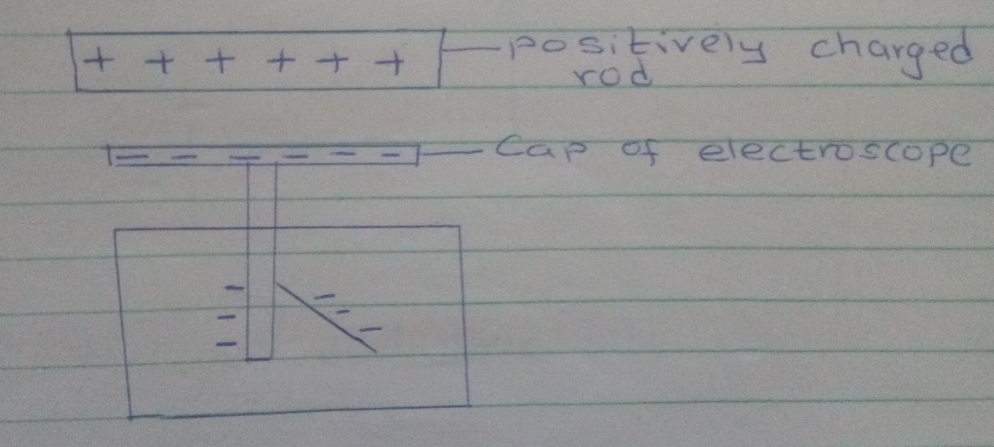
Explain this observation. ( 2 mks )
………………………………………………………………………………………………………………………………………………………………………………………………………………………………………………………………………………………………………………………………………
16. a) State the right – hand grip rule. ( 1 mk )
………………………………………………………………………………………………………………………………………………………………………………………………………………………………………………………………………………………………………………………………………
b) State and explain the functions of the keeper in storing magnets. ( 2 mks )
………………………………………………………………………………………………………………………………………………………………………………………………………………………………………………………………………………………………………………………………………c) The figure below shows a steel bar to be magnetized
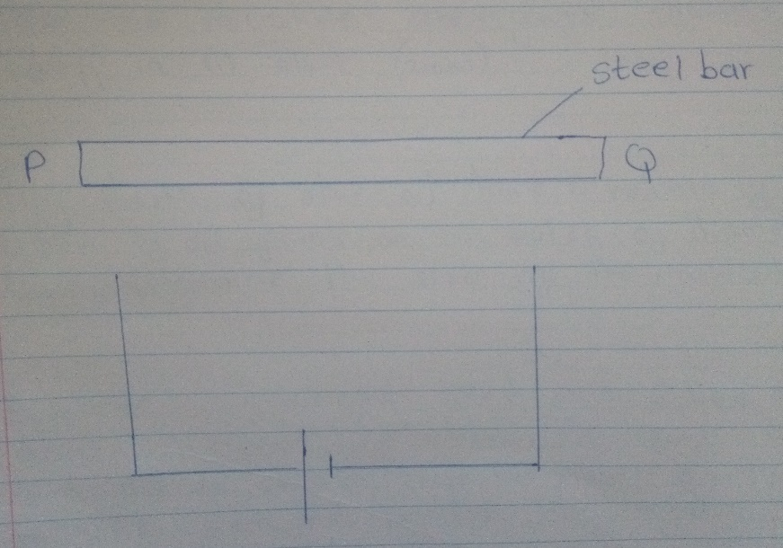
Complete the circuit such that both poles P and Q acquire opposite polarity ( North – South respectively ) ( 2 mks )

d) Name 2 methods of magnetization of a magnetic material. ( 2 mks )
………………………………………………………………………………………………………………………………………………………………………………………………………………………………………………………………………………………………………………………………………
17. a) A micrometer screw gauge which had an error of +0.02mm was used to measure the diameter
of a spherical marble. If the actual diameter was 3.67mm.
i) What was the reading indicated on the instrument. ( 2 mks )
………………………………………………………………………………………………………………………………………………………………………………………………………………………………………………………………………………………………………………………………………
ii) Draw the micrometer screw gauge showing that reading in ( i ) above. ( 2 mks )

b) Fifty drops of olive oil have a volume of 1.0cm³ . If a drop of oil forms an oil patch of diameter 20 cm, determine the size of the molecule. ( 3 mks )
………………………………………………………………………………………………………………………………………………………………………………………………………………………………………………………………………………………………………………………………………

c) A burette was initially filled with a liquid of density 0.8g/cm³ to 12ml. The liquid is allowed to run out for some time. If the volume of liquid removed from the burette has a mass of 14g. Determine the final reading on the burette. ( 3 mks )
………………………………………………………………………………………………………………………………………………………………………………………………………………………………………………………………………………………………………………………………………
18. a ) State the principal of moments ( 1 mk )

………………………………………………………………………………………………………………………………………………………………………………………………………………………………………………………………………………………………………………………………………
b) The figure below shows a uniform metre rule pivoted and supported as shown. If the mass of the rule is 2.4kg, Find the distance X. ( 3 mks )
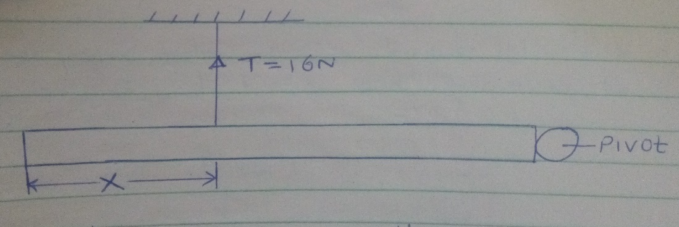
c) A solid weighs 18.5N on the surface of the moon.
The force of gravity on the moon is 1.7N/kg. Determine the mass of the solid. ( 3 mks )

19. Taking the density of water as 1000kg/m³ and atmospheric pressure as 103,000 N/m²,
Determine the pressure of the gas used. ( 3 mks )
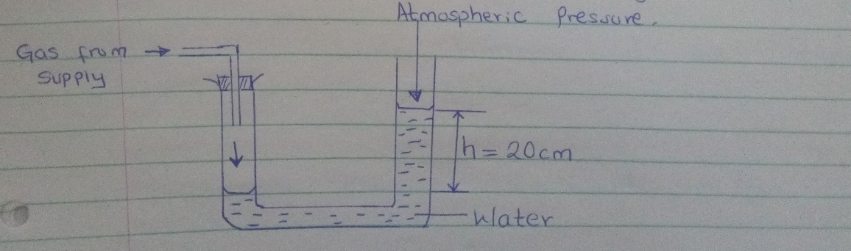
b) State 2 factors that affect the pressure in liquids. ( 2 mks )
………………………………………………………………………………………………………………………………………………………………………………………………………………………………………………………………………………………………………………………………………
c) The figure below show a hydraulic lift If A, = 0.25m², A₂ = 10m² and F₁ is 100N. Determine F_{2.}.
( 3 mks )
20. a) Differentiate between luminous and non-luminous sources of light. ( 1 mk )
………………………………………………………………………………………………………………………………………………………………………………………………………………………………………………………………………………………………………………………………………
b) Differentiate between transparent and translucent objects. ( 1 mk )
………………………………………………………………………………………………………………………………………………………………………………………………………………………………………………………………………………………………………………………………………
c) The figure below shows a pinhole camera.
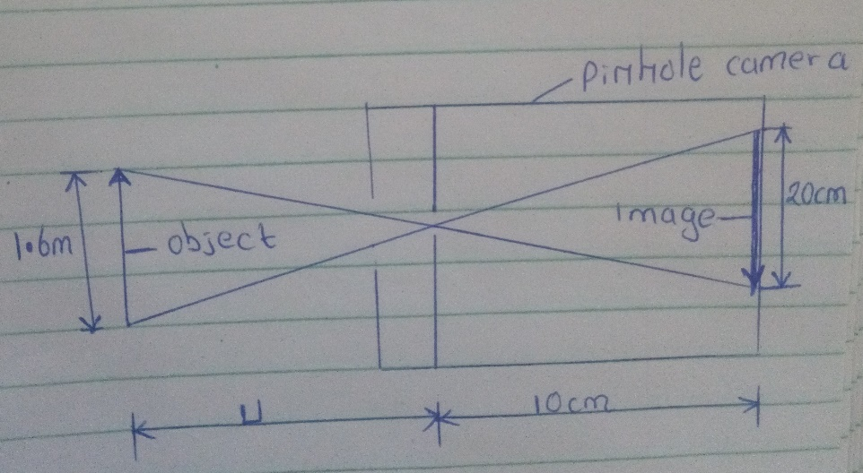
i) At what minimum distance from pinhole must an object stand if a full length image is required.
( 3 mks )
………………………………………………………………………………………………………………………………………………………………………………………………………………………………………………………………………………………………………………………………………
ii) Determine the magnification of the image. ( 2 mks )
………………………………………………………………………………………………………………………………………………………………………………………………………………………………………………………………………………………………………………………………………
iii) From the magnification obtained above comment on the nature of the image. ( 1 mk )
………………………………………………………………………………………………………………………………………………………………………………………………………………………………………………………………………………………………………………………………………

