Name:………………………………………...…………………………Index No…………………………….………...

232/1 Candidate’s Signature:……………….………….……………
PHYSICS
THEORY Date:…………………………….……………….......
PAPER 1
JULY/AUGUST 2014
TIME: 2 HOURS

Kenya Certificate of Secondary Education (K.C.S.E.)

232/1
PHYSICS
Paper 1
2 hours

INSTRUCTIONS TO CANDIDATES
- Write your name and index number in the spaces provided.
- Mathematical tables and non-programmable calculators may be used.
- This paper consists of section A and section B.
- Attempt all the questions in the spaces provided.
- ALL working MUST be clearly shown.

For Examiners Use
SECTION | QUESTIONS | MAXIMUM SCORE | CANDIDATE’S SCORE
A | 1 – 14 | 25
B | 15 | 12
 | 16 | 11
 | 18 | 14
 | 18 | 10
 | 19 | 08
 | TOTAL | 80

This paper consists of 9 printed pages. Candidates should check to ascertain that all pages are printed as indicated and that no questions are missing.
SECTION A (25MARKS)
Answer all questions in this in the spaces provided
- Figure 1. Shows a glass beaker of cross sectional area 10.5cm²

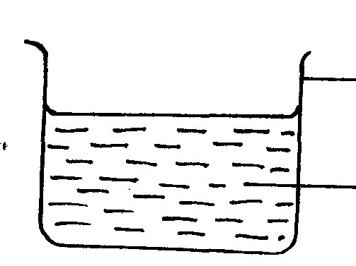
Liquid
Fig 2
Air flow
Tube B
Tube B
Fig 1
Water
Beaker

When a metal block of mass 250 g is immersed into the water, the level of water rises by 3.5 cm. determine the density of the metal block. Express your answer in S.I unit (3mks)

- The figure 2 shows air flowing through a pipe of nonuniform cross sectional area. Two tubes A and B are dipped into the liquid as shown.

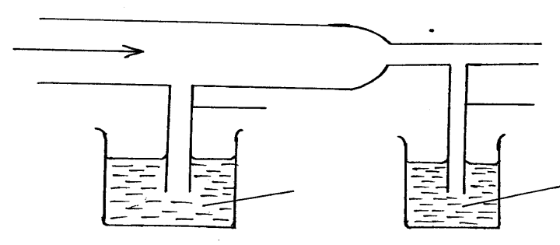

Liquid

- Indicate the level of the liquid in tubes A and B (1mk)

- Explain your answer in part (a) above (1mk)
…………………………………………………………………………………………….

- A motor cyclist wears a helmet in the inside with sponge. Explain how this minimizes injuries to the motorists head when involved in an accident. (2mks)
…………………………………………………………………………………………………..……
…………………………………………………………………………………………………..……
- A balloon is filled with a gas which is lighter than air. It is observed to rise in air up to a certain height state a reason why the balloon stops rising. (1mk)
…………………………………………………………………………………………………..……
…………………………………………………………………………………………………..……

- Figure 3 shows two corks P and Q fixed on a polished and a dull surface with wax.

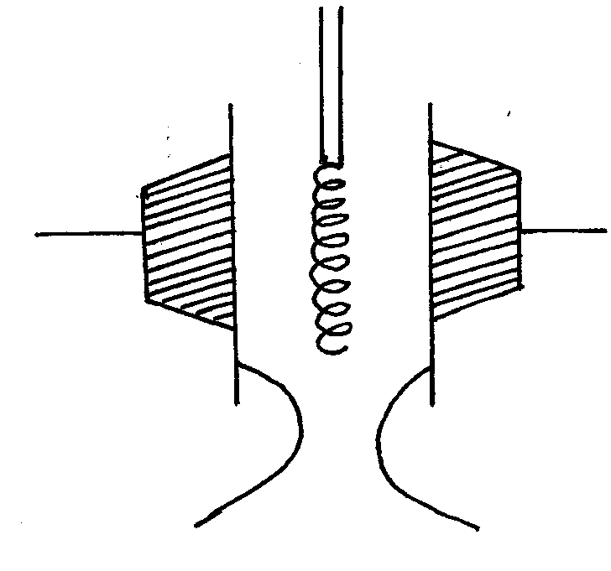

Cork fixed
with wax
Cork fixed with wax

Heat

2N
3N
Fig 5
Fig 4
Fig 3
polished surface
Dull surface

Explain the observation, when the heater is switched on for a short time given that the heater is equidistant from the two surfaces. (2mks)
…………………………………………………………………………………………………..……
…………………………………………………………………………………………………..……
- The air pressure at the base of Mt. Kenya is 70cmHg while at the top of the mountain is 55cmHg. Given that the average density of air is 130kg/m³ and the density of mercury is 13600kg/m³. Determine the height of the mountain. (3mks)

- Figure 4 shows a store of weight W placed on an inclined plane. If the angle of inclination is θ

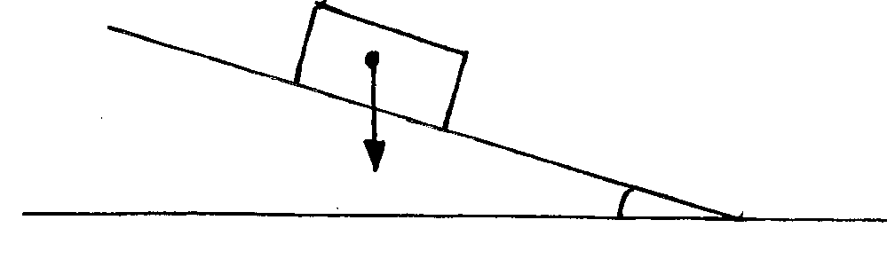

W
θ

- Indicate with arrows, two other forces acting on the stone. (1mk)
…………………………………………………………………………………………………..……
…………………………………………………………………………………………………..……
- State how each of the forces in (a) above is affected when the angle θ is increased. (1mk)

…………………………………………………………………………………………………..……
…………………………………………………………………………………………………..……
- State the reason why it is easier to separate water into drops than to separate a solid into smaller pieces. (1mk)
…………………………………………………………………………………………………..……
…………………………………………………………………………………………………..……
- Figure 5 shows a uniform beam held at equilibrium.
20cm
50cm
20cm
100cm

Determine the weight of the beam. (3mks)

- Figure 6 shows a glass filled with ice placed on a bench.

Fig 6

State the change on the stability of the glass when temperature increases. (1mk)
…………………………………………………………………………………………………..……
…………………………………………………………………………………………………..……
- State the fastest mode of heat transfer. (1mk)
…………………………………………………………………………………………………..……
…………………………………………………………………………………………………..……
- Explain how sensitivity of clinical thermometer can be improved. (1mk)
…………………………………………………………………………………………………..……
…………………………………………………………………………………………………..……
- Figure 7 shows a mass of 12g suspended on a set of 6 identical springs. When the mass was hanged on spring A, it extended by 5cm.
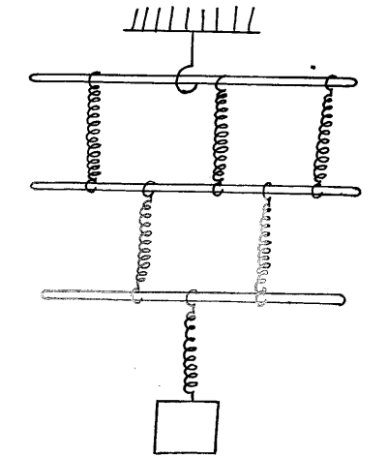

A
C
B
D
E
F

12g

Determine the extension of the combination shown if each spring and rod has negligible weight.
(2mks)

- Sketch a graph of volume of a fixed mass of a gas against pressure on the axes below. (1mk)

Y
Y
A = 2520cm²
25200N
Volume , V
Pressure P

SECTION B ( 55 MARKS)
Answer all the questions in this section in the spaces provided.
- (a) State the law of inertia (1mk)
…………………………………………………………………………………………………..……
…………………………………………………………………………………………………..……
- A ball of mass 50kg is thrown from the top of a cliff 20m high with a horizontal velocity of 20m/s. On reaching the ground it completely covered arm X of a hydraulic lift such that no water splashed out. The other arm Y has a weight of 25200N. Assuming the tap was opened when the ball struck the surface of water.

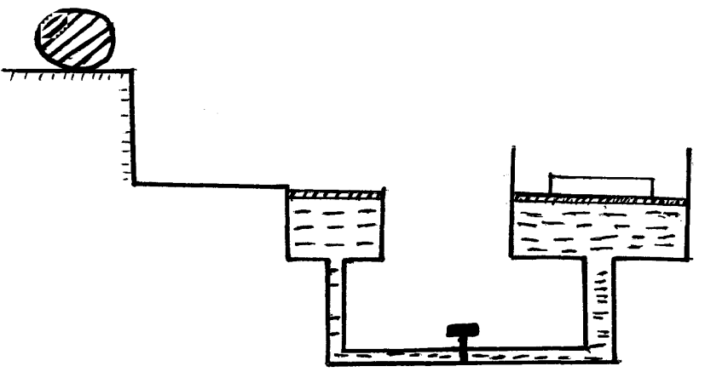
X
Ball

A = 50cm²

Fig 8

Determine

- The time taken by the ball to strike the surface of water at arm X (3mks)
…………………………………………………………………………………………………..……
…………………………………………………………………………………………………..……
- The distance from the foot of the cliff to where the ball strikes the surface of water
(2mks)
…………………………………………………………………………………………………..……
…………………………………………………………………………………………………..……

- The vertical with which it struck the surface of water at arm X (2mks)
…………………………………………………………………………………………………..……
…………………………………………………………………………………………………..……
- The force with which the ball struck the surface of water (2mks)
…………………………………………………………………………………………………..……
…………………………………………………………………………………………………..……
- The distance moved by the 25200N load arm Y if the level of water in arm X and arm Y was initially the same. (2mks)
…………………………………………………………………………………………………..……
…………………………………………………………………………………………………..……
- The graph shows the relationship between volume and temperature for an experiment.

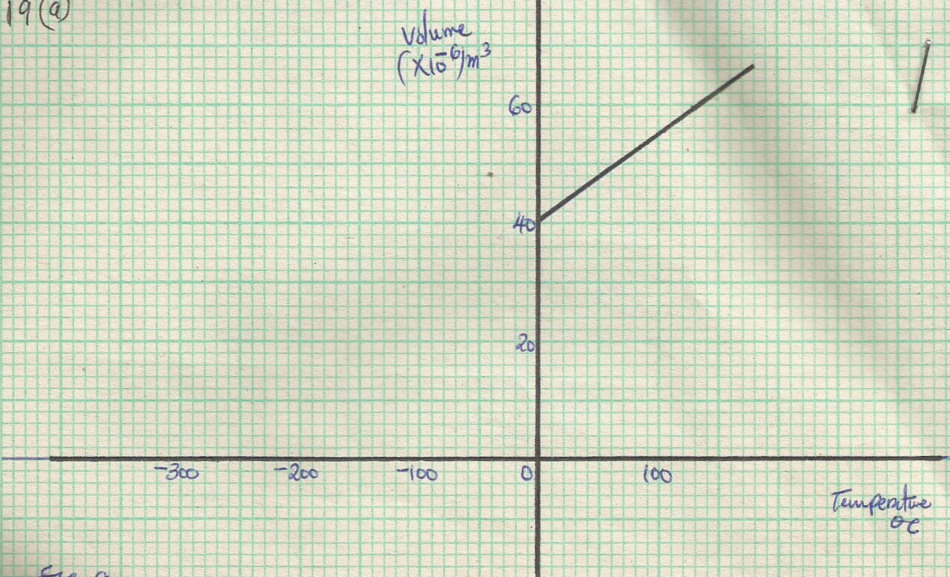

Fig10
Fig 9

- What was the volume of the gas at 0ºC (1mk)
…………………………………………………………………………………………………..……
…………………………………………………………………………………………………..……
- At what temperature would the volume of the gas be Zero (1mk)
…………………………………………………………………………………………………..……
…………………………………………………………………………………………………..……
- Explain why the temperature is part (ii) above cannot be achieved. (1mk)
…………………………………………………………………………………………………..……
…………………………………………………………………………………………………..……
- A wooden block of mass 50g floats with 20% of its volume above the water surface and kept in place by a string as shown below. The tension in the string is 0.06N

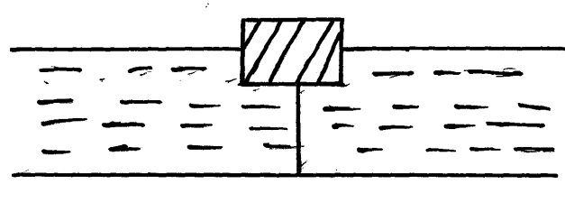

Determine

- The upthrust experienced by the object . (2mks)

- The volume of the displaced. (2mks)

- The density of the object (3mks)

- Figure 11 shows a car of mass, m moving along a curved part of the road with a constant speed.

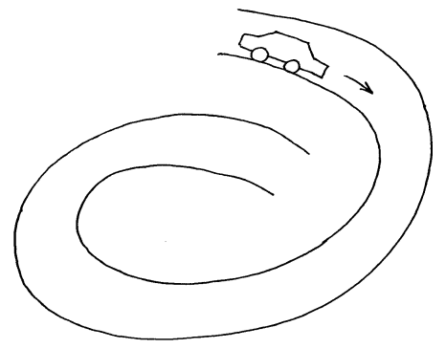

A
B
Fig11

- (i) Explain why the car is more likely to skid at B than at A (2mks)
…………………………………………………………………………………………………..……
…………………………………………………………………………………………………..……
(ii) If the radius of the path at B is 250m and the car has a mass of 6000kg, determine the maximum
speed the a car can be driven while at b to avoid skidding if the co-efficient of friction between
the road and the tyres is 0.3 (3mks)

- A string of length 70cm is used to whirl a stone of mass 0.5kg in a circle of a vertical plane at 5rev/s. determine:
- The period (2mks)

- The angular velocity (3mks)

- The figure 12 shows a flywheel of radius 14cm suspended about a horizontal axis through its centre so that it can rotate freely about the axis. A thread is wrapped round the wheel and mass attached to its loose end so as to hang at a point 1.26m above the ground.

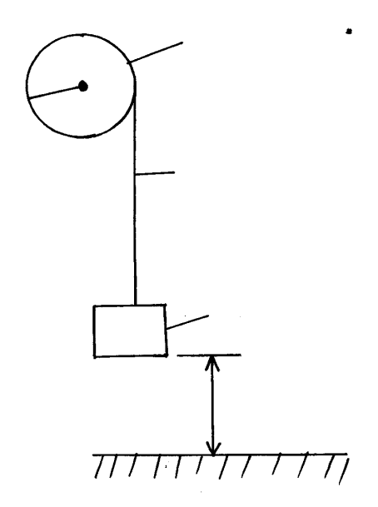
1.26m
Mass
Thread
Fly wheel
Fig12
14cm

When the mass is released, it accelerates at 0.28m/s² determine the angular velocity of the wheel just before the mass strikes the ground. (4mks)

- (a) Define specific latent heat of vaporization. (1mk)
…………………………………………………………………………………………………..……
…………………………………………………………………………………………………..……

- Water of mass 200g and temperature 10ºC is put in a copper calorimeter of mass 80g. steam from boiler at normal pressure is passed into the calorimeter for some time. The total mass of the calorimeter and contents is 283g. the final temperature of the contents is measured and is T.

Determine :

- Heat lost by steam on condensing to water. (2mks)

- Heat lost by condensed water. (2mks)

- Heat gained by the calorimeter and the cold water (3mks)

- The value of T (2mks)

( take specific heat capacity of water = 4200J/kg/k and copper = 900j/kg/k. specific latent heat of vaporization of steam = 2.26 x 10⁶ J/kg)

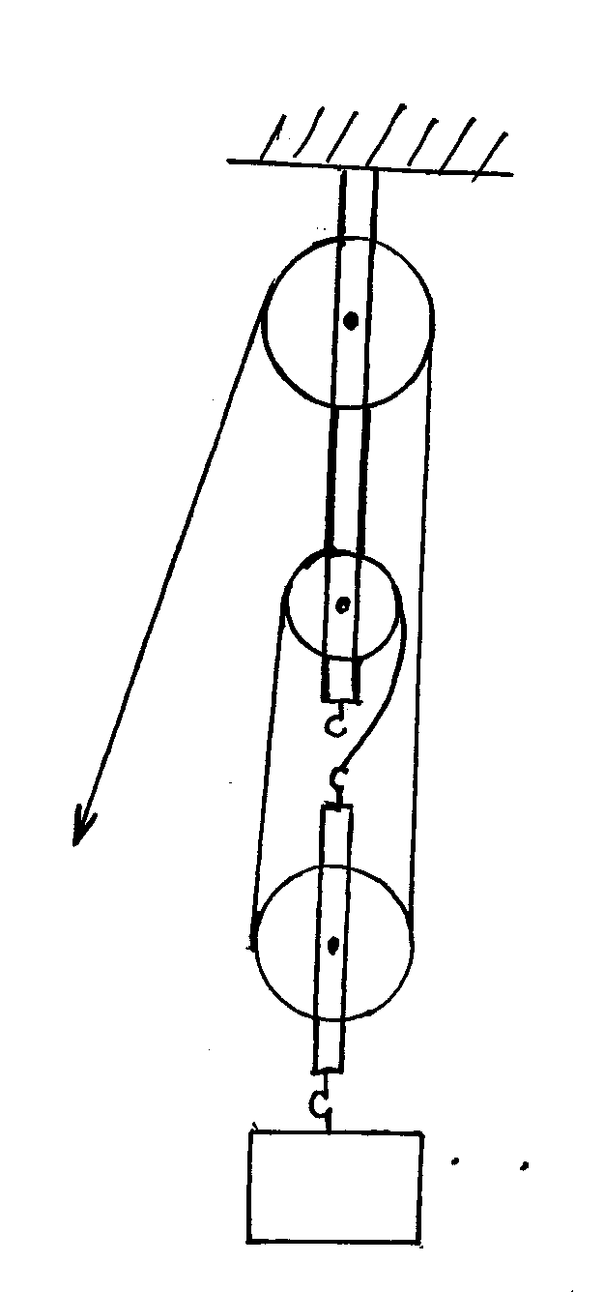
- (a) The figure 13 shows a pulley system used for lifting loads.

Load
Fig13

- What is the velocity ratio of the pulley system (1mk)

- If it’s efficiency is 80%. Determine its mechanical advantage. (2mks)

- If the load is 300N, determine the effort. (2mks)

(b) Derive an expression for the velocity ratio of the wheel and axle machine if the wheel has a
radius of R and axle has a radius of r. (3mks)

