Name:………………………………………...…………………………Index No…………………………….………...

232/2 Candidate’s Signature:……………….………….……………
PHYSICS
THEORY Date:…………………………….……………….......
PAPER 2
JULY/AUGUST 2014
TIME: 2 HOURS

Kenya Certificate of Secondary Education (K.C.S.E.)

232/2
PHYSICS
Paper 2
2 hours

INSTRUCTIONS TO CANDIDATES

- Write your name and index number in the spaces provided.
- Mathematical tables and non-programmable calculators may be used.
- This paper consists of section A and section B.
- Attempt all the questions in the spaces provided.
- ALL working MUST be clearly shown.

For Examiners Use
SECTION | QUESTIONS | MAXIMUM SCORE | CANDIDATE’S SCORE
A | 1 – 12 | 25
B | 13 | 10
 | 14 | 10
 | 15 | 07
 | 16 | 09
 | 17 | 09
 | 18
 | TOTAL | 80

This paper consists of 9 printed pages. Candidates should check to ascertain that all pages are printed as indicated and that no questions are missing.
SECTION A (25 MARKS)
- The figure below shows a series of wavefronts one wavelength apart approaching a gap between two barriers in aripple tank
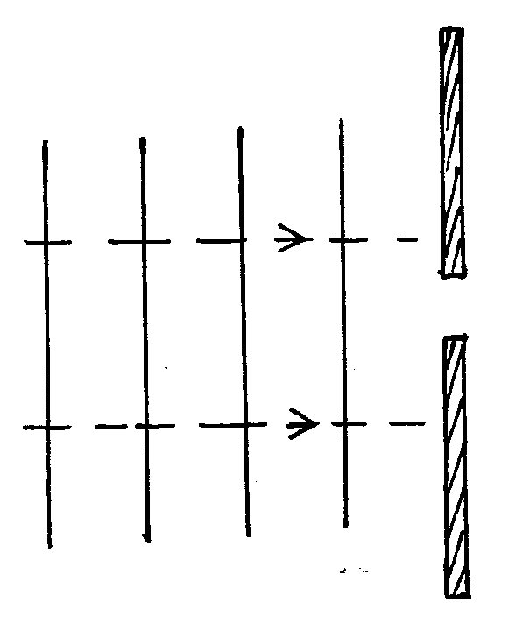

Show on the figure what happens as the waves pass the gap. (1mk)

- A mine worker stands between two vertical cliffs 400m from the nearest cliff. The cliff are x and metres apart. Every time he strike the rock once , he hears two echoes, the first one after 2.5 seconds, while the second follows 2 seconds later.
Calculate
- The speed of sound in air. (2mks)

- The value of x (3mks)

- The coil of an electric motor is usually round on a soft iron armature. State the purpose of soft iron armature. (1mk)
…………………………………………………………………………………………………….

- The diagram below shows a ray of light incident on a glass-oil interface.
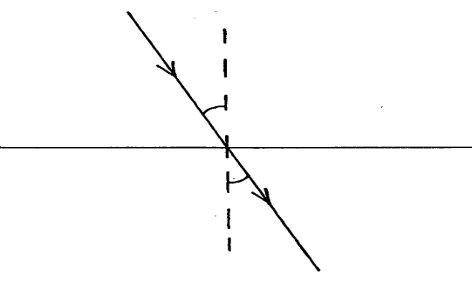
Oil
30º

r
Glass

If the refractive indices of oil and glass are 6/3 and 3/2 respectively, determine the value of r (3mks)

- The figure shows a simple cell.
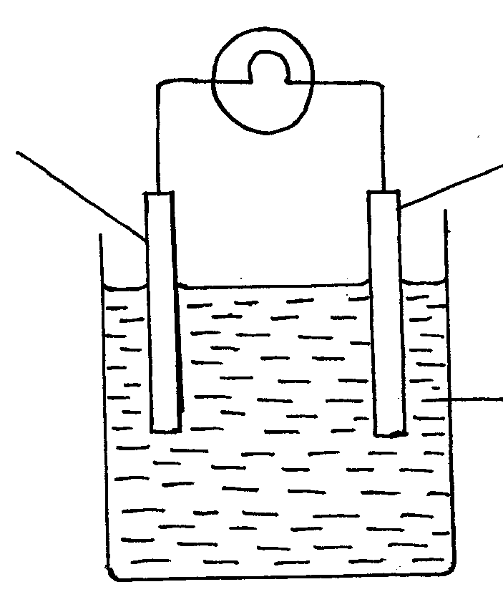

B
I
A

Dilute sulphuric acid

Use the information on the figure to answer the questions below.
- Name the parts labeled A and B (1mk)
A………………………………………………………..
B…………………………………………………………
- It is observed that the bulb goes off after a short time. Explain this observation (2mks)
…………………………………………………………………………………………………….
…………………………………………………………………………………………………….
- The figure below shows how a fuse may be connected in electric current
(a)
(b)
Fuse
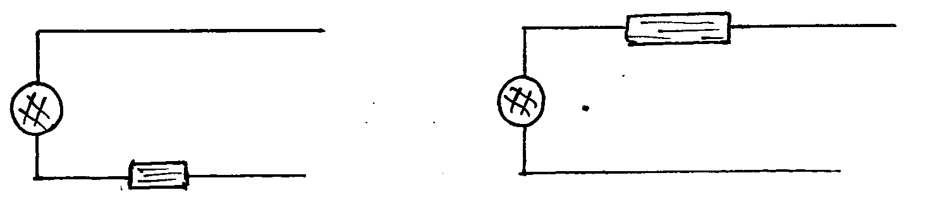

Load
Load
N
L
L
N
Fuse

In either case the fuse blows out but (a) is dangerous while (b) is not. Explain (2mks)
…………………………………………………………………………………………………….
…………………………………………………………………………………………………….
- The figure shows a simple circuit diagram of an electric bell.
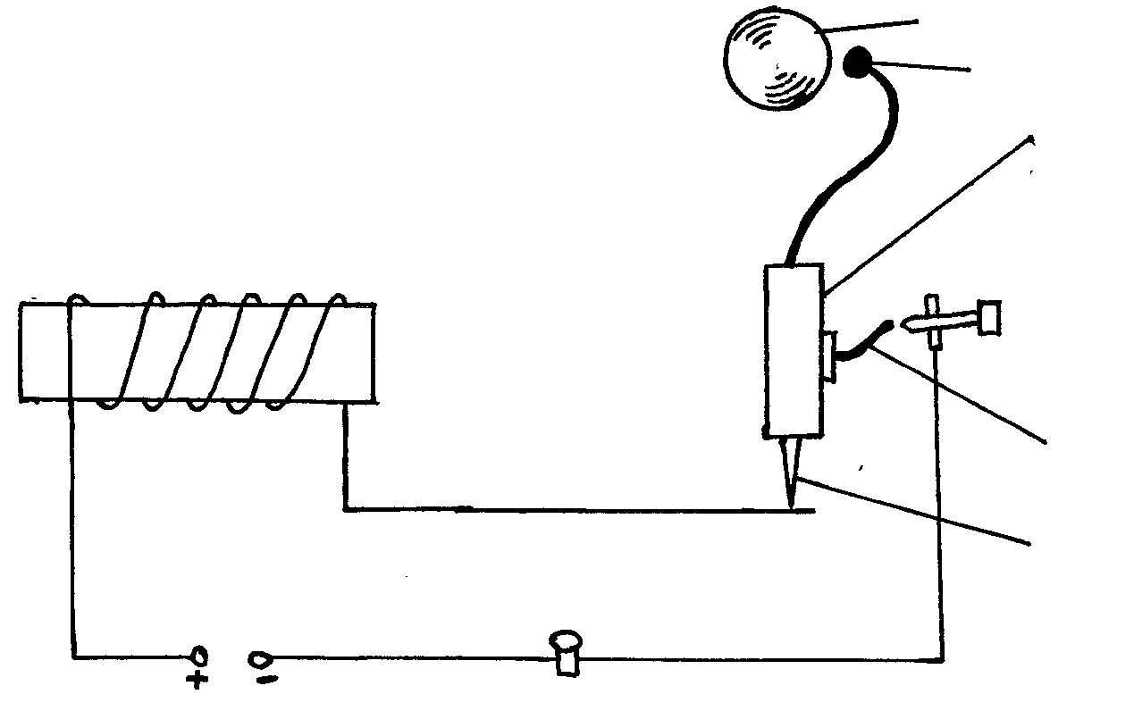
Soft iron armature
Gong
hammer

Solenoid

Contact

Bush button
Spring meter

Explain how it works (2mks)
…………………………………………………………………………………………………….
…………………………………………………………………………………………………….

- The figure shows part of electromagnetic spectrum
Ultra violet rays | Micro wave | x-rays | Red light

Arrange the electromagnetic waves in the order of decreasing energy. (1mk)
…………………………………………………………………………………………………….
…………………………………………………………………………………………………….
- State one advantage of using optical fibres in communication. (1mk)
…………………………………………………………………………………………………….
- Find the current flowing and voltage across the 8Ω resister in the circuit. (3mks)

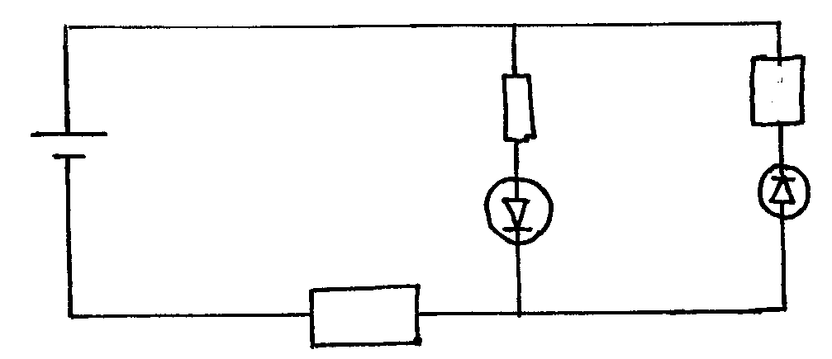
8Ω
3Ω
D₂
D₁
10v

2Ω

ά
β
- The following is part of radio active decay series.
Determine the value of a and b (2mks)

- State one property of cathode rays. (1mk)
…………………………………………………………………………………………………….
…………………………………………………………………………………………………….

SECTION B (55MARKS)
Answer all the questions in this section

- (a) In the experiment to observe interference of light waves a double slit is placed close to the source
see figure.

S₂
S₁

Monochromatic source
Screen
Double slot

- State the function of the double slit. (1mk)
…………………………………………………………………………………………………….
…………………………………………………………………………………………………….
- State and explain what is observed on the screen. (3mks)

…………………………………………………………………………………………………….
…………………………………………………………………………………………………….
…………………………………………………………………………………………………….
…………………………………………………………………………………………………….
- State what is observed on the screen when:
- The slit separation S₁S₂ is reduced. (1mk)
…………………………………………………………………………………………………….
…………………………………………………………………………………………………….
- White light source is used in place of monochromatic source. (1mk)
…………………………………………………………………………………………………….
…………………………………………………………………………………………………….

- (i) The figure below shows a set up by a student.
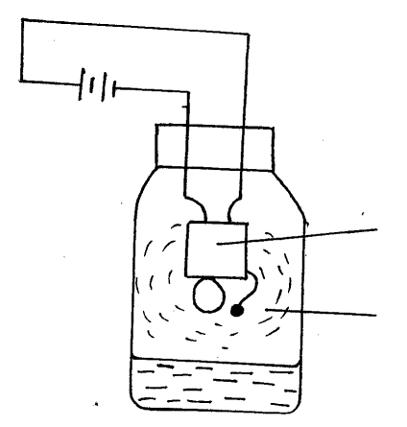

Electric buzzer

Steam from boiling water

State and explain what happens to the sound from the buzzer as the bottle and its contents are cooled to 0ºC (3mks)
…………………………………………………………………………………………………….
…………………………………………………………………………………………………….
…………………………………………………………………………………………………….
- In the pipe below complete the diagram to show how air in the open pipe vibrate with a frequency of first overtone. (1mk)
Open pipe

- (a) The figure below shows an arrangement of capacitor connected to a 10V DC supply.

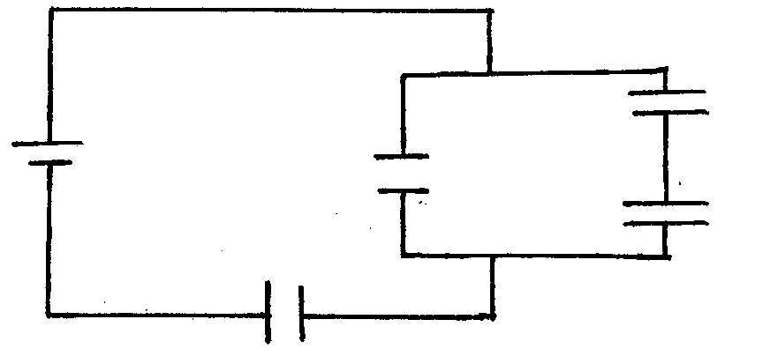
3µF

1µF
10v
2µF
3µF

Determine
- The combined capacitance of the arrangement. (3mks)
…………………………………………………………………………………………………….
…………………………………………………………………………………………………….
…………………………………………………………………………………………………….
- The total energy stored. (2mks)
…………………………………………………………………………………………………….
…………………………………………………………………………………………………….
(b) The graph below shows the variation of potential difference V with current, I for a certain cell.
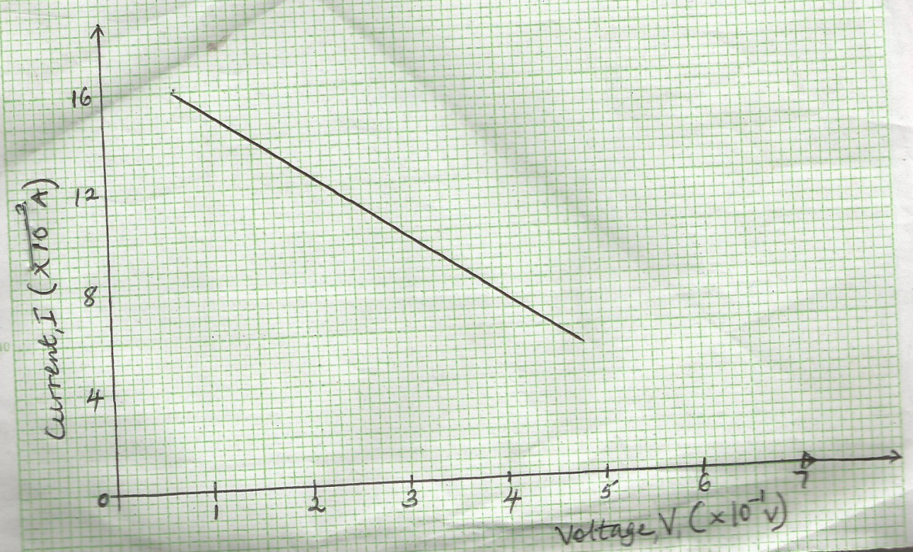

From the graph determine:
- Internal reaction of the cell. (3mks)

- The e.m.f of the cell (2mks)

- (a) (i) State the Lenz’s law of electromagnetic induction. (1mk)
…………………………………………………………………………………………………….
…………………………………………………………………………………………………….
- Use the law to determine the direction of the induced current in the circuit below (1mk)

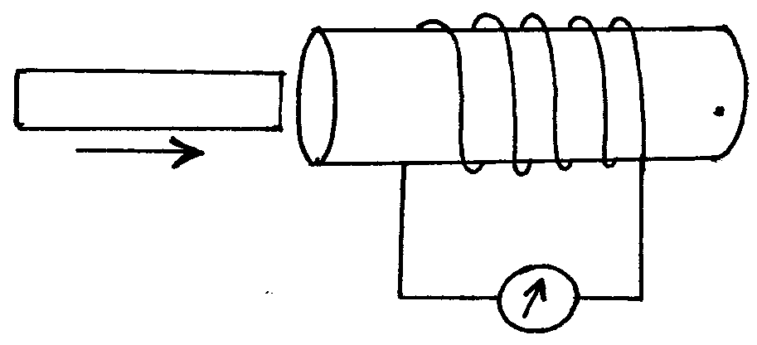
P
N
S

Motion of magnet

(b) Two identical coils P and Q are placed close to each other as shown.
Q
K
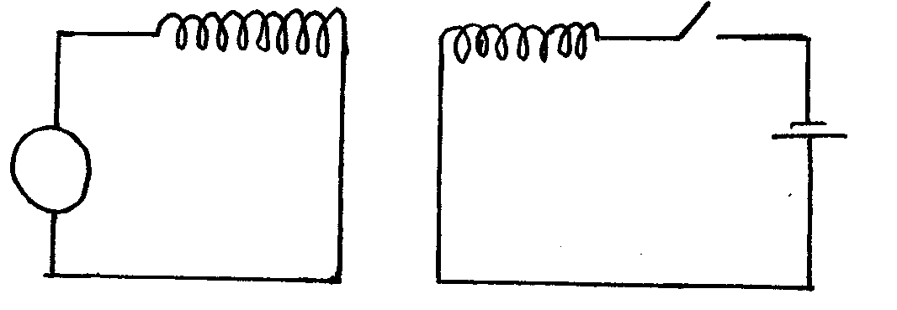

G

- State the observation on the galvanometer made when the switch K is closed. (1mk)
…………………………………………………………………………………………………….
…………………………………………………………………………………………………….
- Explain the observation stated in (i) above (2mks)
…………………………………………………………………………………………………….
…………………………………………………………………………………………………….
- A student designed a transformer to provide power to an electric bell marked 24W, 6V from a 240V mains. He wound 50 turns and N turns on an iron ring. When he a connected the coil of 50 turns to the bell and the N turns coil to an a.c, he found that the transformer was only 60% efficient. Find:
- The value of N (2mks)

- The power in the coil with N turns (2mks )

- (a) (i) With the aid of a diagram differentiate between forward biased and reverse biased
diode. (2mks)

- Sketch a graph to show how a current through a forward biased p-n function varies with potential difference across it. (2mks)

(b) The figure below shows an incomplete circuit for full wave rectification

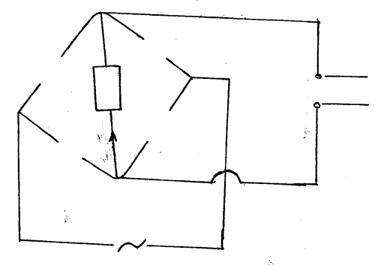
out put to CRO

- Complete the diagram to show how the diodes should be arranges for the current to flow through R in the direction shown with an arrow. (2mks)

- Sketch the output voltage as observed in the CRO (1mk)

- (a) Complete the diagram below indicating the rays that will lead to the formation of the image I
shown below and locate the object position (2mks)
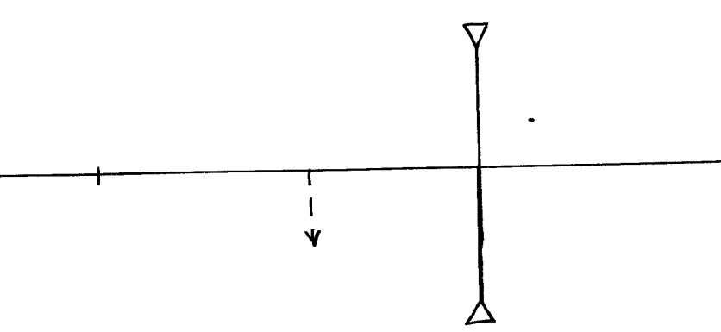

I

F

(b) An object is placed 12cm from a convex lens and it forms a virtual image 36cm from the lens
calculate the focal length of the lens. (3mks)

- The graph below shows variation of (cm ⁻¹) with (cm ⁻¹) for an object placed infront of a concave mirror
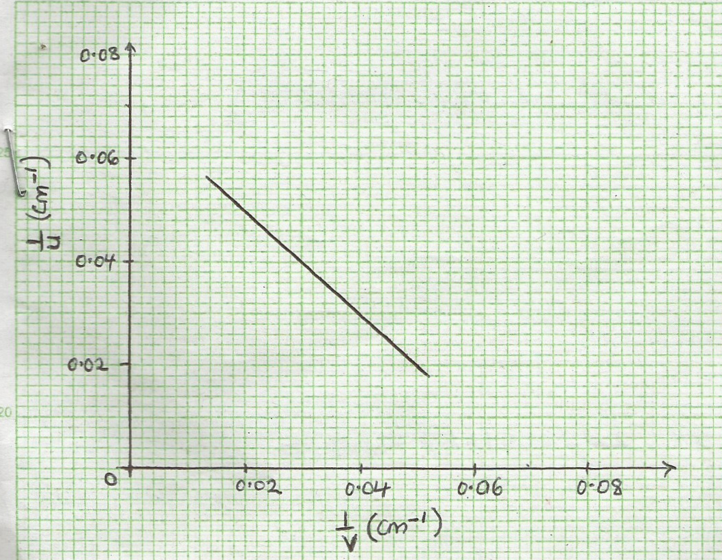

From the graph,
- Determine the focal of the mirror. (2mks)

- Determine the image distance when the object is 20cm from the mirror. (2mks)

- (a) The graph below shows stopping potential V against frequency for a photocell.

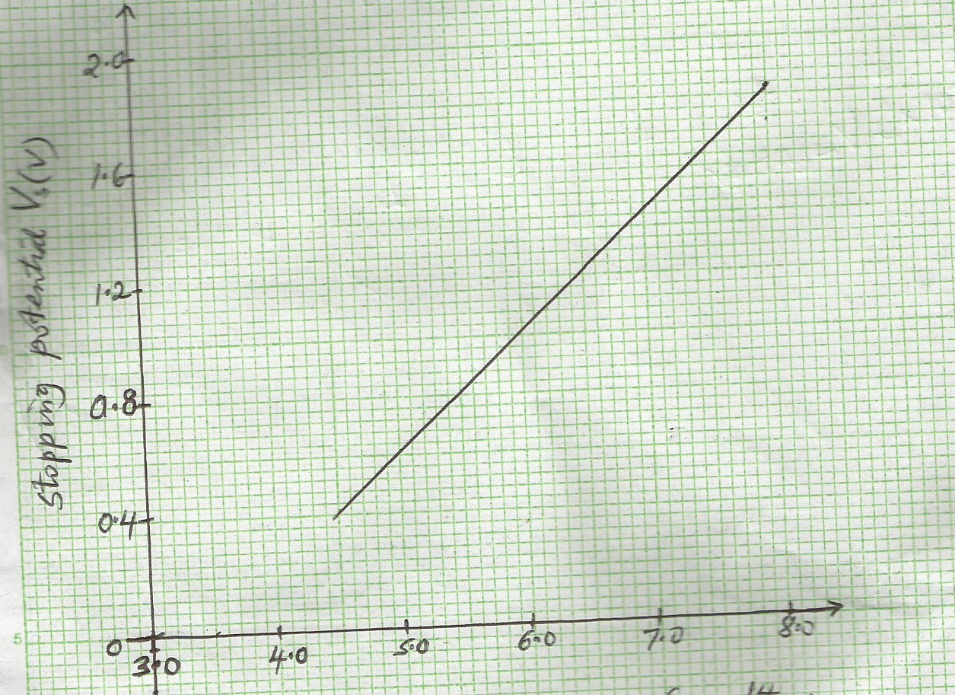
Frequency f (x10¹⁴Hz)

From the graph determine:
- Threshohd frequency (1mk)

- Planck’s constant (2mks)

- Work function of the metal (2mks)
(take e = 1.6 x 10-19c)

(b) The figure below shows an x-ray tube.
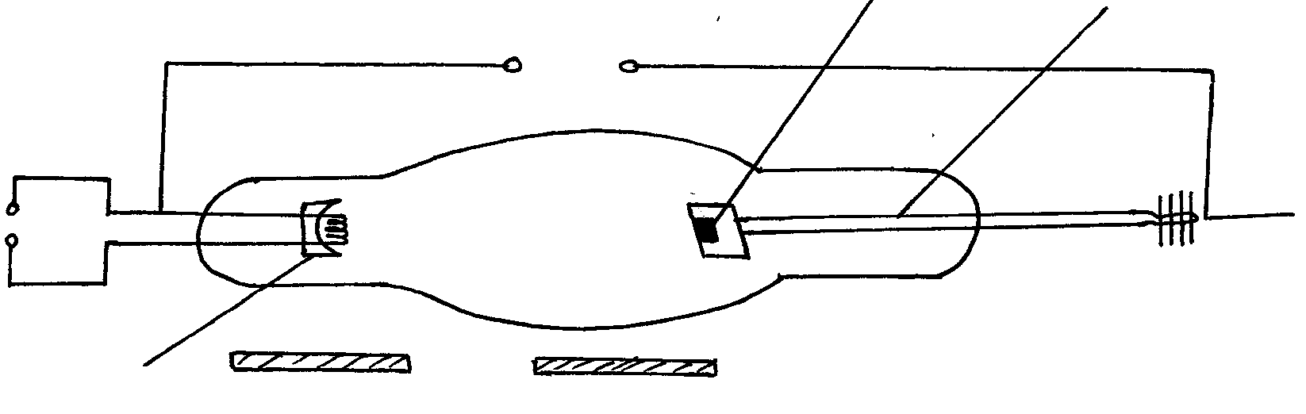
C
A
B
High voltage

Lead shield
Cooling fins

- Indicate on the diagram the path of the x-ray beam supplied by the tube. (1mk)

- Why is B set at an angle of 45º relative to the electron beam. (1mk)
…………………………………………………………………………………………………….
…………………………………………………………………………………………………….
- Why are cooling pins necessary (1mk)
…………………………………………………………………………………………………….
…………………………………………………………………………………………………….
- Why is the tube evacuated. (1mk)
…………………………………………………………………………………………………….
…………………………………………………………………………………………………….
- State the function of the part labeled C (1mk)
…………………………………………………………………………………………………….
…………………………………………………………………………………………………….

