MARKING SCHEME

|  |  |  |  |  |  |  |
| --- | --- | --- | --- | --- | --- | --- |
| Length L  (cm ) | 100 | 80 | 60 | 40 | 20 | 0 |
| Voltage v  (v) | 0.25 | 0.45 | 0.55 | 0.75 | 1.15 | 1.60 |
| Current I  (A) | 0.12 | 0.14 | 0.15 | 0.16 | 0.18 | 0.21 |

1i)

(ii) Brightness increase 🗸 1 1 mk

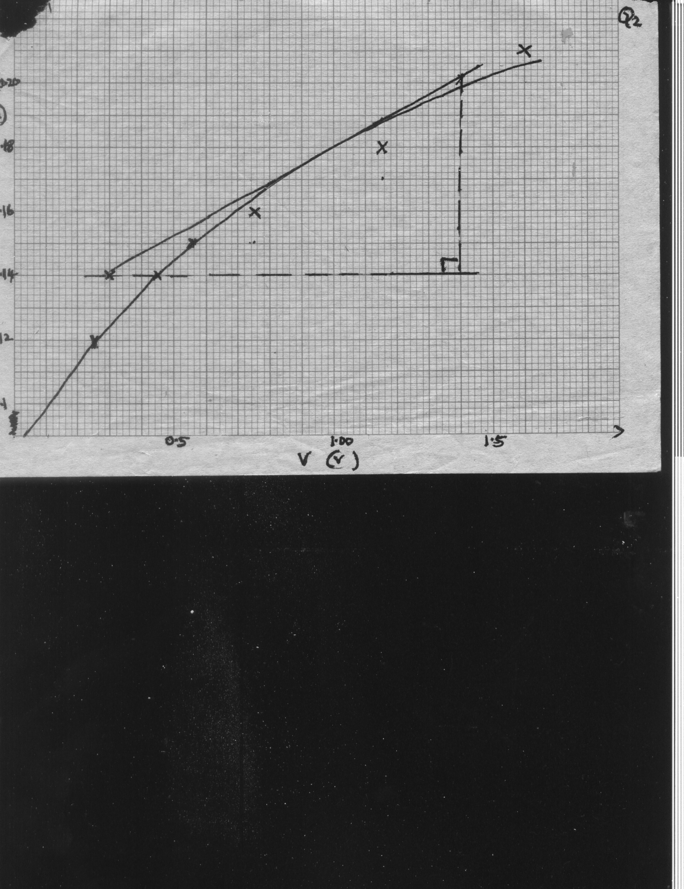

(iv)

Axes – 1

Scale - 1

Plotting – 2 at least four each ½ mark

Curve - 1

(v) Tangent at the point

Slope = 🗸 1 correct intervals

= 

= 0.018 -1 🗸 1 correct evaluation

(vi) Reciprocal of resistance 🗸 1

(b) (i)

Key

Cells

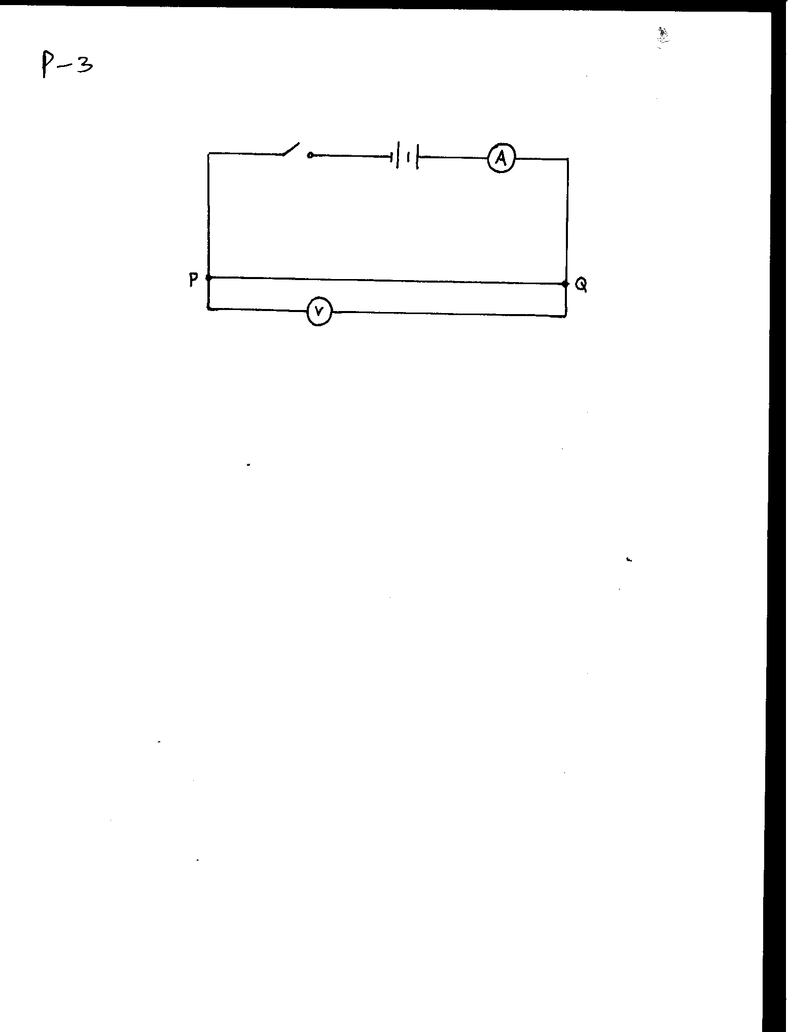

🗸 Circuit

Wire

NB – ammeter in cell switch in series voltmeter parallel to wire

(ii) V = 1.8 V🗸 1

I = 0.14 A 🗸 1

(iii) d = 3.6 x 10-4 m🗸 1

ρ =  🗸 1 correct substitio

= 1.308 x 10-6  m 🗸 1 evaluation and correct units

2 a) Initial pointer reading = “ Candidates” cm mark

|  |  |  |  |  |  |
| --- | --- | --- | --- | --- | --- |
| Mass m(g) | Extension e(cm) | e (m) x 10-2 | Time t, for 20 complete oscillations | Periodic time T (s) | T 2 ( S 2) |
| 30 | 2.0 | 2.0 | 6.63 | 0.3317 | 0.11 |
| 50 | 3.2 | 3.2 | 8.49 | 0.4243 | 0.18 |
| 70 | 6.3 | 6.3 | 12. 00 | 0.6 | 0.36 |
| 100 | 7.5 | 7.5 | 12. 96 | 0.6481 | 0.42 |
| 120 | 9.0 | 9.0 | 14. 97 | 0.7483 | 0.56 |
| 150 | 12 | 12 | 16. 61 | 0.8307 | 0.69 |
|  |  |  |  |  |  |

d) (7mks)

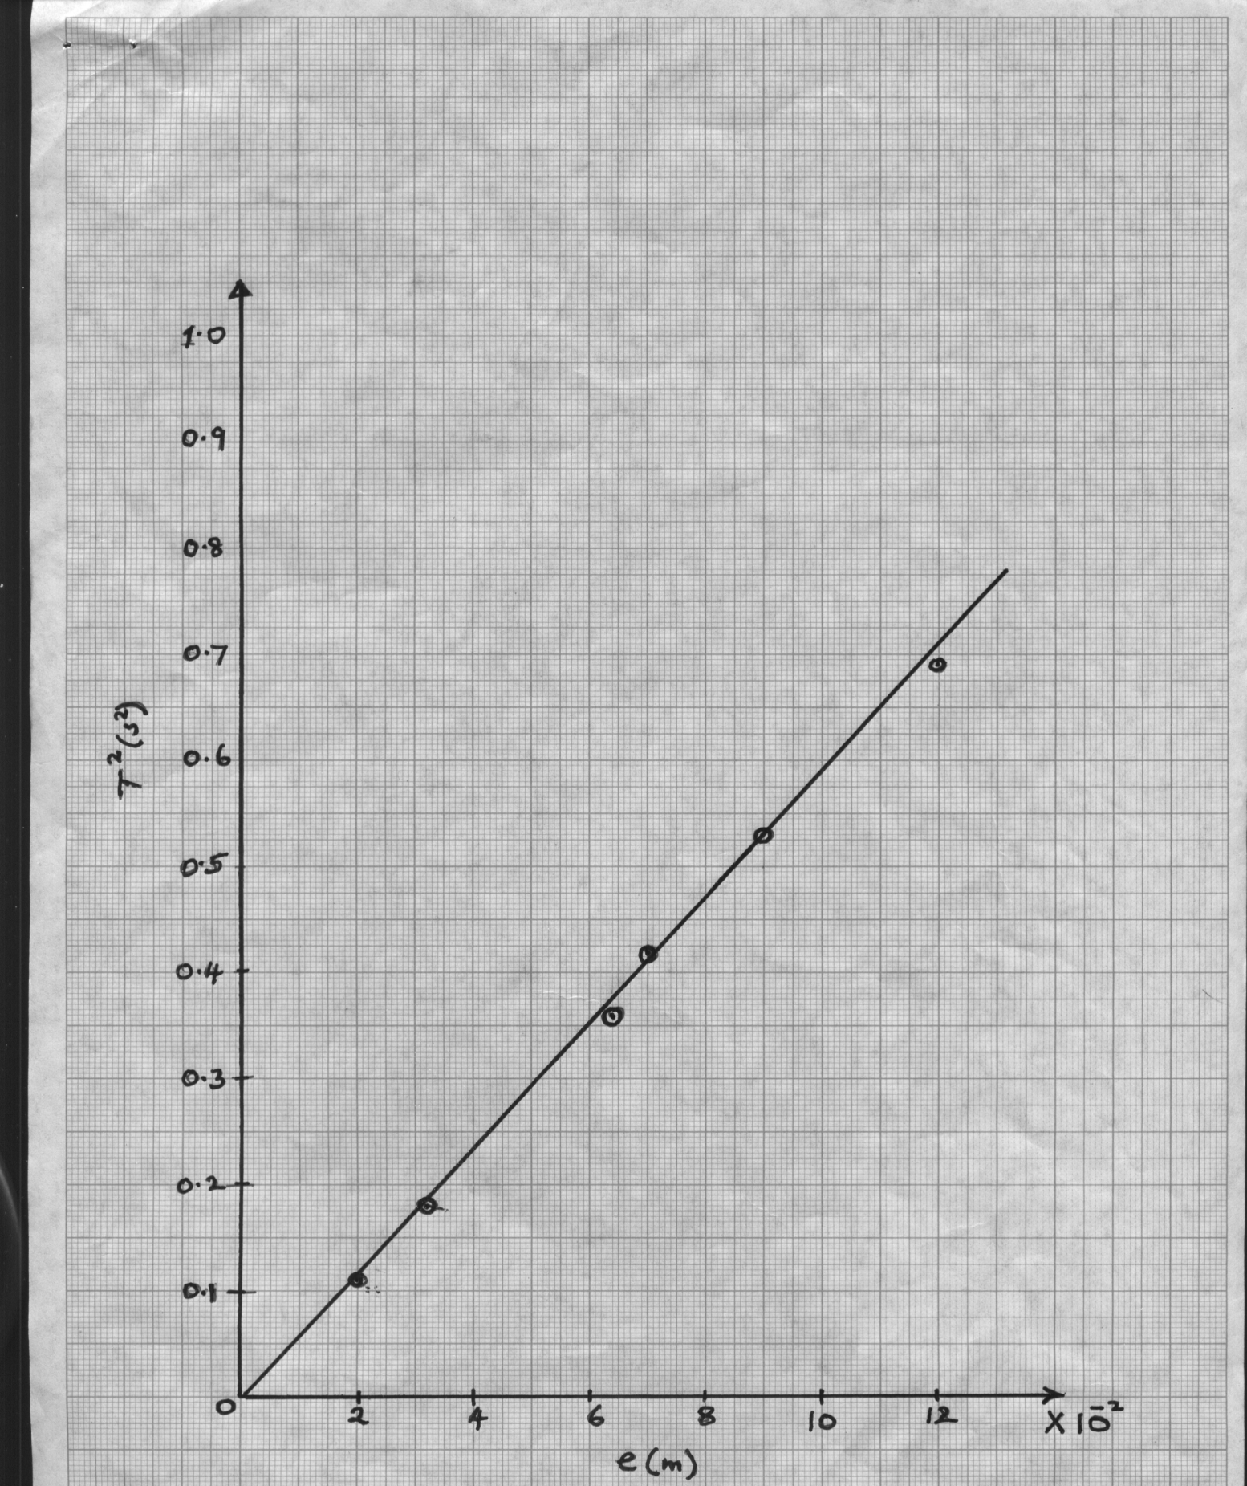

e)

Labelling- correct quantity + units 1 mark

Scale – simple and uniform 1 mark

Plotting- ½ x 4 2 marks

Line 1 marks

5 marks

f) S =  correct internal 1mk

= 9.6 Correct evaluation 1 mk

g) T = 

T2 = 

Slope, 

*k* = 

= 4 . 113 2mks

h) m = 26 g 🗸 ½mk = 0.026 kg ½mk

i) e=0.42 cm ½mk = 4.2 x 10-3🗸 ½ mk

1. ν = mk

e

 Correct substitution 1 mks

= 6. 190 Correct evaluation 1 mk