**MWAKICAN JOINT EXAMINATION (MJET)**

**FORM3 TERM 2 YEAR 2016**

**PHYSICS PAPER 3**

NAME…………………………………………………………………………………………ADM.NO……………

**INSTRUCTIONS TO THE CANDIDATES:**

* Write your **name** and **index number** in the spaces provided above.
* Answer ***all*** questions in the spaces provided in the question paper.
* You are supposed to spend the first 15 minutes of the 2 ¼ hours allowed for this paper reading the whole paper carefully.
* Marks are given for a clear record of the observation actually made, their suitability, accuracy and the use made of them.
* Candidates are advised to record their observations as soon as they are made.
* Mathematical tables, slide rules and calculators may be used.
* Record your observations as soon as you make them.

**QUESTION 1**

You are provide with the following;

* Two dry cells
* One bulb
* Voltmeter (0 – 3 v or o – 5v)
* Ammeter (0 – 2.5A)
* A mounted nichrome wire on millimetre scale;
* Switch
* Seven connecting wire at least two with crocodile clips.
* Micrometer screw gauge

Procedure as follows;

a) (i) Set up the circuit as shown in figure below;

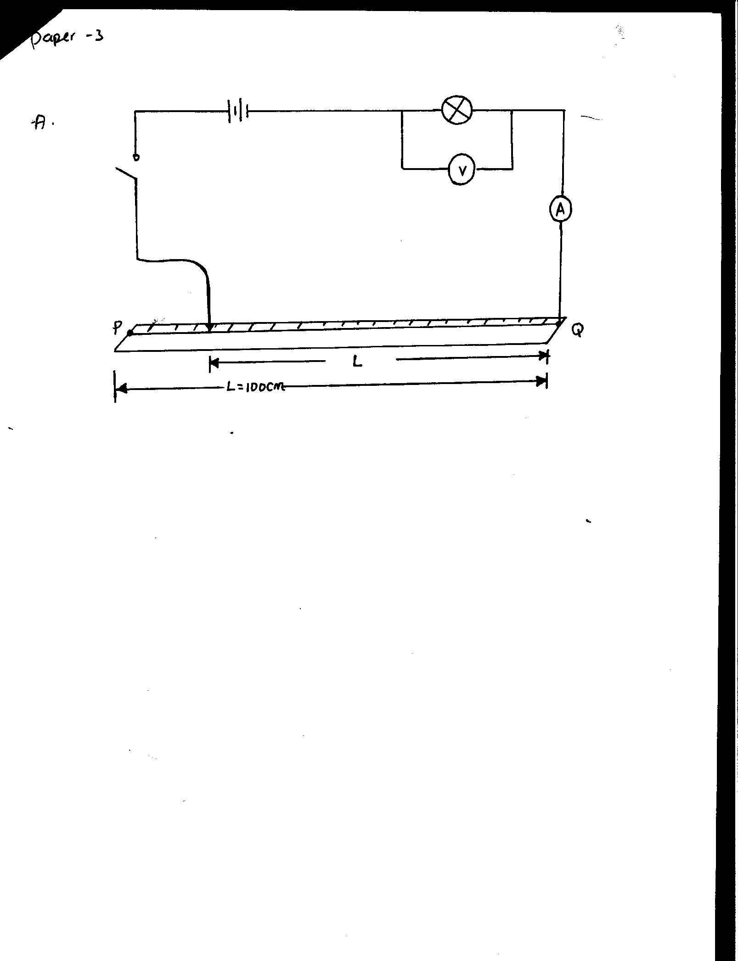

Nichrome wire

Key

Cells

Bulb

ii) With the crocodile clip at P take the voltmeter reading and the ammeter reading. Record V and I. Repeat the readings for L = 80,60,40,20 and 0 cm respectively. Complete the table below;

|  |  |  |  |  |  |  |
| --- | --- | --- | --- | --- | --- | --- |
| Length L (cm) | 100 | 80 | 60 | 40 | 20 | 0 |
| Voltage V (v) |  |  |  |  |  |  |
| Current, I (A) |  |  |  |  |  |  |

(4mks)

(iii) What changes do you observe on the bulb as L decreases from P ? (1mk)

(iv) Plot a graph of the ammeter reading (y = axis) against voltmeter reading (5mks)

v) Determine the slope of your graph at V = 1 volt (3mks)

(vi) What physical quantity is represented by the slope of the graph at any given point.? (1mk)

b) (i) Given the apparatus in a (i) above, draw a diagram of the a circuit you would use to determine the current through the resistance wire and the potential difference across it. (1mk)

(ii) Set up the circuit you have drawn. Record the ammeter reading I and the voltmeter reading

V, when L = 100cm. (2mks)

V = ………………………………………………………………….

I = …………………………………………………………………..

(iii)Using a micrometer screwgauge, measure the diameter d of the wire. (1mk)

d = …………………………………m

(iv) Calculate the quantity,

p = 0.785  and give its units, where L is one metre. (2mks)

**QUESTION2.** You are provided with the following;

* A Complete retort stand
* A Stop watch/stop clock
* A Metre rule
* Two identical springs labeled R and P.
* A Weighing balance (to be shared)
* A Set of masses 10g, 20g, 50g and 100g
* A Pendulum bob

Proceed as follows

1. Join springs R and P in parallel so that it has only one hook at one end and then arrange the apparatus as shown in the figure below.

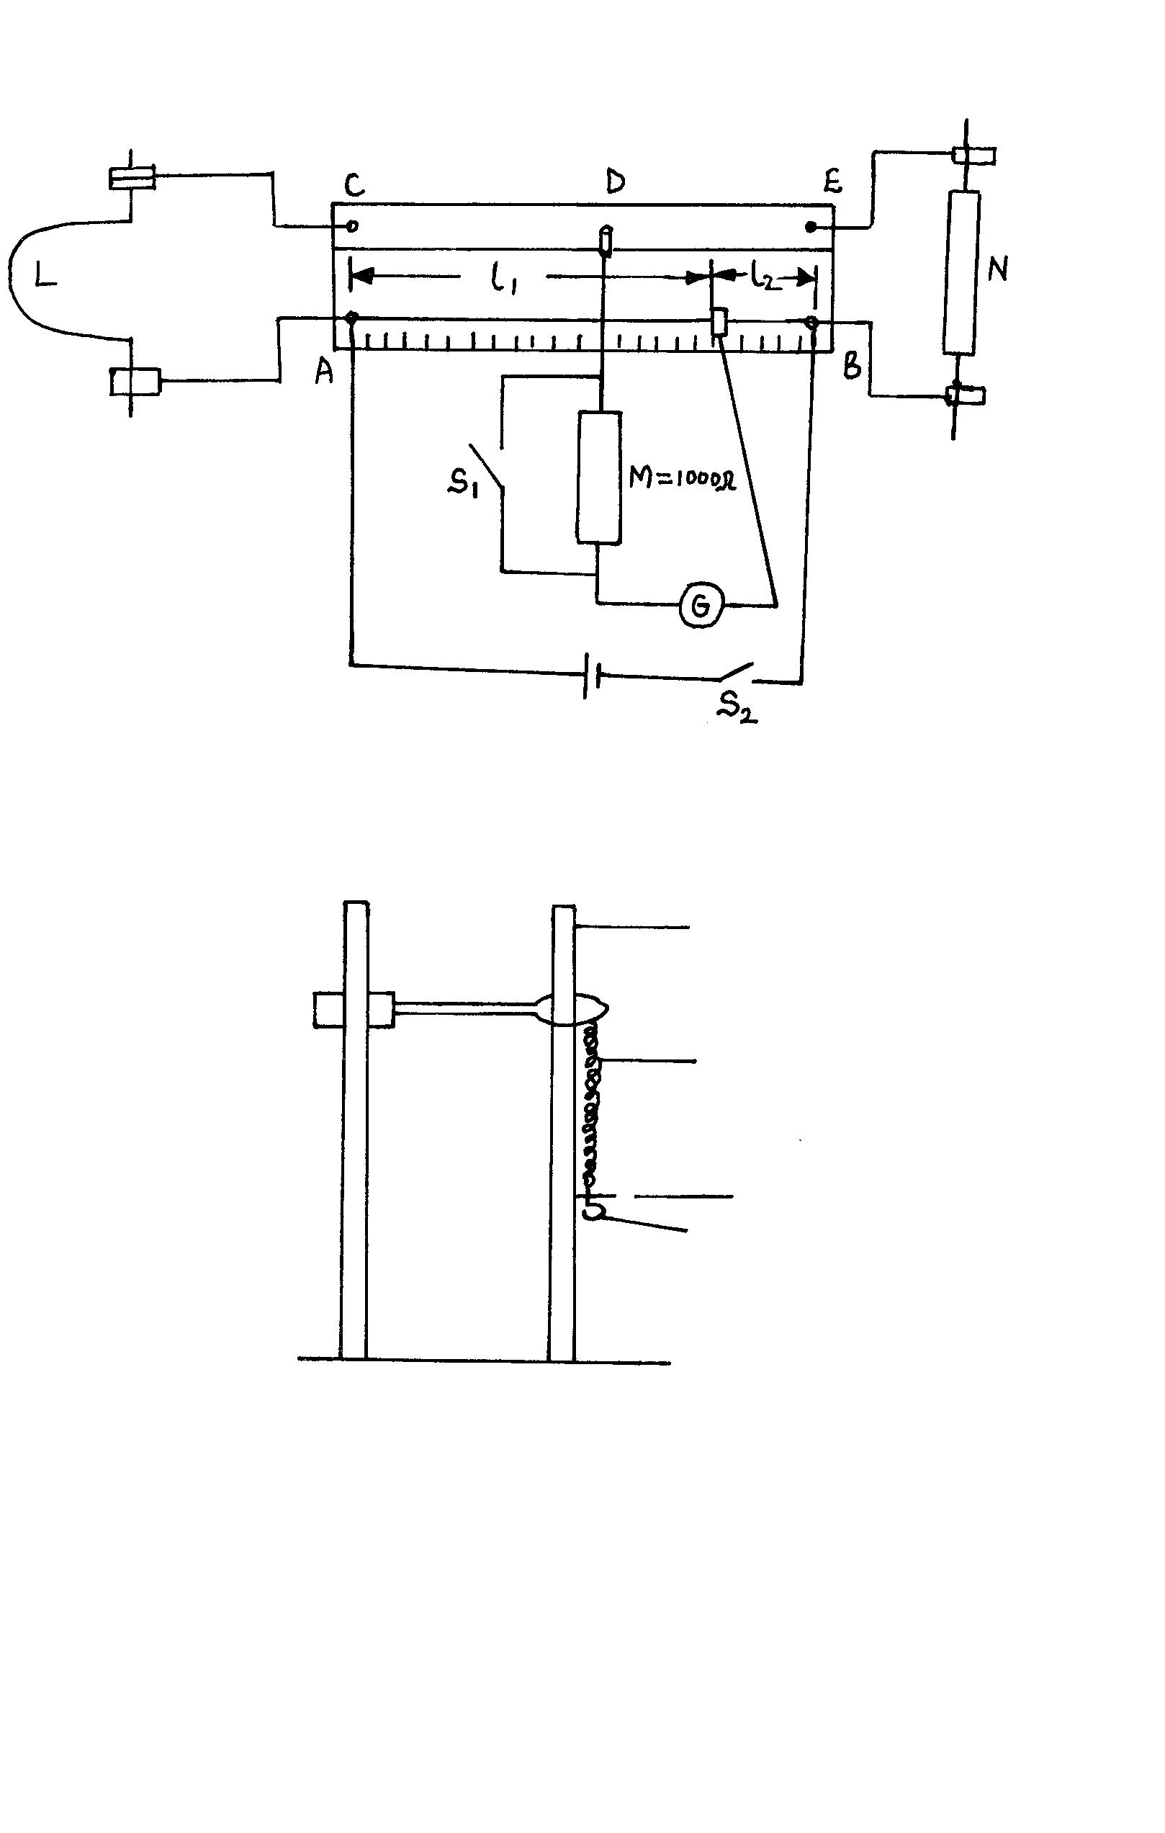

Hook

Pointer

Spring R

Spring P

Metre rule

Retort stand

Note and record the initial pointer reading.

Initial pointer reading = ………………………………………………………….……cm mark.

(This mark should be maintained throughout the experiment)

1. Hang the 30g mass on the hook of the combined spring balance and record the final pointer reading. Hence calculate the extension, e, for m = 30g.
2. With mass, m = 30g, still suspended, slightly displace the mass vertically and time 20 complete oscillations
3. Repeat the experiment for m = 50, 70, 100, 120 and 150g and record your results in the table below.

|  |  |  |  |  |  |
| --- | --- | --- | --- | --- | --- |
| Mass m (g) | Extension *e* (cm) | *e* (m) | Time, *t*, for 20 complete oscillations | Periodic time, T (s) | T2(s2) |
| 30 |  |  |  |  |  |
| 50 |  |  |  |  |  |
| 70 |  |  |  |  |  |
| 100 |  |  |  |  |  |
| 120 |  |  |  |  |  |
| 150 |  |  |  |  |  |

(7mks)

1. (i) On the grid provided, plot a graph of e(x – axis) against T2 (5 mks)

ii) determine the slope, S, of the graph. ` (2 mks)

1. If the experiment obeys the law T =  where *k* is a constant, determine the value of *k* (= 3.142) (2 mks
2. Weigh and record the mass of the pendulum bob provided.

Mass, m of pendulum bob = ……………..………………..g = ……………………….…….kg (1 mk)

1. Suspend the pendulum bob on the combined spring balance and note the extension produced.

extension*e*1= ………………………………….………..cm = ……………………..………..m (1 mk)

1. If ν =  where *m* = mass of the pendulum bob and *e* is the extension produced, find the value of ν where ν is the elastic constant of the springs. (2 mks)