END TERM 2 2019
FORM 4 PHYSICS PAPER 3
MARKING SCHEME
- You are provided with the following;
- A stopwatch
- Cotton thread at least 120cm long
- Stand and a clamp
- Pendulum bob
- Metre rule
Arrange your apparatus as shown
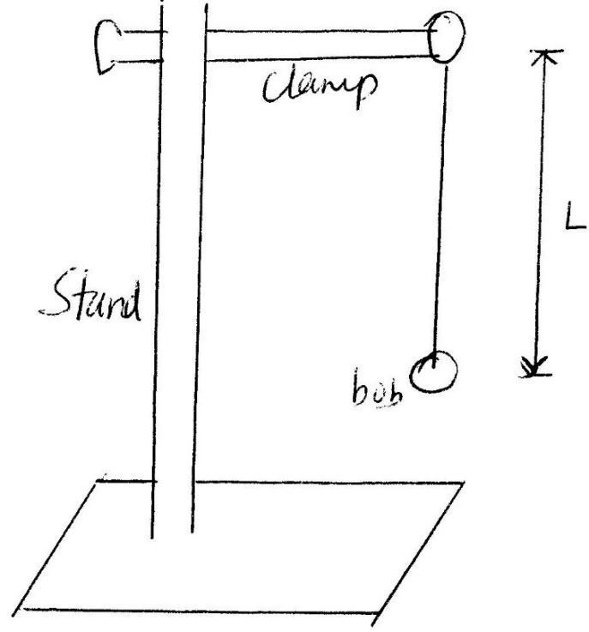
Proceed as follows;
- Adjust the length Lof the pendulum to 1meter.
- Displace the bob side ways to an angle of about 45º (estimate) and let the pendulum switching for 10 oscillations and record the time, t, take for the ten oscillations.
- Repeat the same for other values of L as shown in the table below and fill in the columns of the table as indicated. (8mks)
Length L(in m) | Time for 10 oscillations (in sec) | Periodic time (T) | Periodic Time )² ie T² (in 2 dec pls
1.0 | 20 | 2.0 | 4.0
0.8 | 18 | 1.8 | 3.24
0.7 | 17 | 1.7 | 2.89
0.6 | 15.5 | 1.55 | 2.40
0.5 | 14 | 1.4 | 1.96
0.4 | 13 | 1.3 | 1.69
0.3 | 11 | 1.1 | 1.21

- Plot a graph of T2 against L. (5mks)
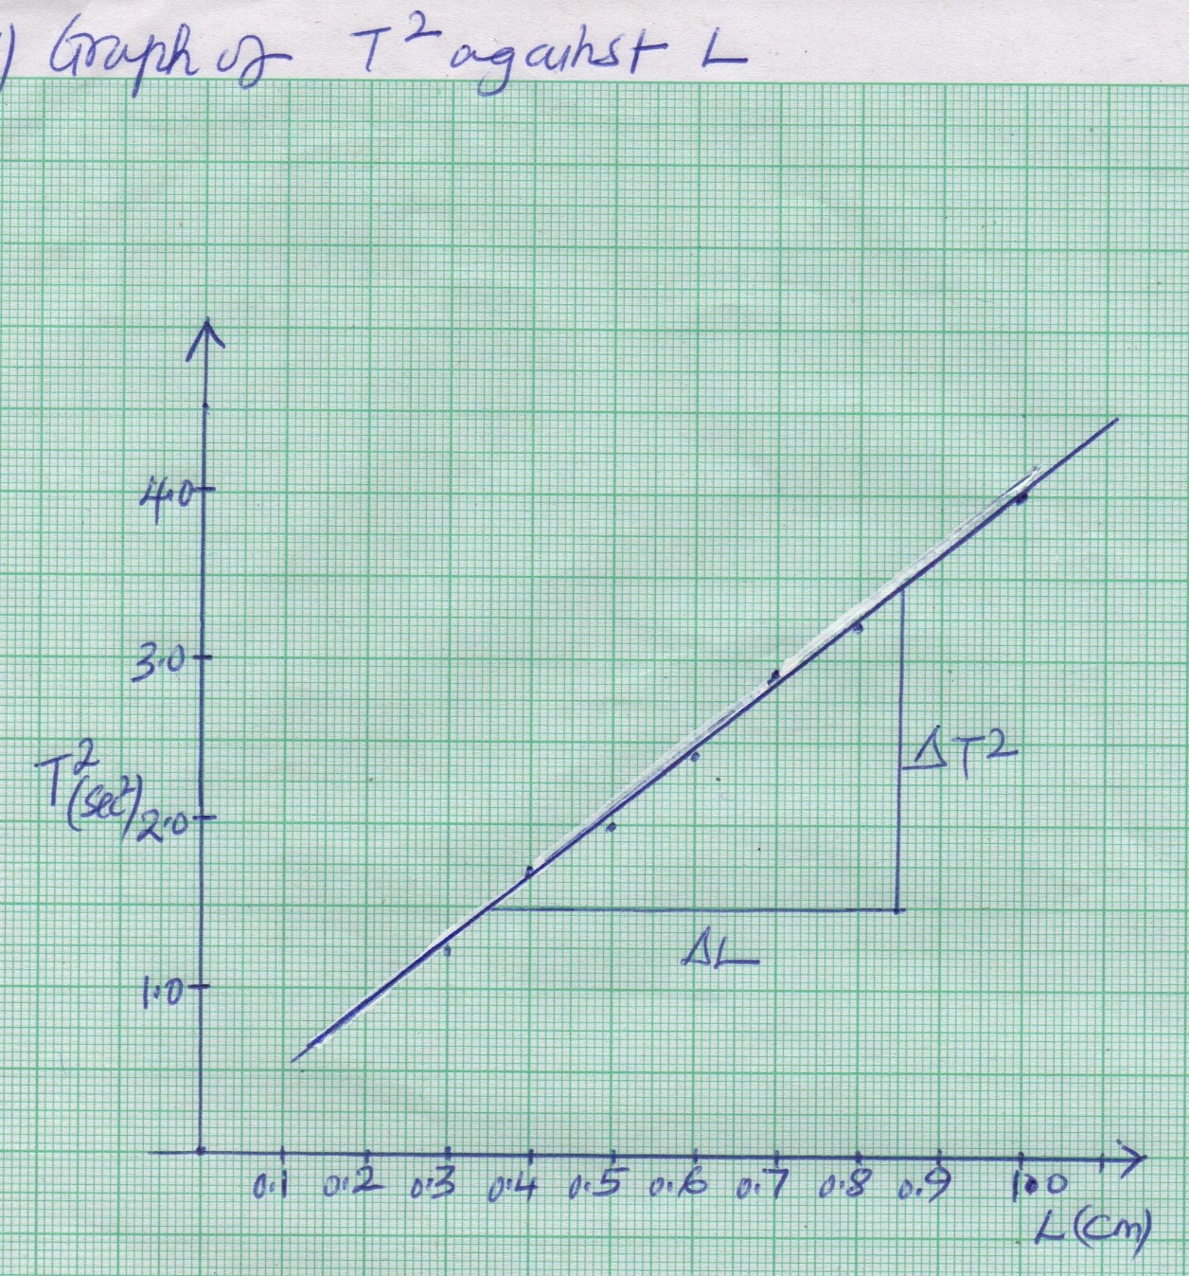
- Determine the gradient (3mks)
Gradient = $\frac{Change in T^{2}}{Change in L}$
= $\frac{0.85-0.35}{3.4-1.5}$ = 0.5/1.9
= 0.263 S²/m
- Given that period (T) of a pendulum and the length (<) are related by the equation
T = $\sqrt[2π]{\frac{l}{g}}$’
Where g is the gravitational pull, use your graph to determine the value of g. (4mks)
T² = 4π² $\frac{L}{g}$
T² = ($\frac{{4π}^{2}}{g}$)L
Gradient = $\frac{{4π}^{2}}{g}$
g = $\frac{4π^{2}}{Gradient}$
- Part A
You are provided with the following apparatus.
- a Convex lens
- A candle
- White screen
- Lens holder
- Metre rule
- Set up the apparatus as shown in the figure below.

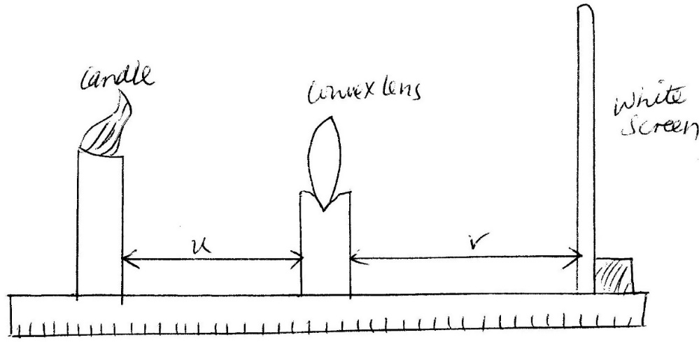

- Place a lighted candle at object distance, U = 20cm. Move the screen, towards or away the lens until a sharp image of the candle flame is obtained on the screen. Measure the distance V and record the results in the table below.
- Repeat the same for other values of U as shown in the table and fill their respective values of V. (5mks)
Object distance U (in cm) | Image distance V(in cm) | U + V (cm) | UV (cm2)
20 | 20 | 40 | 400
30 | 15 | 45 | 450
45 | 13 | 58 | 585
60 | 12.5 | 72.5 | 750
75 | 12.0 | 87.0 | 900
90 | 11.5 | 101.5 | 1035

- Plot a graph of UV (cm2) against (U + V) (cm). (5mk)
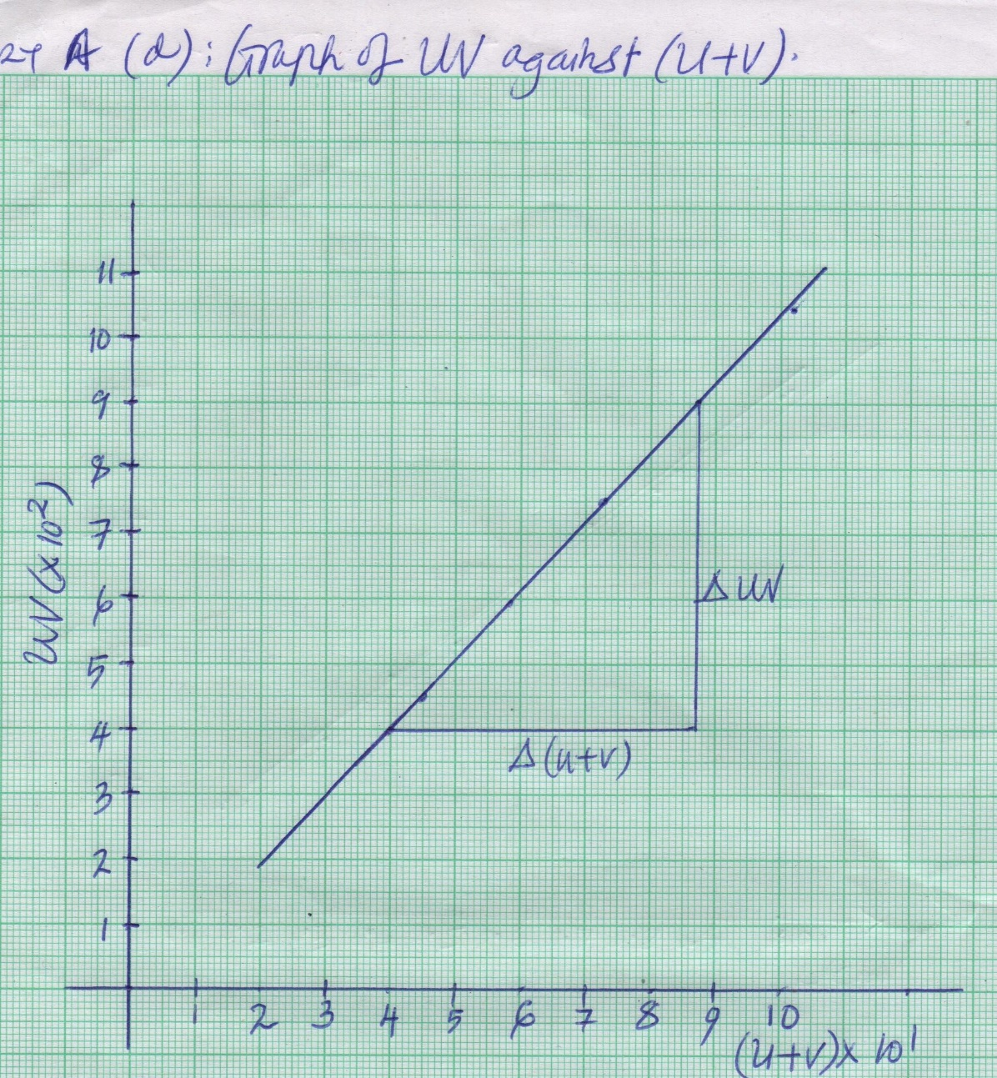
- Determine the slope of the graph (2mks)
Slope = change in uv /change in (u+v)
= $\frac{900-450}{87.5-45}$
= 10.59 cm.
- Determine the power of the lens used in the experiment. (2mks)
Power of lens = 1/f
= 1/10.59x10⁻²
= 9.443 Dioptre

Part B

You are provided with the following apparatus
- 2 New dry cells
- An ammeter
- A mounted wire labelled AB
- A cell holder
- A switch
- Connecting wires
- Draw a circuit that can be used to determine the resistance of the wire AB. (2mks)
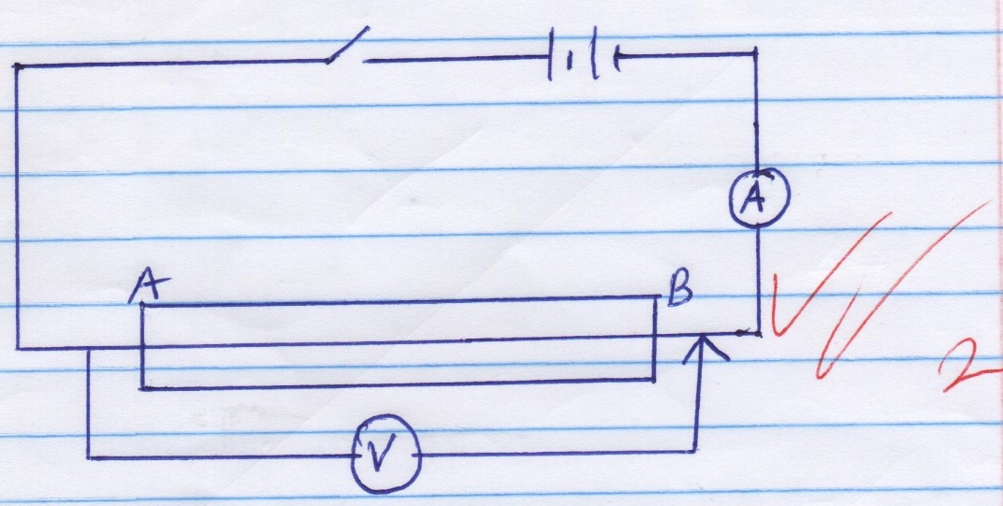
- Set up the apparatus as in your circuit diagram and tabulate two set of values. (2mks)
V | 2.55 | 2.5
I | 0.35 | 0.35

- Calculate the resistance of the wire (2mks)
R = V/I
Where V = $\frac{2.55+2.50}{2}$ = 2.525
I = $\frac{0.35+0.35}{2}$ = 0.35
Hence R = $\frac{2.525}{0.35}$ = 7.214Ω

