END OF TERM 2 EXAMINATION 2019
FORM IV PHYSICS PAPER ONE ( 232 / 1 ); TIME 2 HOURS

NAME----------------------------------------------------------------AD.NO .--------------------------
INSTRUCTIONS TO CANDIDATES
Write your name and Admission number in the spaces provided above
Answer all questions in the spaces provided.
All working must be clearly shown in the spaces provided
Take g = 10 N / kg, density of mercury = 13600 kg / m³ and density of water = 1000 kg / m³

FOR EXAMINER’S USE ONLY
SECTION | QUESTIONS | MAX. SCORE | CANDIDATES’S SCORE
A | 1--13 | 25
B | 14 | 14
 | 15 | 9
 | 16 | 10
 | 17 | 11
 | 18 | 11
TOTAL

SECTION 1 ( 25 MARKS )
ANSWER ALL QUESTIONS
1)The instrument shown in the fig. below has a Zero error of -0.02mm.It was however used to measure the diameter of a marble as shown. Determine the correct diameter of the marble. ( 2 mks )

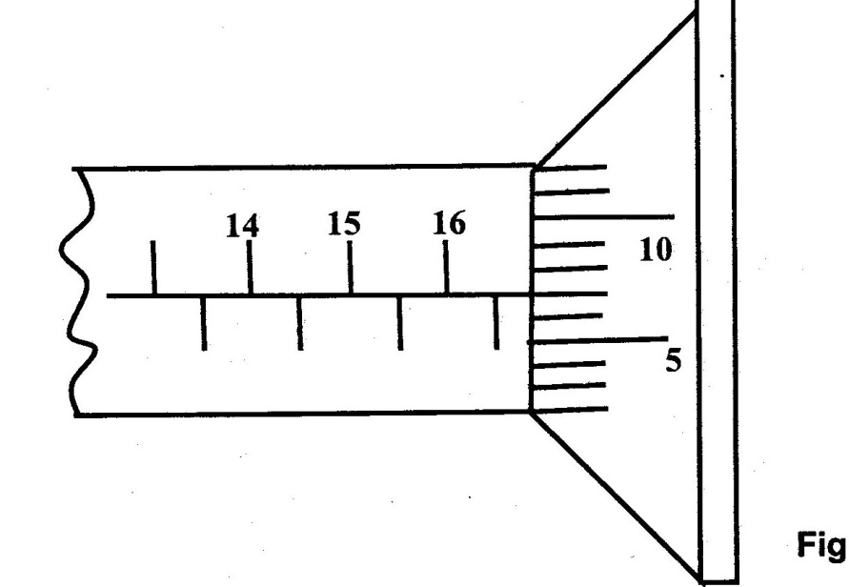

2) Equal volumes of water was poured into a narrow beaker and a wide beaker .The two beakers were then exposed to the same heat for some time as shown in the fig. below.
State with reason the difference in volume of water in the two beakers after some time. ( 2 mks )

3) A mother mixes 2 kg of hot water at 40 0c and 3 kg of cold water at 25 0c to enable john have a warm bath and leave for school. Determine the temperature of the water john used to take a bath. ( 2 mks )

4) A small drop of volatile liquid such as Freon placed on your skin feels colder than a drop of water of the same volume. Explain this observation. ( I mk )

5) Oxygen gas of volume 1.2 m3 is prepared at standard atmospheric pressure ( 76 cm Hg ) and at a temperature of 25 oc. The gas is then compressed into a cylinder of volume 0.24 m3 and stored at a temperature of 20 oc. Determine the pressure of the stored gas. ( 2 mks )

6) In an experiment to determine the size of an oil molecule, an oil drop of volune 0.12 mm3 is placed on clean water surface. The oil drop spreads into a circular film of diameter 0.2m. Use the information to estimate the size of the oil molecule ( Give your answer to 2 decimal places ) ( 2 mks ).

7) A uniform plank of length 100 cm and mass 200g is supported by a spring balance at the 30 cm mark. The plank is balanced horizontally by a 1.6 N weight suspended at a distance ( d) from the pivot as shown in the fig. below.
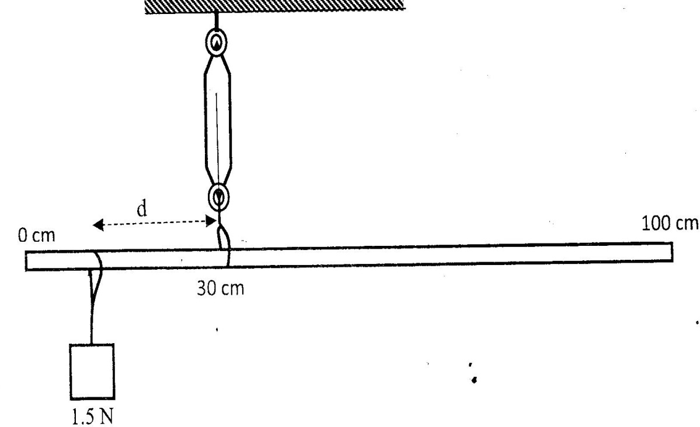
Determine the distance ( d ). ( 3 mks ).

8) The fig. below shows a graph of stretching force F ( N ) Against extension e ( cm ) of an elastic material.
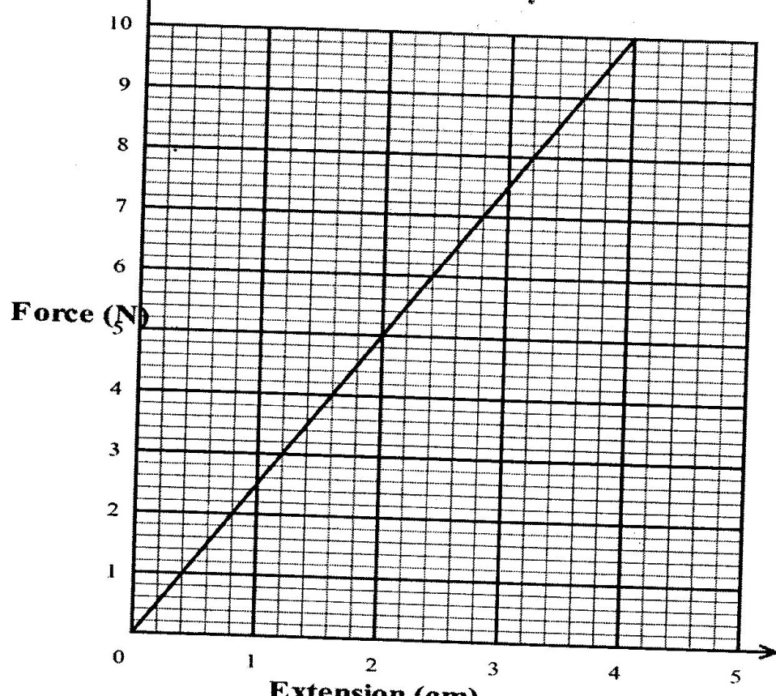

Determine the work done to stretch the material by 4 cm. ( 2 mks )

9) State any two advantages of mercury over alcohol as thermometric liquids. ( 2 mks )

10 ) Similar lift pumps were supplied to two sets of farmers. Those at high altitude and others at low altitude. The pumps were to be used to draw water from drilled wells. The pumps could not draw water for one set of farmers. State with a reason the likely set of farmers whose pumps could not draw the water . ( 2 mks)

11) Give a reason why smoke particles in a smoke cell are observed to be in a continuous random motion when viewed under a microscope. ( 1 mk )

12) An object dropped from a height (h) attains a velocity of 6 m / s just before hitting the ground. Find the value of h. (2 mks )

13)The height of mercury in a barometer at a place is 62 cm. What would be the height of a column of paraffin in the barometer at the same place ?
(Density of paraffin = 8.0 x10² kg/m³, density of mercury = 13600 kg/m³ ). ( 2mks )

SECTION 2 ( 55 MARKS )
14)a) State Archimedes principle. ( 1mk )

b) A balloon of volume 3m3 is filled with hydrogen of density 0.09 kg /m 3. The weight of the balloon fabric is 10 N . (Density of air is 1.31 kg / m3 ). Determine the ;
(I ) Weight of air displaced. ( 2 mks )

(ii ) Weight of hydrogen gas in the balloon. ( 2 mks )

(iii ) Maximum load the balloon can lift. ( 2 mks )

C) A uniform test tube of diameter 2.8 cm is placed on water in a beaker and some sand added till it just floats upright. The length of the test tube in water is measured to be 10 cm as shown in the fig. below.
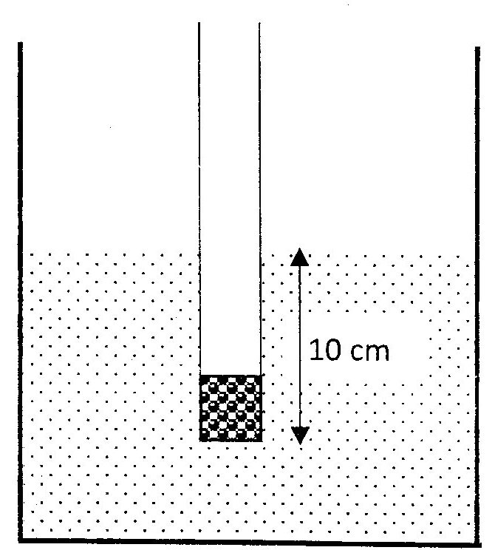
( Density of water is 1000 kg / m3 )
Determine the ( I ) Volume of water displaced. ( 2 mks )

( ii ) Upthrust on the test tube. ( 3 mks )

( iii ) When placed in another liquid , the length of test tube in the liquid is 15 cm. Determine the density of the liquid. (2 mks )

15) a) Define angular velocity. ( 1 mk )

b)Similar 1 kg masses m₁, m₂ and m₃ are placed 20 cm, 30 cm and 40 cm respectively from the center of a turn table of uniform surface as shown in the fig. below;
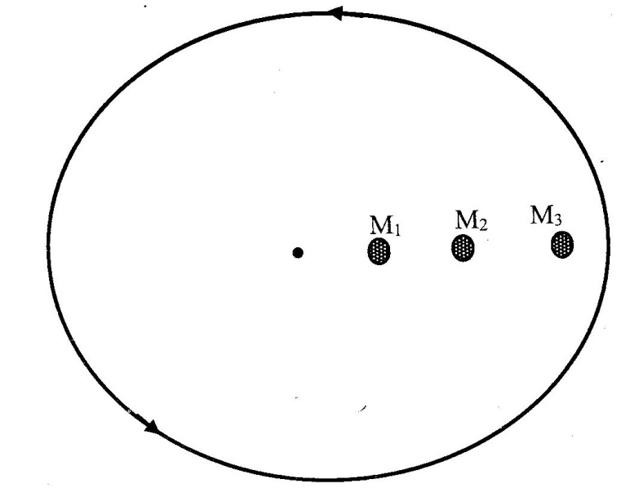
The masses m₁, m₂ and m₃ fly off the table tangentially at different angular velocities v₁, v₂ and v₃ respectively.
( I ) If m1 flies off when v1 = 10 rad / sec, determine the centripetal force. ( 2 mks )

( ii ) Arrange v₁, v₂ and v₃ in order from the highest to the smallest. ( 1 mk )
C) A 2 kg mass is attached to an inelastic string and whirled in a horizontal circle at an angular velocity of 14 rad / sec. Determine the tension in the string. ( 2 mks )

d) If the mass in ( c ) above is whirled in a vertical circle at the same angular velocity, Determine the tension at the bottom ( lowest point ) D of the vertical circle shown in the fig. below. ( 2 mks )

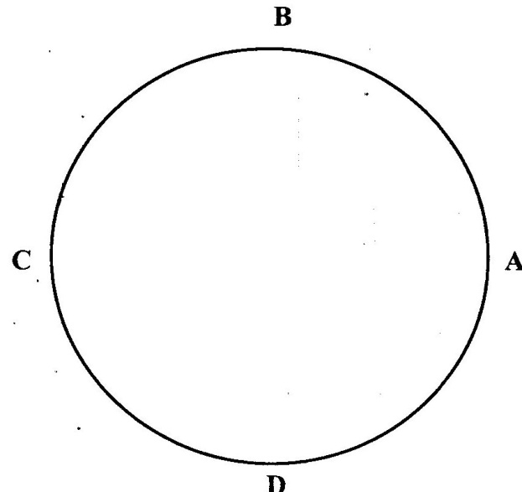

e) State the position A, B , C and D of the mass where the string is least likely to break. ( 1 mk )

16) a) Define specific heat capacity. ( 2mks)

b) In an experiment to determine specific latent heat of water , steam at 100⁰c was passed into water contained in a well lagged copper calorimeter. The following measurements were made.
Mass of calorimeter = 60g
Initial mass of water = 80g
Initial room temperature of water = 15⁰c
Final temperature of the mixture = 45⁰c
Final mass of water+ calorimeter + condensed water = 160g
Specific heat capacity of water = 4200 j/kg k
Specific heat capacity of copper = 3900 j/kg k
Calculate;
(i)mass of condensed steam. ( 1mk)

(ii)Heat gained by the calorimeter and water. (3mks)

(iii)Given that L is the specific latent heat of vaporization of steam,
a)Write an expression for the latent heat of vaporization of steam. (1mk)

b)Determine the value of L ( 3mks)

17) a) Use the table below to answer the questions that follow;
Mass m (g) | 0.0 | 50 | 100 | 150 | 200 | 250 | 300
Force F (N) | 0.0 | 0.5
Length (cm) | 34.2 | 35.8 | 37.8 | 38.9 | 40.5 | 42.0 | 43.6
Extension e (cm)
(i)Complete the table by filling in the missing values. ( 2mks)
(ii)Plot a graph of force ( x-axis ) against extension. ( 4mks )

(iii)From the graph, determine the spring constant. ( 2mks)

(iv)Why will the graph not be linear if a large mass is hung ? (1mks)

b)A spring with a spring constant of 25 N/cm extends by 5 cm when a certain force acts on it. Determine the work done by the force. ( 2mks)

18)The figure below shows a trolley of weight 20 N pulled by a force of 4 N from the bottom to the top of an inclined plane at a uniform speed.

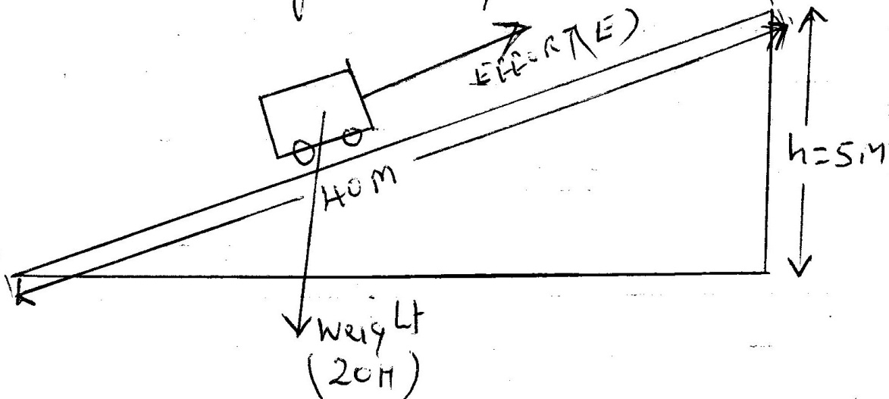
a) (i) State the value of the force acting downwards along the inclined plane. ( 1 mk )

( ii ) Explain how the value in part (a)(i) is obtained. ( 2 mks )

b) For the system, determine the ;
(i) Mechanical advantage ( 3 mks )

( ii ) Velocity ratio. ( 3 mks )

( iii) Efficiency ( 2 mks )

