Name: …………………………………Adm .No……….Index No. ……………… Class……….

Candidate’s Sign.…………….…........

Date:………………………..

**232/3**

**PHYSICS**

**PRACTICAL**

**Paper 3**

**Time: 2 ½ Hours**

**FORM 4 END OF TERM II EXAMINATION 2019**

***Kenya Certificate of Secondary Education(KSCE)***

**232/3**

**PHYSICSPRACTICAL**

**Paper 3**

**Time: 2 ½ Hours**

**INSTRUCTIONS TO THE CANDIDATES:**

* *Write your* ***name*** *,* ***admission number*** *and* ***index number*** *in the spaces provided above.*
* *Answer* ***all*** *questions in the spaces provided in the question paper.*
* *You are supposed to spend the first 15 minutes of the 2 ½ hours allowed for this paper reading the whole paper carefully.*
* *Marks are given for a clear record of the observation actually made, their suitability, accuracy and the use made of them.*
* *Candidates are advised to record their observations as soon as they are made.*
* *Mathematical tables, slide rules and calculators may be used.*

**For examiner’s use only**

**Question 1**

|  |  |  |  |  |  |  |  |
| --- | --- | --- | --- | --- | --- | --- | --- |
|  | **a** | **c** | **d** | **e** | **f** | **g** | **TOTAL** |
| **Maximum score** | 1 | 7 | 5 | 3 | 2 | 2 | 20 |
| **Candidate’s score** |  |  |  |  |  |  |  |

**Question 2**

|  |  |  |  |  |  |  |  |  |  |  |
| --- | --- | --- | --- | --- | --- | --- | --- | --- | --- | --- |
|  | **a** | **b i** | **b ii** | **b iii** | **c** | **d** | **e** | **f** | **g** | **TOTAL** |
| **Maximum**  **score** | 1 | 5 | 4 | 2 | 1 | 1 | 2 | 3 | 1 | 20 |
| **Candidate’s**  **score** |  |  |  |  |  |  |  |  |  |  |

***This paper consists of 10 printed pages. Candidates are advised to check and to make sure all pages are printed.***

**GRAND**

**TOTAL**

1.  ***You are provided with:***

* A resistance wire mounted on millimeter scale
* Two dry cells in a cell holder
* A voltmeter
* A switch
* Six connecting wires, two with a crocodile clip at one end

***Proceed as follows:-***

(a) Set up the circuit as in the figure below and determine the total electromotive force E, of the cells.

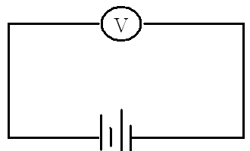

Electromotive force E, of thecells……………….………………………..…..Volts. ( 1 mark)

(b) Set up the circuit shown in the figure below, connect the wire with clip on the mounted wire at a length (L) of 10cm from the end marked A. Record the voltmeter reading in the table provided in part (c) below:

**v**

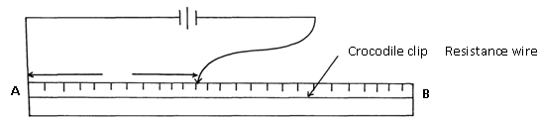

(c) Repeat the procedure in (b) above for the following values of L

|  |  |  |  |
| --- | --- | --- | --- |
| L(cm) | V(volts) | E-V(volts) | V  E- V |
| 10 |  |  |  |
| 20 |  |  |  |
| 30 |  |  |  |
| 40 |  |  |  |
| 50 |  |  |  |
| 60 |  |  |  |

(d) Plot a graph of  against L (cm) (5marks)

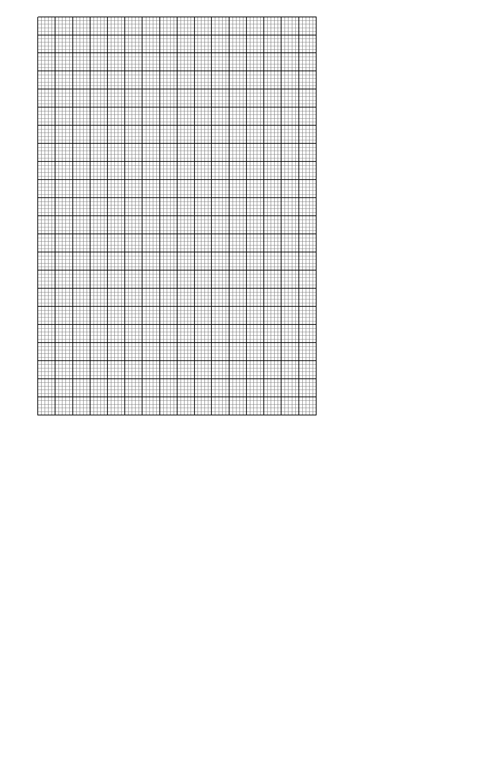

(e) Determine the slope of the graph. (3marks)

(f) Given the equation = K1L1+ K2

Determine the values of K1 and K2 (2marks)

K1……………………………………

K2…………………………………….

(g) Given that 4K2r = 10 where r is the internal resistance of the cells. Determine the

value of r. (2marks)

**Question 2**

**PART A**

2. ***You are provided with the following apparatus***:

* A candle
* A lens holder
* A convex lens
* A screen
* A metre rule
* An object

***Proceed as follows:***

Using an object infinity outside the room, focus its image on the screen provided. The image should be as sharp as possible and inverted. Measure the distance from the lens to the screen h cm.

h………………………………………………………………..cm (1 mark)

Arrange the candle flame, the lens, and the screen as shown in the diagram below:

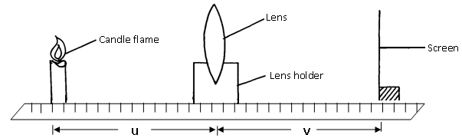

b) i) For particular value of u, adjust the position of the screen until a sharp image appears on the screen. Measure distance Vcm. Repeat the experiment for each of the other values of u, and enter the results in the table below: (5mks)

|  |  |  |  |
| --- | --- | --- | --- |
| **Distance u(cm)** | **Distance V(cm)** | **uv(cm2)** | **U + v (cm)** |
| 12 |  |  |  |
| 15 |  |  |  |
| 18 |  |  |  |
| 21 |  |  |  |
| 24 |  |  |  |
| 27 |  |  |  |

(ii) Plot a graph of uv cm2 against u + v cm (4 marks)



iii )Determine the slope of the graph ( 2 marks)

**PART B**

You are provided with the following:

* A metre rule.
* A knife edge.
* One 50g mass and a 100g mass.
* Some thread.
* Some water in a beaker.
* Liquid L in a beaker.
* Tissue paper.

Proceed as follows:

(c) Balance the metre rule on the knife edge and record the reading at this point.

Balance point ……………………….. cm (1 mark)

For the rest of this experiment the knife edge must be placed at this position.

(d) Set up the apparatus as shown in the figure 1. Use the thread provided to hang the masses such that the positions of the support can be adjusted.

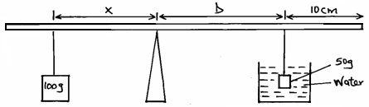

Figure 1

The balance is attained by adjusting the position of the 100g mass. Note that the distance **X** and **D** are measured from the knife edge and the 50g mass is fully immersed in water. Record the values of **X** and **D**.

**X** = …………………………………….. cm (1 mark)

**D** = …………………………………….. cm

e) Apply the principle of moments to determine the weight W1 of the 50g mass in water and hence determine the upthrustUw in water. (2 marks)

**W1**= ……………………………………………………………………………………

…………………………………………………………………………………………..

…………………………………………………………………………………… N

**Uw** = ………………………………………………………………………

…………………………………………………………………………………… N

Remove the 50g mass from the water and dry it using tissue paper.

(f) (i) Now balance the metre rule when the 50g mass is fully immersed in the liquid L. Record the value of the distance χ.

χ = ………………………………………..cm (1 mark)

1. Apply the principle of moments to determine the weight W2 of the 50g mass in the liquid L and hence determine the up thrust UL in the liquid.

**W2**= …………………………………………………………………(1 mark)

**UL**= ………………………………………………………………… (1 mark)

(g) Determine the relative density R.D of the liquid L, given that: (1mark)



Hence determine the density of liquid χ in kg/m³. (Given that density of water in 1000kg/m³).