Name: …………………………………………………………… Index No. …………………………
232/1 Candidate’s Sign. …………............
PHYSICS Date: ………………………………..
PAPER 1
JULY/AUGUST 2014
TIME: 2 HOURS

Kenya Certificate of Secondary Education (K.C.S.E.)

232/1
Physics
Paper 1
2 hours

INSTRUCTIONS TO THE CANDIDATES:
- Write your name and index number in the spaces provided above.
- Answer all the questions both in section A and B in the spaces provided below each question
- All workings must be clearly shown; marks may be awarded for correct steps even if the answers are wrong.
- Mathematical tables and non programmable silent electronic calculators may be used.
(Take acceleration due to gravity g= 10ms⁻² Density of water 1g/m⁻³)
For examiners use only
SECTION | QUESTION | MAXIMUM SCORE | CANDIDATE’S SCORE
Section A | 1-12 | 25
Section B | 13 | 09
 | 14 | 14
 | 15 | 14
 | 16  17 | 09  09
 | TOTAL | 80

paper consists of 8 printed pages. Candidates should check to ascertain that all pages are printed as indicated and that no questions are missing.

SECTION A (25 MARKS)
Answer all questions in this section in the spaces provided

1. Give the reason why it is easier to separate water into drops than to separate a solid into small
pieces (1mk)
…..………………………………………………………………………………………………………
…..………………………………………………………………………………………………………
2. A drug manufacturer gives the mass of the active ingredient in a tablet as 5mg. express this quantity in Kilogramme and in standard form (1mk)
…..………………………………………………………………………………………………………
…..………………………………………………………………………………………………………
3. Some water in a tin can was boiled for some times, the tin was then sealed and cooled. After some time it collapsed. Explain this observation (2mks)
…..………………………………………………………………………………………………………
…..………………………………………………………………………………………………………
4. The figure below shows a micrometer screw gauge being used to measure the diameter of a metal rod. The thimble scale has 50 divisions. The reading on the gauge when the jaws were fully closed without the rod was 0.012cm
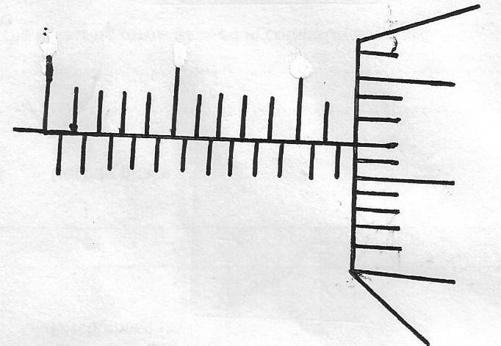
0
10
15
20
25

What is the actual diameter of the rod (2mks)
…..………………………………………………………………………………………………………
…..………………………………………………………………………………………………………
5. The figure shows a sheet of paper rolled into a tube
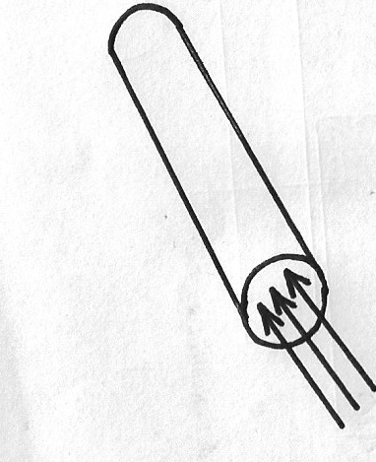

Paper tube

When a stream of air is blown into the tube as shown into the diagram, the paper tube collapses . Explain the observation (2mks)
…..………………………………………………………………………………………………………
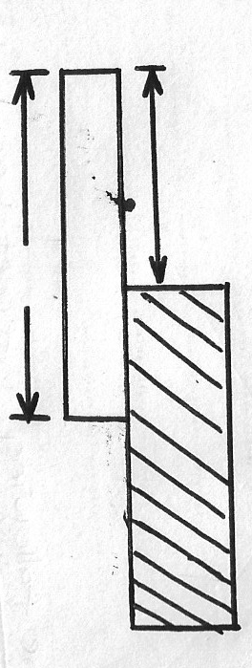
…..………………………………………………………………………………………………………
6. The figure below shows a uniform wooden block of mass 2kg and length 25cm lying on a bench. It hangs over the edge of the bench by 10cm

10cm
Wooden block
25cm
Bench

(a) Indicate on the diagram two forces acting on the wooden block to make it turn about the edge
of the bench (1mk)
(b) Determine the minimum force that can be applied on the wooden block to make it turn about
the edge of the bench (2mks)
…..………………………………………………………………………………………………………
…..………………………………………………………………………………………………………
7. The three springs shown in the figure below are identical and have negligible weight. The extension produced on the system of the spring is 20cm
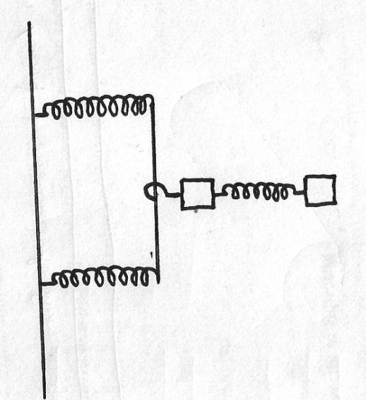

20N

20N

(a) State the SI unit of a spring constant (1mk)
…..………………………………………………………………………………………………………
(b) Determine the constant of each spring (2mks)
…..………………………………………………………………………………………………………
…..………………………………………………………………………………………………………
8. A bag of sugar is found to have the same weight on the planet earth as an identical bag of dry saw dust on planet Jupiter. Explain why the masses of the two bags must be different (2mks)
…..………………………………………………………………………………………………………
…..………………………………………………………………………………………………………

9. The temperature of water inn a measuring cylinder is lowered from about 20oC to 0oC. On the axes provided, sketch the graph of volume against temperature assuming the water does not freeze(2mks)

10. The figure show an athlete lifting weights while standing with the feet apart
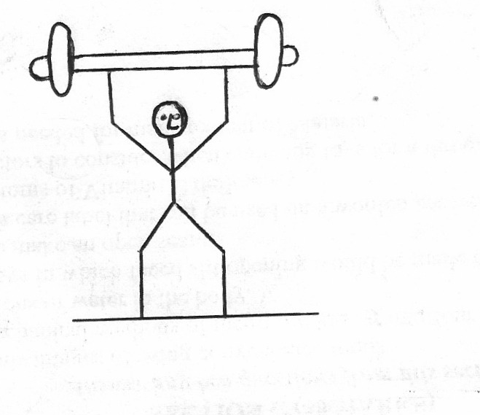

Explain why standing with the feet apart improves the athletes stability (1mk)
…..………………………………………………………………………………………………………
…..………………………………………………………………………………………………………
11. Give a reason why heat transfer by radiation is faster than heat transfer by conduction (1mk)
…..………………………………………………………………………………………………………
…..………………………………………………………………………………………………………
12. A block of glass 250g floats in mercury. What volume of glass lies under the surface of the mercury? Volume of glass lies under the surface of the mercury (Density of mercury is 13.6x103Kg/m³)

13. Explain why a glass with a thick wall is more likely to crack than one with a thin wall when a very hot liquid is poured into them (2mks)
…..………………………………………………………………………………………………………
…..………………………………………………………………………………………………………
SECTION B (55 MKS)
14 (a) Explain why it is advisable to use pressure cooker at high altitudes (2mks)
…..………………………………………………………………………………………………………
…..………………………………………………………………………………………………………
(b) Water of mass 3.0kg initially at 20oC is heated in an electric kettle rated 3.0Kw. the water is heated until it boils at 100ºC (Take specific heat capacity of water=4200JKg⁻K⁻, Heat capacity of the kettle=450JK⁻1 and specific latent heat of vaporization of water =2.3MJKg⁻¹
Determine
(i) The heat absorbed by the water (2mks)

(ii) The heat absorbed by the electric kettle (2mks)

(iii) The time taken by far the water to boil (3mks)

(iv) How much longer it will take to boil all the water (3mks)

15. (a) Define the term velocity ratio of a machine (1mk)
…..………………………………………………………………………………………………………
…..………………………………………………………………………………………………………
(b) The figure below shows part of hydraulic press. The plunger is the position where the effort is applied while the Ram piston is the position where load is applied. The plunger has cross section area am² while the Ram piston has cross section area Am²

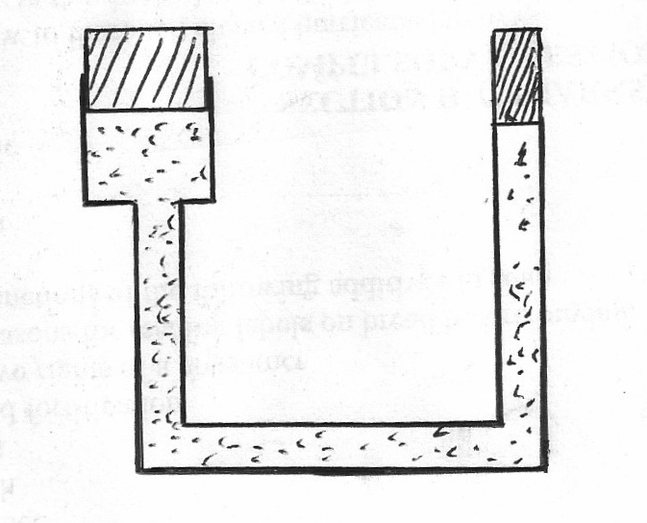
Plunger of cross sectional area=a
Ram piston cross sectional area =A

Oil

When the plunger moves down a distance d, the Ram piston moves up distance D
(i) State the property of liquid pressure on which the working of the hydraulic press operates(1mk)
…..………………………………………………………………………………………………………
…..………………………………………………………………………………………………………
(ii) Derive an expression for the velocity ratio (V.R) in terms of A and a (3mks)

(c) A machine of velocity ratio 45, overcomes a load of 4.5x 103N when an effort of 135N is applied. Determine
(i) the mechanical advantage of the machine (2mks)

(ii) efficiency of the machine (2mks)

(iii) the percentage of the work that goes to waste (1mk)

16. (a)Using the kinetic theory of matter, explain how a rise in the temperature of a gas causes a rise
in the pressure of the gas if the volume is kept constant (2mks)
…..………………………………………………………………………………………………………
…..………………………………………………………………………………………………………
(b) The figure shows a set-up that can be used to verify Charle’s law
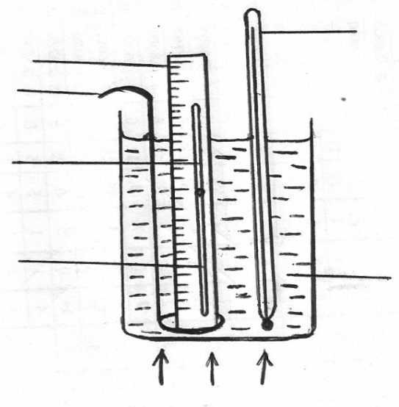
Thermometer
Mercury bath
Scale
Stirrer
Uniform tube
Dry air
Heat

(i)State the measurements that should be taken in the experiment (2mks)
…..………………………………………………………………………………………………………
(ii) Explain how the measurements taken in (i) above may be used to verify Charles’ law (3mks)
…..………………………………………………………………………………………………………
…..………………………………………………………………………………………………………
(iii) What’s the purpose of the water bath (1mk)
…..………………………………………………………………………………………………………
…..………………………………………………………………………………………………………
(c) A certain mass of hydrogen gas occupies a volume of 1.6m³ at a pressure of 1.5x1.5 pa and temperature 12ºC. Determine its volume when the temperature is 0ºC at a pressure of 1.0x 10⁵p.a
(3mks)

17. (a) A tape attached to a moving trolley is run through a ticker timer. The figure shows a section of the tape after running

1.5cm
B
C
3.2cm
D
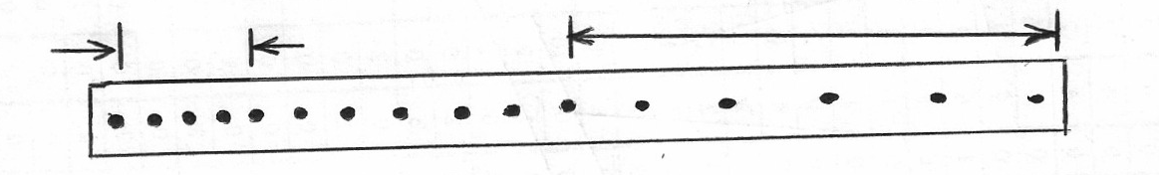
A

If the frequency of the ticker timer is 50Hz, calculate
(i) average velocity at intervals AB and CD (2mks)
…..………………………………………………………………………………………………………
(ii) average acceleration of the trolley (3mks)
…..………………………………………………………………………………………………………
…..………………………………………………………………………………………………………
(b) A stone is released from a height h, of the acceleration due to gravity is g, derive an expression of the velocity of the stone just before hitting the ground (2mks)
…..………………………………………………………………………………………………………
…..………………………………………………………………………………………………………
(c) The figure shows, velocity time graph of an object in motion
Velocity
Displacement
Time
Time

(i) (ii)
Sketch on the axes provided in (ii) , the displacement time graph of the motion. (motion upwards is taken as positive) (1mk)

18. (a) The figure below shows a simple hydrometer
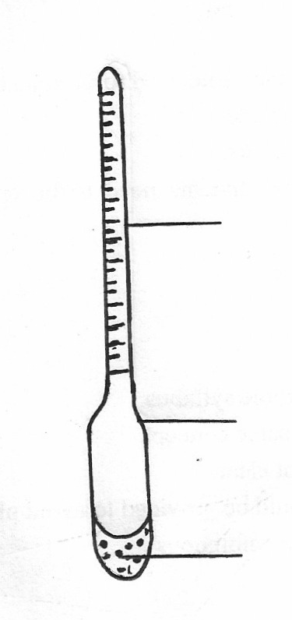

Uniform tube
Glass bulb
Lead shorts

(i) State the purpose of the Lead shots in the glass bulb (1mk)
…..………………………………………………………………………………………………………
(ii) How would the hydrometer be made more sensitive (1mk)
…..………………………………………………………………………………………………………
(iii) Describe how the hygrometer is calibrated to measure relative density (2mks)
…..………………………………………………………………………………………………………
…..………………………………………………………………………………………………………
(b) The figure below shows a cork floating on water and held to the bottom of the beaker by a thin thread
Cork
Thread
Water
Beaker
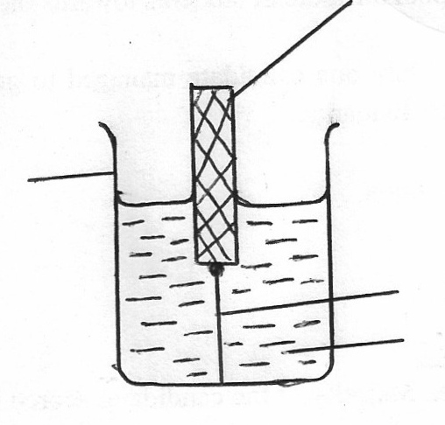

Name the forces acting on the cork (3mks)
…..………………………………………………………………………………………………………
…..………………………………………………………………………………………………………
…..………………………………………………………………………………………………………
19 (a) A glass block of mass 10g is placed in turn at various distances from the centre of a table which is at constant angular velocity . its found that distance of 8.0cm from the centre, the block just stats to slide off the table. If the force of friction between the block and the table is 0.4N, determine

(i) The angular velocity of the table (3mks)
…..………………………………………………………………………………………………………
…..………………………………………………………………………………………………………
(ii) The force acquired to hold the block at a distance of 12cm from the centre of the table (2mks)
…..………………………………………………………………………………………………………
…..………………………………………………………………………………………………………
(b) A glass of mass 200g is now placed at a distance of 8.0cm from the centre of the table in (a) above and the table rotated at the same constant angular velocity. State with a reason whether or not the block will slide (2mks)
…..………………………………………………………………………………………………………
…..………………………………………………………………………………………………………

