3KNT FRATERNITY
PHYSICS PAPER THREE
1.QUESTION ONE.
You are provided with the following:
-Salt solution in a 250ml container.
-Two identical cylindrical 100g masses.
-A string.
-A meter rule.
-Knife edge.
-Two pieces of thread.

Procedure.
1.(a)Determine the volume of one the masses by using the apparatus provided. Record the volume ,V
V=……… () ( 1 mk)
Explain how you have determined the volume V (1mk)
b(i)Determine the centre of gravity of the metre rule and record it.
Centre of gravity = ……. (1 mk)
b(ii)Arrange the apparatus as shown in diagram 1 below,show that the metre rule is at equilibrium,starting with x=100mm
Diagram 1.
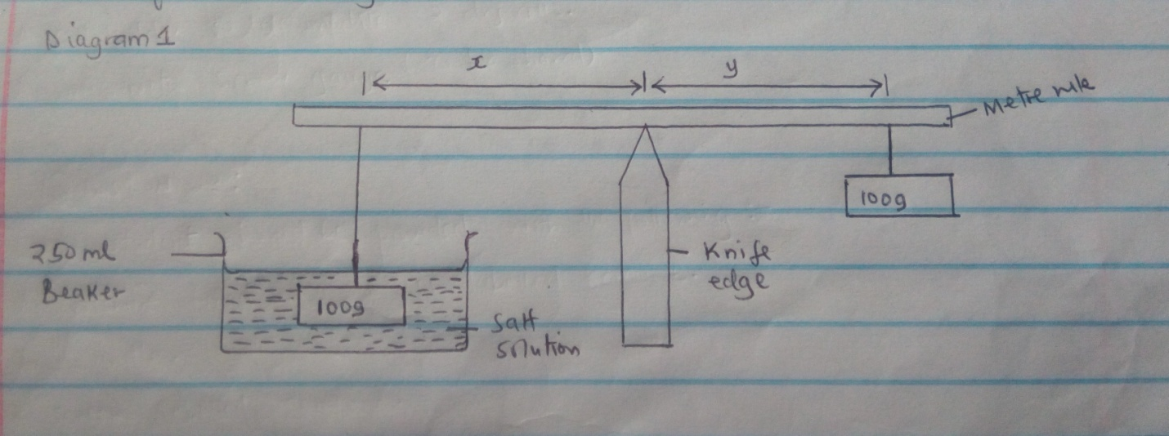

Measure and record the length ,Y
Y=_
C Repeat procedure a (ii) with the following values of X and fill table 1 below.
Table 1 (3mks)
X mm | 100 | 150 | 200 | 250 | 300 | 350
Ymm

(d)On the grid provided , plot a graph of Y (y axis) against X (5mks)
(e)Determine the gradient,N of the graph. (3mks)
(f)The gradient ,N given by the equation N=F/W,where F is the apparent weight of the mass in the salt solution and w is the actual weight of the mass.Calculate the value F and the upthrust U’
(i)F (1 mk)
(ii)U (2 mks)
(h) Hence determine the density,$s$ (2 mks)

QUESTION 2
PART A.
Your are provided with following apparatus;
-Ammeter (0-1A)
-Voltmeter (0-3v)
-2 dry cells.
-A resistance wire fixed on a metre rule ,labeled Y
- A resistance wire fixed on a metre rule ,labeled X
- A switch.
- Seven connecting wires,4 with crocodile clips.
-A cell holder ,to accommodate two dry cells.
-A micrometer screw gauge (to be shared)
Proceed as follows:
(i)Set up the circuit as shown in the diagram 2 below.
Diagram 2
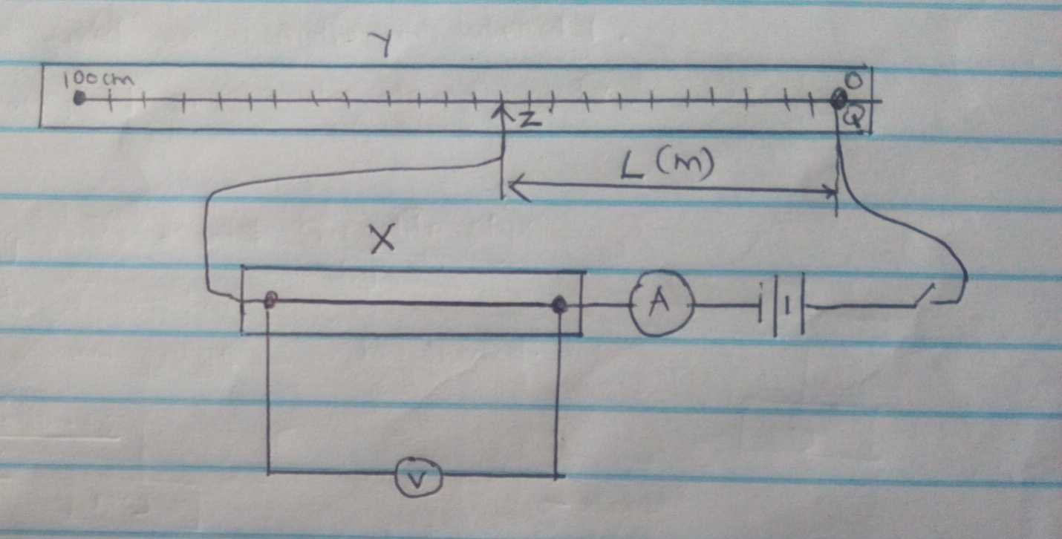

(ii)Keeping both crocodile clips attached on the resistance wire QZ for a length l=0.2 m form Q,record the corresponding values of currents,I (A) and voltage V in table 2 below.
(iii)Repeat procedure (ii) for other lengths, L=0.4m,0.6m,0.8m and 1.0 m (4mks)
Table 2.
Length (l) (m) | 0.2 | 0.4 | 0.6 | 0.8 | 1.0
Current,I (A)
Voltage,V (v)

(a)Plot a graph of V (y-axis) against I on the grid provided below. (5mks)
(b)Calculate the slopes,S of the graph (3mks)
(c)Using the micrometer screw gauge provided,measure the diameter ,d of the resistance wire labeled X.
D= m (1mk)
(d)Calculate the quantity ,k of the wire from the equation.
K=sx$d^{2}$xII,giving its unit;where s the gradient in (b) above, (2mks)
2

PART B
You are provided with the following:
1.A cross wire fixed on the screen
2.A candle.
3.A screen
4.A convex lens.
5.a convex mirror.
6.A metre rule.
(i)Determine the focal f ,of the lens by locating the image of a distant object.
F,= (1mk)
(ii)Place the lens at a distance of x=35 cm from the crosswire and move the screen A until a sharp image of the crosswire is focused on it as shown in the diagram 3(a) below
Diagram 3(a).
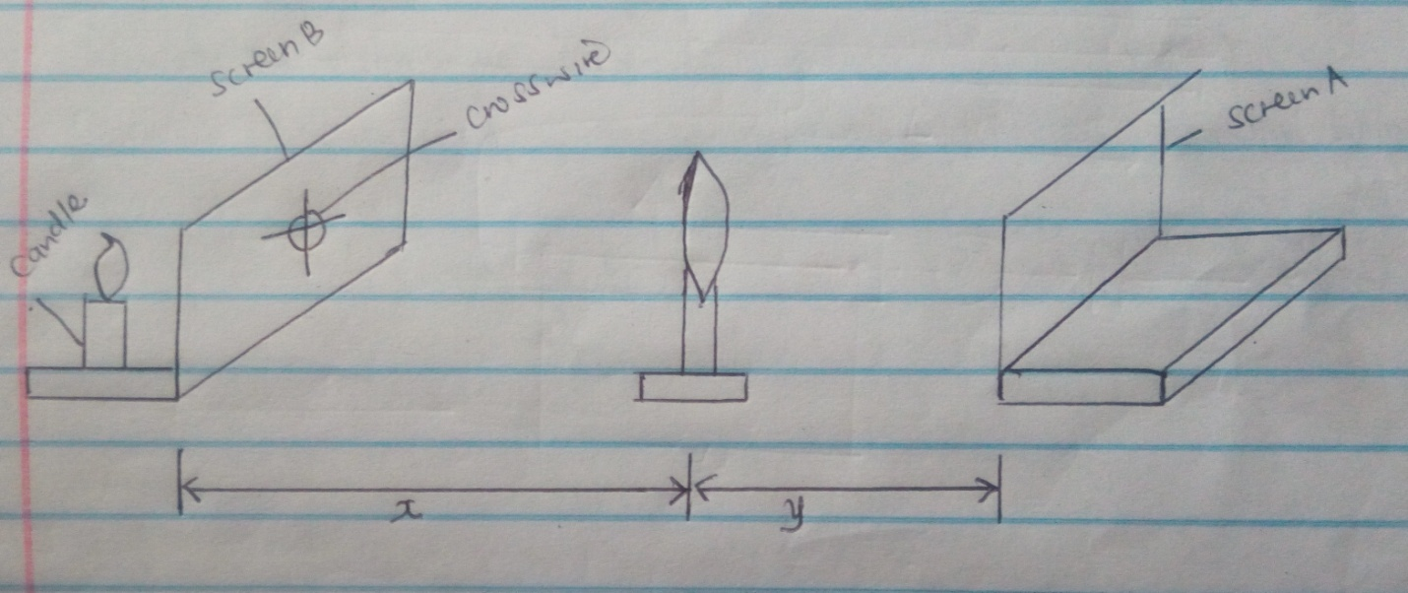

(iii)Without moving the lens and the screen A ,place a convex mirror as shown in diagram 3 (a) below and move it until a sharp image of the cross wire is formed on the screen B next to the cross wire.
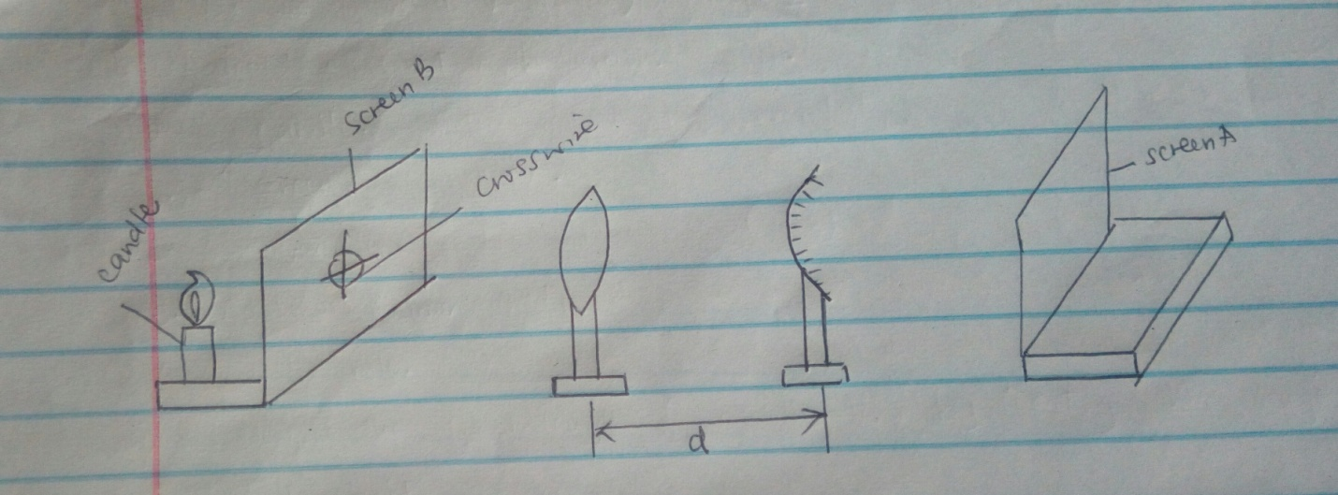

(iv)Measure the distance ,d between the lens and the mirror and record on table below. ( 3 mks)
Distance,x of lens from crosswire (cm) | Distance,Y (cm) | Distance X (cm) | y-d (cm)
35
40

(v)Repeat procedure (ii) to (iv) for the value of X=40 cm
(vi)Calculate the mean value of (y-d)
(vii)Calculate the quantity $f_{2}$ of the convex mirror from the equation below,

$f_{2}$=mean of (y-d)
2 ( 1mk)

