NAME____________________________ INDEX NO____________________
DATE___________________________ SIGNATURE ___________________
3KNT FRATERNITY 2017
TERM II FORM IV EXAM
PHYSICS PAPER I THEORY
231/1
TIME: 2HOURS
Instructions to candidates
- Write your name and index number in the space provided above
- This paper consists of two sections section A and section B
- Answer all the questions in section A and B in the spaces provided
- All working must be shown clearly
- Non programmable silent electronic calculator may be used
- The paper consist of 18 questions
- Use English to answer the questions

FOR EXAMINERS USE ONLY
SECTION | QUESTION | MAX SCORE | CANDIDATES SCORE
A | 1-11 | 25
B | 12 | 10
 | 13 | 7
 | 14 | 10
 | 15 | 10
 | 16 | 8
 | 17 | 10

Paper one
1.A text book has 1000 sheets bound between two covers each of thickness 0.10mm. Each sheet of paper is 0.5mm thick. Determine the thickness of the text book. (2mks)

2.Study the diagram below from diagram
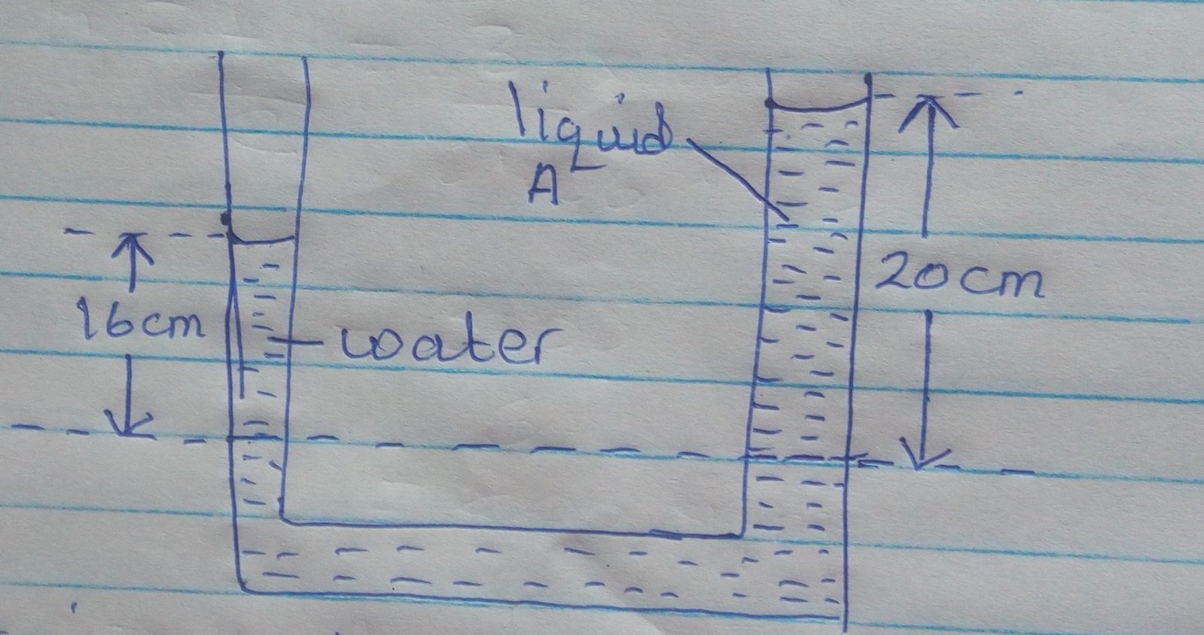

Determine the pressure at point Q due to the liquid column. (3mks)

3.A drop of oil has a volume of 5.0x10⁻⁸m³. When it is put on the surface of some clean water. It forms a circular film of 0.1m² in area.
- What is the size of molecule of oil (2mks)

- State two assumption you make in your calculations (2mks)

4.Figure below shows a section of steel pipe for steam supply. The curved part (loop) is a precaution against danger caused by temperature variations. Explain how you expect it to work. (1mk)
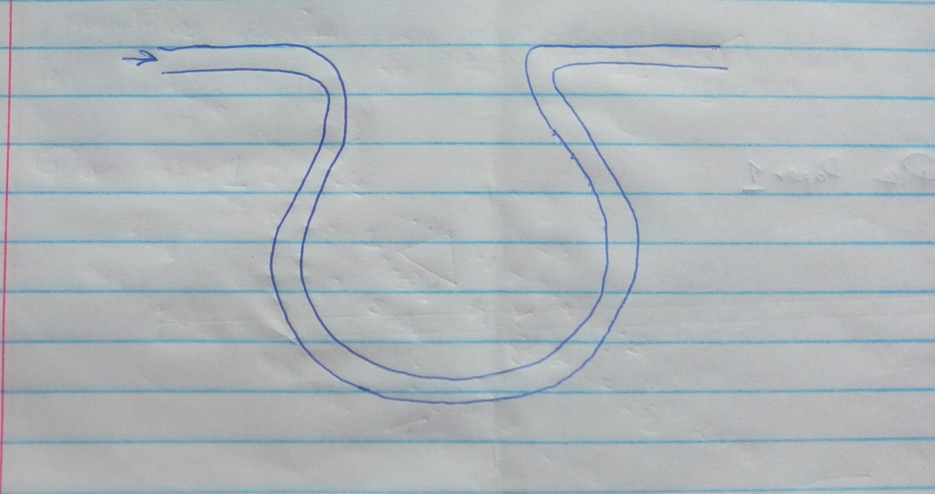
steam

5. When a gas is turned on and lit above the wire gauze, the flame stays above the wire gauze for sometimes. Explain the observation. (2mks)

6.The figure below shows a micrometer screw gauge being used to measure the diameter of a metal rod. The reading on the gauge when the jaws were fully closed without the rod was 0.014cm.
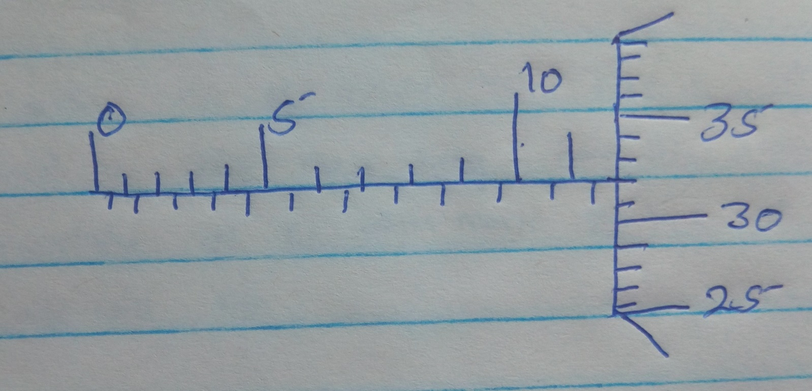

What is the actual diameters of the rod (2mks)

7.a. Explain why it would be very difficult to open a door with the handle near the hinges (1mk)

b.A uniform meter rule of mass 90g has a 72g mass hung from the 20cm mark and a 20g mass hung from the 70cm mark. The rule is balanced horizontally at the 40cm mark. Deduce with reason in which direction the rule will hit (2mks)

8.State two factors that govern the strength of spiral spring of a given materials (2mks)

9.The figure below shows a sheet of paper rolled into a tube
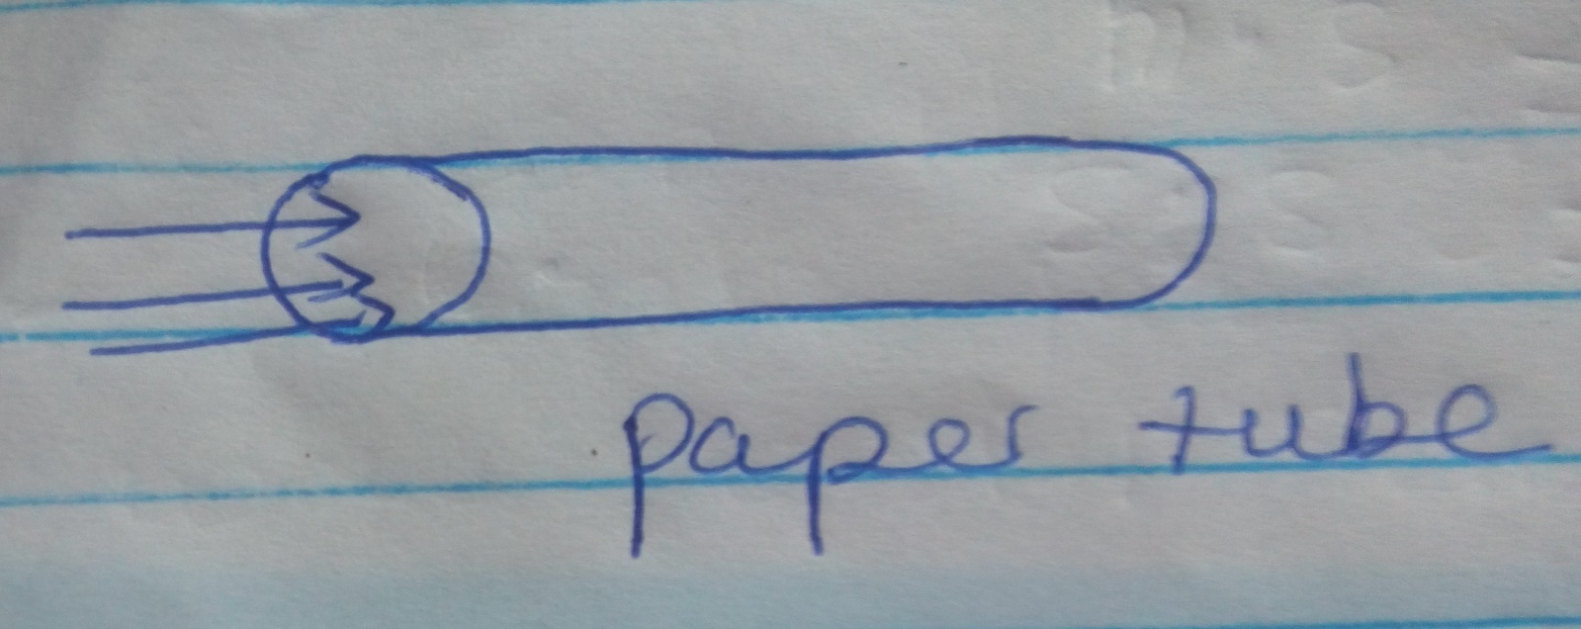
Stream of air

When a stream of air is blown into the tube as shown into the diagram, the paper tube collapses. Explain the observations (2mks)

10.The figure below shows a ticker –tape drawn through a ticket time vibrating at 100Hz.
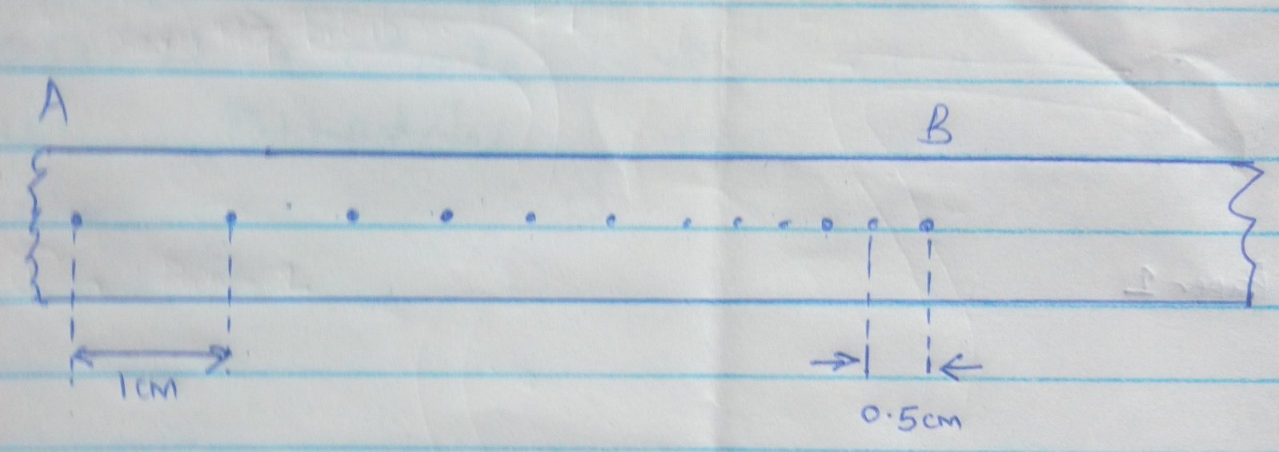

Calculate the acceleration between A and B (3mks)

11.A spiral spring stretches by 0.6cm when a mass of 300g is suspended on it. Calculate the work done in stretching the same spring by 4cm. (3mks)

12.Figure below shows a set up to demonstrate Boyles’ law
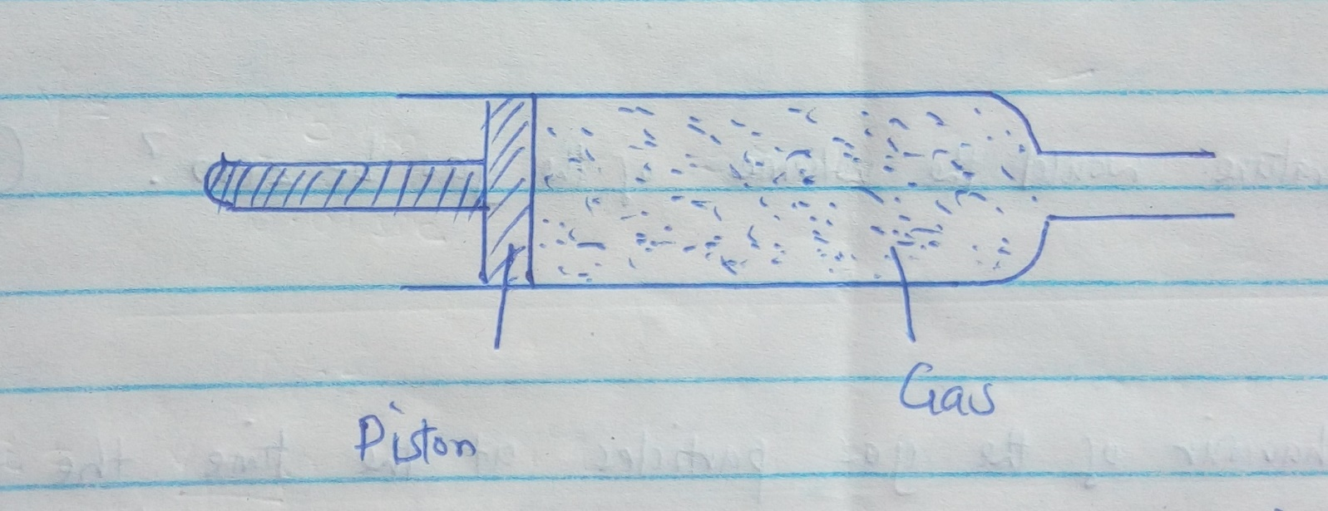

a.State two factors that are kept constant in order to verify Boyle’s law (2mks)

b.The graph in figure below shows the relationship between volume and temperature of a gas from an experiment.
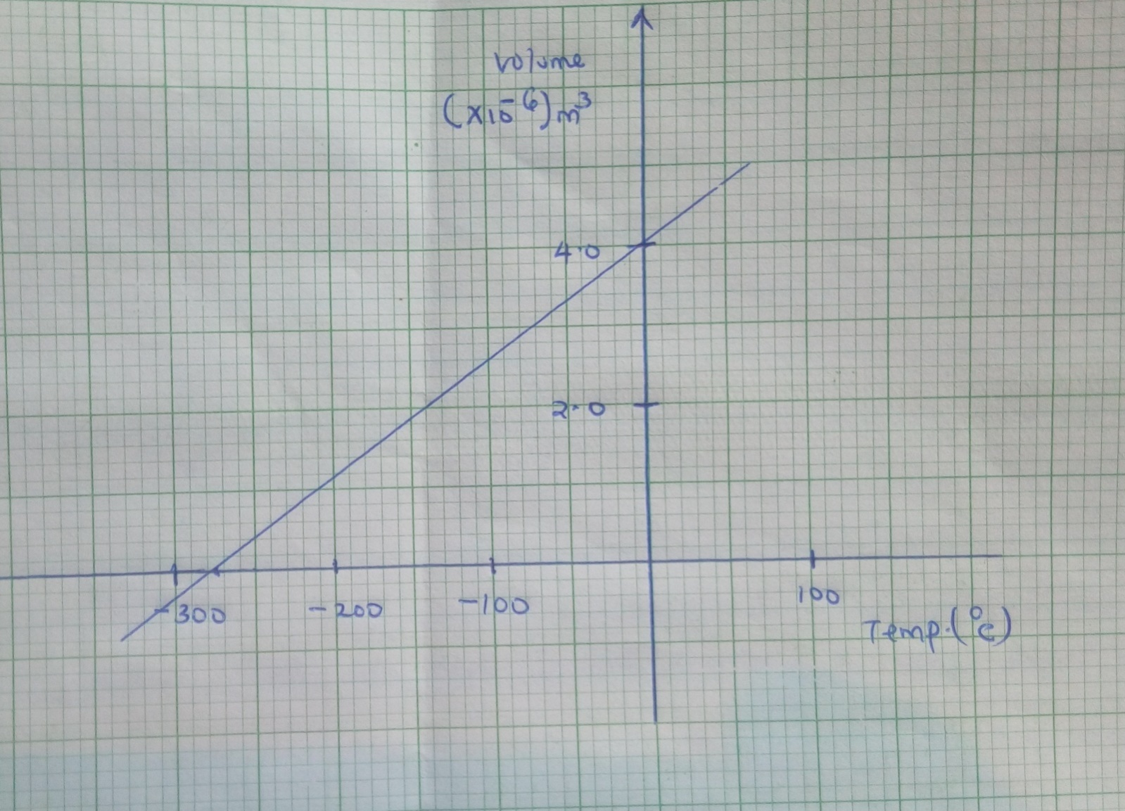

- What was the volume of the gas at 0ºC (1mk)

- At what temperature would the volume of the gas be zero (1mk)

- What is the behavior of the gas particles at the time the temperature is zero (1mk)

- Explain why the temperature of the gas in part (ii) above cannot be achieved(1mk)

c.A sealed gas cylinder contains 300cm³ of a certain gas at a temperature of 25ºc and at a pressure of 9.5x10⁴pa. The gas in the cylinder is then cooled to 10ºC. Determine the new pressure of the gas in the cylinder (4mks)

13.In an experiment to determine the power of an electric heater, melting ice was placed in a container with an outlet and the heater placed in the ice as shown in fig. below. The heater was connected to a power supply and switched on for some time.
The melted ice was collected.
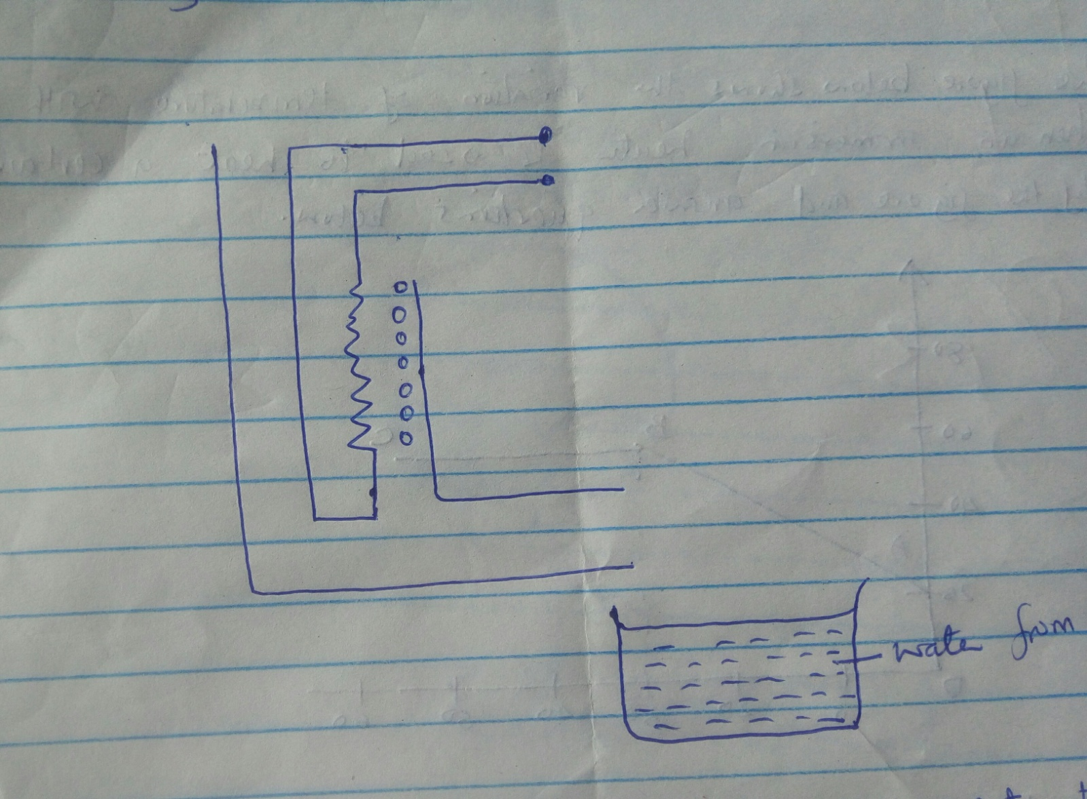

- Other than current and voltage, state the measurement that would be taken to determine the quantity of heat absorbed by the melted ice in unit time (2mks)

- If the latent heat of fusion of ice is L1 show how the measurement in (a ) above would be used in determining the power P1 of the heat. (2mks)

- It is found that powered determined in this experiment is lower than the manufacturers value indicated on the heater. Explain (1mk)

- The figure below shows the variation of temperature with time t. when an immersion heater is used to heat a certain liquid. Study the figure and answer questions below .
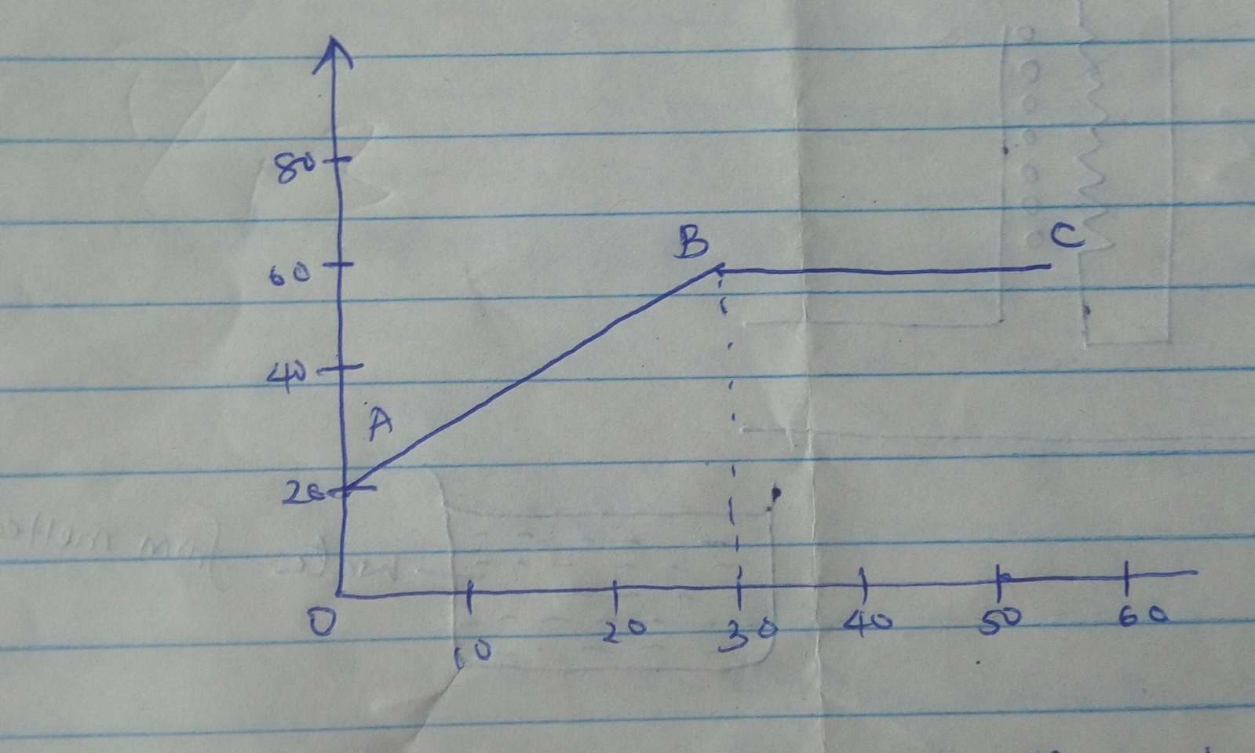

- State the reason for the shape of the graph in the section labeled BC (1mk)

- Sketch on the same axes, the graph of a liquid with a higher specific heat capacity

14.The figure below shows a mass m which is rotated clockwise in a vertical circle. The speed of the mass is gradually increased until the string breaks at the lower position A and at a speed of 30m/s. point A i+s 5M above the ground.
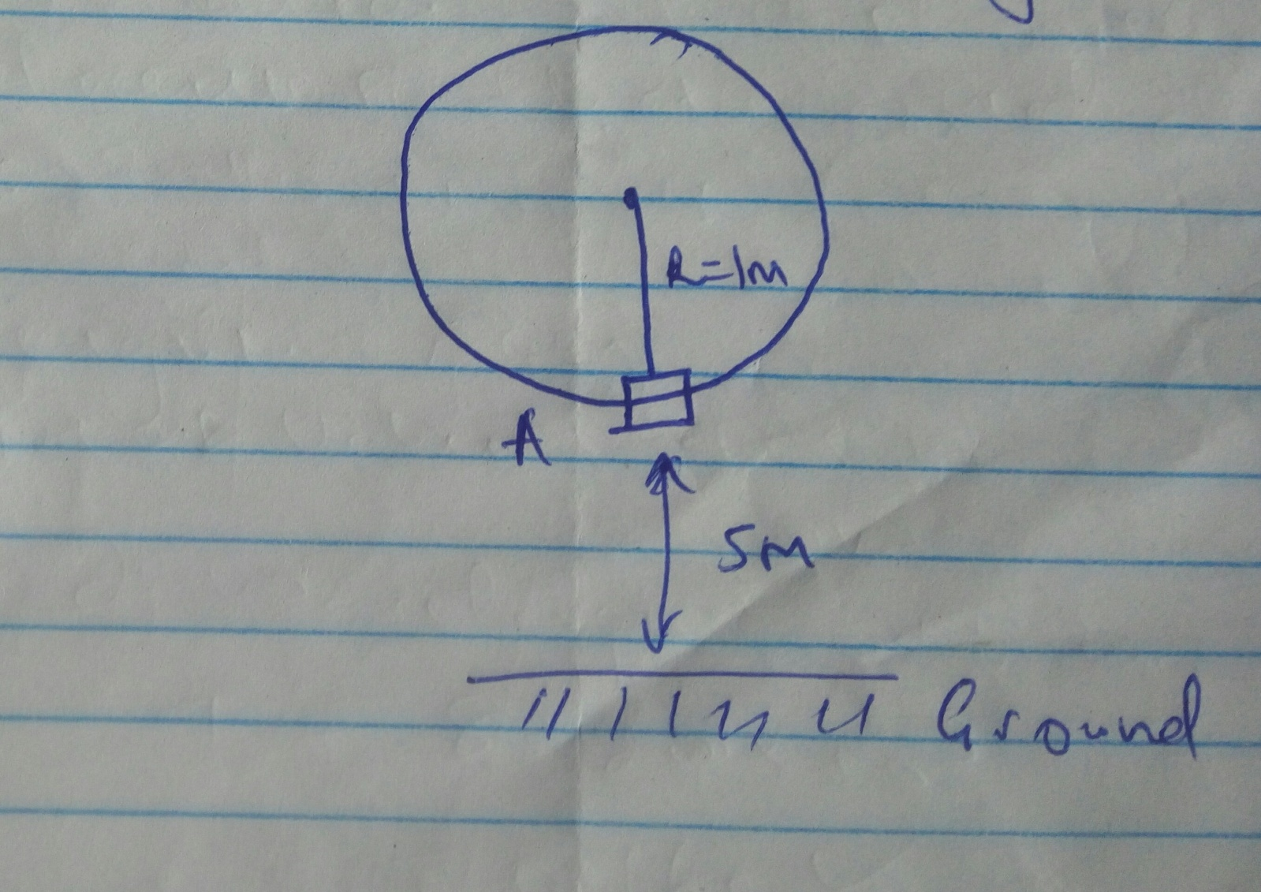

a )Show on the diagram
- The initial direction of the mass at the point the string breaks. (1mk)
- The path of the mass from A until it strikes the ground at point B (1mk)

b)Calculate
i).The time the mass take to reach the ground after breaking off (3mks)

iiThe horizontal distance the mass travel before it strikes the ground (2mks)

iii.The vertical velocity with which the mass strikes the ground (3mks)

15.The figure below shows a block and tackle system of pulleys
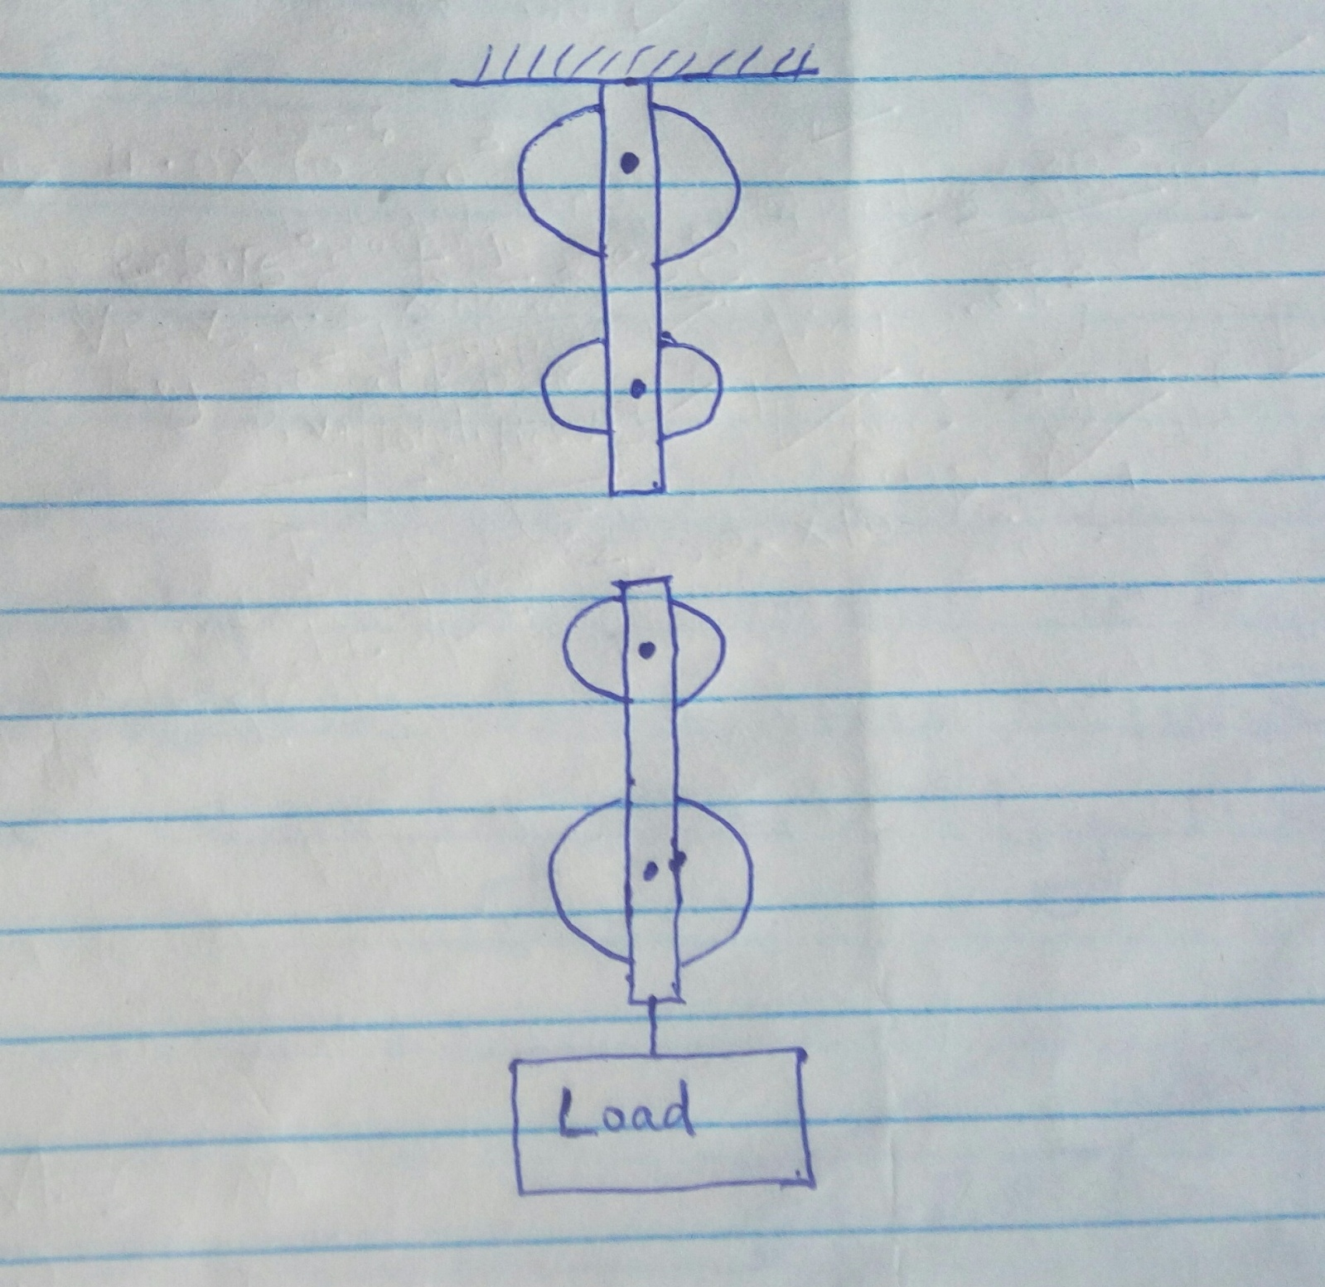

ai.Thread the pulley system so that the effort acts upwards (1mk)

ii.Determine the velocity ratio of the system (1mk)

b.If the efficiency of the system is 80%. Determine
- The mechanical advantage (MA) of the system (3mks)

- The effort which can be used to lift a load of 2800N (3mks)

c.State two reasons why the efficiency of this system is not 100% (2mks)

16a.State the law of floatation (1mk)

b.The figure below shows a rectangular body of mass 10kg tethered to the sea bed by wire. The dimension are 3m by 2m by 1.8m
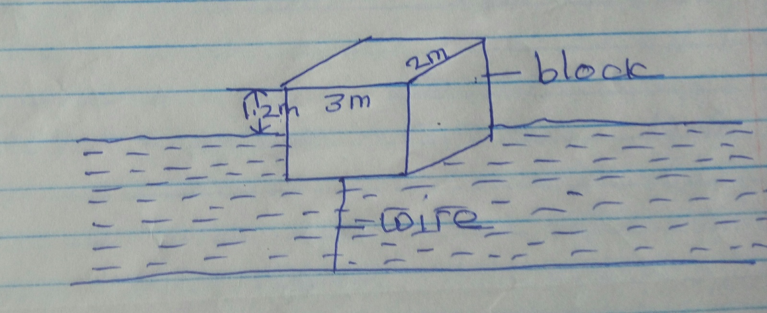

Calculate the
- Weight of the sea water displaced by the body (density of sea water =1030kg/m³)(3mks)

- Upward force exerted on the body by the water (2mks)

- Tension in the wire (2mks)

17a.On the axis below, sketch a velocity time graph for a body fall from a considerable height above the ground (1mk)
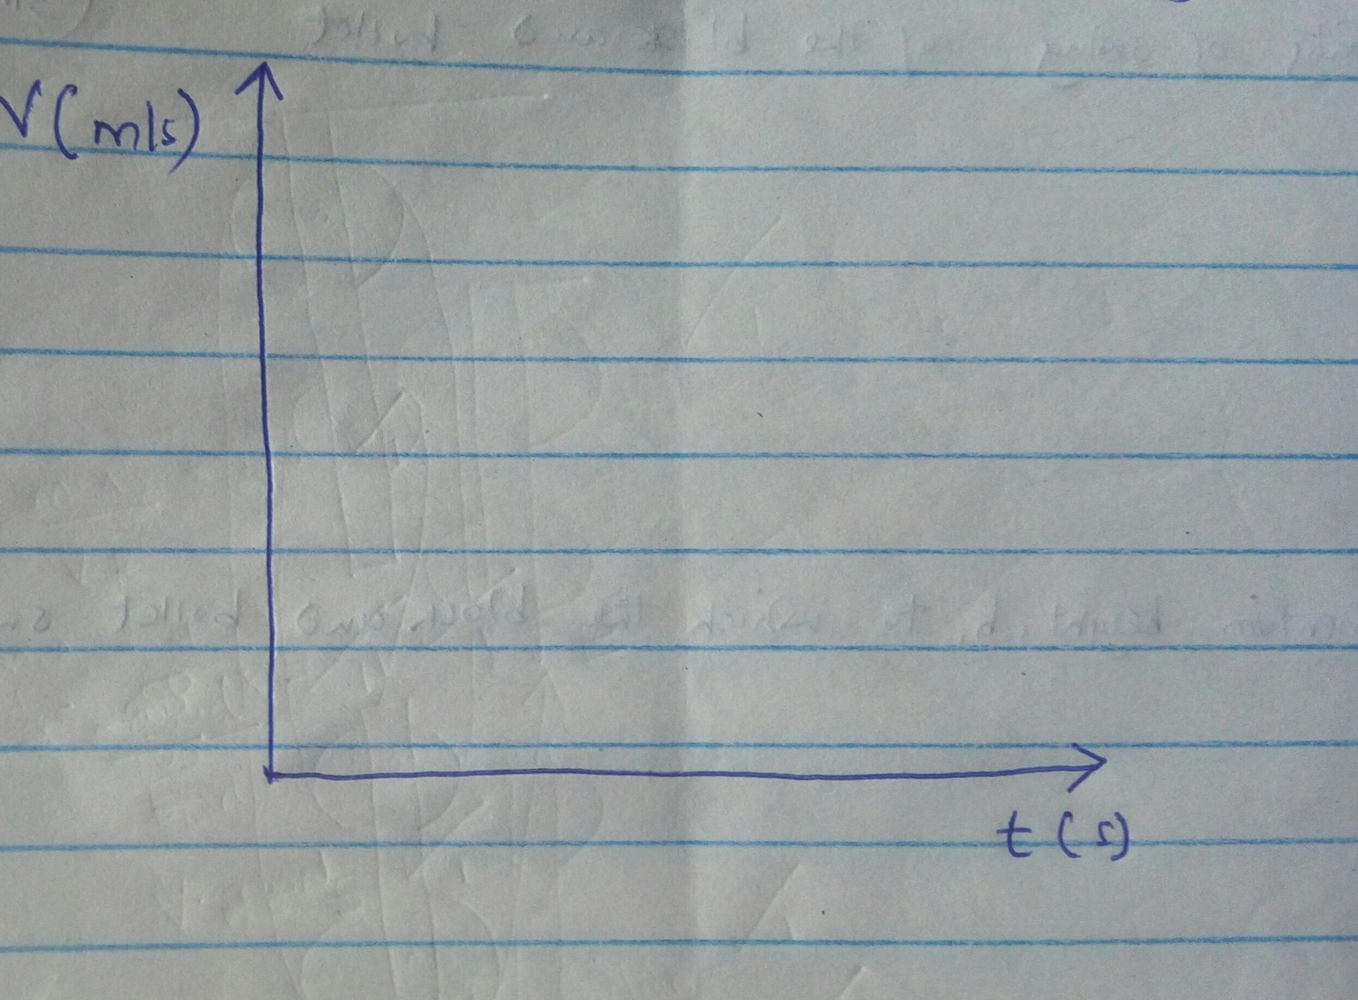

b.Explain the shape of your graph in (a ) above (1mk)

c.A bullet of mass 500g travelling horizontally at 10ms⁻¹ hits and enters into a 1.5kg mass wooden block. The block is hanging on a string freely as shown in figure below. The block and bullet swing to one side.
. 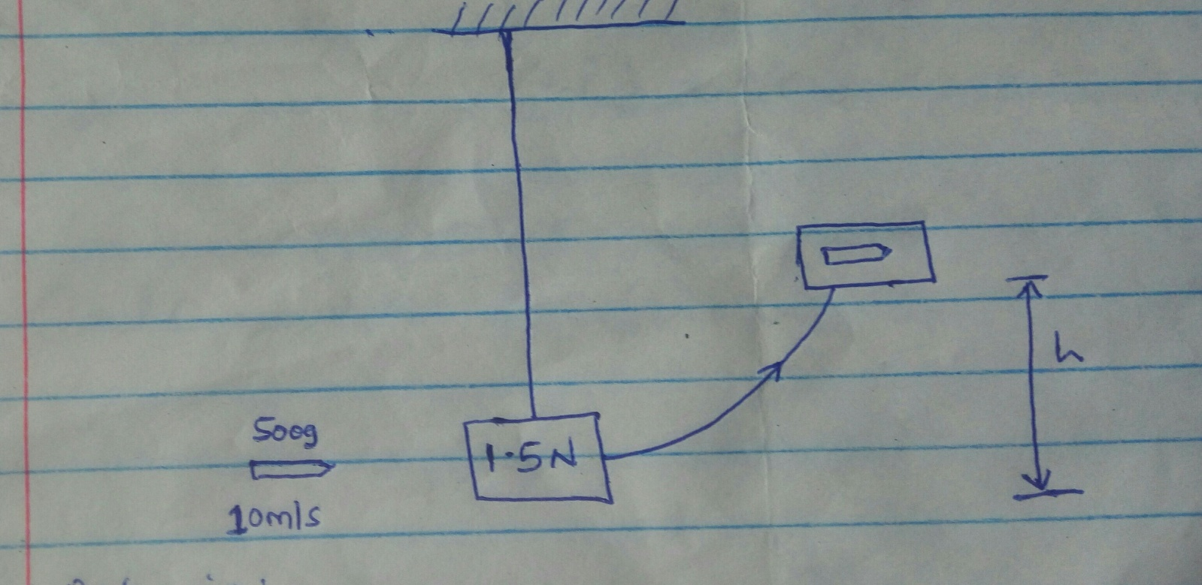

Determine:
- The initial momentum of the bullet (2mks)

- The velocity of swing of the block and bullet (3mks)

- The maximum height, h to which the block and bullet swing (take g=10ms⁻²) (3mks)

