PHYSICS PAPER 2 MARKING SCHEMES
1. To oxidize hydrogen gas to water
2.
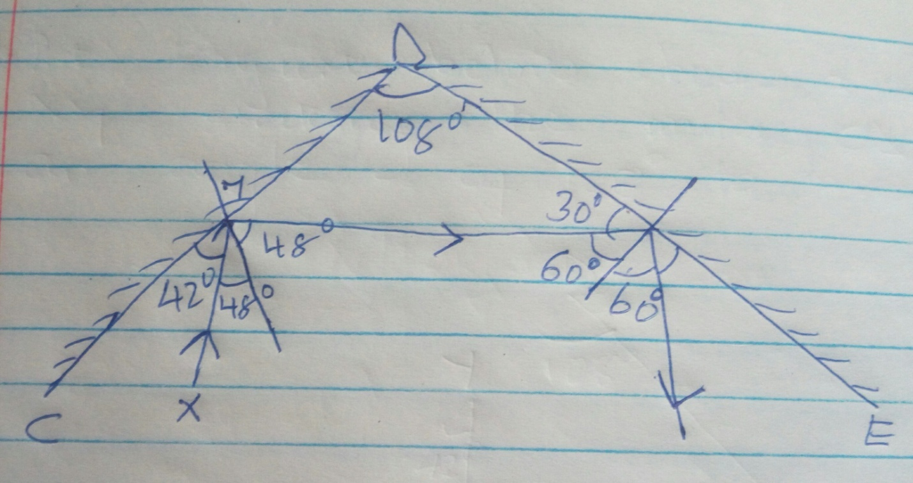

Correction direction of two reflected rays
Final angle of reflection =60º
3.The leaf divergence increases
Like charges (negative ) repel
4.Iron filling remain infact on the steel rod. Which it fell off from the iron rod. Steel rods retain magnetization form a longer time.
5.The bars repel
The ends acquire the same polarity
6a. 3 waves =0.4sec
1 wave =?
^{0.4/}₃=0.13 sec
T=0.13
F=¹/_{T}=¹/_{0.13}
b.
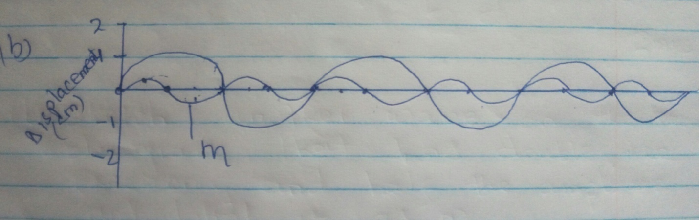

7i. Both are virtual images
ii.Used as showing mirror
Used by dentists to examine the teeth
8.Wavelength (a)=^{V}/_{f}=3.0x10⁸/1.5x10⁷
=20m
9a. Gamma rays, x-rays, ultra violet, visible light infra-red, radio waves.
b.Infrated –used in :
Control pests
Remote controls
Green house
Missiles
10i. A –neutral
B –live
ii.To protect the circuit against damage by excessive current by melting or cutting it out
11.
Sound wave | Light wave
Longitudinal wave | Transverse wave
Travel at speed lower than 3.0x108m/s | Travels at 3.0x108m/s
Mechanical wave | Electromagnetic wave  any two correct pairs

12.
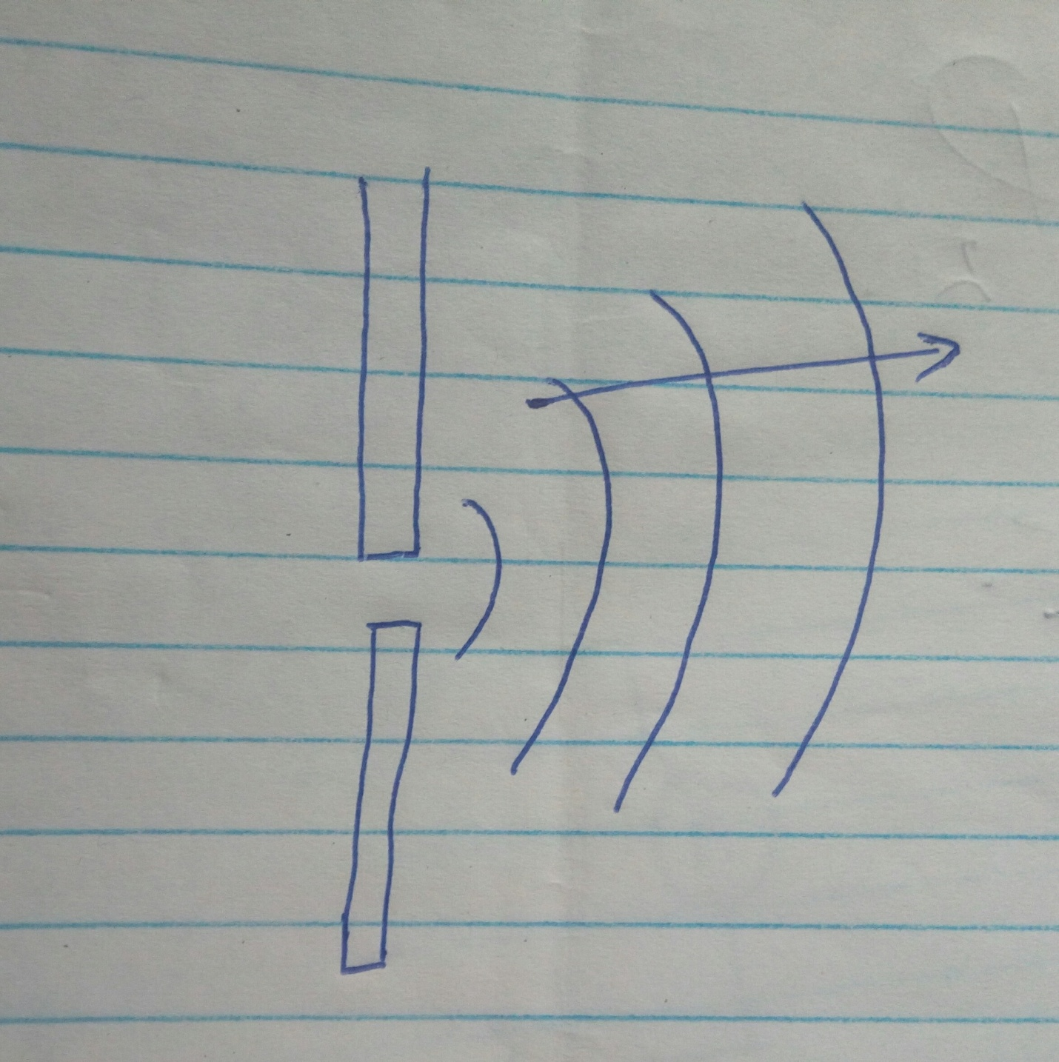

13. The current flowing a conductor is directly proportional to the p.d provided temperature and other physical factors are kept constant
Bi.
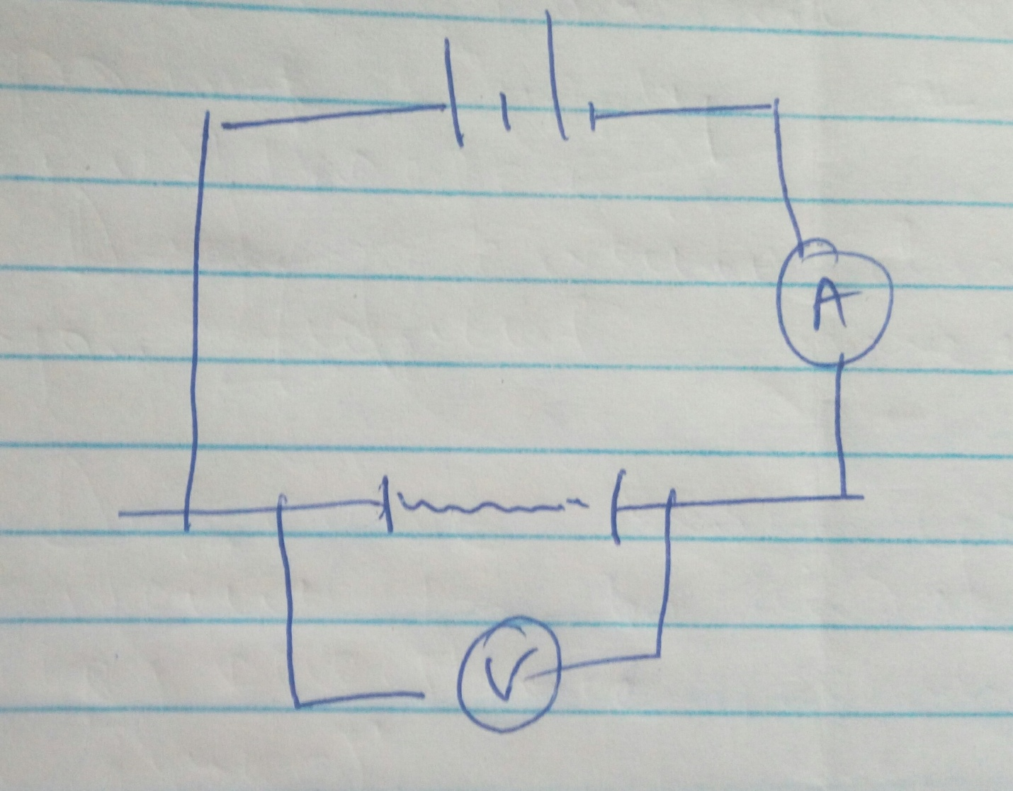

Measure length of wire (l)
Take reading of A metre and voltmeter (V)
Calculate the resistance R
Then find the value ^{R}/_{L}
_{c.}
^{I}/_{R}=^{I}/_{S}/¹/₅  i.=²/₅ | RT=52.55
R=⁵/₂  =2.5 | =12.5
ii. I=^{V}/_{R}
=¹⁰/_{12.5}
=0.8
14a.Capacitors are used in
Rectification smoothing circuits
Tuning circuits
Camera flash
Reduction of sparking in induction coil contact
^{bii. 2x8}/_{2x8}=¹⁶/₁₀=1.6µf
1.63.=4.8µf
CT=^{5x4.8}/_{5x4.8}=²⁴/_{9.8}=2.45x10⁻⁶
ii.Q=CV
=2.45x10⁻⁶x12=2.94x10⁻⁵C
Charge on 3.2µf=²/₃x2.94x10⁻⁵
=1.96x10⁻⁵c
iii. p.d on 5µf=2.94x10⁻⁵/5x10⁻⁶
=5.88volts
iv.Energy =¹/₂Cr²
=¹/₂x2x10⁻⁶x6.122
3.75x10⁻⁵J
15ai.The negative charge on the electroscope repel the photoelectrons produced when the ultraviolet radiation falls on zinc plate therefore both zinc plate and the electroscope loose charges discharging the electroscope
ii.Work function of metal
Frequency of the incident radiation
Thresh hold frequency of metal
bi.h=slope
= (9-3)x10⁻¹⁹
(2.5-1.5)x10¹⁵
=6.0x10⁻³⁴js
ii.F_{o}=x-intercepts =1.0x10¹⁵hz
W_{o}=hf₀
=6x10⁻³⁴x1.0x10¹⁵
=6.0x10⁻¹⁹j
16i.Filament heats the cathode electrons which gain energy to escape from the surface.
ii.Accelerating the electrons of focusing
iii.Across x plate
iv.To reduce collisions with air \molecules that could lead to ionization
b.Height =4cm
Meet value =4x5
=20V
ii.2 wavelength =16cm.
T=8x20x10⁻³
=0.16s
F=¹/_{T}
=¹/_{0.16}
=6.25Hz
iii.Double the cycles
17i.
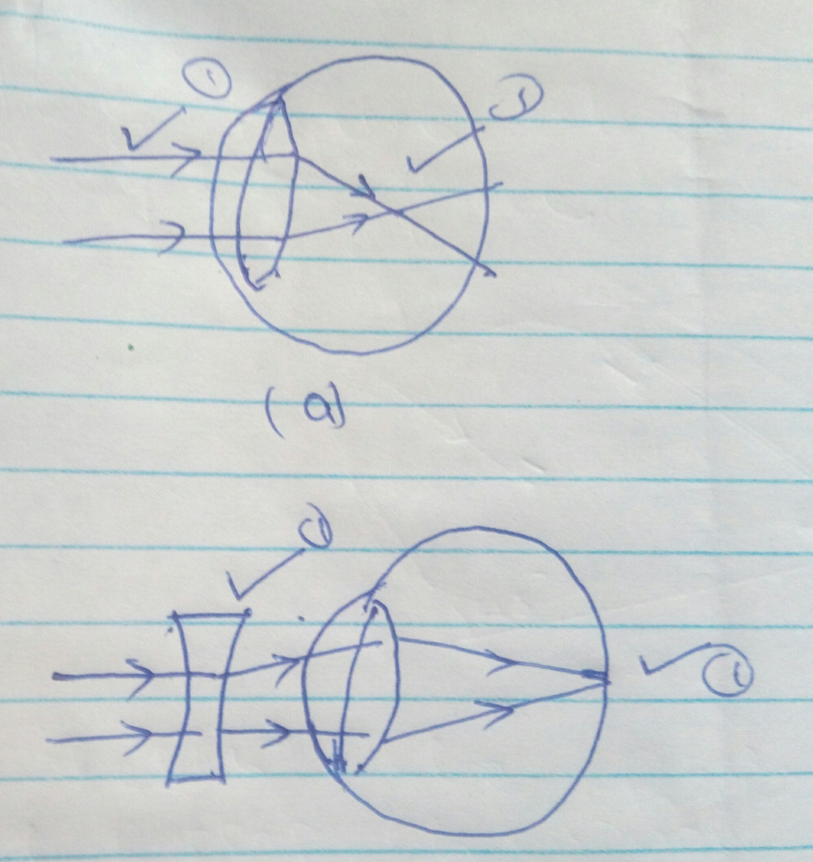

ii.

bi.M=^{V}/_{U}=3 V/_{80-V}=3
VU=80 V=240-3V
U=80-v V=60cm
iii. h=80-60
=20cm
¹/f=¹/_{u +} ¹/_{v}
=¹/₆₀-¹/₂₀
=15cm
c.
