NAME…………………………………………………………………………INDEX NO……………………...
DATE……………………………………………………CANDIDATE’S SIGNATURE………………………
PHYSICS
231/2
PAPER II THEORY
2HRS

3KNT ALLIANCE JOUNT EXAMINATIONS – 2017
FORM FOUR

INSTRUCTIONS TO CANDIDATES
- Write your name and index number in the spaces provided above.
- This paper consists of two sections A and B.
- Answer all the questions in sections A and B in the spaces provided.
- All working must be clearly shown.
- Non-programmable electronic calculators may be used.
- The paper consists of 18 questions.
- Use English to answer the questions.

FOR EXAMINERS USE
SECTION | QUESTION | MAX. SCORE | CANDIDATE’S SCORE
A | 1 - 12 | 25
B | 13  14  15  16  17 | 12  10  11  11  11

1. State the purpose of manganese (IV) oxide in a dry cell. (1mk)

2. The figure below shows a ray of light XY striking the mirror CD held at an angle of 108⁰ to mirror DE.
D

$${108}^{0}$$

$${42}^{0}$$

C X
E

Complete the path of the ray XY and state the final angle of reflection. (3mks)

3. The figure below shows a gold leaf electroscope charged negatively.

cap

leaf

State and explain what happens to the leaf when a negative charged rod is brought near the cap without touching it. (2mks)

4. The figure below shows iron and steel rods placed in contact with a magnet.

N

SS
S S

N N

State with a reason what is observed when magnet is removed from the rods. (2mks)

5. A soft iron core is placed in a solenoid with two soft iron bars X and Y.

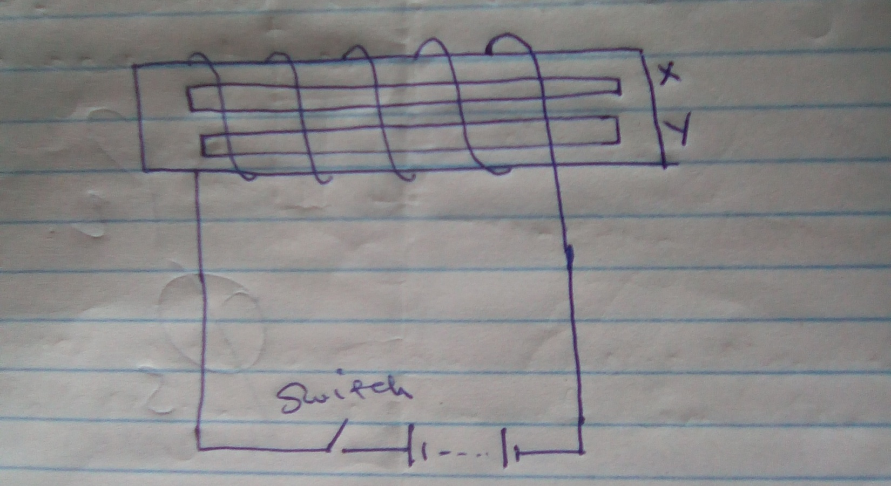

State and explain the observation made when switch is closed. (2mks)

6. The figure below shows a transverse wave.

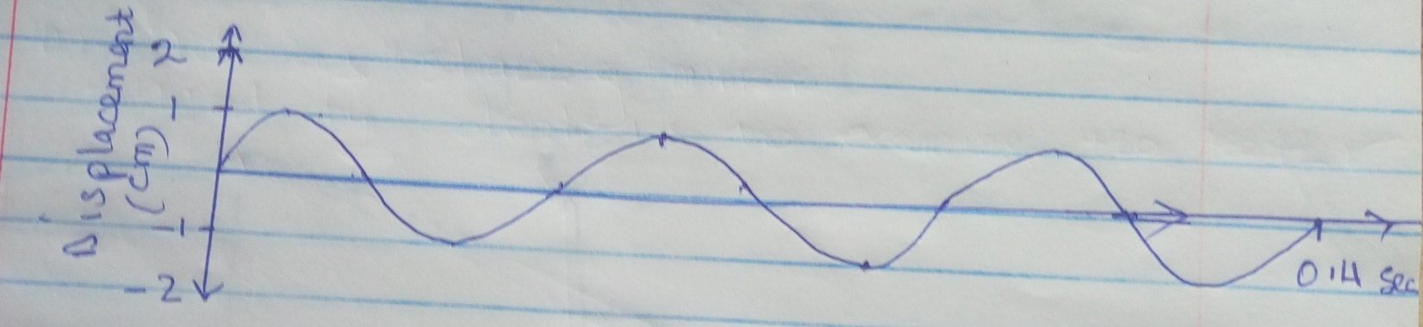

a) Calculate the frequency of the wave. (2mks)

b) Sketch another wave on the same diagram that has double the frequency and half the amplitude and label it as m (1mk)

7. The figure below shows an object O placed infront of a concave mirror and the image formed.

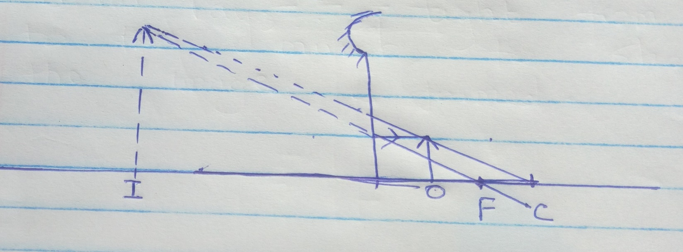

State one
i) Similarity between the image formed above and that formed by a plane mirror. (1mk)

ii) Application of the set up above. (1mk)

8. A radio station is transmitting at a frequency of 15MHz. Calculate the wavelength of the transmission. (2mks)

9.a) Arrange the electromagnetic wave below is ascending order of wavelength, visible light, infrared, ultraviolet, radio waves, gamma rays, x-rays. (1mk)

b) State one use of infrared. (1mk

10. The figure below shows a part of a ring main circuit.

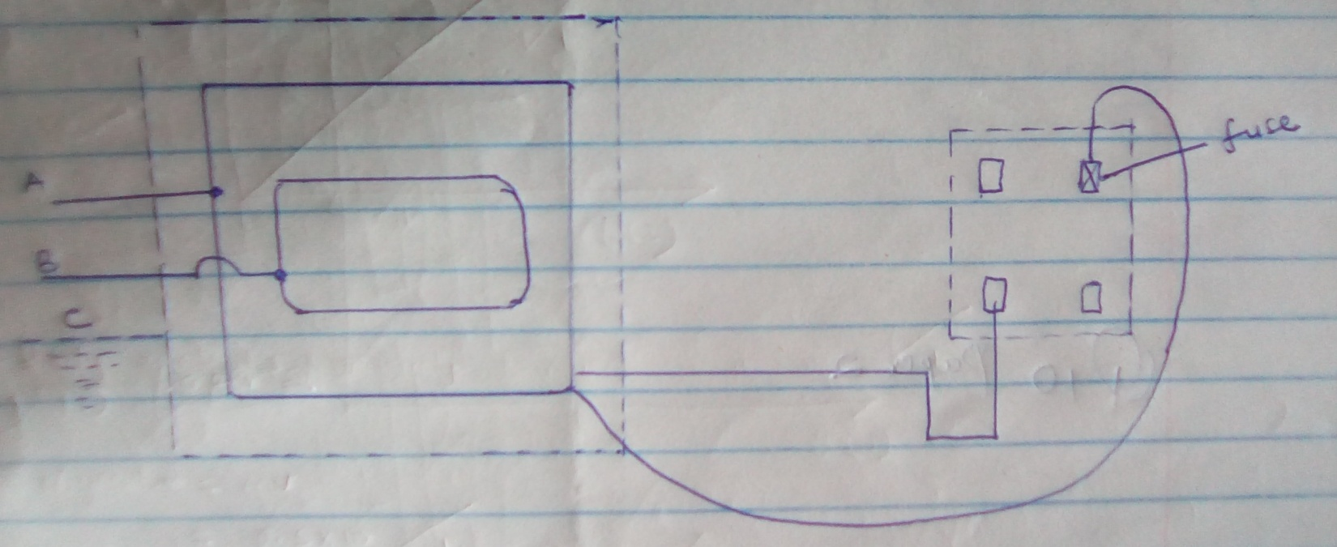

i) Identify the wires A and B. (2mks)
A –

B –

ii) What is the work of the fuse in this circuit? (1mk)

11. State two differences between light waves and sound waves. (2mks)

12. The figure shows straight wave front passing through a narrow slit. Sketch on the same diagram the wave front of the wave after passing the slit. (1mk)

13.a) State Ohms law. (1mk)

b) You are required to determine the resistance per unit length of a Nichrome wire X. You are provided with a d.c. power supply, an ammeter a switch and a voltmeter.
i) Draw a circuit diagram to show how you would connect the circuit. (3mks)

ii) Describe how you would use the circuit in b(i) above to determine the resistance per unit length of X. (3mks)

c) Four 5Ω resistors are connected to a 10V d.c. supply as shown in the diagram below.

5ῼ
5ῼ

5ῼ

5ῼ
10 V

Calculate;
i) The effective resistance in the circuit. (2mks)

ii) The current I flowing in the circuit. (2mks)

14.a) State one application of a capacitor. (1mk)

b) The figure below shows four capacitors connected to a battery of 12 volts.

12 V

5µ

2µ 8µ

3.2µ

Calculate:
i) Effective capacitance. (3mks)

ii) Charge on 3.2 µF (2mks)

iii) P.d across 5µF (2mks)

iv) The energy stored by 2µF. (2mks)

SECTION B (55MKS)
15.a) Figure below shows ultraviolet light striking a polished zinc plate placed on a negatively charged gold leaf electroscope.

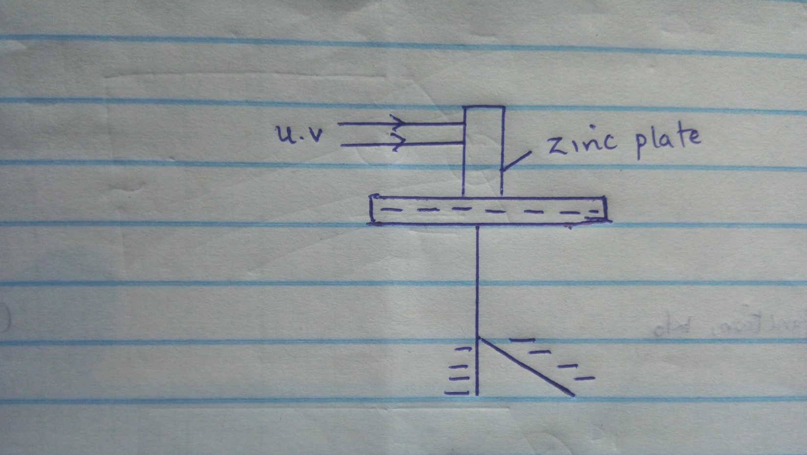

i) Explain why the leaf of the electroscope falls. (2mks)

ii) State three factors which determine the speed of photoelectrons emitted by a metal surface.(3mks)

b) In an experiment using a photocell, ultraviolet light of varying frequency but constant intensity was made to strike a metal surface. Themaximum kinetic energy (K E_{max}) of photoelectrons for each frequency f, was measured. The graph below shows how the K E_{max} varies with f.

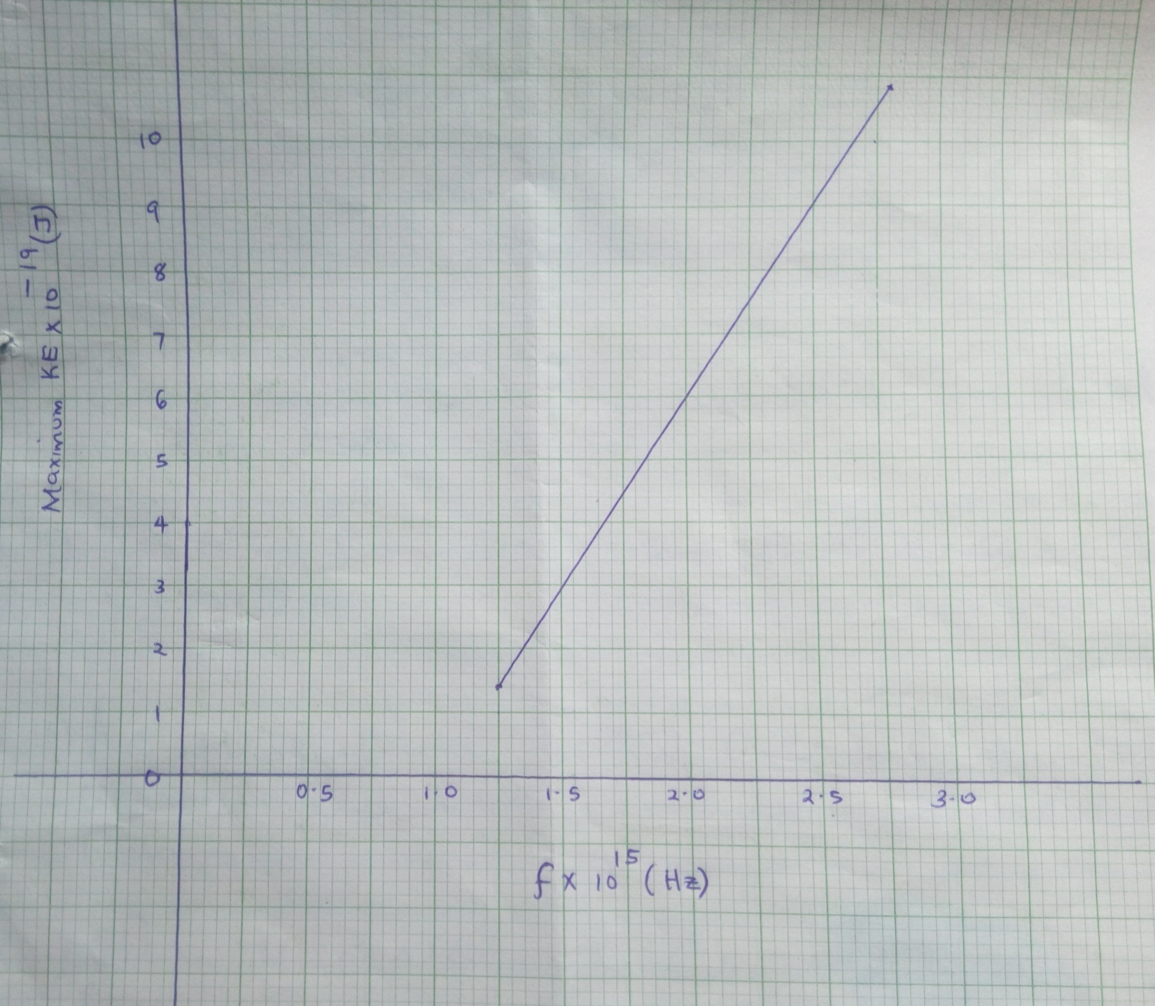

Given that K. E_{max} = hf – W_{o} determine from the graph the value of:

i) Plancks constant, h (3mks)

ii) The work function, W_{o} (3mk

16.a) The figure shows the features of a cathode ray tube.

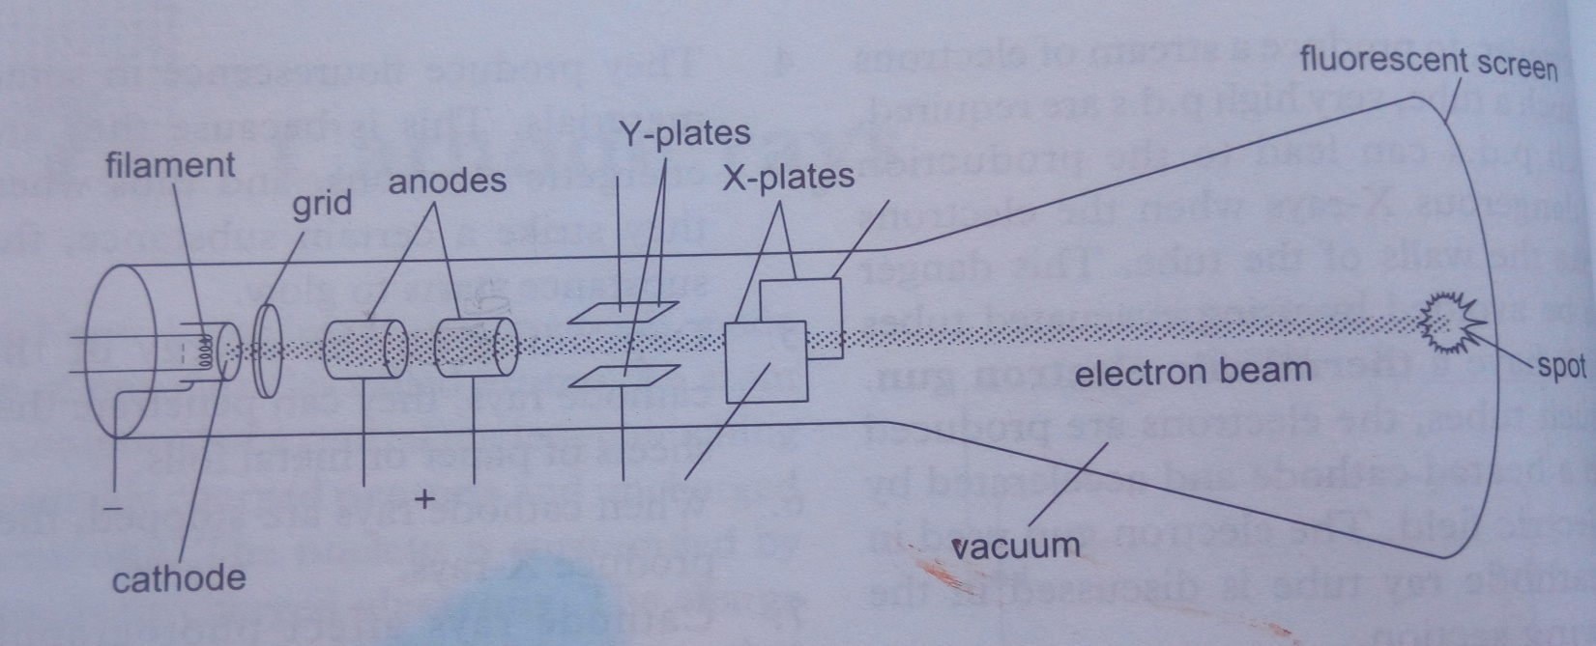

i) Explain how the electron are produced in the tube. (2mks)

ii) State one function of the anodes. (1mk)

iii) At what part of the cathode ray tube would the time base be connected? (1mk)

iv) Why is a vacuum created in the tube? (1mk)

b) The graph in figure was obtained on a cathode ray oscilloscope (C.R.O) screen when the output of an a.c. generator was connected to the input of the CRO. The time base calibration of the CRO was set at 20 milliseconds per centimeter and the Y again at 5 volts per centimeter.

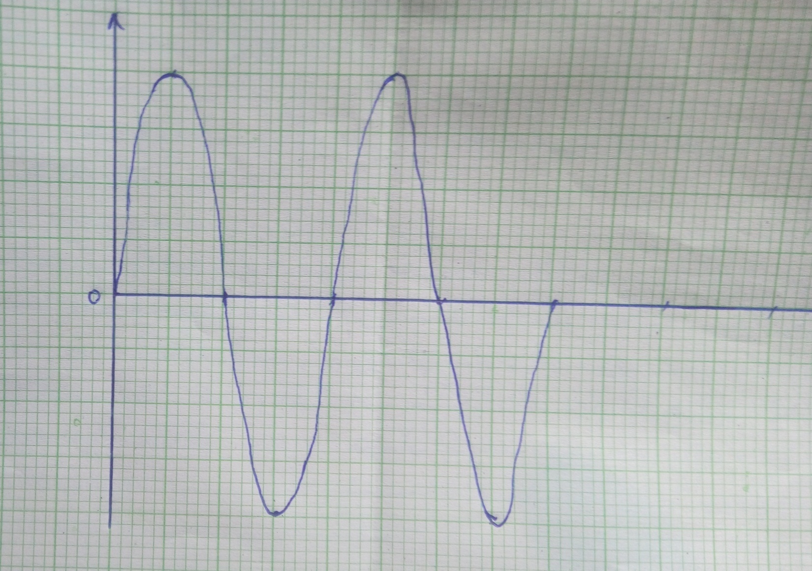

i) Determine the pick voltage of the generator. (2mks)

ii) Determine the frequency of the voltage. (2mks)

iii) On the same grid, draw the graph for the voltage when the time base calibration is set at 40millisecods per centimeter. Show at least one complete cycle. (2mks)

17.a) The figure shows diagrams of the human eye.

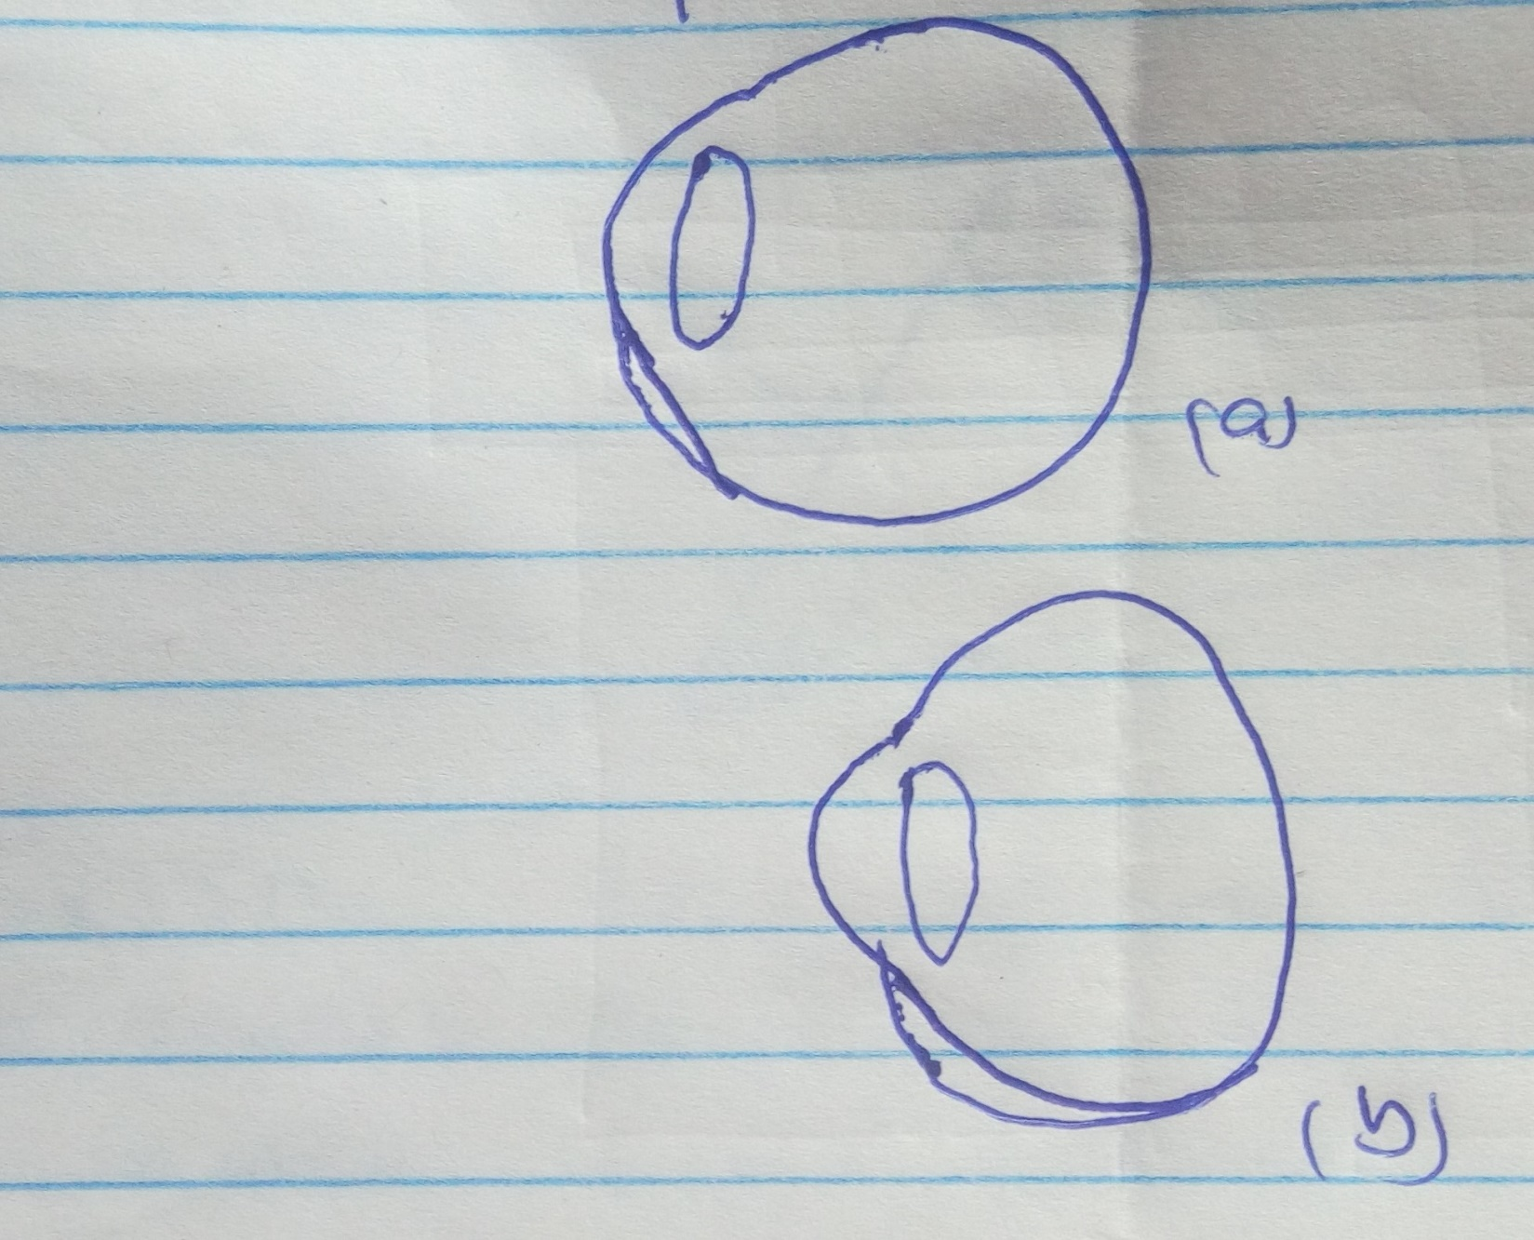

i) Sketch in the figure (a) rays diagram to show short sightedness. (2mks)

ii) Sketch in figure (b) a ray diagram to show how a lens can be used to correct the short sightedness. (2mks)

b) A lens from clear image on a screen when the distance between the screen and the object is 80cm. If the image is 3 times the height of the object determine;
i) The distance of the image from lens. (3mks)

ii) The focal length of the lens. (2mks)

c) The figure shows a ray of light incident on the face of a water prism.

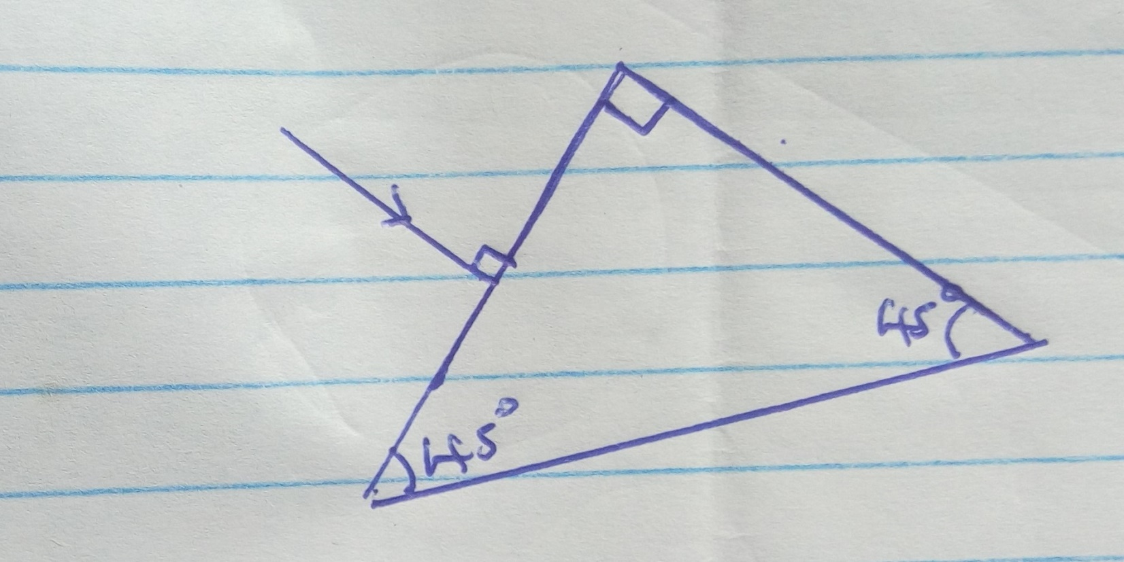

Sketch the path of the rays as it passes through the prism. Critical angle of water is 41⁰. (2mks)

