DARAJANI BOYS’ SCHOOL,P.O BOX 20,90129 NGWATA

PHYSICS CAT 1 TERM 2 2015

FORM FOUR

NAME………………………………………… ADM.NO…………….. CLASS…………

ANSWER ALL THE QUESTIONS IN THE SPACES PROVIDED

1. (a) Define the term velocity ratio of a machine. (1mk)

(b) Fig. 12 shows part of a hydraulic press. The plunger is the position where effort is applied while the Ram piston is the position where load is applied. The plunger has cross-section area, a m2 while the Ram piston has cross-section area, a m2.



When the plunger moves down a distance d the Ram piston moves up a distance D.

(i) State the property of liquid pressure on which the working of the hydraulic press

works. (1mk)

(ii) Derive an impression for the velocity ratio (V.R) in terms of A and a.

(4mks)

c) A machine of velocity ratio 45, overcomes a load of 4.5 x 103N when an effort of 135N is

applied.

Determine:

1. The mechanical advantage of the machine; (2mks)
2. Efficiency of the machine; (2mks)
3. The percentage of the work that goes to waste. (1mk)
4. (a) Define the term angular velocity ( 1 mark)

(b) A body moving with uniform angular velocity is found to have covered an angular distance of 170 radians in t seconds. Thirteen seconds later it is found to have covered a total angular distance of 300 radians. Determine t. (3 marks)

(c) Fig 8 shows a body of mass m attached to the centre of a rotating table with a string whose tension can be measured. (The device for measuring the tension is not shown in the figure)



The tension, T on the string was measured for various values of angular velocity, w. The distance r of the body from the centre was maintained at 30cm. Table 1 shows the results obtained.

**Table 1**

|  |  |  |  |  |  |
| --- | --- | --- | --- | --- | --- |
| W2 | 4.0 | 9.0 | 16.0 | 25.0 | 36.0 |
| Angular velocity w (rads-1) | 2.0 | 3.0 | 4.0 | 5.0 | 6.0 |
| Tension T (N) | 0.04 | 0.34 | 0.76 | 1.30 | 1.96 |

1. Plot the graph of T (y- axis against w2) ( 5 marks)
2. From the graph, determine the mass, m of the body given that

T = mw2 –C

Where C is a constant (4 marks)

1. Determine the constant C and suggest what it represents in the set up. (2 marks)

3. a) State Hooke’s law. (2mks)

b) The graph shows how extension e of a helical spring varied with load, hanging on it. (cm)

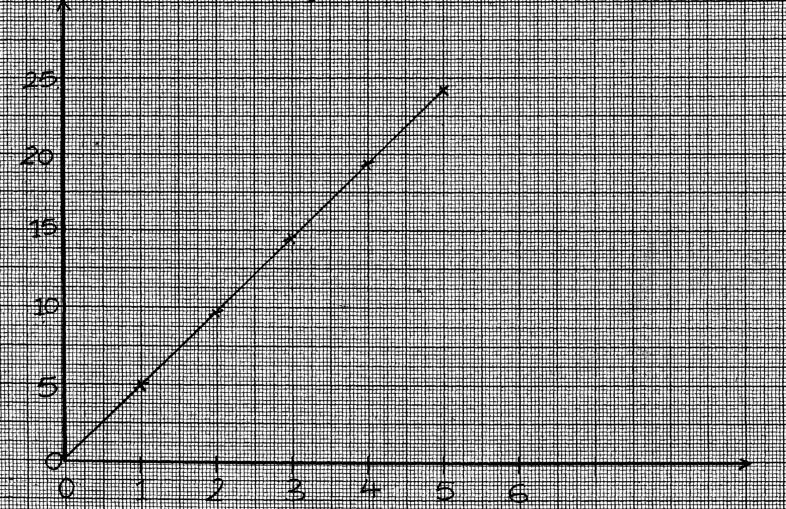

**5, 23.2**

**4,, 18.5**

**Extension (cm)**

**3,, 13.8**

**1, 4.5**

**2, 9.2**

**Load ( N)**

Determine from the graph, the proportionality constant of the spring. (3mks)

c) State **three** factors that affect the proportionality constant of a helical spring. (3mks)

d) Two springs Q and R have proportionality constants 20Nm-1 and 25Nm-1 respectively. Q weighs

0.2 N while the weight of R is negligible. The two springs are arranged to support a load 3.0N as

shown in the diagram that follows.

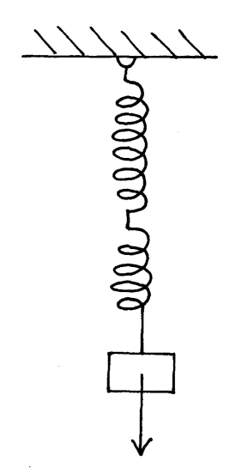

**R**

**Q**

**3.0N**

Determine the extension in

i) Q (2mks)

ii) R (2mks)

4 . (a) State the law of conservation of linear momentum. (1mk)

(b) Distinguish between elastic and inelastic collisions. (2mks)

(c) A bullet of mass 22g travelling horizontally with a velocity of 300m/s strikes a block of wood of mass 1978g which rests on a rough horizontal surface. After the impact the bullet and the block move together and come to rest when the block has travelled a distance of 5M.Calculate,

(i) the velocity of bullet and wood after the impact. (2mks)

(ii) the force of friction between wood and the surface. (3mks)

1. (a) State Ohm’s law. (1mk)

(b) The figure below shows a circuit.

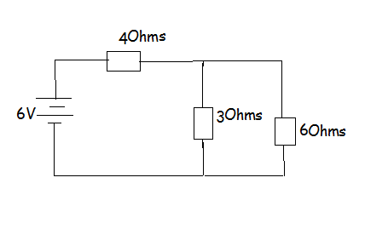

Calculate,

(i)the equivalent resistance in the circuit. (3mks)

(ii) the total current flowing in the circuit. (2mks)

(iii) the voltage drop across resistor R1. (2mks)

(iv) the current through the 3 resistor. (3mks)