GATITU MIXED SECONDARY SCHOOL
TUNE UP EXAM
PHYSICS FORM IV.
Answer all the question in the space provided.
1)Explain why a needle can be carefully made to float on pure water but sink if dertergent is added to water. (2mks)

2)In the set up below it is that the level of water initially drops before starting to rise.

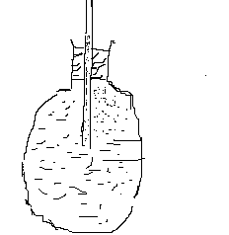

Explain the observation made. (2mks)

3) State two factors that determine moment of a force.
4)The figure below shows a velocity time graph for a racing car.

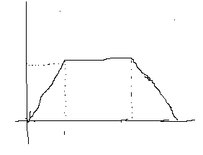
What is the total distance covered by the car?

5)State Newton’s second law of motion. (1mk)

6)A mass of 50g is whirled at the end of a string 200cm long in a horizontal circle.If the mass is whirled at 10 revolutions (3mks)

7) (a)Define the term efficiency as applied to simple machines (1mk)

(b)A man used a wooden plank to push a log of wood from the ground to a stationary lorry on a flat ground as shown in the figure below.The wooden plank was inclined at an angle of 30 to the ground.
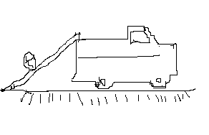
(i)Indicate with an arrow on the diagram,the diagram of the effort and the load.(2mks)

(ii)Calculate the velocity ratio of the set up .(2mks)

(iii)Calculate the mechanical advantage of the set up if its efficiency is 65%. 3mks

8)When an inflated baloon is placed in a refrigerator,it is noted that its volume decreases.Use the kinetic thoery of gases to explain this observation.(3mks)

9)An electric bulb with a filament of a resistance 480 is connected to a 240V mains suply.
Determine the energy dissipated in 2 minutes.

10)State one advantage of alkaline accumilator over lead acid accumilator (1mk)

11)The figure below shows how magnets are stored in pairs with keepers at the ends

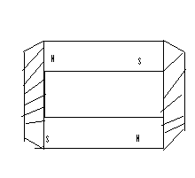

Explain how this method of storing helps in retaining magnetism longer(2mks)

12)An electric bulb rated 40w is operating on 240v mains. Determine the resistance of it filament (3mks)

13)A positively charged rod is brought near the leaf of a leaf electroscope. The cap is then earthed momentarily by touching with the finger. Finally the rod is withdrawn. The electroscope is found to be negatively charged Explain how this is acquired.(2mks)

16)The figure below shows bimetallic thermometer

Explain how a rise in temperature causes the pointer the move in the direction shown. 2mks

17. A high jumper usually lands on thick soft mattress. Explain how the mattress helps in reducing the force of impact. 2mks

18. The figure below shows part of the circuit containing two capacitors 2uf and 3 uf respectively.
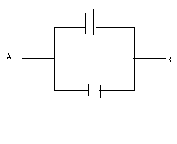
Determine the p.d across AB given that the total change in the capacitors is 1× 10-4 coulombs. 3mks

19. In an oil drop experiment, a student estimated the diameter of an oil molecule as 1.62 × 10 -9 m.Given the volume of the drop was 0.22 mm3, determine the area of the patch. 3mks
20. The figure below shows the image of an object placed in front of the mirror M.

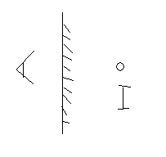

By ray diagram construction, locate the position of the object 3mks

21. Define pressure and state its SI units. 2mks

Mr. Karanja.
‘Plan intelligently towards your success’

