MOKASA II PRE-MOCKS 2019

MARKING SCHEME

FORM IV
232/3
PHYSICS PAPER 3

Table 1
Length X cm | 32 | 28 | 24 | 20 | 16 | 12
Time t for 10 oscillations (s) | 9.32 | 8.72 | 8.00 | 7.40 | 6.62 | 5.75
Period T=$\frac{t}{10}$ (s) | 0.932 | 0.872 | 0.8 | 0.74 | 0.662 | 0.575
T² (S²) | 0.87 | 0.76 | 0.64 | 0.55 | 0.44 | 0.33

2

2

1
(any 4 to 6 correct values, 2 marks, 2 to 4 values, 1 mark, less than 2 values, no mark)

- Plot a graph of T² (y-axis) against X (metres) on the graph paper provided. (5 marks)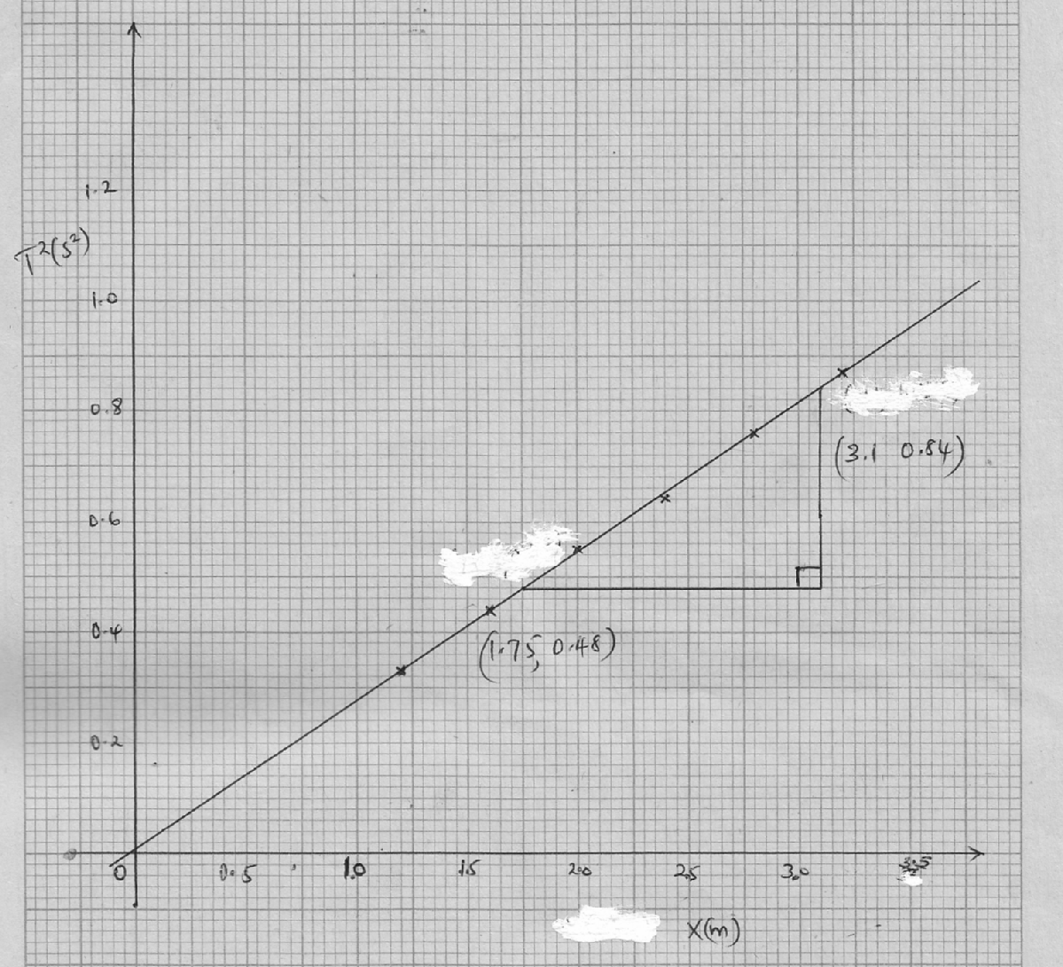
Scale =1 mark
Axes with units=1 mark
Plots = 2 marks
Line = 1 mark
- i)

slope= $\frac{0.84-0.48(S^{2})}{3.1-1.75(m)}$

slope = $\frac{0.36}{1.35}$
slope = 2.67s²/m (3 marks)
ii) Obtain the value of K in the equation S= $\frac{8π}{3k}$ (2marks)
2.67s²/m= $\frac{ 8×3.142}{3k}$

$3k$ = $\frac{ 8×3.142}{2.67}$

$k$ = $\frac{ 8×3.142}{3×2.67}$

$k=3.1381 m$/$s^{2}$
PART B
- (3 marks)
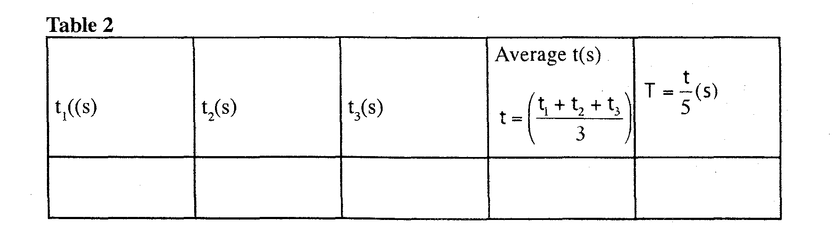
1
½
3.81 ½
$$T=\frac{3.747}{3}=0.7494$$
$$\frac{3.68+3.75+3.81}{3}$$
3.75 ½
3.68 ½
- (2 marks)
P= $\frac{40×0.12(m)}{{0.7494}^{2}}$
P=8.547m/s²
QUESTION TWO
h= 6.3cm (1 Marks)

R= $\sqrt{\frac{100}{6.3}}=3.98$ cm (1 Marks)

(i) (8 marks)
 | 10R | 9R | 8R | 7R | 6R | 5R | 4R | 3R
U (cm) | 39.8 | 35.9 | 31.9 | 27.9 | 23.9 | 19.9 | 15.9 | 12.0
V (cm) | 8.5 | 8.8 | 9.1 | 9.1 | 10.4 | 10.6 | 11.4 | 15.0
NB: Any other appropriate value of u and v depending on the value of R obtained can be awarded.
-each correct value = ½ mark
(5 marks)
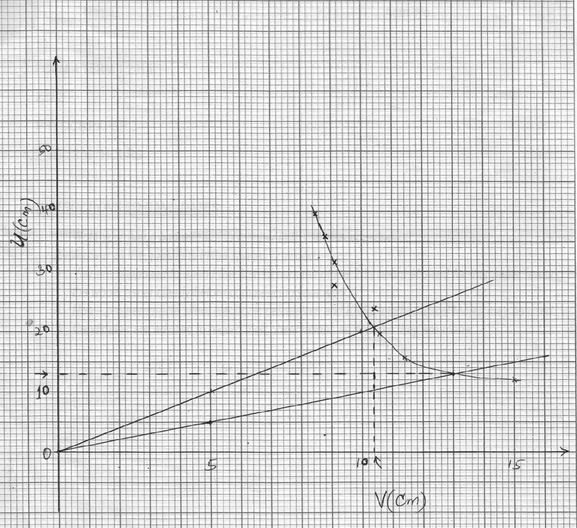

Scale =1 mark
Axes with units=1 mark
Plots = 2 marks
Smooth Curve = 1 mark
- From the graph determine
‘V’ the value of V for which v=u (1 Mark)
‘V’=13cm
- ‘U’ the value of U for which u=2v (1 Mark)
‘U’ = 10.4cm
- Determine the effective focal length of the ‘lens’ from the formulae f=$\frac{{}^{'}u^{'}+'v'}{5}$ (2 Marks)
$f=\frac{10.4+13.0 }{5}$
=$\frac{23.4}{5}$
$f=4.68cm$
- Hence determine the value of $\frac{R}{f}$ (1 Mark)
$\frac{R}{f}=\frac{3.98cm}{4.68cm}=0.85$

