MWAKICAN JOINT EXAM TEAM (MJET)

FORM 1 PHYSICS

END OF TERM 2 – 2016

- Name three physical quantities and their SI units. (6mks)

- Name the instruments you would use to measure each of the following:
- The length of a football field. (1mk)

- The height of a 20 litre jerrican (1mk)

- The circumference of your waist. (1mk)

- A cylinder has a diameter of 4.2cm. How many times would a thread of 132cm be wound around the cylinder ? (3mks)

- A page of a book measures 14.5cm x 21.4 cm. What is its area in square millimetres ? (3mks)

- Define density and state its SI units. (2mks)

- The water level in a burette is 30cm³. If 55 drops of water fall from the burette and the average volume of one drop is 0.12cm³, what is the final water level in the burette ? (3mks)

- A cube of iron of side 4cm has a mass of 512g. Find:
- The volume of the cube in m³ (3mks)

- The density of iron in kgm⁻³ (3mks)

- What is pressure ? State its SI unit. (2mks)

- Explain the action of drinking straw. (3mks)

- Using the crashing can experiment, explain using a diagram the existence of atmospheric pressure (5mks)

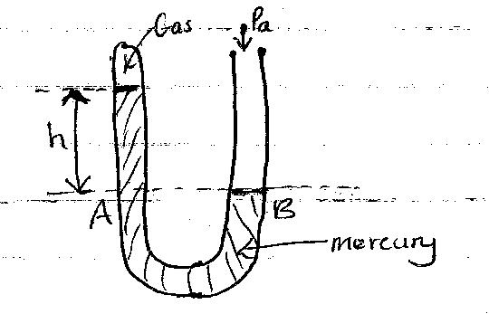
- The diagram below shows a mercury manometer. Some dry gas is present in the closed space in limb A, while limb B is open. If atmospheric pressure Pa = 103 000 pa, h = 30mm and density of mercury is 13 600kgm⁻³. Determine pressure Pg of the gas. (Take g = 10Nkg⁻¹) (4mks)

- The figure below shows a simple hydrauric press used to compress a bale. The cross-section areas of A and B are 0.002m² and 0.30m² respectively:

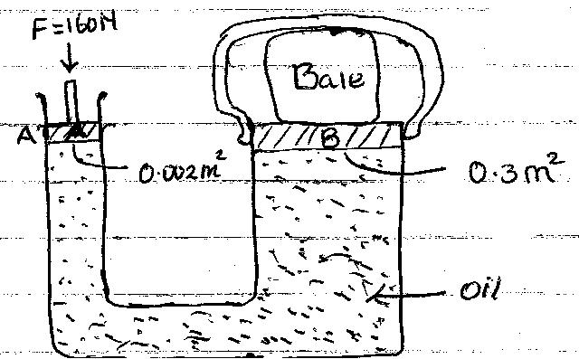

- Pressure exerted on the oil by the force applied at A. (3mks)

- Pressure exerted on B by the oil. (2mks)

- Force produced on B compressing the bale. (3mks)

- A sea diver is 35m below the surface of sea water. If the density of the sea water is 1.03gcm⁻³ and g is 10N/kg. Determine the total pressure on him.
(Atmospheric pressure = 103 000Nm⁻²) (3mks)

- A brick 20cm long, 10cm wide and 5cm thick has a mass of 500g. Determine the:
- Greatest pressure that can be exerted by the brick on a flat surface. (3mks)

- Least pressure that can be exerted by the brick on a flat surface. (Take g = 10N/kg) (3mks)

- Define matter and give the three states of matter. (4mks)

- Explain why the density of a gas is much less than that of a solid or liquid. (2mks)

- Explain the following:
- It is possible to compress gases but not solids and liquids. (2mks)

- A perfume sprayed at one corner of a room spreads quickly to the entire room. (2mks).

- A smoke cell contains a mixture of trapped air and smoke. The cell is brightly lit and viewed through a microscope. Small bright specks are seen dancing in a random manner.
- What are these small bright sperks ? (1mk)

- Why do they move in a manner described above ? (2mks)

- Using pollen grains placed in water, explain how their motion supports the idea that matter is not continuous. (2mks)

- Define force and give its SI units. (2mks)

- A concrete slab of mass 90kg is held by a steel cable of a crane as shown in the fig below.
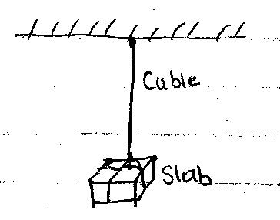

- Draw and name the forces acting on the slab. (2mks)

- Determine the tension in the cable. (3mks)

- When water is poured on a dry glass slab it spreads uniformly but it forms spherical droplets on a waxed glass slab. Explain. (4mks)

- A man has a mass of 70kg. Determine
- His weight on earth, where the gravitational field strength is 10N/kg. (3mks)

- His weight on the moon, where the gravitational field strength is 1.7N/kg. (3mks)

- A mass of 7.5kg has weight of 30N on a certain planet. Calculate the acceleration due to gravity on this planet. (3mks)

- A spring stretches by 6cm when supporting a load of 15N.

- How much would it stretch when supporting a load of 5kg? (3mks)

- What load would make the spring extend by 25mm ? (3mks)

- Describe a method that can be used to open a tight lid of a bottle without damaging it. (2mks).

