MWAKICAN JOINT EXAM TEAM

FORM 1 PHYSICS MARKING SCHEME
END OF TERM 2 – 2015

- Length - Metre
Mass - Kilogram
Time - Second
Electric current - Ampere
Thermodynamic temperature – Kelvin
Luminous intensity - Candela
Amount of substance - Mole (Any 3)

2(a) Surveyor’s tape measure
(b) Metre rule
(c) Tailor’s tape measure

3. Circumference = π d

= 22 x 4.2 = 13.2
7
132cm
13.2cm

= 10 times.

4. 145mm x 214mm = 31 030mm²

5. - Mass per unit area
- Kgm⁻³ or Kg/m³

6. Vol of water dropped = 55 x 0.12
= 6.6 cm³

Final water level = 30cm³ – 6.6. cm³ 30cm³ + 6.6cm³ = 36.6cm³
= 23.4 cm³

7(a) 4cm = 0.04m
V = (0.04)³
= 0.000064m³

(b) P = M
V
= 0.512
0.000064
8000Kgm⁻³

- Force acting normally per unit area.
N/m² or Pascals

- When you suck the straw the air pressure inside it decreases making the atmospheric pressure outside to press the liquid hence it rises on the straw.

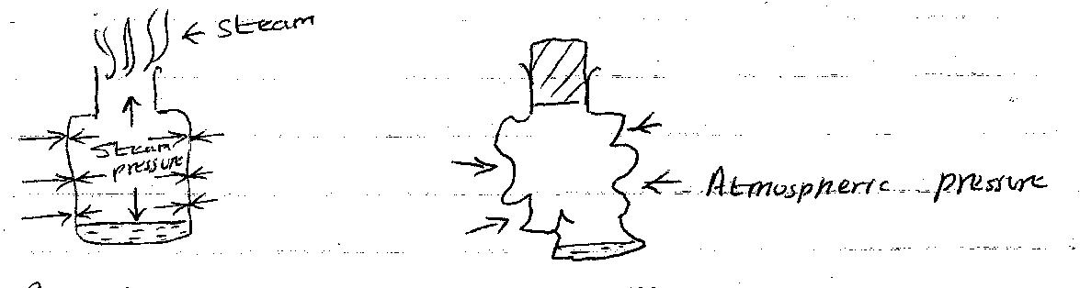

- Boil the water for several minutes.
- Replace the cork and allow the container to cool. You may pour cold water on it to cool it faster.
- The container crushed in.
- On cooling, the steam condenses. A partial vacuum is therefore created inside the container. Since the pressure inside is less than atmospheric pressure outside, the container crushes in.

- Pressure at A = Pressure at B
Pg + hpg = Pa
Pg + 0.03 x 13600 x 10 = 103 000
Pg + 4080 = 103 000
Pg = 98 920 Nm⁻²

- (a) P = F = 160
A 0.002

= 80,000 Nm⁻²

(b) Pressure at A = Pressure at B
= 80 000 Nm⁻²

(c) F = P X A
= 80 000 X 0.3
= 24 000 Nm⁻²

- Total pressure = Pressure of water Atmospheric pressure
= hpg + 103 000
= 35 x 1030 x 10 + 13 000
= 463 500 Pa

- Greatest pressure = Force
Smallest area
= 0.5 x 10
0.05 x 0.1

= 5 = 1000 Nm ⁻²
0.005

Smallest pressure = Force
Largest area

= 5 = 5__ = 250 Pa
0.2 x 0.1 0.002

- Anything that occupies space and has weight.
- Gas
- Liquid
- Solid

- This is because the particles in gases are wide spread compared to liquid and solids which are closely parked.

- (a) This is because the particles in gases are wide spread compared to liquid and
solids which are closely parked.

(b) This is because the particles of the spray move from region of high concentration to region of low concentration.

- (a) Smoke particles.

(b) They collided with denser and invisible air particles.

- The pollen grains are very light and they collided with invisible water particle making them to move in random motion.

- - It is a push or pull
- Newton

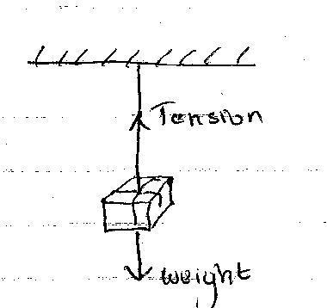
- (a)

(b) Tension = Weight = mg
= 90 x 10
= 900N

22. When the water was poured on a dry glass slab it spread uniformly because the adhensive force was higher than cohesive force but on a waxed glass slab it formed spherical droplets because cohesive force was higher than adhesive force.

23(a) W = mg
= 70 x 10
= 700N

(b) W = mg
= 70 x 1.7
= 119N

24. g = w
m

= 30
7.5
= 4N/kg

25(a) W = mg
= 5 x 10 = 50N
= 15N 6cm
50N ?

50 x 6 = 20cm
15

(b) 6cm 15N
2.5cm ?

2.5 cm x 15N
6cm

= 6.25 N

26. Dip the lid in hot water, it will expand, then dip the bottle itself in cold water, it will
contract allowing the opening of the lid to be easy.

