NAME………………………………………………ADM.NO……………CLASS:……….

MWAKICAN JOINT EXAMINATIONS

FORM ONE PHYSICS TERM III 2019
MARKING SCHEME

INSTRUCTION TO CANDIDATE’S:
- Write your name, Admission number and class in the spaces provided above.
- This paper consists of TWO Sections; Section A and Section B.
- Answer ALL the questions in both Section A and B in the spaces provided.
- ALL working MUST be clearly shown.
- Candidates should check the question paper to ascertain that all the 9 pages are printed as indicated and that no questions are missing.
- Candidates should answer the questions in English.

Where necessary, take:
g = 10N/kg
Density of water = 1000kg/m³

For Examiners Use only

Section | Marks | Marks awarded
A | 25 Marks
B | 55 Marks
 | Total (80Marks)

Section A (25marks)
- How is physics related to the following subjects:(2mks)
- Biology
Knowledge of lenses has helped in making of microscope which assist in study of cell
- History

Carbon dating has been used to establish age of fossils in study of early patterns of life
- Explain the first aid measures for a cut(2mks)

Direct compression to the wound in case of excess bleeding. Proper dressing of wound thereafter.

- State two apparatus in the laboratory that measure volume of liquids. (2mks)
Burette, pipette, measuring cylinder, volumetric flask and graduated beaker.

- By definition, differentiate between mass and weight and state their SI units. (2mks)

Mass is quantity of matter contained in a substance; SI Units-kilogramme. Weight is pull of gravity; SI units -Newton

- State two factors that affect surface tension (2mks)
- Temperature
- Addition of Detergents or impurities

- The length of mercury thread in a thermometer at 0⁰c is 1cm while the length at 100⁰c is 6cm. what is the temperature when the length is 4cm (3mks)
Length of the temperature scale is 6cm-1cm = 5cm
Therefore 5cm =100⁰ (1mk)
(4-1) cm= ?
= 3x100/ 5 (1mk)
= 60⁰ (1mk)

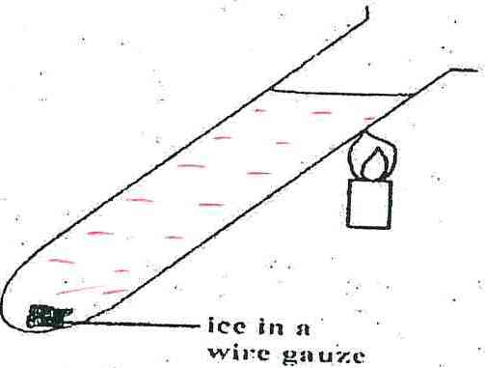
- The figure below shows an ice cube wrapped in a wire gauze and dipped in water in a test tube. The test tube is then heated at the top.Giving reason, explain what is observed.(2mks)

Water boils at the top part only (where the heat is concentrated).Heat doesn’t reach bottom of the tube where the ice cube is thus it doesn’t melt. Water is a poor conductor of heat.

- On the diagram below show how the body can be acted upon by two forces 6N and 7N to give a resultant force of 1N. (2 mks)

6N 7N

NB; accept resultant force of 1N for either sides (left or right)

- State twofactors that affect rate of heat transfer in solids.(2mks)

- Length of the conductor
- Thickness/diameter/Cross-sectional area of the rod
- Temperature difference
- Type of the material making the solid

- Draw a graph to show how volume of water varies with temperature as it raises form 0⁰cto 10⁰c(2mks)
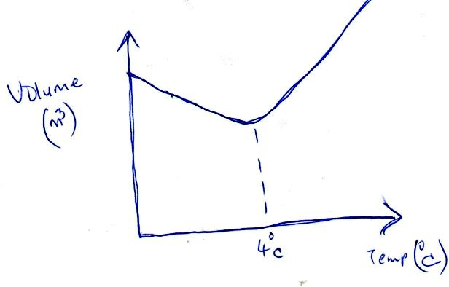

- State two effects of anomalous expansion of water (2mks)
- Freezing of lakes and ponds
- Bursting of water pipes
- Weathering of rocks
- Formation of icebergs in sea

- On heating brass-iron bimetallic strip, brass expands more than iron. Use a diagram to illustrate this (2mks)

SECTION B: 55marks
- a)What property of light is manifested by formation of shadows (1mk)

light travel on a straight line/rectilinear propagation of light
b)State two examples of luminous sources of light (2mks)
Sun, burning candle, electric light bulbs, glow worms, charcoal fire and TV screens

c) State two characteristics of image formed by a pinhole camera (2mks)
inverted/upside down and real

d)The figure shows a ray of light being reflected from a mirror.find the angle of reflection? (2mks)

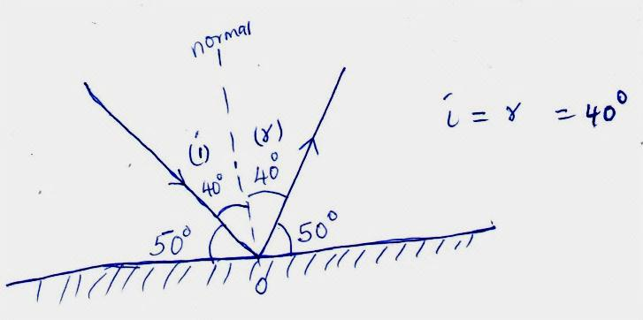

- a) Differentiate between cohesive and adhesive forces (2mks)

cohesive force exist in same kind molecules. Adhesive force exist in different kind molecules

- The figure below shows water drops on two surfaces. In a) the glass is smeared with wax and in b) the glass surface is clean. Explain the difference in the shapes of the drops. (2mks)
In a) cohesive force between water molecules is greater than adhesive force between glass and water molecules.
In b) adhesive force between glass and water molecules is greater than cohesive force between water molecules.

- a) Differentiate between conduction and convection as modes of heat transfer. (2mks)

conduction is transfer of heat through solids while convection is transfer of heat through fluids(gases/liquids)

b)In the set up below, when the flask is heated, level of water in the tube drops and bubbles are observed from the water in the trough.Explain this observation. (2mks)
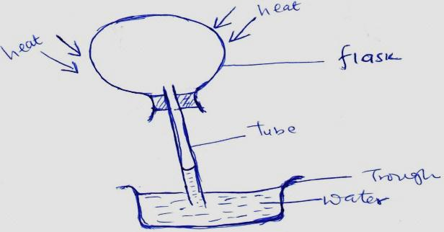
When air is warmed it expands and increase its volume. As it tries to seek for more space it’s drawn out through the tube thus a drop in level of water and formation of bubbles in water.

- Explain why houses in Mombasa which experiences hot weather should be painted in white colors while those in Limuru which experiences cold weather should be painted in dull colors. (2mks)
White colors reflect away radiant heat(reduce too much heat in house) whereas dull colours are good absorbers of radiant heat(maintain stable temperature in the house)
- The figure below shows a vacuum flask
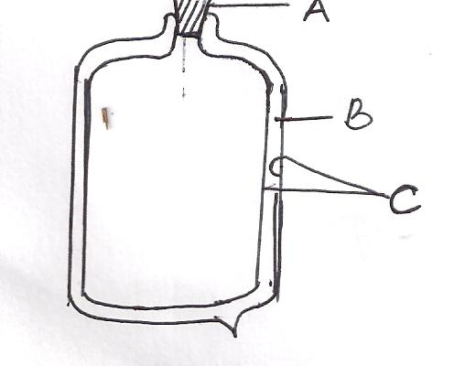

    - Name the parts labeled (3mks)
- _cork stopper____________________________
- _____vacuum________________________
- ______double silvered wall_______________________
b) Explain how the parts A, B and C minimize heat loss from the flask. (3mks)
cork stopper- minimize heat loss through evaporation
vacuum-minimize heat loss through conduction and convection
double silvered wall-minimize heat loss through radiations

- a)Using kinetic theory of matter, state any three differences between solids and liquids (3mks)
solids have particles fixed at a single point-liquid particles are always in motion unless constrained
solid particles have small intermolecular distances between them-liquids have larger intermolecular distance
solid particles have strong intermolecular forces of attraction_ liquids have weak forces between their particles

b) A girl weighs 400 N on the surface of the earth and 240N on the surface of the moon. If the gravitational field strength on earth is 10N/kg. Determine:
    - The mass of the girl (2mks)
W=mg 400= m x 10
Mass=400/10 = 40 Kg

    - The gravitational field strength on the surface of the moon (2mks)

g on moon = 240/40 =6N/kg

- a) What is diffusion? (1mk)

movement of molecules from region of high concentration to region of low concentration.

b).Figure below shows a smoke cell being used to study Brownian motion. Use the diagram to answer the questions that follow.

State the purpose of the following: (3mks)
- Lamp
Supply light to the smoke cell

- Smoke particles
show movement of invisible air molecules
- Microscope
Magnify or enlarge the smoke particles

c).State and explain what is observed in the smoke cell (2mks)

random motion- smoke particles collide with invisible air molecules

d).State what is observed when temperatures in the smoke cell are raised (1mk)

smoke particles move at a higher speed/ collision increases

- a) Define the term atmospheric pressure (1mk)

pressure due to the weight of the column of air above the earth

b) high-heeled shoes make deeper marks on soft ground than flat shoes. Explain. (2mks)

high heeled shoes exerts much pressure on soft ground due to smaller area in contact with ground. Flat shoes exert less pressure on the ground thus make less marks.

c) The figure below shows the measurements of a solid of mass 40 Kg and dimensions 2.5m by 2.0m by 1.3m as shown below

Determine:
- The weight of the solid. (1mk) 40 x 10 = 400N

- The greatest pressure it can exert on a flat surface (3mks)

Pmax = Force/ Area min (1mk)
= 400/ 2.6 (1mk)
= 153.85 N/m² (1mk)

  - Given that the density of sea water is 1.03g/cm³, what is the pressure in pascalsdue to the column of water on a body which is 20m below the surface of sea water? (3mks)
Pressure = density x gravity x column of water (1mk)
= 1030 x 20x 10 (1mk)
=206000 pascals (1mk)

  - Explain why the wall of a dam are thicker at the bottom than at the top. (2mks)
To reduce breakage of dam due to too much pressure experienced at the bottom than at the top

  - A hydraulic lift has a smaller piston of area 0.02m² and a larger piston of area 0.04m². If a force of 40N is applied on the smaller piston, what load can this force support on the larger piston (3mks)

Pressure in smaller piston = F/A = 40/0.02 = 2000N/m² (1mk)
Force on the larger piston =P x A = 2000x 0.04 (1mk)
= 800N (1mk)

- a) State the basic law of electrostatics (1mk)

like charges attract while unlike charges repel

b).State how you would manifest electrostatics by use of a plastic ruler and a sheet of paper (2mks)

cut the sheet of paper into small pieces. Rub the ruler against the head to charge it. Then bring the charged ruler close to the small pieces of paper. The pieces of paper are attracted to the ruler illustrating electrostatic charges.

