INTRODUCTION TO PHYSICS
The primary school science syllabus covers topics such as matter and its properties, energy in its various forms for example heat, light, sound and their corresponding sources, machines and the way they make work easier, balancing and weighing of various shapes of objects, electricity and magnetism. These topics and more are covered in physics.

MEANING OF PHYSICS
Physics is the study of matter and its relation to energy. Matter is anything that occupies space and has weight.

The study of physics allows one to understand and enjoy other subjects
As a subject, the study of physics involves measurement of quantities and collection of data. Through experimentation and observation, hypotheses are drawn, test and laws and principles established.

BRANCHES OF PHYSICS
Physics may be split into the following key areas;
- Mechanics
- Electricity and magnetism
- Thermodynamics
- Geometrical optics
- Waves
- Atomic physics

RELATIONSHIP BETWEEN PHYSICS AND OTHER SUBJECTS
- Physics and religion
- Physics and history
- Physics and Geography
- Physics and Home Science
- Physics and Biology
- Physics and Chemistry
- Physics and Mathematics
- Physics and Technology

A physics student will have the following opportunities in the following areas;
- Medicine
- Engineering
- Weather Forecast or studies(meteological courses)
- Construction
- Information technology
- Education
- Pharmacy
- Food Technology e.t.c

BASIC LABARATORY RULES
LABARATORY- This is a room containing facilities, apparatus and equipment that aid the investigative study of physics

BASIC LABARATORY RULES
- Proper dressing
- Note the location of electricity switches, fire-fighting equipments, First aid kit, gas supply and water supply taps.
- When in the laboratory open doors and windows to let in fresh air.
- Follow instructions given carefully.
- No eating or drinking in the laboratory.
- Turn off electrical switches, gas and water taps when not in use.
- When handling electrical apparatus hands must be dry.
- Do not plug foreign objects into electrical sockets.
- Keep floors and working surfaces dry.
- Clean and return all apparatus used in their correct location.
- All equipments should not be taken out of the laboratory.
- Wash your hands before leaving the laboratory.

MEASUREMENT (I)
Scientists from various parts of the world were giving measurements in different units and languages. This made it impossible for them to compare discoveries.
In 1960 they met in France and agreed on one Universal System of units called system international d’ unites (International system of units) SI units which assigned seven basic quantities as shown below.
 | UNIT | S.I UNIT | SYMBOL OF UNIT
1. | Length | Metres | M
2. | Mass | Kilogram | Kg
3. | Time | seconds | S
4. | Electric Current | Ampere | A
5. | Thermodynamic temperature | Kelvin | K
6. | Luminous Intensity | Candela | Cd
7. | Amount of Substance | Mole | mol

Basic Physical Quantity -This are quantities that cannot be obtained by any other quantity e.g. mass, time, length.
Derived Quantity-This are quantities obtained by multiplication or division of basic physical quantities e.g. Area, Volume, Density.

LENGTH

This is the distance between two fixed points
The S.I Unit is metre (M)

Other units of length include;
Unit | symbol | Equivalence in metres
Kilometre | Km | 1000
Hectometre | Hm | 100
Decametre | Dm | 10
Decimetre | dm | 0.1
Centimetre | Cm | 0.01
Millimetre | Mm | 0.001
Micrometre | m | 0.000001

Measurement of length
- Approximation – This includes estimating the length.
- Using a standard measure(instruments)
- Metre rules and half metre rules are used.
- They are graduated in centimetres and millimetre.
- They are made of wood, plastic or steel.

Use of a Ruler
- Put the zero (0) mark to coincide with the start of the object to be measured.
- Look perpendicular to the edge end of the measurement taken
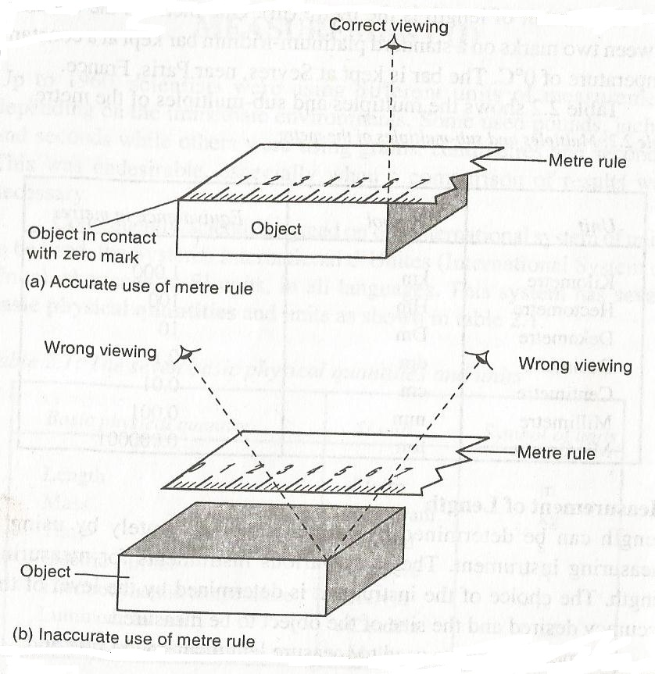

When using a ruler the following should not be done;
- Never drop a metre rule
- Never use it as a walking stick
- Never use it as a cane
- Put it at the centre of the table.
- Keep it in a dry place away from corrosive substances

Tape measure
It is graduated in millimetre (mm) or centimetre (cm)
They are three types;
- Tailor’s tape measure
- Carpenter’s tape measure
- Surveyor’s tape measure
NOTE: The choice of a tape measure depends on accuracy required and the size of object to measure.
A tape measure can be made up of cloth, steel or flexible plastic. Always ensure that the tape measure is taut when measuring.

Measurement of curved length
Curved length can be measured using a thread. The thread is placed along the required length and the length is found by placing the thread on a scale.
EXPERIMENT: Measuring the circumference of a cylinder using a thread.
APPARATUS: A cylinder, a thread and a metre rule

PROCEDURE
- Wrap a thin thread say 10 times around the cylinder
- Mark with ink the beginning and end of turns as shown
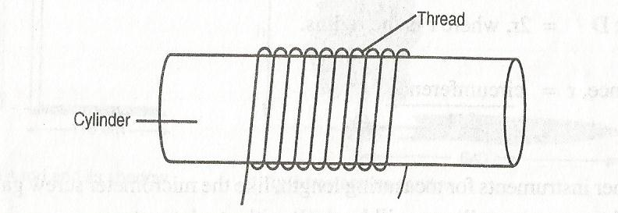
- The circumference of the cylinder will be given by;

Circumference=[length of thread]
10
Circumference=IID or 2IIr (where r is the radius of the cylinder)

Estimation of Length

EXPERIMENT: To estimate the height of a tree
APPARATUS: A metre rule, tape measure

PROCEDURE
- Measure the length of the metre rule when upright using a tape measure followed by measuring its shadow.
- Measure the shadow of the tree in the school compound.

RESULTS
Height of metre rule = ............Cm
Height of shadow of metre rule=............Cm
Height of shadow of the tree =...............Cm

Estimation of the height of the tree is given by;
Height of the tree Length of the shadow of the tree
Height of the metre rule Length of the shadow of the metre rule

AREA
Area refers to a measure of surface covered by a body.
It is measured in metre-square (m²), that means its a derived quantity.
Other multiples and sub-multiples are; cm², mm2, km2

CONVERTING
- Mm² toM²
1m²=1000*1000
= 1000000mm² (Divide by 1million)
1mm² = {1/1000000} m²

- M² to mm²
1m²1000000mm²{multiply by 1 million}

- Cm² to m²

1cm=0.01m
1cm²=0.0001m²{multiply by 0.0001}
- M² to cm²
1m=100cm
1m²=100cm*100cm
=10000cm²{multiply by 10000}

EXERCISE
- Convert 7.5m² to cm²
- Convert 940mm² to cm²
- Convert 12000mm² to m²

Measurement of area (Accurate Measurement)
Area of a regularly shaped object can be found by applying an appropriate formula e.g.
REGULAR BODY | FORMULAE
( Square) | LxL
(Rectangle) | LxW
(Circle) | IIr²
(Triangle) | ½ bh
(Cylinder) | 2IIDh
(Trapezium) | ½ (a+b)h

Approximation of area of irregular bodies

We trace their outline on the square paper of 1cm² e.g.
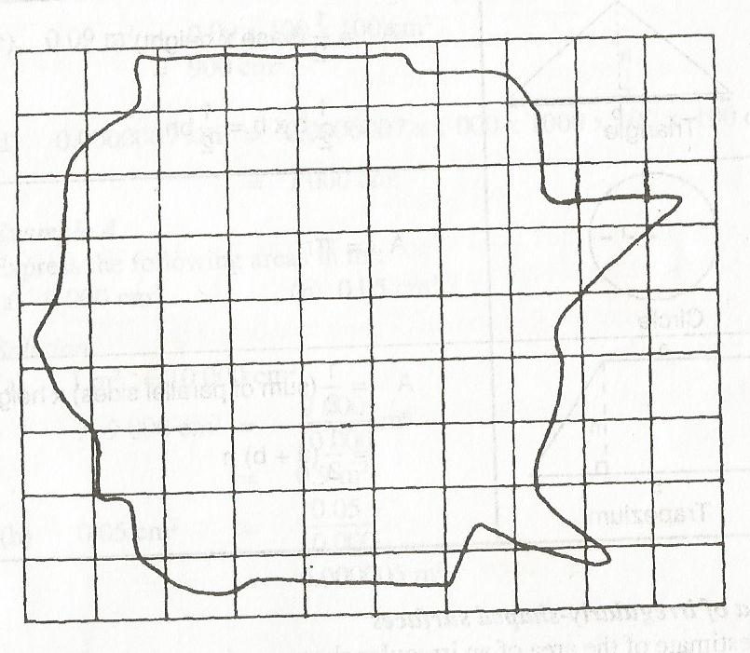
Full squares=............cm²
½ full squares=...........cm²
AREA=full square+½full squares

Assignment

VOLUME

Volume is the amount of space occupied by space
The SI unit of volume is cubic metres [M³ ].It is a derived quantity of length
Multiples and submultiples are; MM³, CM³ and KM³

CONVERTING
- From m³ to mm³
1m =1000mm
1m³=1000mm*1000mm*1000mm
=1000000000mm³

To change m³ to mm³ you multiply by 1 billion
- From mm³ to m³
To change m³ to mm³ you divide by 1 billion i.e. 1/10000000000

Example
- Express 9cm³ in m³
- Express 9000000000mm³ in m³
- Express 0.0546m³ to cm³

Measurement of volume
The volume of regularly shaped solids can be obtained by applying the appropriate formula i.e.
- Cuboids L X W X H.
- Cylinder πr²h
- Triangular prism ½bhl
- Sphere 4/3 πr³

Examples

Measurement of volume of liquids
Liquids have no definite shape but they assume the shapes of the container in which they are put.
One of the methods which can be used to measure the volume of liquids is to pour the liquids into a container with a uniform cross-section as shown,
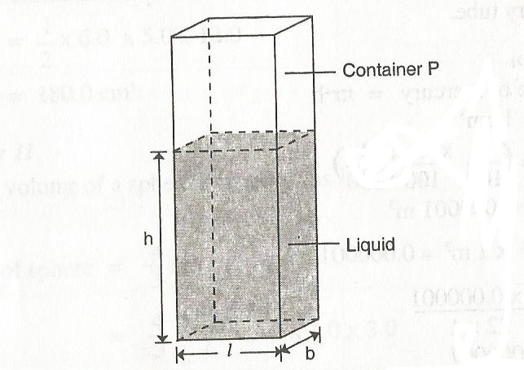

Volume=Area of cross-section x height
=Ah where A=LX b
=l b h
Instruments can also be used to measure the volume of liquids. They include; Burette, Pipette, Measuring cylinder, graduated beaker and Volumetric flask:
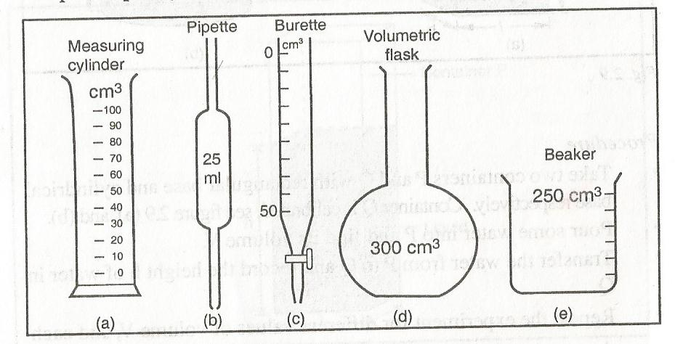
NOTE: The scale of the Burette begins from zero at the top and increases downwards to the maximum value e.g. a reading of 31.0ml on the burette means that volume of the liquid is [50-31] ml

Measurement of volume of irregular objects
- Using a measuring cylinder

PROCEDURE
- Fill the measuring cylinder with water.
- Record the volume of water as V₁₋
- ₋Submerge gently a stone [irregular object] tied around a thread.
- Record the volume of water and the stone as V_{2.}
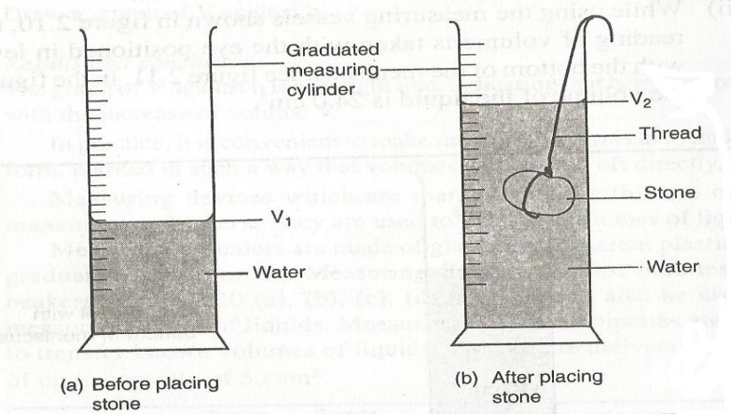
- Volume of the stone =V₂-V₁
- Using a Eureka can
A Eureka or displacement can is a container with a spout from the side.
Apparatus; Eureka can, measuring cylinder, irregular object e.g. a stone, water

Procedure
- Fill the Eureka can with water until it flows out of the spout.
- Place a measuring cylinder under the spout of the can.
- Tie the solid [irregular object] with a thread and submerge it gently inside the can.
- The result [water] collected to the measuring cylinder is the volume of the irregular object.
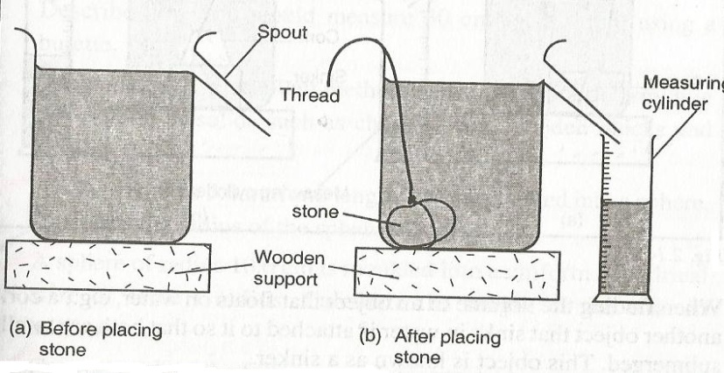

EXERCISE 2.5

MASS
Mass is a quantity of matter in a body.
Its S.I unit is kilogrammes (Kg)
It is measured using a beam balance or top pan balance.
The multiples and submultiples include;
Unit | symbol | Equivalence in Kg
Tonne | t | 1000
Gram | g | 0.001
Milligram | mg | 0.000001

The mass of an object is the same everywhere because the number of particles in an object remains constant.

Measurement of mass
There are two common types of balances for measuring mass; Electrical and mechanical types.
Electrical types are very accurate and the mass of the object is read on display (Top Pan Balance).
A Mechanical type(Beam Balance), the object whose mass to be measured is balanced against a known standard mass on an equal level.
The three balances used in measuring are;
- Top Pan Balance
- Beam balance
- Level balance
In a level balance combination of levers moves the pointer along a scale when the mass is placed on it.

EXERCISE 2.6

DENSITY
The density of a substance is defined as its mass per unit volume. Its symbol is rho( ).
The SI unit is kilogram per cubic metre (Kg/m³)

Conversion from kg/m³ to g/cm³
1g/cm³ = 1000kg/m³

EXAMPLE
A Block of glass of mass 187.5g is 5cm long, 2.0cm and 7.5cm high. Calculate the density of the glass block.

Solution
Density =$\frac{m}{v}$ =$\frac{187.5g}{5 x 2 x 7.5}$
=2.5g/cm³ or 2500kg/m³

MEASUREMENT OF DENSITY
The density of an object is calculated from the formula;
Density =mass/volume

Density of common substances
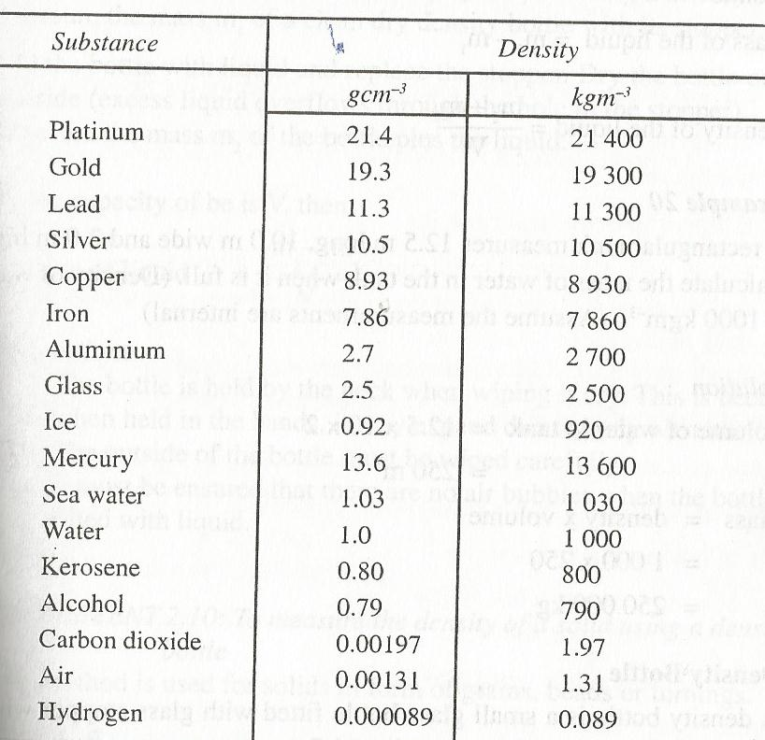

Density bottle
A Density bottle is a small glass bottle fitted with a glass stopper which has a hole through which excess liquid flows out.
Normally, the density bottle has its capacity indicated on the side.
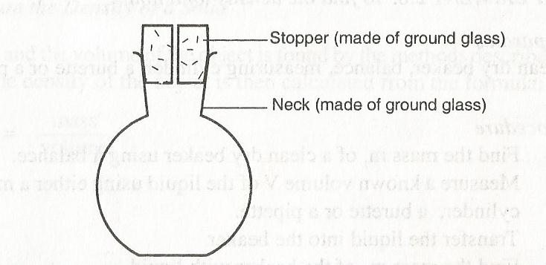
To find the density of the liquid using a density, measure the mass m₁ of a dry clean density bottle with its stopper.
Fill the bottle with liquid and replace the stopper. Dry the bottle on outside (excess liquid overflows through the hole in the stopper).
Measure the mass m₂ of the bottle plus the liquid.
If the volume of the liquid is V then;
Density =(m₂-m₁)/V

PRECAUTIONS
- The bottle is held by the neck when wiping it dry. This is because when held in hands, it may expand due to warmth from the hand.
- The outside of the bottle must be wiped carefully.
- Ensure that there are no air bubbles when the bottle is filled with liquid

To measure the density of a solid using a density bottle

This method is used for solids in form of grains, beads or turnings
Apparatus: density bottle, lead shots and beam balance.
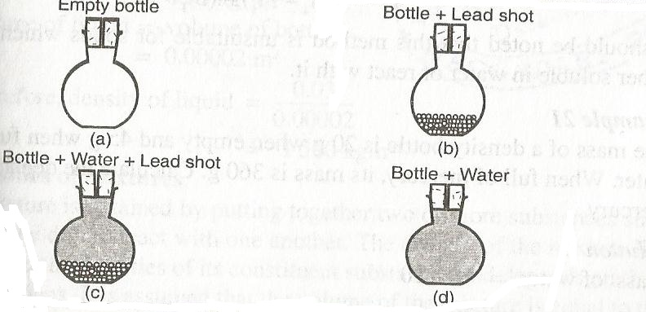

PROCEDURE
- Measure the mass m₁ of a clean dry empty density bottle.
- Fill the bottle partly with the solid (lead shots) and measure mass m₂.
- Fill up the bottle with water up to the neck and measure its mass as m₃.
- Empty the bottle and rinse it
- Fill it with water and replace it with the stopper, wipe outside dry and measure the mass m₄ of the bottle filled with water.

RESULTS

Mass of water = (m₄-m₁)g
Volume of water= (m₄-m₁) cm³ (since density of water is 1g/cm³)
Mass of lead shots (solid)=(m₂-m₁)g
Mass of water present when
The bottle is filled with lead and water = (m₃-m₂)g
Volume of water = (m₃-m₂) cm³
Volume of lead shots= (m₄-m₁)-(m₃-m₂) cm³ (since density of water is 1g/cm³)
Therefore density of lead shot= (m₂-m₁)-{(m₄-m₁)-(m₃-m₂)}

NOTE: This method is unsuitable for solids which are either soluble or react with it.

EXAMPLE
- The mass of a density bottle is 20g when empty and 45g when full of water. When full of mercury, its mass is 360g. Calculate the density of mercury.

SOLUTION

Mass of water = 45-20 =25g
Volume of water=25g/1g/cm³
=25cm³
Volume of bottle = 25cm³
Mass of mercury = 360-20 =340g
Volume of mercury= 25cm³
Density of mercury=340/25
=13.6g/cm³ or
=13600kg/m³

DENSITY OF MIXTURES
A Mixture is obtained by putting together two or more substances such that they do not react with one another.
The density of the mixture lies between the densities of its constituent substances and depends on their proportions.
Density of the mixture=mass of the mixture/volume of the mixture

EXAMPLE
100cm³ of fresh water of density 1000kg/m³ is mixed with 100cm³ of sea water of density 1030kg/m³. Calculate the density of the mixture.

Solution

Mass of fresh water= density x volume
=1g/cm³ x100cm³
=100g
Mass of sea water = 1.03 x 100

=103g
Mass of the mixture= 100+103

=203g
Volume of the mixture=100+100

=200cm³
Density of the mixture =203/200
=1.015g/cm³

Assignment

Exercise 2.7 no. 2 &3

TIME
It is a measure of duration of an event. Some ancient measuring instruments were the sundial and the hour glass
The SI unit of time is seconds (s)

Multiples and submultiples of time
Time | symbol | Equivalent in seconds
Microsecond | s | 0.000001
millisecond | ms | 0.001
Minute | min | 60
Hour | hr | 3600
Day | day | 86400
Week | wk | 604800

Measurement of time

Time is measured using either a stopwatch (digital) or stop clock
They are used depending on the accuracy required.

REVISION EXERCISE 2

FORCE

Force is a pull or a push on a body
Its SI unit is newtons (N)

Effects of force
- It can increase the speed of a moving object or make a stationary object start moving.
- Slow down or stop a moving object.
- Change the direction of a moving object.
- Distort (change) the shape of an object.
Force is that which changes a body’s state of motion or shape. Some forces are small and others are large.
Force is represented by a line with an arrow showing the direction it acts. i.e

F

TYPES OF FORCES
- Gravitational force
- Tensional
- Upthrust
- Frictional force
- Magnetic force
- Centripetal force
- Cohesive adhesive force
- Molecular force
- Electric force
- Nuclear force
- Electrostatic force

Gravitational force
Is a force of attraction between two bodies of given mass?
Objects thrown from the earth’s surface always falls back to the surface of the earth. This force which pulls the body towards the centre of the earth is called Gravitational force.
Moon and other planets also have their gravitational force to objects.
The pull of gravity on the body towards the centre is called weight. The weight of an object varies on different planets because of different gravitational pull.

Tension Force
Tension force is as a result of two opposing forces applied. The pull or compression of a string or spring at both of its ends is called Tension.
Compressed or stretched object will tend to regain its original shape ,when the stretching or compressing force is removed .Materials that can be extended without breaking are called elastic materials. Such materials can be used to make a spring balance an instrument used to measure force. Other examples include; bows and catapults.

Upthrust Force
The upward force acting on an object immersed in a fluid (liquid or gas) is called upthrust force.
An object in a vacuum will not experience upthrust.

Example
An object weighs 80N in air and 60N when immersed in water. Calculate force acting on the object.

Solution

Upthrust force = weight of object in air –weight of object in the liquid
=80-60
20N

Exercise
- An object weighs 100N in air and 26N when immersed in water. Calculate the apparent loss weight of the object. Calculate also the mass of object in water.(1Kg=10N).
- 2kg blue band weighs 20N when placed in air .The apparent loss in water is 2N .Calculate the mass of blue band in water.
Frictional Force
Frictional force is a force that opposes relative motion between two surfaces in contact.
The opposing force involving a fluid is called viscous drag (viscosity).This viscous drag limits the speed with which a body can move in a liquid.
Friction can be applied during walking.
EXPERIMENT: To investigate frictional force.

Apparatus: wooden block , rollers .

Procedure:
- Put a block of wood on a horizontal surface such as a bench as shown.
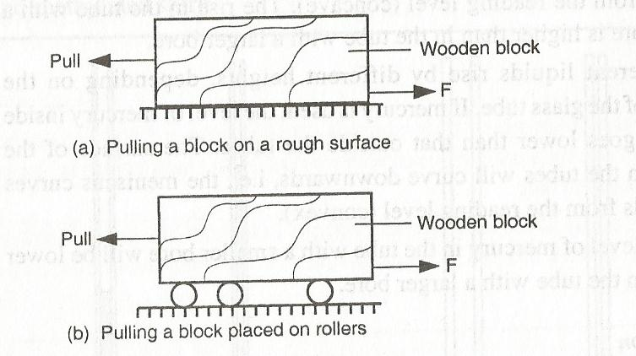
2. Pull the block gradually, increasing the force.
3. Repeat the experiment, this time resting on rollers as shown above
conclusion
The wooden block starts to move when the applied force is just greater than frictional force between the block and the surface of the bench.
Frictional force can be reduced by using rollers, oiling and smoothening.
MAGNETIC FORCE
Magnetic force is the force of attraction or repulsion between a magnetic material and a magnet.
A magnet has two types of poles, a north pole and a south pole. Like poles repel while unlike poles attract. some materials are attracted by a magnet while others are not .Those that are attracted are called magnetic materials e.g iron ,steel ,nickel and cobalt while those that are not attracted are called non-magnetic materials e.g. wood and aluminium.

COHESIVE AND ADHESIVE FORCES
The force of attraction between molecules of the same kind is known as cohesive force e.g. A water molecule and another water molecule.
The attraction between molecules of different kinds is known as adhesive force e.g. between water molecules and molecules of the container in which the liquid is put.

EXPERIMENT: To see the behaviour of water on different surfaces.
- Water wets glass
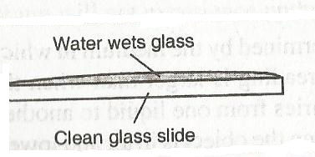

Observation

Water on the glass slide spreads
- Water forms spherical water drops on waxed surface
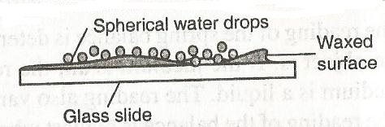

Observation

Small spherical balls was observed on a waxed glass

EXPLANATION
Water wets the glass surface because the adhesive forces between the water molecules and the glass molecules are greater than the cohesive forces between water molecules.
Water does not wet the waxed glass surface because the cohesive force is greater than the adhesive.
If mercury was used in the experiment it could be observed that small drops on a clean glass dish collect into spherical ball as shown below
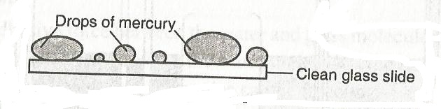
This is due stronger cohesive forces between mercury molecules which forms small spherical drops. The adhesive force between mercury and glass makes mercury not wet glass.
N/B: Mercury is poisonous and should not be handled in ordinary laboratory.
EXPERIMENT: to demonstrate cohesive and adhesive forces of liquids on narrow tubes
APPARATUS: narrow tubes of different size of bore, beaker and water

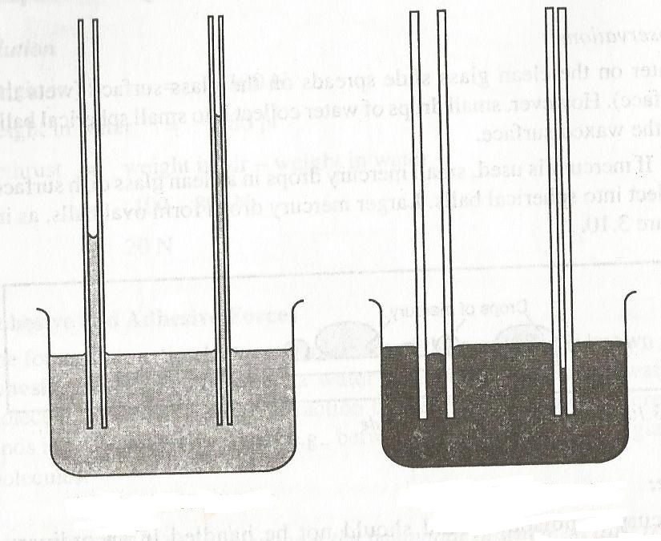
- Glass tubes dipped in water b) Glass tubes dipped in mercury

OBSERVATION
The level of the water inside the tubes is higher than outside the tubes. A meniscus is formed at the top of the water level and it curves upwards (concave).
The rise in the tube with a smaller bore is higher than in the tube with a larger bore.
Different liquids rise by different heights depending on the diameter of the glass tube.
When mercury is used, the level of mercury inside the tubes goes lower than that outside the tubes. The surface of the mercury will curve downwards (convex).

EXPLANATION
Adhesive forces between the water and glass is greater than cohesive forces between the water molecules, the water rises up the tube so that more water molecules can be in contact with the glass. This wets the glass. Liquids such as glycerol, kerosene and methylated spirit rise in tubes.
On the other hand, the force of cohesion with the mercury is greater than the force of adhesion between glass and mercury. The mercury sinks to enable mercury molecules to keep together.

SURFACE TENSION
This is a force that causes the surface of a liquid to behave like a stretched plastic skin.
The force is due to the force of attraction between individual molecules in a liquid.
Its due to this force that liquids form drops, water wets the surface but runs off others, some insects like pond skaters manage to rest on the surface of water without sinking, water rises up in narrow glass tubes but mercury is pushed down to a lower level in the same tube and steel needle or razor blade floats on water even though steel is denser than water

EXPERIMENT: to investigate the behaviour of a liquid surface
APPARATUS: Beaker, water, soup solution, razor blade or steel needle.

PROCEDURE:
- Fill the beaker with clean water to the brim as shown
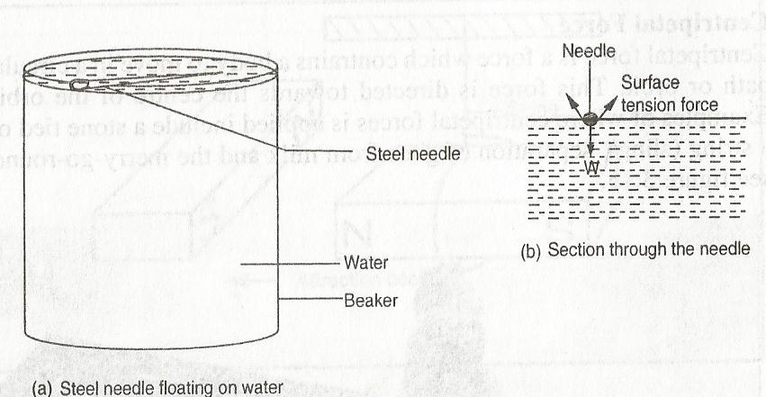
- Place a dry steel needle or razor blade at the edge of the beaker and carefully introduce it on the surface of water. Take care not to break the surface of water. Observe what happens.
- Put a few drops of soap solution and observe what happens.
- Depress the tip of the needle into the water and observe what happens.

OBSERVATIONS
- The razor blade/needle floats on the surface of water and remains resting so long as the water surface is not broken.
- When drops of soap solution are put on the surface of the water around the razor blade/steel needle, the razor blade/steel needle sinks after a few minutes.
- Depressing the razor blade highly allows it to sink very quickly

EXPLANATION
- The razor blade/needle floats because the surface of water behaves like a fully stretched, thin, elastic skin. The force which causes the surface of a liquid to behave like a stretched skin is called surface tension. This force is due to the force of attraction individual molecules of the liquid. (cohesive force)
- The needle or blade sinks when drops of soap solution are put near the razor/needle because the soap solution reduces surface tension of the water.
- When the tip of the needle or razor is depressed into the liquid, it pierces the surface skin and sinks.

MOLECULAR EXPLANATION OF SURFACE TENSION

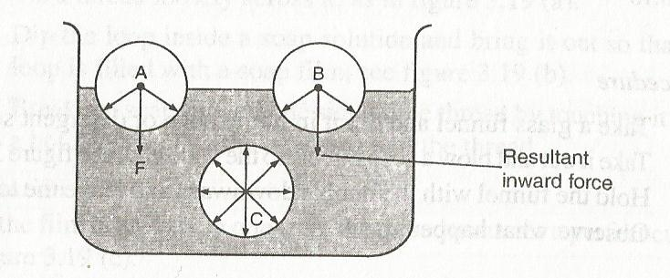
A Molecule say C deep in the liquid is surrounded by molecules on all sides so that the net force in it is zero. However, molecules of the surface, say A and B will have fewer molecules on the vapour side and hence it will experience a resultant inward force causing the surface of the liquid to be in tension.

Factors Affecting Surface Tension
- Impurities – impurities reduces surface tension of a liquid. Detergents weaken the cohesive forces between the liquid molecules.
- Temperature – Increasing the temperature of a liquid increases kinetic theory of molecules. The inter-molecular distance increases and the force of cohesion is decreased hence surface tension is lowered..

Consequences/Effects of surface tension
- Water insects can rest on the surface of water without breaking the surface. The insects skate across the surface at high speed.
- Mosquito larvae float on water surface. Oiling the surface using kerosene lower surface tension making larvae to sink.

ASSIGNMENT (make notes)
- To Study the behaviour of soap bubbles
- To study the behaviour of soap film
- To examine the appearance of water drops coming out of a tube

ELECTROSTATIC FORCE
This is a type of force which causes attraction or repulsion between charges. Charges can be positive or negative.

Like charges repel and unlike charges attract

EXAMPLES
- A plastic pen or ruler rubbed on a dry hair or fur picks up small pieces of paper lying on a table when it’s brought near them. (Charges are created on the pen and attract the pieces of paper). The same pen or ruler attracts a stream of water from a tap. The rubbing creates static charges
- When a glass window is wiped with a dry cloth on a dry day, dust particles are attracted on it.
- When shoes are brushed, they tend to attract dust particles.
Question: Explain why when you remove cloth at night you observe sparks

ELECTRIC FORCE
It’s a force which acts on two conductors carrying electricity.

ACTION AND REACTION
They are two equal forces but acting in opposite to each other.
When a block of wood is placed on a table, its weight acts on a table (action). It is pressed on the surface downwards. The reaction (opposite force) of the table acts on the block.
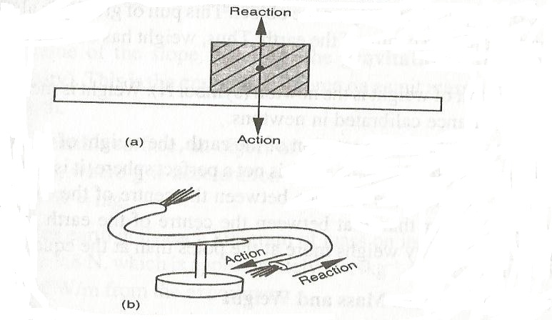
When one force acts on a body, an equal and opposite force acts on one another.

EXERCISE
Work to be done | Type of force
Separate a mixture of iron filings and sand | Magnetic force
Fire a gun | Action and reaction
Cause tide in sea or ocean
Absorb shock in vehicles | Electrostatics
Swim
Water rising a narrow tube | Cohesive and adhesive
Toy boat on water surface | Surface tension

MASS AND WEIGHT
Mass is the quantity of matter in an object while weight is a measure of the pull of gravity on an object. The S.I unit of mass is kg (kilogram) and of weight is Newton (N).
Mass of an object is a scalar quantity while weight is a vector quantity (since weight is a pull of gravity directed to the centre of the earth).
Due to the shape and rotation of the earth, the weight of an object varies from place to place while mass is constant (does not change).
A body weighs more at the poles than at the equator.

Differences between mass and weight
Mass | Weight
1. Its a quantity of matter on a body. | 1.It is a pull of gravity on a body .
2. It’s measured in kg. | 2. It is measured in (N)
3. Same everywhere . | 3. Varies from one place to another.
4. Measured using a beam balance. | 4.Measured using a spring balance
5.Has magnitude only (scalar quantity) | 5.Has both magnitude and direction.(vector quantity)
Relationship between mass and weight
Weight =Mass x gravitational
W=mg

Example
- Find the weight of an object whose mass is 50 kg.
W=mg
50 x10 =500 N
- Find the mass of an object whose weight is 900N
W =mg
900/10=10/10M
M=90kg
- An astronaut weighs 900N on earth .On the moon, he weighs 150 N .Calculate the moon’s gravitational strength. (g=10N/Kg)

M=w/g
=900/10
=90kg
On moon, w=mg
g=w/m
=150/90
=1.67N/Kg
EX. 3.2(NOs. 1, 2, 4)

MEASURING FORCE
Force is measured using an instrument called a spring balance.
The extension of a spring can be used to measure an applied force. The larger the force, the more the spring extends.
A spring balance measures forces and should therefore calibrated in newtons. Some spring balances are calibrated in kilograms. In such cases, one is advised to convert from kilograms to newtons. (1Kg=10N)

EXAMPLE
- The length of a spring is 16.0cm. Its length becomes 20.0cm when supporting a weight of 5.0N. calculate the length the length of the spring when supporting a weight of; a)2.5N b)6.0N c)200N

Solution
a)5N - 4cm b) 5N - 4cm c)5N = 4cm
2.5N- ? 6N - ? 200N =?
(2.5 x 4)/5=2cm (6 x 4)/5 =4.8cm (200 x 4)/5= 160
2+16=18cm 4.8+16 = 20.8cm 160+16 =176cm
Note; In c) extension is too large and spring may straighten out.
- A spring stretches by 8.0mm when supporting a load of 2.0N.(i) By how much will it stretch when supporting a load of 6.0N. (ii) What load would make the spring extend by 2.5cm.
i) 8.0mm -2.0N ii) 8.0mm -2.0N
?-5.0N 25mm=?
(5 x 8)/2 =20mm (25 x2)/8 = 6.25N

Exercise 3.3 no.2

SCALAR AND VECTOR QUANTITIES
A SCALAR QUANTITY – is a quantity which has magnitude (size) only. It can be specified by a number and unit. Examples include; mass, area, density, volume, energy, time, pressure, temperature, and length.

Scalar quantities are added by the normal rules of arithmetic e.g. 3cm²+4cm²=7cm²
A VECTOR QUANTITY – is a quantity which has direction and magnitude (size). It can be specified by a number, unit and direction. Examples include; weight, force, velocity, displacement, acceleration, momentum and magnetic field strength.
A vector quantity is represented on a diagram by a straight line with an arrow i.e 10N or

2N
The sum of two or more vectors is the resultant vector. Parallel forces can be added arithmetically which act on an object.

Examples of addition of parallel forces on a body

NOTE; Forces acting in opposite directions, the resultant is their difference.
To specify resultant force, both magnitude and direction are given

EXERCISE 3

PRESSURE
Pressure is the force acting normally (perpendicularly) per unit area.
The SI unit of pressure is N/M² or Nm⁻², which is also called pascal (Pa).
Pressure in solids depends on two main factors i.e. force and area

Example
A force of 100N is applied to an area 100mm². What is the pressure exerted on the area in Nm⁻².

Solution

Area; 100mm² = 0.0000001m² and Force = 100N
Pressure =F/A =100/0.0000001 = 1.0 x 10⁹Nm⁻²

Maximum and minimum pressure

Maximum pressure = Force/minimum area
P_{max} = F/A_{min}

Minimum pressure = Force/maximum area
P_{min} = F/A_{max}.

Example
A block of wood measures 2cm by 3cm by 4cm and has a mass of 6 kg. Calculate its pressure when; a) Area is minimum (maximum pressure) b) Area is maximum (minimum pressure).
Area -2 x 3 =6cm2
-2 x 4 =8cm2
-3 x 4 =12cm2

- A _{min} =6cm² =0.006m² and F =60N
P _{max} =60/0.006 =100,000Nm⁻²
- A _{max} =12cm²=0.0012m² and f = 60 N
P_{min} = 60/0.0012 =50,000Nm⁻²

Exercise
- A block of wood measures 3m by 6m by 2m and mass 3kg. Calculate;
- Maximum pressure
- Minimum pressure
- A brick 20cm by 10cm by 5cm has a mass of 500g. Find maximum and minimum pressure. (take g = 10N/kg)
- How much force must be applied on a blade of length 4cm and thickness 0.1mm to exert pressure of 5,000,000 Pa.

Exercise 4.1 (no 1, 2, 3, 4, 5)

PRESSURE IN LIQUIDS
Pressure in liquids depends on the following;
- Depth of the liquid
- Density of the liquid
Pressure in liquids increases with depth and density.

EXPERIMENT: To show variation of pressure in liquids

APPARATUS: A tall tin, nail and water

PROCEDURE
- Using the nail, make 3 holes A,B,C of the same diameter on a vertical line of one side of the tin
- Fill the tin with water as shown below.
- Observe water jets from the holes A,B,C.
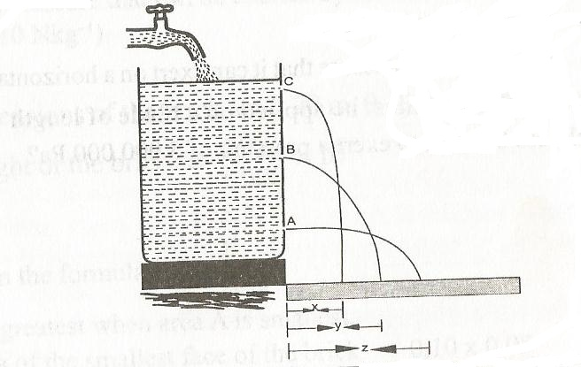

OBSERVATION

The lower hole, A, throws water farthest, followed by B and lastly by c

EXPLANATION
the pressure of water at A is greatest than pressure at B and pressure at B is greater than pressure at C. Hence , pressure increases with depth.

QUESTION

Explain why a diver at the bottom of the dam experiences greatest pressure
At the bottom of the dam depth is greatest and therefore the diver experiences greatest pressure due to the weight above him.

LIQUID LEVELS
When a liquid is poured into a set of connected tubes with different shapes, it flows until the level are the same in all tubes as shown
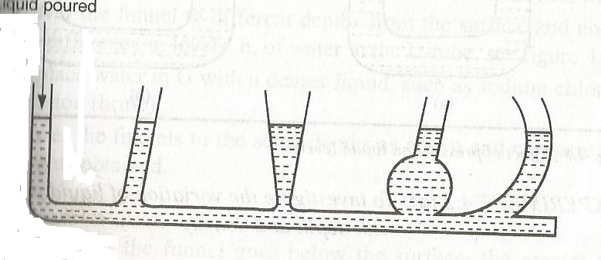
This shows that the liquid flows to find its own level.

LIQUID LEVELS IN A U-TUBE
When water is poured into a u-tube, it will flow into other arm. Water will settle in the tube with the levels on both arms being the same.
When one arm is blown into with the mouth, the level moves downwards, while on the other arm it rises. This is caused by pressure difference between the two arms as shown,
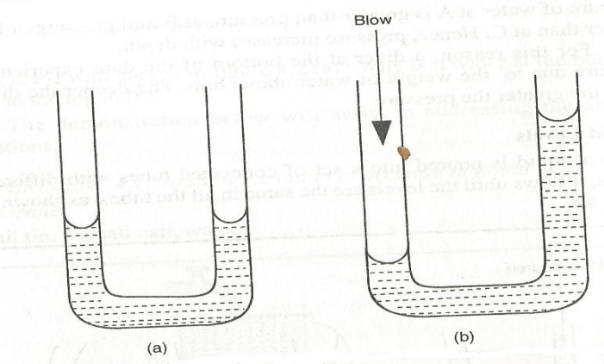

Pressure in liquids increases with depth below its surface
Pressure in a liquid at a particular depth is same in all directions.
Pressure in a liquid increases with density of the liquid.

FLUID PRESSURE FORMULA

Consider a container containing a liquid as shown below;
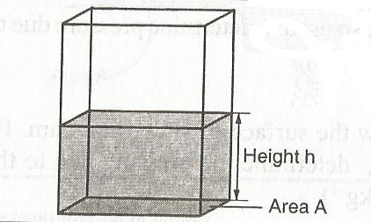
If A is the cross-section area of the column, h the height of the column and e the density of the liquid then;

Volume of the liquid=cross-section area x density
=Ah

Mass of the liquid = volume of the liquid x density
=Ahe

Therefore, Weight of the liquid = mass x gravitational force
=Aheg

From definition of pressure = force/area
Pressure=Aheg / A

=ehg
From the formula (p=ehg) pressure is directly proportional to;
- Height of the column
- The density of the liquid
NOTE: Pressure in liquids does not depend on the cross-section area of the container.

The formula is also used to determine pressure due to a gas column.

EXAMPLE
- A diver is 10m below the surface of water in a dam. If the density of water is 1000kg/m³. Determine the pressure due to the water on the diver. (take g=10N/Kg)

Pressure = heg = (10 x 1000 x 10) = 100,000 N/m²
- The density of mercury is 13600Kg/m³. Determine the liquid pressure at a point 76cm below mercury level.

Pressure =heg =0.76 x 13600 x 10 = 103,360 N/m²
- Calculate the pressure due to water experienced by a diver working 15m below the surface. (take g = 10N/kg and density of sea water = 1.03 g/cm³)

TRANSMISSION OF PRESSURE IN LIQUIDS
Pressure applied at one part in a liquid is transmitted equally to all other parts of the enclosed liquid. (Plunger).
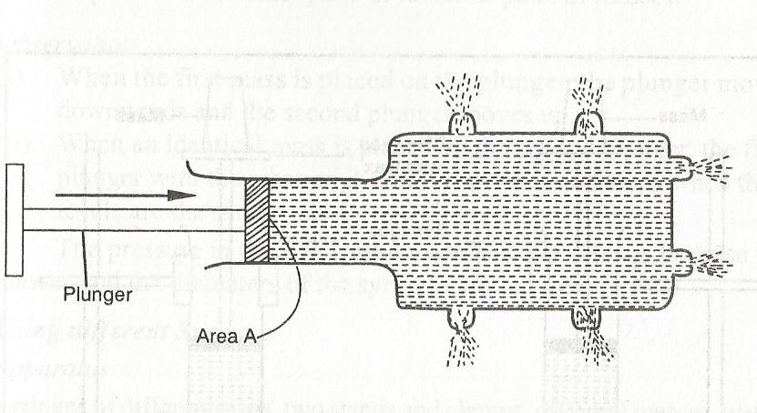
This is the principle of transmission of pressure in liquids called Pascal’s principle which states that pressure applied at a given point of the liquid is transmitted uniformly or equally to all other parts of the enclosed liquid or gas.
Gases may transmit pressure in a similar way when they are confined and incompressible.

HYDRAULIC MACHINES
The principle of transmission of pressure in liquids is made use in hydraulic machines where a small force applied at one point of a liquid produces a much larger force at some other point of the liquid.
- HYDRAULIC LIFT
The hydraulic lift consists of a small piston S of cross-section A₁ and a large piston L of cross-section area A₂. When a force is applied on piston S, the pressure exerted by the force is transmitted throughout the liquid to piston L.
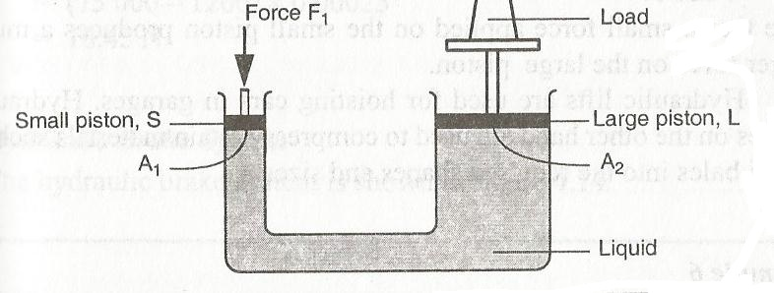
At the smaller piston S the force applied F₁ cause a pressure P₁ at the cross-section area A_{1.}

Therefore P₁=F₁/A₁
The pressure is equally transmitted throughout the liquid to the larger piston. Thus at small piston pressure is equal to the pressure at the large piston

F₂=P₁ x A₂

But P₁=F₁/A₁
F₂=F₁/A₁x A₂
F₂/F₁=A₂/A₁

NOTE; Equation applies if pistons are at the same level

EXAMPLE 1

Find F₂ if A₁ = 0.52m², A2 = 10m² and F₁= 100N

F₂/100=10/0.25

F₂= (100 x 10)/0.25
=4000N

EXAMPLE 2

Determine f₂ in the figure below. Density of the liquid =800kg/m³ and g=10N/kg
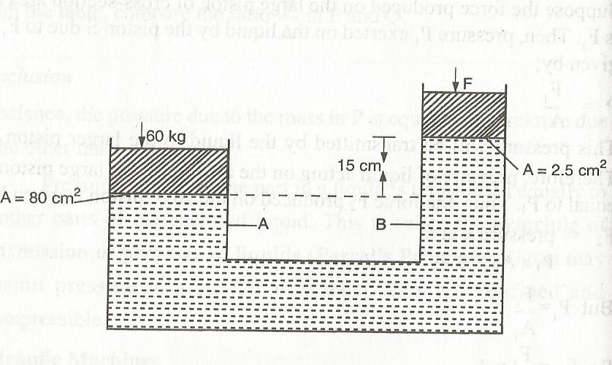

P_{A} = P_{B}
(60 x 10)/0.008 = (F₂/0.00025)+ (0.15 x 800 x 10)
0.00025(7500 -1200) = F₂
F₂=18.45N

Exercise 4.2 no.7

HYDRAULIC BRAKE SYSTEM
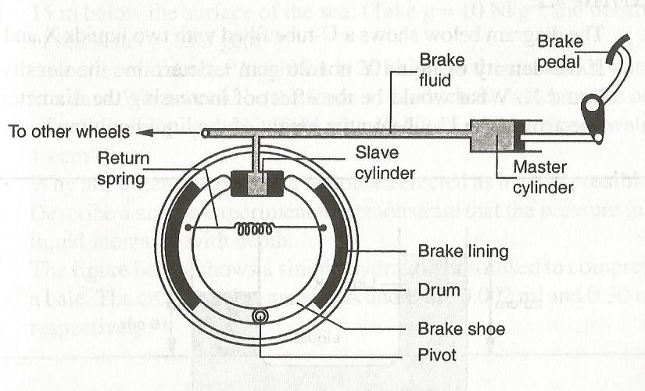
The force applied on the foot pedal exerts pressure on the master cylinder. The pressure is transmitted by the brake fluid to the slave cylinder. This causes the pistons of the slave cylinder to open the brake shoe and hence the brake lining presses the drum. The rotation of the wheel is thus resisted. When the force on the foot pedal is withdrawn the return spring pulls back the brake shoe which then pushes the slave cylinder piston back.
Advantage of this system is that the pressure exerted in master cylinder is transmitted equally to all four wheel cylinders.
The liquid to be used as a brake fluid should have the following properties;
- Be compressible, to ensure that pressure exerted at one point is transmitted equally to all other parts in the liquid
- Have low freezing point and high boiling point.
- Should not corrode the parts of the brake system.

ASSIGNMENT (exercise 4.2 nos 1,2,3,4,5,6 & 8)

ATMOSPHERIC PRESSURE
Atmosphere means the air surrounding the earth. The air is bound round the earth by the earth’s gravity.
The atmosphere thins outwards indicating the density of air decreases with the distance from the surface of the earth
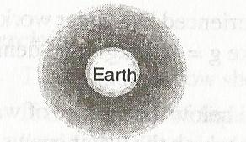
The pressure exerted on the surface of the earth by the weight of the air column is called air pressure.
Atmospheric pressure can be demonstrated by crushing can experiment.

EXPERIMENT: To demonstrate the existence of the atmospheric pressure
APPARATUS: Tin container with a tight-fitting cork, water, tripod stand, Bunsen burner.

PROCEDURE
- Remove the cork from the container and pour in some little water.
- Boil the water for several minutes.
- Replace the cork and allow the container to cool or pour cold water to cool it faster.
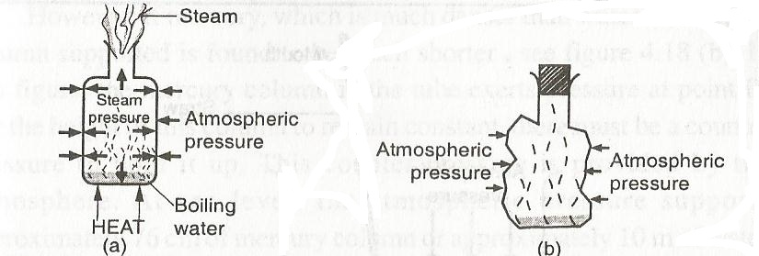

OBSERVATION

During cooling, the container crushes in.

EXPLANATION
Steam from boiling water drives out most of the air inside the container. When heating, the steam pressure inside the container balances with atmospheric pressure outside.
On cooling the steam condenses. A partial vacuum is therefore created inside the container. Since pressure inside the container is less than the atmospheric pressure outside, the container crushes in.
NOTE: Steam inside the container condenses lowering the pressure. The outside atmospheric pressure exceeds the pressure inside the container thereby crushing it.

MAXIMUM COLUMN OF LIQUID THAT CAN BE SUPPORTED BY ATMOSPHERIC PRESSURE
When water is sucked up a straw, the air inside the straw reduces. The atmospheric pressure acting on the surface is now greater than the pressure inside the straw. Water is thus pushed up the straw by atmospheric pressure.
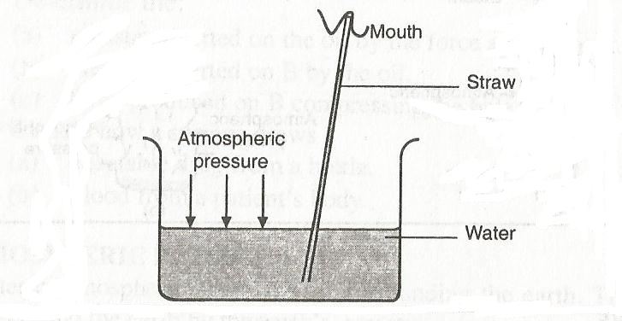
If the straw was long enough and sealed at the top, it would be possible to estimate the height of water that would be supported by atmospheric pressure
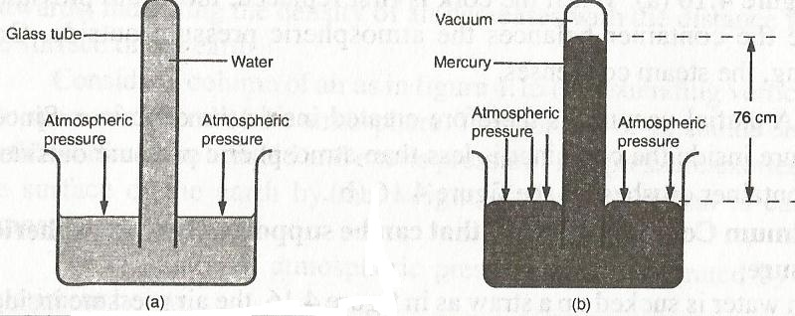

In case of water the column is too large.
At sea level the atmospheric pressure supports approximately 76cm of mercury column or approximately 10m of water column.

EXAMPLE
- A girl in a school situated in the coast (sea level) plans to make a barometer using sea-water of density 1030 kg/m³. If atmospheric pressure is 103,000 N/m², what is the minimum length of the tube that she will require?
P=heg but p is atmospheric pressure
103,000=h x 1030 x 10
H=10m
- A sea diver is 35m below the surface of sea water. If the density of the sea water is 1.03g/cm³ and g=10N/kg. Determine the total pressure on him.

P_{T} =P_{a} + heg
=103,000 + (35 x 1030 x 10)
=463,500N/m²
- The air pressure at the base of a mountain is 75cm of mercury while at the top is 60cm of mercury. Given that the average density is 1.25kg/m³ and density of mercury is 13,600kg/m³. Calculate the height of the mountain.

Pressure difference due to column of air = pressure difference due to mercury column
h_{a}e_{a}g = h_{m}e_{m}g
h_{a} = h_{m}e_{m}g/e_{a}g
h_{a}=(0.15 x 13600 x 10)/(1.25 x 10)
=1632m

EXERCISE
- The barometric height at sea level is 76cm of mercury while that at a point on a highland is 74cm of mercury. What is the altitude (height) of the point? Take g =10N/kg, density of mercury =13600kg/m³ and density of air =1.25kg/m³.

- A student in a place where the mercury barometer reads 75cm wanted to make an alcohol barometer, if alcohol has a density of 800kg/m³, what is the minimum length of the tube that could be used?

MEASUREMENT OF PRESSURE
- THE U-TUBE MANOMETER
Is an instrument used to measure fluid pressure.
It consists of a u-tube filled with water or any other suitable liquid or gas as shown
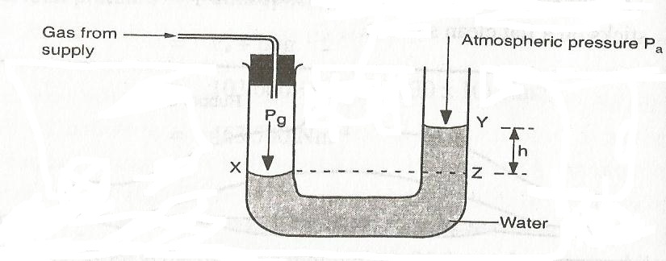
Pressure at Z = Atmospheric pressure due to column of water.
Pressure at X = pressure at Z
P_{g} = P_{g}
Pressure at Z = atmospheric pressure + pressure due to column of water
P_{g} = P_{a} + heg.
Since the density of water and gravitational force is known we can determine pressure of a gas if the atmospheric pressure is known.

EXAMPLE
Suppose h=20cm, P_{a} = 103,000N/m² and density=1000kg/m³, determine the total pressure (P_{g})
P_{g} =103,000 + (0.2 x 1000 x 10)
=105,000N/m²

- SIMPLE MERCURY BAROMETER
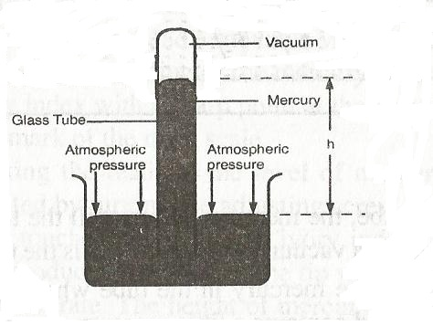
At sea level atmospheric pressure supports approximately 76cm of mercury column or 10m of water column.
This difference in height column between mercury and water is that mercury is much denser than water.
Mercury column forms a simple barometer, its height changing inside on the glass tube as air pressure outside changes.
The space above mercury in the barometer tube must contain air or water vapour since the barometer reading will be as shown above.

The space above in mercury in the tube when upright is called toricellian vacuum

The height h of the column is a measure of the atmospheric pressure.

At sea level, h=76cm since density of mercury = 13600kg/m³.

P_{a} = heg

=0.76 x 13600 x 10
= 103,360N/m² (it is also referred as one atmosphere 1 atm)
- FORTIN BAROMETER.
Is an improved version of a simple mercury barometer. Was designed by FORTIN
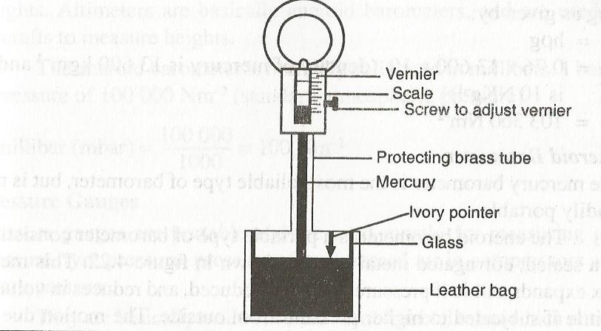
The ivory pointer acts as the zero mark of the main scale. The leather bag acts as reservoir of mercury height.
Before taking the reading, the level of mercury surface in the reservoir is adjusted by turning the adjusting screw until the surface of mercury just touches the tip of the ivory index.
The height is the read from the main scale and vernier scale.
The reading obtained from the barometer are in terms of the height of mercury column and written as mmHg or cmHg.
For example at sea level h=760mmHg and density of mercury=13600kg/m³

P_{a} =heg =0.76 x 13600 x 10
=103,360Nm⁻²
- ANEROID BAROMETER
Is a portable type of barometer consisting of a sealed, corrugated metal box as shown below
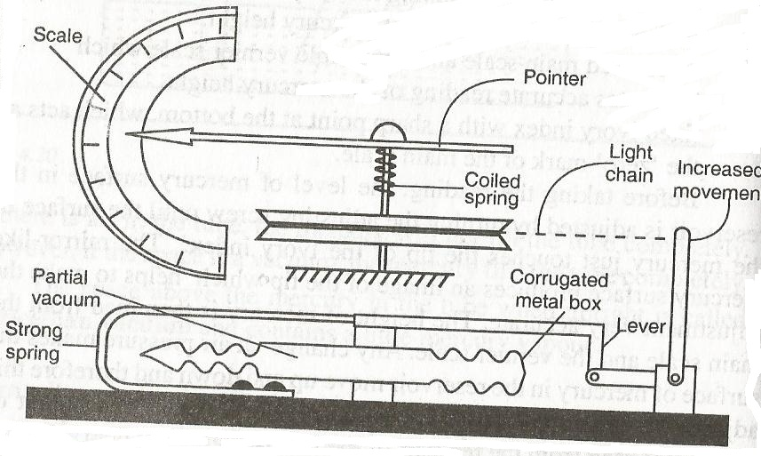
The pointer would indicate a particular value of atmospheric pressure of the surrounding so that any changes in pressure would be noticeable by movement of the pointer to either side of this atmospheric value on the scale.
The aneroid barometer movement makes it adaptable to measure heights. Aneroid barometers (Altimeters) are used in aircrafts to measure heights.

Its normally calibrated in millibars. 1 bar=100,000Nm⁻²
1millibar (mbar)=100Nm⁻²
- PRESSURE GAUGES
They are portable and are used mostly for measuring gas pressure, tyre pressure, pressure of compressed air compressors and steam pressure
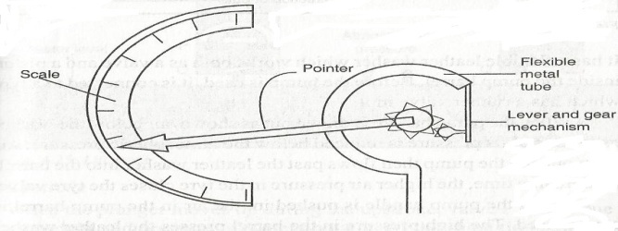
It is made of coiled flexible metal tubes which uncoil when the pressure inside increases. The movement of the tube is made to drive a pointer across a scale, through a combined system of levers and gears.

EXAMPLE
The pressure of a car tyre, measured with a pressure gauge is 40Ncm⁻². What is the total pressure of the tyre in Nm⁻².

P_{Total} =p_{a} +gauge pressure
=103,360 + (40 x 10,000)
=503,360Nm⁻²

APPLICATION OF PRESSURE IN LIQUIDS AND GASES
- The Bicycle Pump
A bicycle pump is a simple form of compression pump.
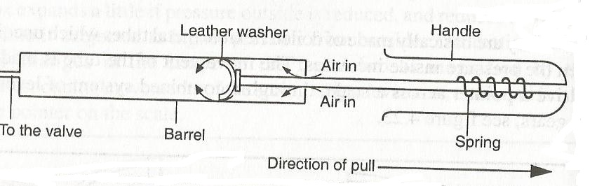
The pump is connected to a tyre which has a rubber valve in it. When the pump handle is drawn out air below the washer expands and its pressure is reduced below the atmospheric pressure.
Air from outside the pump the flows past the leather washer into the barrel. The higher air pressure in the tyre closes the tyre valve.
When the pump handle is pushed in, the air in the pump barrel is compressed. The high pressure in the barrel presses the leather washer against the sides of the barrel. When the pressure of the compressed air becomes greater than that of air in the tyre, air is forced into the tyre through the tyre valve which now opens.
NOTE: There is an increase in temperature of the pump barrel during pumping because work is done during compressing the air.

- THE LIFT PUMP
It is used to raise water from wells. It consists of a cylindrical metal barrel with a side tube. It has two valves P & Q.
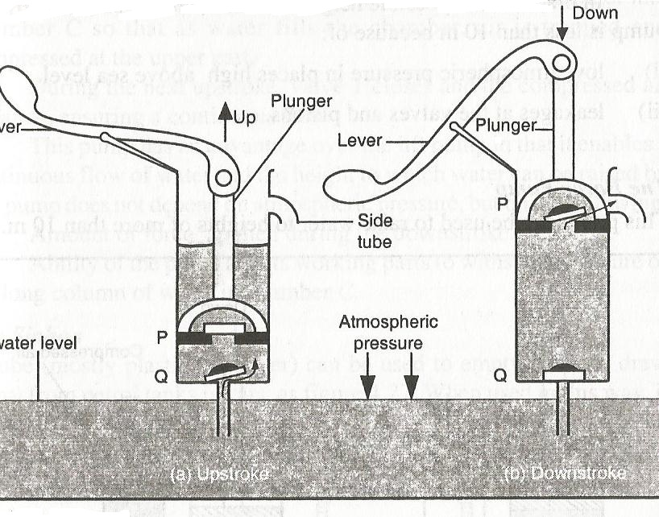

UPSTROKE
When the plunger moves during upstroke, valve P closes due to weight and pressure of water above it. At the same time, air above valve Q expands and the pressure reduces below atmospheric pressure.
The atmospheric pressure on the water surface in the well below this pushes water up past valve Q into the barrel.
The plunger is moved up and down until the space between P and Q is filled with water.

DOWNSTROKE
During down stroke valve Q closes due to its weight and pressure of water above its piston.

Limitations of Lift Pump
The atmospheric pressure support only 10m column of water, which is actually a theoretical value but practically this pump raises the water less than 10m because of;
- Low atmospheric pressure in places high above sea level.
- Leakages at the valves and pistons

FORCE PUMP

This pump can be used to raise water to heights more than 10m.
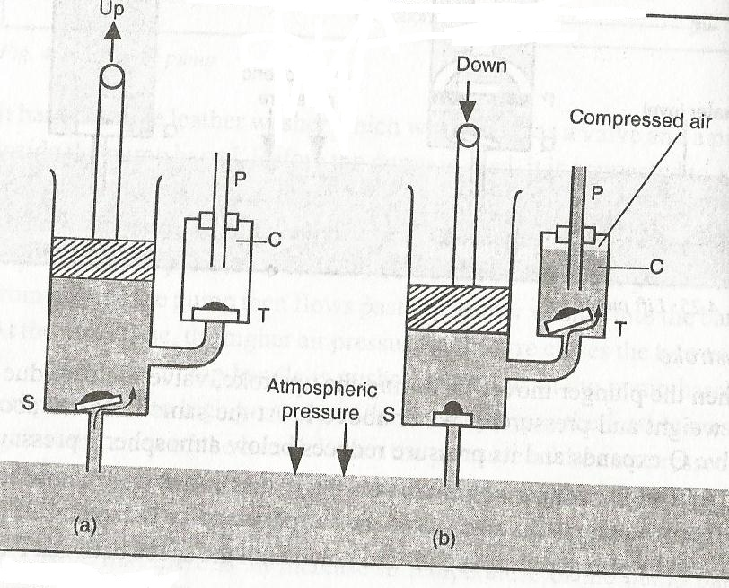

UPSTROKE
During upstroke, air above the valve S expands and its pressure reduces below atmospheric pressure. The atmospheric pressure on the water in the well below pushes water up past valve S into the barrel.
NOTE: Pressure above valve T is atmospheric hence the valve does not open.

DOWNSTROKE
During down stroke, the valve S closes. Increase in pressure in the water in the barrel opens valve T and forces water into chamber C so that as water fill the chamber air is trapped and compressed at the upper part.
During the next stroke, valve T closes and the compressed air expands ensuring continuous flow.

Advantages of a Force Pump over a Lift pump
- Force pump enables continuous flow of water.
- Height to which water can be raised does not depend on the atmospheric pressure. It depends on;
- Amount of forces applied during down stroke.
- Ability of the pump and its working parts to withstand pressure.

THE SIPHON
A tube can be used to empty tanks or draw petrol from petrol tanks in cars. When used in this way it is referred as a siphon

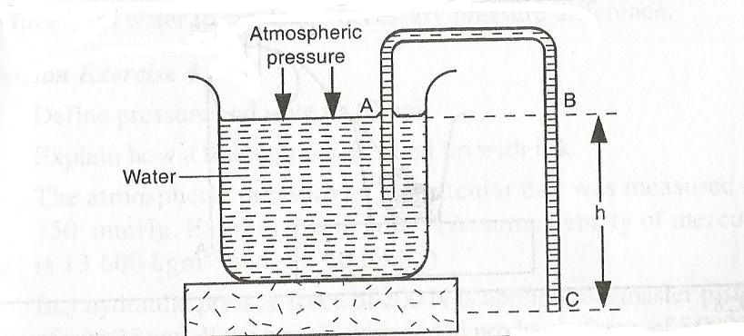
Pressure on the surface of the liquid is atmospheric pressure. Since end C of the tube is below the surface A by height h, pressure at C is greater than that at the surface.
The tube is first filled with the liquid after which it will continue to run so long as end C is below the liquid surface.
Pressure at C = p_{a} + heg. The excess pressure (heg) cause the liquid to flow out of end C
The siphon will work only if;
- End of the tube C is below the surface of A of the liquid to emptied.
- The tube is first filled with the liquid, without any bubbles in it.
- The tube does not rise above the barometric height of the liquid from the surface A of the liquid to be emptied.
- One end of the tube is inside the liquid to emptied.
NOTE: A siphon can operate in a vacuum.

REVISION QUESTIONS
- The atmospheric pressure on a particular day was measured as 750mmHg. Express this in Nm⁻². (density of mercury = 13600kg/m³ and g=10N/kg)

P=heg=0.75 x 13600 x 10
- A roof has a surface area of 20,000cm². If atmospheric pressure exerted on the roof is 100,000Nm⁻², determine the force on it. (take g = 10N/kg)

P =F/A

PARTICULATE NATURE OF MATTER
Matter is anything that occupies space and has mass. Matter commonly exists in three states i.e. solid, liquid and Gas
The process of sub-dividing matter into smaller units and smaller units continues indefinitely, suggesting that matter is not continuous, but is made up of even smaller parts e.g. A piece of paper can be cut endlessly until a stage when the small pieces cannot be cut into pieces. This suggests that the sheet of paper is made up of tiny particles
EXPERIMENT; To Demonstrate Dilution
APPARATUS: Beaker and potassium permanganate crystals
PROCEDURE
- Pour water into the beaker to half full.
- Dissolve the potassium permanganate crystals until the solution is purple.
- Transfer half of the solution to another beaker and add water
- Continue the process with other beakers, comparing the colour to each other.
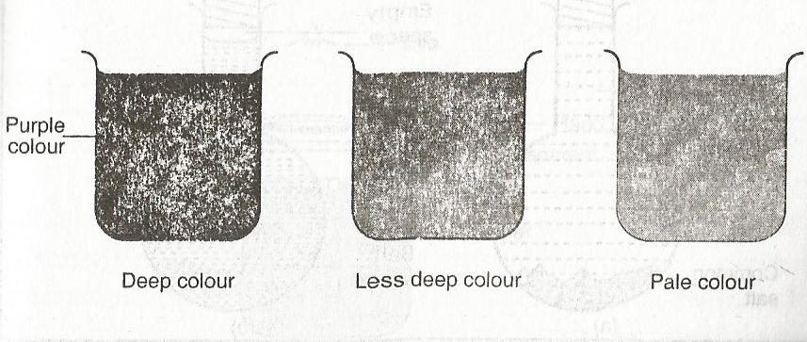
OBSERVATION
The process of dilution can continue until the solution appears colourless. This suggests that the particles of potassium permanganate are spread evenly on water.
As water particles increase, the particles of potassium permanganate are spread further, making the purple colourless and less until it appears colourless.
CONCLUSION
Potassium permanganate is made up of tiny particles.
DISSOLVING A SOLID IN A SOLVENT
- Put 100g of salt into the flask and add water carefully using a pipette without shaking the salt until it is full.
- Insert the stopper to the mouth of the flask and shake to dissolve the salt.

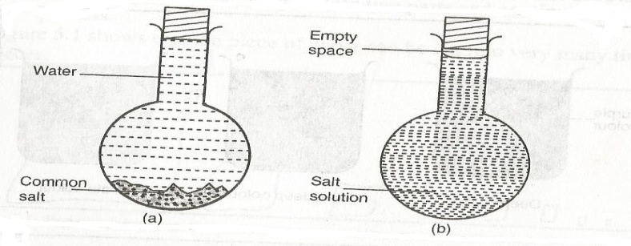
OBSERVATION
The volume of the solution of salt is less.
CONCLUSION
Particles of salt are able to occupy some spaces between the water particles. This suggests that the particles of salt differ in size.
The particles of the solution pack more closely in the available space, thus reducing the volume. This further suggests that particles of salt are broken down to fit into spaces between water particles.
BROWNIAN MOTION
This is the random movement of particles of a substance e.g. a gas or a liquid. The particles are in a constant random motion.
Brownian motion in Liquids
Experiment; To demonstrate the Brownian motion
Apparatus: Beaker, hand lens, chalk dust, transparent lid.
PROCEDURE
- Pour water into the beaker about $\frac{3}{4}$ full as shown
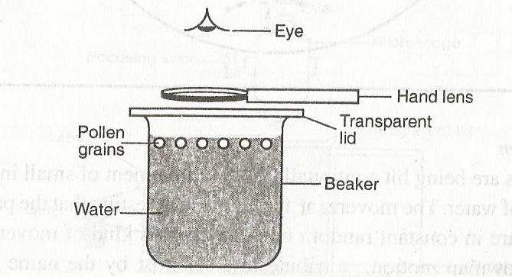
- Sprinkle pollen grains or chalk dust on the surface of water (particles should be small in size, light and sprinkled evenly).
- Cover the beaker with a transparent lid and with the help of a hand lens observes what happens to pollen grains or chalk dust.
OBSERVATION
The pollen grains or chalk dust is in constant random motion.
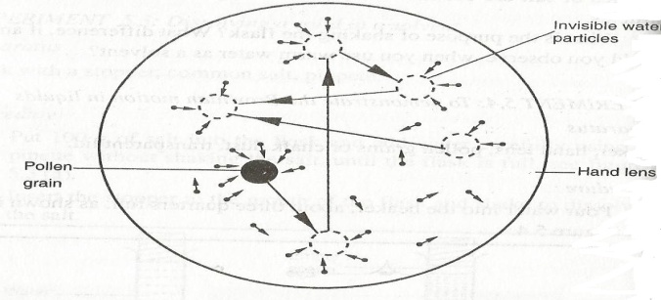
CONCLUSION
The particles are hit continually by the movement of small invisible particles of water. The movement is random, suggesting that the particles of water are in constant random movement. This kind of movement is called Brownian motion a tribute to a scientist Robert Brown who first observed the effect.
BROWNIAN MOTION IN GASES
The smoke cell experiment
Experiment: To demonstrate the Brownian motion in Air
Apparatus: Drinking straw, smoke cell, microscope and a bright light source

PROCEDURE
- Burn one end of the straw and let the smoke cell from the other end of the straw as shown above.
- Put a cover plate on top to seal the smoke and air in the cell.
- Illuminate the cell with bright light. Use a converging lens to focus the light to the smoke cell.
- Adjust the microscope until you see very bright specks against the grey background.
OBSERVATION
Bright specks are in continuous random motion are seen.
EXPLANATION
The bright specks are particles of smoke which scatter the light shining on them and appear as bright points. They move about in a continuous random movement because of uneven bombardment by the invisible particles or molecules in air. This suggests that air is made up of small particles which are in constant motion.
CONCLUSION
From the experiments above, matter is made up of very small particles which are in constant random motion. This is called kinetic theory of matter.
ARRANGEMENT OF PARTICLES IN THE STATES OF MATTER
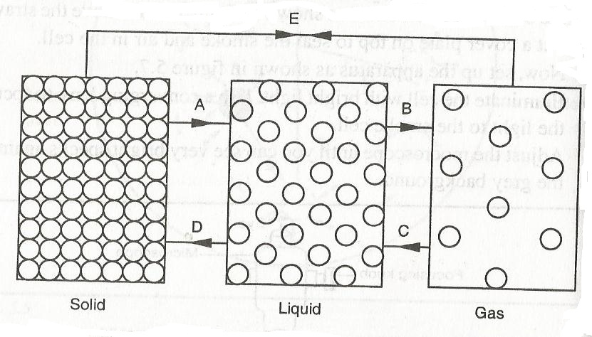
Solid
- The particles of solids are closely packed together in an organised way.
- The closely knit structure is due strong attractive forces (cohesive forces) between the particles.
- In their fixed positions, they vibrate to and from so that increasing the temperature of the solid increases this vibratory motion.
- At a certain temperature the solid breaks away from this knit structure and the solid is said to have melted.
LIQUIDS
- The particles are further apart. They are not fixed as in solids but move about in Brownian motion.
- Liquids can break a solute put in it. Its easier to dissolve a solute in hot water because the particles have increased energy.
- The cohesive forces between the particles in liquids are weaker compared to those in solids. Due to this liquids can flow and take up the shape of the container in which they are put.
- When a liquid is heated molecules gain kinetic energy, they vibrate about and expand. The space between them widens further apart and the liquid changes into gaseous state by a process called vaporization.
GASES
- The particles are further apart and have increased random motion compared to those in the liquid state.
- The cohesive force between the particles is extremely small and as the particles move they collide with each other and with the walls of the container in which they are trapped. This produces gas pressure.
- Gases are easier to compress indicates that there exists a large intermolecular distance in gas than in liquids. Gas molecules or particles can lose some of their energy and fall back into the liquid state by a process known as condensation.
NOTE: Solids which when heated change directly into gas undergo the process called sublimation.
DIFFUSION
- This is the process by which particles spread from regions of high concentration to those of low concentration. Diffusion takes place in solids, liquids and gases.
- In solids, diffusion is exceedingly slow but occurs when two metals are placed in contact with each other e.g. lead and gold, metal block vibrating atoms breaks away from the substances to which they belong and enter the other substance to be trapped by its attractive forces. This process is speeded up by high temperature.
- Diffusion in liquids occurs at a faster rate than in solids.
- Diffusion in gases is faster due to their low density, high kinetic energy and weak cohesive forces.
DIFFUSION IN LIQUIDS
To investigate diffusion in liquids
Apparatus: Funnel, beaker, copper (II) sulphate solution.
PROCEDURE
- Pour water into the beaker until it is half full.
- Pour saturated copper (II) sulphate solution down the funnel slowly and notice how the two liquids settle.
- Remove the funnel carefully so that the liquids are not disturbed.
- Repeat the same steps for another set of apparatus but using warm liquids. Make observation.
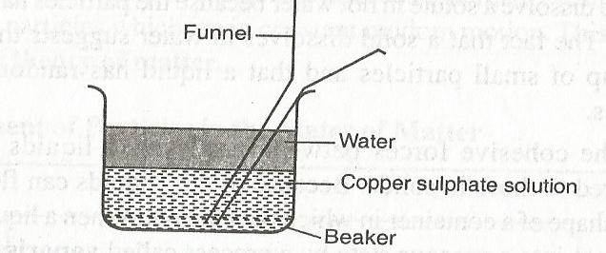
OBSERVATION AND EXPLANATION
- Initially, the water layer floats on top of the saturated copper (II) sulphate because it is less dense. After sometime, the boundary disappears and the liquids form a homogeneous pale blue mixture.
- Formation of the mixture is faster with hot liquids than because the movement of particles is faster due to increased energy. There is greater movement of water particles (molecules) from the water layer into copper (II) sulphate layer because it has greater concentration of water molecules than copper (II) sulphate particles.
- Similarly, there is a greater movement of particles from copper (II) sulphate layer into the water layer because of greater concentration of copper (II) sulphate particles than water molecules.
DIFFUSION IN GASES
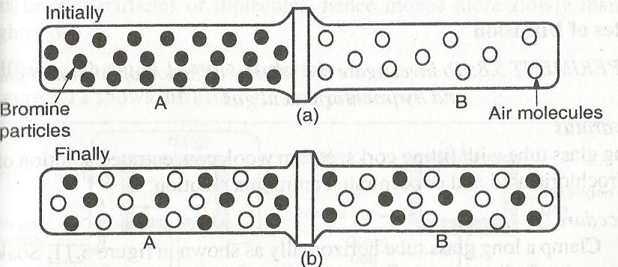
OBSERVATION AND EXPLANATION
- The bromine gas spreads into the gas jar B at a greater speed than it returns to gas jar A because of high concentration of bromine particles.
- Likewise, air spreads in gas jar A at a greater rate than it returns to gas jar B because of high concentration of air particles in B.
- A homogenous pale brown mixture forms in the two jars and because this happens in a very short time, it suggests that the random movement of particles is rapid (faster) than diffusion in liquids.
NOTE: Performing the same experiment with the jars held vertically instead of horizontally slows down the rate of diffusion because of the densities of the gases. The less dense gas diffuses much faster into the more dense gas.
RATES OF DIFFUSION
To investigate the rates of diffusion of ammonium gas and hydrochloric gas
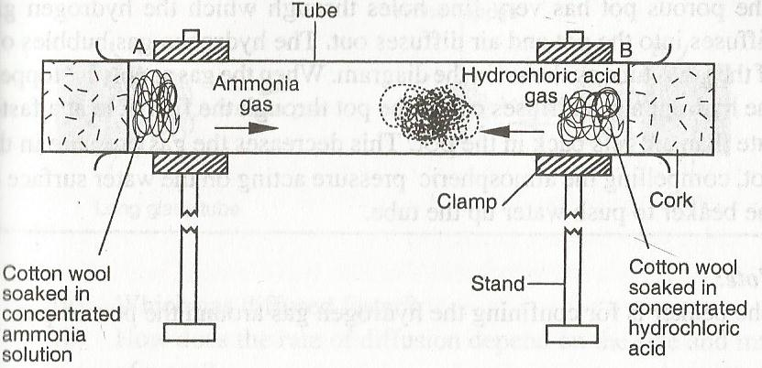
OBSERVATION AND EXPLANATION
- A white deposit of ammonium chloride forms on the walls of the glass tube in the region nearer end B. This suggests that ammonia gas diffused at a higher rate than hydraulic acid gas.
- Different gases have different rates of diffusion. A gas of high density has heavier particles hence moves more slowly than lighter one.
Diffusion through porous materials
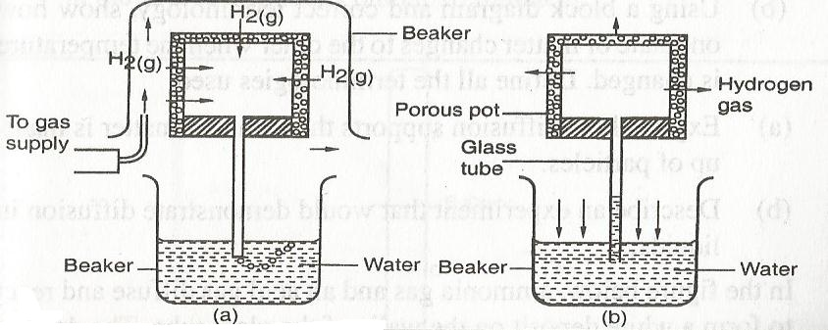
- The porous pot has very fine holes through which the hydrogen gas diffuses into the pot and air diffuses out.
- Hydrogen gas bubbles out of the glass tube as shown in the set up above.
- When the gas supply is stopped hydrogen gas diffuses out of the pot through the fine holes at a faster rate than air gets back to the pot. This decreases the gas pressure acting on the water surface in the beaker to push water up the tube.
NOTE: The beaker is used to confine the hydrogen gas around the porous pot.
QUESTION
- Describe the difference between solids, liquids and gases in terms of;
- Arrangement of particles/molecules.
- Distance separating molecules
- The movement of molecules
- Explain why rotten eggs broken at one end soon spreads the room.

THERMAL EXPANSION
TEMPERATURE is the degree of hotness or coldness of a body
Temperature of a body is measured by an instrument called a thermometer.
Temperature is a basic physical quantity and is measured in degrees celcious (⁰C) or Kelvin (K).
The S.I unit of temperature is Kelvin (K) which is a scalar quantity.
THERMAL EXPANSION AND CONTRACTION OF SOLIDS, LIQUIDS AND GASES
All substances increase in size when heated. This increase in size of a substance is called expansion. On the other hand when a substance is cooled it decreases in size. This decrease in size is called contraction.
EXPANSION IN SOLIDS
Thermal expansion and contraction in solids can be demonstrated using a ball and ring experiment. Set the apparatus as shown below.
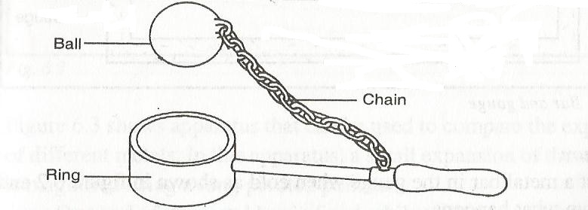
NOTE: The ball should pass through the ring when both are at room temperature
- Heat the ball and try to pass it through the ring. Observe what happens.
- Leave it for sometime
OBSERVATION
- When both the ball and the ring are at the same room temperature, the ball just passes through the ring.
- When the ball is heated, it does not go through the ring but when left there for sometime, it goes through.
EXPLANATION
- When heated, the ball expands so that it cannot go through the ring. When left on the ring for some time, the temperature of the ball decreases and it contracts.
- At the same time, the temperature of the ring increases and it expands so that the ball goes through.
WHY SOLIDS EXPANDS ON HEATING
The molecules of a solid are closely packed together and are continuously vibrating in their fixed positions
When a solid is heated the molecules gain more kinetic energy and therefore make larger vibrations about their fixed positions. This increase in vibration means that the molecules collide with each other with larger forces and the molecules increases and so the solid expand.
LINEAR EXPANSIVITY
The measure of the tendency of a particular material to expand is called its expansivity e.g. aluminium expands more than iron thus aluminium has higher expansivity than iron.
material | Linear exapnsivity (K⁻¹) x 10⁻⁶
Aluminium | 26
Brass | 19
Copper | 16.8
Iron | 12
Concrete | 11
Steel | 11
Glass | 9
The knowledge of linear expansivity values is applied in the designing of materials to ensure that they are able to operate well under varying thermal conditions.
Ordinary glass expands at a higher rate than Pyrex glass. When hot water is poured into a tumbler made of glass it breaks but does break in Pyrex glass.
Concrete and steel are reinforced together because they are of the same linear expansivity. Hence cannot crack under varying thermal conditions.
The bimetallic strip
When two metals of different linear expansivity are riveted together they form a bimetallic strip.
Brass and iron are used to make the bimetallic strip as shown.
Brass
Iron
On heating the bimetallic strip, brass expands more than iron. The brass thus becomes longer than the iron for the same temperature range. Hence, the bimetallic strip bends with brass on the outside of the curve as shown in (b) below
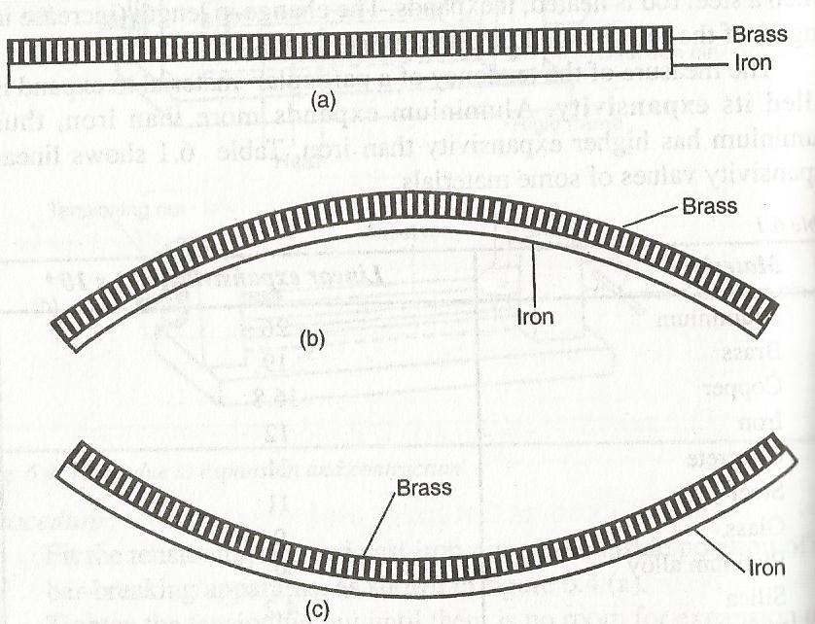
On cooling, the brass contracts more than iron. It therefore becomes shorter than the iron and thus ends up being on the inner side of the curve as shown in (c) above
APPLICATIONS OF EXPANSION AND CONTRACTION IN SOLIDS
- RAILWAY LINES
Gaps are left between the rails. Expansion for the rail is provided by overlapping the plane ends using overlapping joints as shown in the figure below
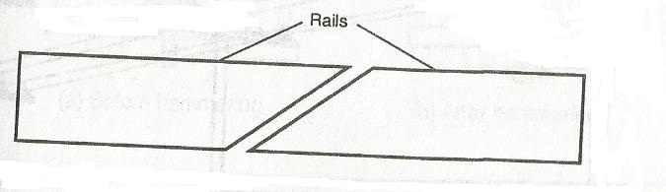
If these gaps for the expansion are not provided then during hot weather, they rails may buckle out, bend and cause derailment of the train leading to destruction and accidents.
- STEAM PIPES
Pipes carrying steam from boilers are fitted with loops or expansion joints to allow pipes to expand and contract easily when steam passes through and when it cools down.
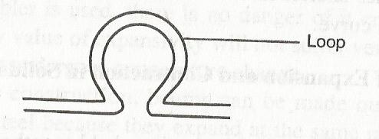
- TELEPHONE WIRES
They are loosely fixed to allow for contraction and expansion. During cold weather, they contract and when it is warm they expand.
Telephone or electricity wires appear to be shorter and taut in the morning. However in hot afternoons, the wires appear longer and slackened.
- STEEL BRIDGES
In bridges made of steel girders, one end is fixed and the other end placed on rollers to allow for expansion as shown
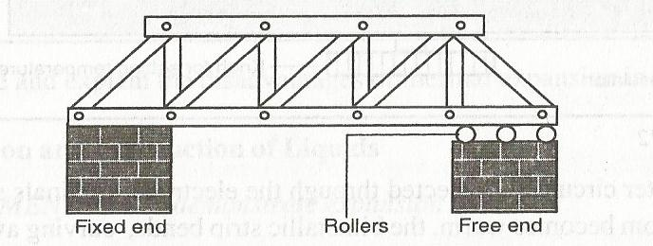

- RIVETS
Thick metal plates, sheets and girders in ships are joined together by means of rivets.
The rivet is fitted when hot and then hammered flat. On cooling, it contracts, pulling the two firmly together as shown
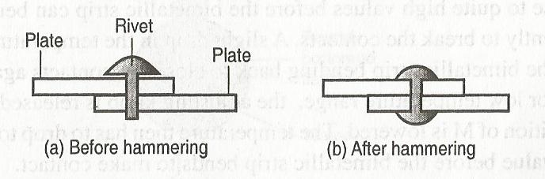
- ELECTRIC THERMOSTAT
A thermostat is used to maintain a steady temperature in some devices such as electric iron box, refrigerators, fire alarm and flashing unit for indicator lamp in motor cars.
EXPANSION AND CONTRACTION IN LIQUIDS
The experimental set up below can be used to demonstrate expansion of a liquid.
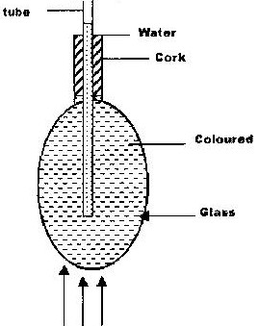

Heat
A glass flask is filled with coloured water and heated as shown above
OBSERVATION
Immediately the level of coloured water on the tube drops slightly at first and then starts rising.
EXPLANATION
The initial fall of the level of the water is due to the expansion of the glass flask which gets heated first. The water starts expanding when heat finally reaches it and it rises up the tube.
NOTE: The water expands faster than the glass.
QUESTION
Explain why there is a drop in the level of the water initially followed by a steady rise in the level of water.

Different liquids expand more than others for a given temperature as shown in the diagram
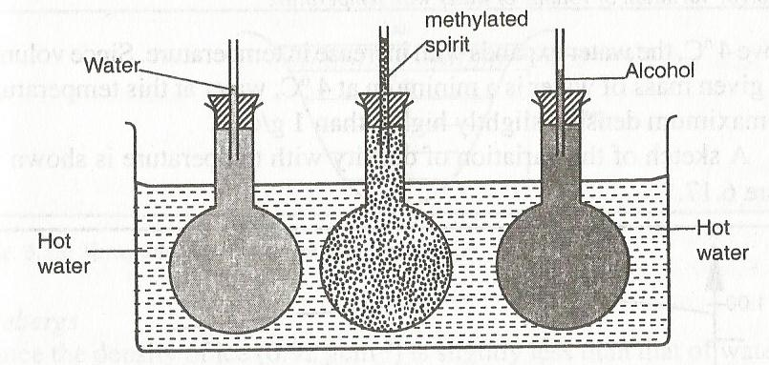
In this case, methylated spirit expands most, followed by alcohol and finally water.
EXPANSION IN GASES
The experiment below can be used to demonstrate expansion of air.
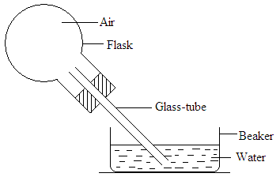
Invert the flask with glass tube dipped into the water as shown.
Warm the flask with your hands for some time and note what happens.
Remove your hand and let the flask cool while the tube is still inserted in water.
OBSERVATION AND EXPLANATION
When the flask is warmed the level of water column inside the glass tube drops indicating air expands. When the flask is warmed further, some bubbles are seen at the end of the glass tube.
On cooling the air inside the flask contracts and water rises up the glass tube.
THE ANOMALOUS (UNUSUAL) EXPANSION OF WATER
Solids, liquids and gases expands when heated and contracts when cooled. Water however shows an anomalous (unusual) behaviour in that it contracts when it is temperature is raised from 0ºC to about 4ºc.
When ice is heated from say -20ºC, it expands until its temperature reaches 0ºC and it melts with no change in temperature. The melting is accompanied by contraction. The water formed will still contract as its temperature rises from 0ºC as shown
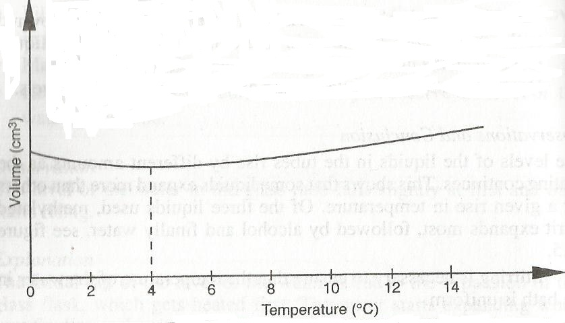
Above 4⁰C, the water expands with increase in temperature. Since volume of a given mass of water is minimum at 4ºC, water at this temperature has a maximum density, slightly higher than 1g/cm³.
A sketch of the variation of density with temperature
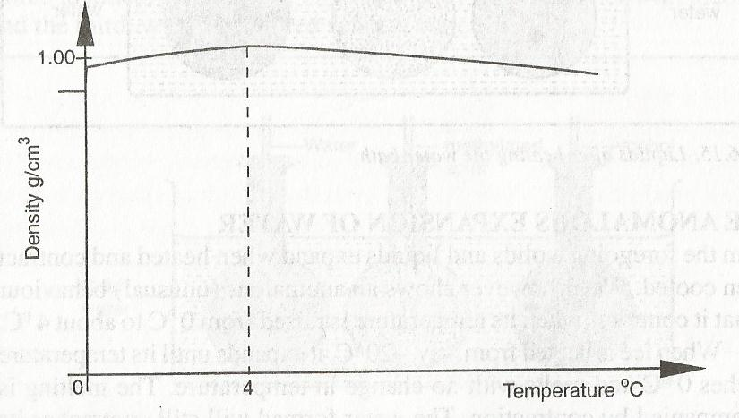
At the melting point of water (o⁰C) there is a drastic increase in the volume, resulting in a large decrease in density as the ice forms.
EFFECTS OF ANAMALOUS EXPANSION OF WATER.
- Freezing of lakes and ponds
Water in lakes and ponds usually freezes in winter. Ice is less dense than water and floats on water.
Since ice a bad conductor of heat it insulates the water below against heat losses to the cold air above.
Water remains at 4⁰C being the most dense, remains at the bottom of a lake while ice being less dense floats on layers of water at different temperatures as shown.
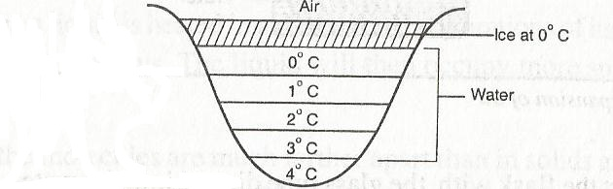
Fish and other aquatic animals and plants can therefore survive by living in the liquid layers below the ice.

- Icebergs
Since the density of ice (0.92g/cm³) is slightly less than that of water it floats with only a small portion above the water surface. The rest and bigger portion rests under water. A big mass of such submerged ice is known as an iceberg.
It poses a great danger to ships as navigators cannot see the submerged part.
- Weathering of Rocks
When water in a crack in a rock freezes, it expands. This expansion breaks the rock into small pieces.
- Water pipes
Water pipes bursts when the water flowing through the pipes freezes

MEASURING TEMPERATURE
THERMOMETER
A thermometer is an instrument used for measuring temperature. There are various types of thermometers in use.
The common types of thermometer include;
- Liquid-in-glass thermometer.
- Clinical thermometer
- Six’s maximum and minimum thermometer
LIQUID-IN-GLASS THERMOMETER
A liquid-in-glass thermometer commonly in use is mercury or coloured alcohol as the thermometric substance.
The volume of the liquid changes uniformly with the change in temperature.
The liquid in the bulb must; (characteristics)
- Be easily seen (visible).
- Expand or contract uniformly and by a large amount over a small range of temperature.
- Not stick to the inside of the tube. (Should not wet the inside of the tube.
- Have a wide range of temperature.
THERMOMETRIC LIQUIDS-the most common in use is mercury and alcohol.
Mercury freezes at -39ºC and boils at 357ºC while alcohol freezes at -115ºC and boils at 78ºC. Alcohol is therefore suitable for measuring temperatures below -39ºC.

PROPERTIES OF THE TWO THERMOMETRIC LIQUIDS
Alcohol | Mercury
Low boiling point, 78ºC | High boiling point, 357ºC
Low melting point, -115ºC | Relatively higher melting point, -39ºC
Poor thermal conductor | Good thermal conductor
Expansion slightly irregular | Expands regularly
Wets glass | Does not wet glass
Coloured to make it visible | Opaque and silvery

QUESTION
Explain why water is not used as a thermometric liquid?
TEMPERATURE SCALE
A scale of temperature is obtained by selecting two temperatures known as fixed points
The range between this two fixed points is divided into a number of equal divisions.
On the celcious scale, the lower fixed point is the temperature of pure melting ice and is taken as 0ºC. The impurities in the ice would lower its melting point.
The upper fixed point is the temperature of steam above water boiling at normal atmospheric pressure of 760mmHg and is taken as 100ºC.
The temperature of boiling water itself is not used because any impurities in water would raise its boiling point. The temperature of steam is not affected by impurities in water.
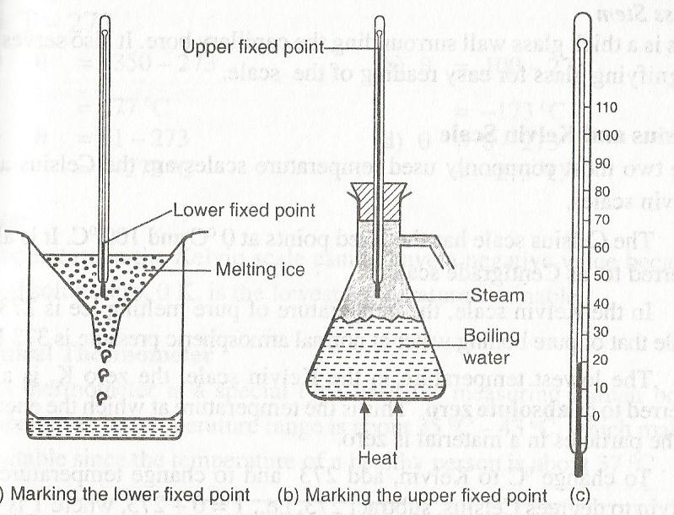
When these points have been marked, the range between them is divided into 100 equal divisions. Each division is called degree.
FEATURES OF A COMMON THERMOMETER
The basic features of a common laboratory are as shown below.
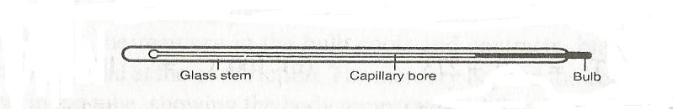
Bulb- Carries the liquid in the thermometer. It has a thin glass wall for effective heat transmission between the liquid and body whose temperature is taken.
Capillary bore – Liquid expands and contracts along the capillary tube. It is narrow for high degree of accuracy.
Glass stem – Is a thick wall surrounding the capillary bore. It also serves as a magnifying glass for easy reading of scale.
CELCIOUS AND KELVIN SCALE
They are the commonly used temperature scale.
The celcious scale has the fixed points at 0ºC and 100ºC.
In Kelvin scale, the temperature of pure melting ice is 273K while that of pure boiling water at normal atmospheric pressure is 373K.
The lowest temperature in the Kelvin scale (0K) is referred as absolute zero. This is the temperature at which the energy of the particles in material is zero.
To change ºC to Kelvin
T = (ѳ – 273) K where ѳ is the temperature in ºC

Example
Convert 25ºC in Kelvin
T = (25 + 273)
= 298 K
To change Kelvin to ºC
Ѳ = (T- 273) ⁰C where T is the temperature in Kelvin
Example
Convert 1 K
Ѳ = 1-273
=-272ºC
NOTE: Temperature in Kelvin scale cannot have a negative value because the absolute zero, (0 K), is the lowest temperature attainable.

CLINICAL THERMOMETER
A clinical thermometer is an instrument used to measure the temperature of a human body.
It uses mercury as its thermometric substance and has a narrow constriction in the tube just above the bulb.
The diagram below shows the main features of a clinical thermometer.
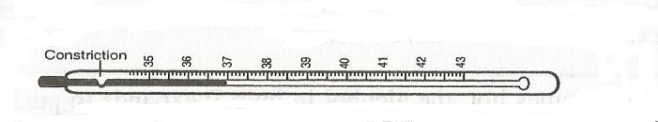
The constriction prevents the mercury level from falling down when it contacts with the human body.
The clinical thermometer has a short scale of temperature from 35ºC to 43ºC spread over its entire level. This is because the human body temperature falls slightly above or below 37ºC which is the temperature of a normal and healthy person.
SIX’S MAXIMUM AND MINIMUM THERMOMETER
This thermometer is used to record the maximum and minimum temperature of a place during a day.
The thermometer consists of a U-tube connected to two bulbs. The U-tube contains mercury.
The two bulbs contain alcohol.
The figure below shows the main features of a six’s maximum and minimum thermometer.
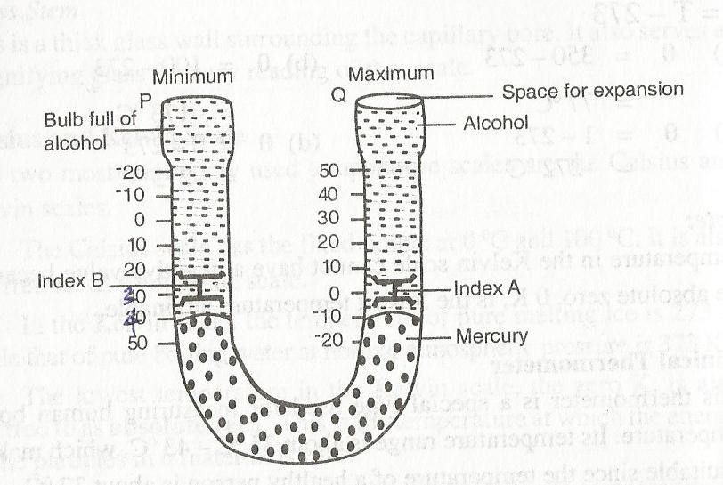
Working of the thermometer
When temperature raises alcohol occupying volume of bulb A expand and forces mercury in the U-tube to rise on the right hand side.
The mercury in turn pushes the steel index A upwards. The maximum temperature can be noted from the lower end of the steel index A.
On the other hand when the temperature falls, alcohol in the bulb A contracts and the mercury is pulled back rising u the left hand side of the U-tube. The index B is then pushed up. During contraction of the alcohol, index A is left behind ( in the alcohol) by the falling mercury.
The minimum temperature is then read from the lower end of index B.
NOTE: To reset the thermometer, a magnet is used to return the steel indices to the mercury surfaces.
The bimetallic thermometer

HEAT TRANSFER
Heat and Temperature
Heat is a form of energy which passes from a body at high temperature to a body at a lower temperature.
When a body receives heat energy its temperature increases whereas the temperature of a body that gives away energy decreases.
Thermal equilibrium- Condition when if two bodies at the same temperature are in contact, there is no net flow from one body to the other.
` 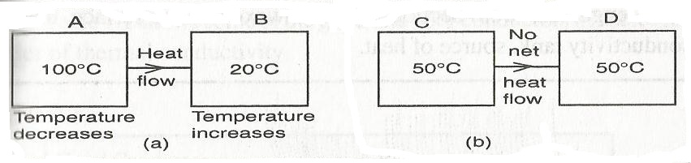
The SI unit of heat is joules.
Heat cannot be measured directly by an instrument as temperature is measured by a thermometer.
Modes of heat transfer
Heat can travel through a medium and also in a vacuum.
There are three (3) modes of heat transfer namely;
- Conduction – takes place in solids.
- Convection – takes place in fluids (liquids and gases).
- Radiation – takes place in gases (vacuum)
CONDUCTION
In stirring a hot tea the handle of a spoon becomes warm. The mechanism to this is explained below,
- Heat energy entering the spoon from the hot end increases vibrations of the atoms at this ends. These atoms in turn collide with neighbouring atoms, increasing their vibrations and hence passing the heat energy along.
- Metals have free electrons which travel throughout the body of the metal. Heat energy injected at the hot end of the metal spoon increases the vibration of the particles at the end. The free electrons in that region gain more kinetic energy and because they are free to move, they spread heat energy to the other parts of the spoon.
Thermal conductivities of various conductors
Different materials have different thermal conductivities. Metals are generally good conductors of heat. Non-metals are poor conductors of heat (insulator).
Solids that are good conductors of heat use both atom vibration and free electrons to conduct heat.
Solids that are poor conductors of heat like glass, wood, rubber make use of atom vibration as a mechanism to conduct heat because they have no free or mobile electrons.
The table below shows some of the good and poor conductors in decreasing order of thermal conductivity.
Good conductors | Poor conductors
Silver | Concrete
Copper | Glass
Aluminium | Brick
Brass | Asbestos paper
Zinc | Rubber
Lead | Wood
Mercury | Water
Air
NOTE: During thermal condition, heat flows through the materials with the material shifting or flowing. Conduction is therefore transfer of heat as a result of vibration of particles.
Conductivity of wood and iron rods
Set the apparatus as shown
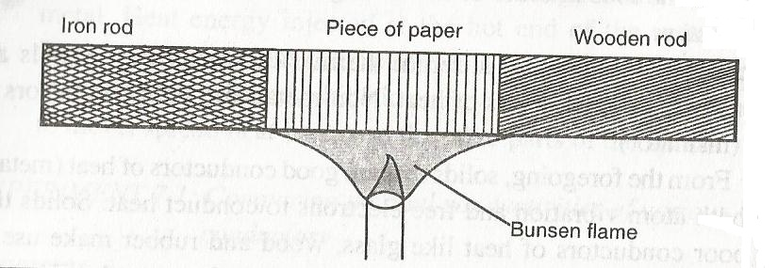
Observation and explanation
The paper gets charred (blackened) on the region covering the wooden rod. This is because the wood does not conduct heat from the paper.
Wood is said to be a bad conductor of heat while iron is a good conductor.
Factors affecting thermal conductivity
Thermal conductivity in materials depends on the following factors;
- Temperature difference ( Ѳ) between the ends of the conductor.
- The length of the conductor.
- The cross-sectional area (A) of the conductor.
- The nature of the material (K)

Temperature difference
To demonstrate how temperature difference ( Ѳ) affects thermal conductivity
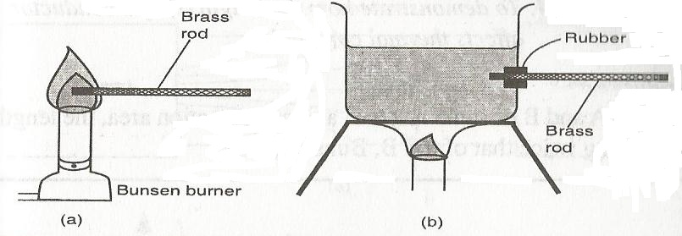
Observation
The rod placed in the flame becomes too hot faster than the one placed in the boiling water.
Explanation
The rate of heat flow (thermal conduction) increases with increase in temperature.
Thermal conduction in metals is by two mechanisms i.e. vibration of atoms and by free electrons.
A high temperature difference between the ends of the conductors sets the atoms into vibrations more vigorously and the vibrations are passed more quickly to the cooler end. The electrons on the other hand gain a lot of kinetic energy causing them to spread the heat energy to cooler parts of the metal within a short time.
Length of the conductor
Consider the set up below
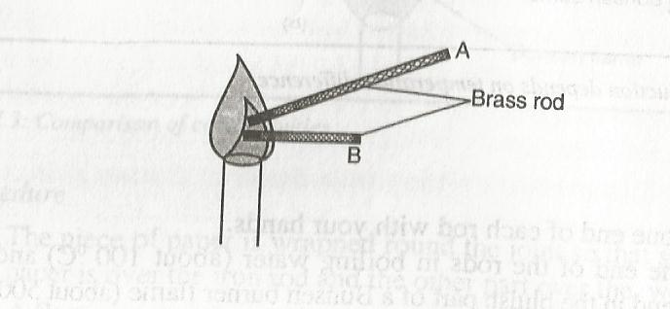
Observation
The end of metal B held in hand becomes too hot earlier than metal A. Thermal conductivity increases with decrease in length.
Explanation
Heat travels within a conductor along imaginary lines called lines of heat flow. These lines diverge from the hot end as shown
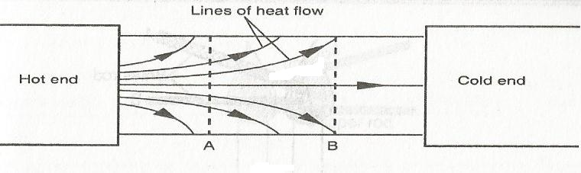
The graph of temperature (Ѳ) against length (l) is as shown.
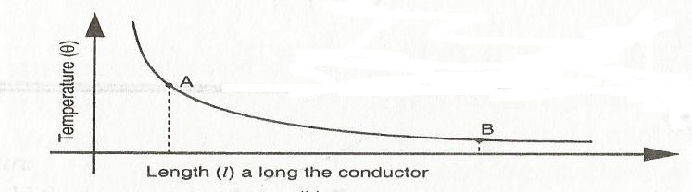
When the heat energy gets to the surface of the metal it is easily lost to the surroundings.
The lines of heat are more divergent near the hot end than they are far away (position A and B).
The slope of the graph in the above figure is steeper at A (near the hot end) than at B further away. This indicates that the shorter the length of the material, the higher the rate of heat flow.
The cross-sectional area of the conductor
Consider the set up below,
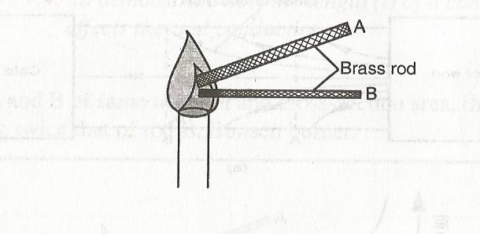
Observation
The end of metal A held in the hand becomes too hot earlier than metal B.
Thermal conductivity increases with increase in area of cross-section of the conducting material.
Explanation
The number of free electrons per unit length of the thicker length A is more than those in the thin metal rod B.
The nature of the material K
To demonstrate how the type of the material K affects thermal conductivity, consider the diagram below,
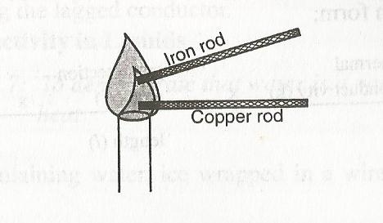

Observation
The end of copper rod held in the hand becomes too hot earlier than iron rod. This shows that thermal conductivity depends on the nature of the material.
Explanation
Different materials have different strength of force bonding the atoms within the material. The number of free electrons also differs from one material to another material.
Materials with many free electrons are better conductors of heat e.g. copper has more free electrons than iron.
Rate of heat flow = $\frac{Thermal conductivity \left(c\right)x cross-sectional area \left(A\right)x temperature difference}{length (l)}$

LAGGING
This is the covering of good conductors of heat with insulators to reduce heat loss through surface effects. For example, iron pipes carrying hot water from boilers are covered with thick asbestos material.
The figure below shows lines of heat flow in a lagged metal bar.
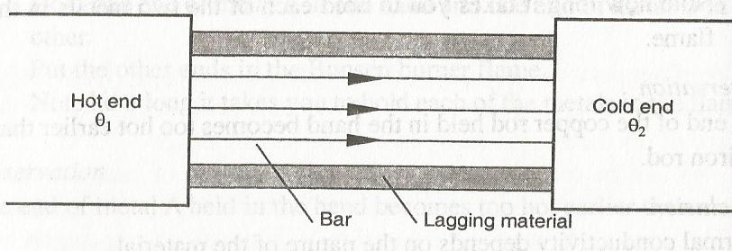
A graph of temperature (ѳ) against the position along the lagged conductor is as shown below.
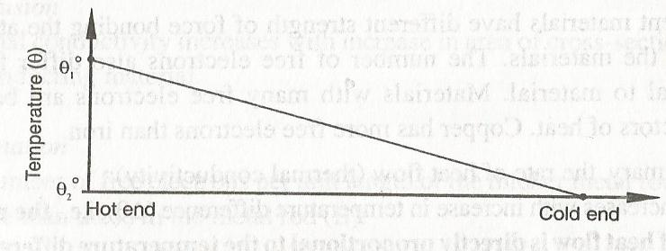

THERMAL CONDUCTIVITY IN LIQUIDS
To demonstrate that water is a poor conductor, consider the set up below,
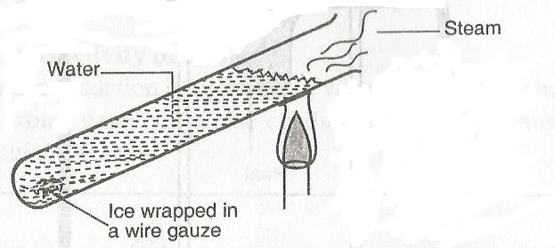
Observation and explanation
Water at the top of the boiling tube boils while ice remains unmelted. This shows that water is a poor conductor.
NOTE: The boiling tube is made of glass (poor conductor of heat) which limits possible conduction of heat down the tube.
The ice is wrapped in wire gauze to ensure it does not float. The fact that the wire gauze is a good conductor of heat and yet ice remained unmelted shows that there is very little heat conduction in water, unable to melt the ice.
Water is heated at the top to eliminate possibility of heat transfer to the ice by convection.
Although liquids are in generally poor conductors of heat, some liquids are better heat conductors than others e.g. mercury is a better conductor of heat than water.
Why liquids are poor conductors of Heat
Pure liquids have molecules further apart from each other. Although molecules move about within the liquid, they are slow to pass heat to other regions compared to the free electrons in metals. This is because there are large intermolecular distances between liquid molecules. There are also fewer and rare collisions between the molecules.
Electrolytes e.g. salt solution, are better conductors of heat than pure liquids because of increased compactness of the particles.
Mercury is a metal existing as a liquid at room temperature. Bromine, the only non-metal existing as a liquid at room temperature, is a poor conductor.
Thermal conductivity in gases
Since thermal conductivity is by means of vibration of atoms and presence of free electrons, gases are worse conductors of heat because of large inter-molecular distance.
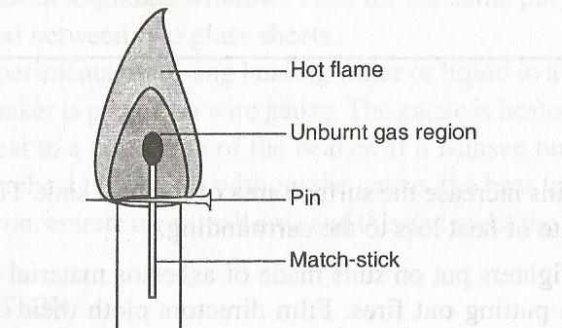
A match stick held within the unburnt gas region of a flame cannot ignited by the heat from the hot part of the flame. This is because gas is a poor conductor of heat.
Applications of good and poor conductors
- Cooking utensils, soldering irons and boilers are made of metals which conduct heat rapidly. For cooking utensils, the handles are made of insulators such as wood or plastic. Metal pipes carrying hot water from boilers are lagged with cloth soaked in a plaster of paris to prevent heat losses.
- Overheating of integrated circuits (ICs) and transistors in electronic devices can drastically affect their performance such components are fixed to a heat sink (a metal plate with fins) to conduct away undesired heat. The fins increase the surface area of heat sink and conduct more heat away to the surrounding.
- Fire fighters put on suits made of asbestos material to keep them safe while putting out fire.
- Birds flap their wings after getting wet as a means of introducing air pockets in their feathers. Air being a poor conductor reduces heat loss from their bodies.
- In modern buildings where desired inside temperatures is to be stabilised, double walls are constructed. Materials that are good insulators of heat and can trap air put between the walls. Examples of such materials that are glass, wool (fibre glass) and foam plastic.
Air on its own may not effectively give the desired insulation because it undergoes convection.
Double glazed windows used for the same purpose have air trapped between two glass sheets.
- In experiment involving heating water or liquid, the beaker is placed on the wire gauze. The gauze is heated and spreads the heat to a large area of the beaker. If the gauze is not used, heat from the Bunsen burner may concentrate on a small area and may make the beaker crack.
CONVECTION
Convection is the process by which heat is transferred through fluids (liquids and gases). The heat transfer is by actual movement of the fluid called convection currents, which arise out of the following;
Natural convection – It involves change in density of the fluid with temperature.
Forced convection – Mixing of hot and cold parts of the fluid through some external stirring like a fan or pump.
Convection in liquids
To demonstrate convection in liquids the set up below is used
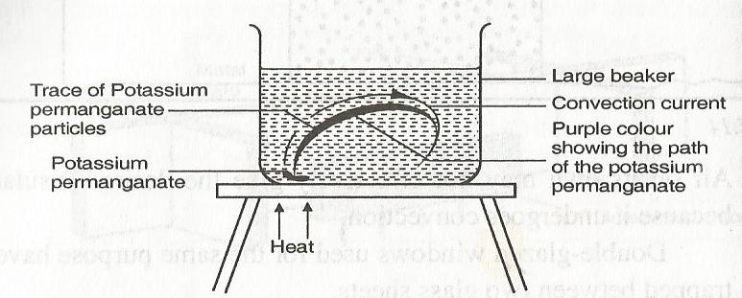
Observation
A purple colourisation rises up from the potassium permanganate, forming a loop.
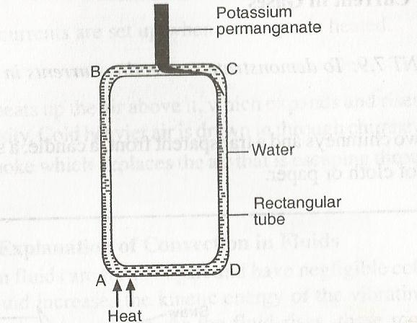
Observation
The colourisation arising from the potassium permanganate flow in clockwise direction
From the experiments, it is clear that when a liquid is heated, it rises while cold liquid replaces it.
Explanation
When a liquid is heated, it expands and this lowers its density. The less dense liquid rises and its place is taken by more dense colder liquid. This movement of liquid forms convection currents
CONVECTION IN GASES
To demonstrate convection currents in gases, consider the set up below
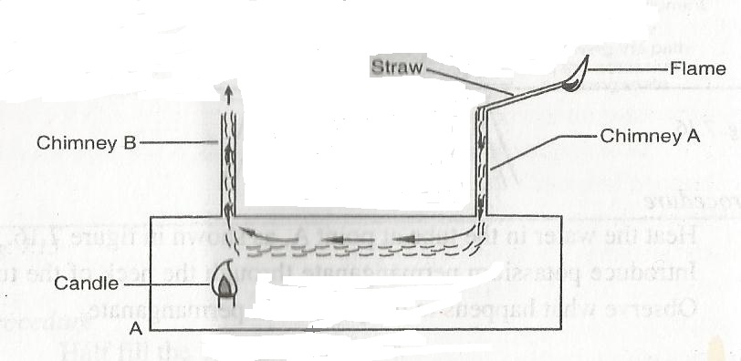

Observation
Smoke is sucked into the box through chimney A and exists through chimney B. When the candle is put off, the smoke is not drawn into the box.
This shows convection currents are set up when air or gas is heated.
Explanation
The candle heats up the air above it, which expands and rises up because of lower density. Cold heavier air particles is drawn into chimney A, carrying along the smoke which replaces the air that is escaping through chimney B.
Molecular explanation of convection in fluids
Molecules in fluids are further apart and have negligible cohesive force. Heating a fluid increases the kinetic energy of the vibrating molecules and their random movement.
As the fluid rises, these molecules pass energy to the molecules in the colder regions which have less energy. Because the molecules are further away from the heating source, their temperature is reduced.
Pressure near the heating source decreases because of the depletion of molecules as they rise. Colder molecules move into the low pressure zone to fill up the void being created.
This movement of molecules constitutes convection currents. Convection currents are set up much faster in gases than in liquids because of relatively low cohesive force in gases.

APPLICATION OF CONVECTION IN FLUIDS
- Domestic hot water system
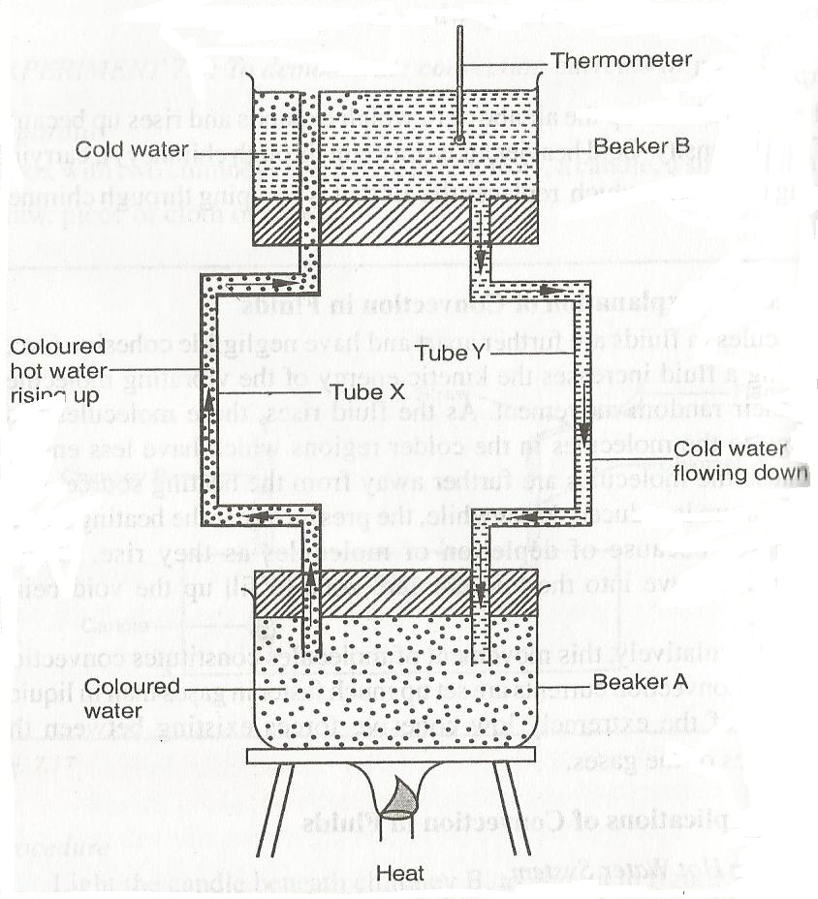
Initially, the two beakers A and B have cold water. Water in beaker A is coloured to distinguish it from that in beaker B. When the water in beaker A is heated, it is observed to rise up through tube X and emerges on top of cold water in beaker B. The cold water flows down from beaker B to beaker A.
As long as heating continues, there will be movement of hot water into beaker B and cold water will flow down into beaker A. Thermometer will show increase in temperature for water in beaker B.
The commercial domestic hot water system utilises the same principle of operation. The hot water rises up because of the effective lowering of density. The force of gravity helps the cold water to flow down from the cold tank.
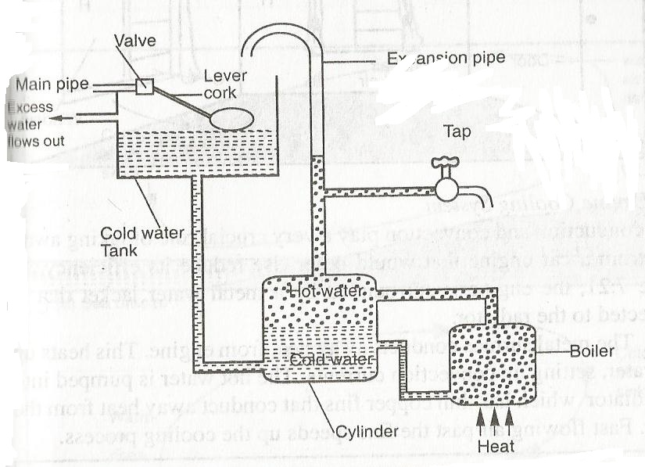
The hot water tap and expansion pipe are connected to the upper region of the cylinder. The expansion pipe is an outlet for excess water that could have resulted from overheating.
Once the cold water flows down the cylinder, the main pipe allows more cold water to flow into the tank. When filled to capacity, the ball cork floating on water closes a valve i the main pipe, stopping further in flow of cold water.
An overflow pipe lets out water from the cold tank when the valve is not sufficiently functional.
Lagging is done on the pipe that conveys hot water to minimise heat losses.
- VENTILATION
This is the supply of fresh air into the room. Air expelled by the room occupants is warm and less dense. It rises up and escapes through the ventilation holes. Cold fresh air flows into the room to replace the rising warm air. The room gets continuous flow of fresh air.
NOTE: Some devices are fitted with air conditioning devices which cause forced convection of air, giving out cold dry air and absorbing warm moist air.

- CAR ENGINE COOLING SYSTEM
Heat conduction and convection play a very crucial role of taking away heat from a car engine that would reduce its efficiency.
The engine is surrounded by a metal water jacket that is connected to the radiator. The metal surface conducts heat away from the engine. This heats up the water, setting up convection currents. The hot water is pumped into the radiator which has thin copper fins that conduct away heat from water.
Fast flowing air past the fins speeds up the cooling process.
- LAND AND SEA BREEZES
This is a natural convection of air, and occurs at sea shores because of temperature difference between the mass of water and the land.
The mass of water takes longer time than land nearby land by the same temperature from the sun. Water also takes a longer time to cool than the land after being raised at the same temperature.
During the day, the land heats up much faster than the sea. The air just above the land gets heated up and rises because of reduced density. Cold air above the sea blows towards the land to replace the void created by warm air rising. This is called sea breeze.
In the evening, temperature of the sea water is higher than that of the land. The air above the sea gets heated up and rises. Cold air from the land blows to the sea. This is called land breeze.
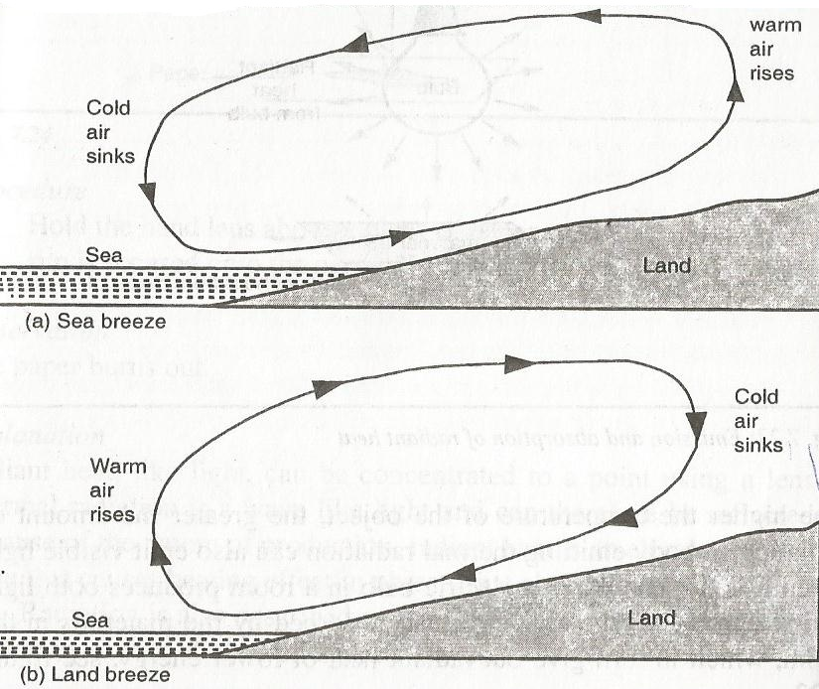

RADIATION
Heat from the sun to the earth reaches us by radiation.
Thermal radiation is heat transfer through a vacuum.
All bodies absorb and emit radiation. The higher the temperature of the object, the greater the amount of radiation
A body emitting thermal radiation can also emit visible light when it is hot enough.
An electric bulb in a room produces both light and radiant heat. The radiant heat is absorbed by the materials in the room, which in turn give out radiant heat of lower energy.
NATURE OF RADIANT HEAT
To demonstrate the radiant heat
Consider light rays travelling from sun light to hand lens as shown,

OBSERVATION
When light rays are focussed onto the paper, it burns out.
EXPLANATION
Radiant heat, like light can be concentrated to a point using a lens. Thermal radiation is a wave like light and can be reflected. Because of the nature of production, radiant heat is an electromagnet wave which causes heating effect in objects that absorb it.
Radiation can also be described as the flow of heat from one place to another by means of electromagnetic waves.
EMISSION AND ABSORPTION OF RADIATION
To compare radiation from different surfaces (shiny and black surfaces),
Consider the set up below,

The two surfaces are heated to a certain temperature say 80⁰C. The temperatures of the two tins taken after sometime.
Observation
After sometime, it is noted that the temperature recorded by T_{B} is lower than that recorded by T_{S}.
Explanation
The experiment shows that black surfaces are better emitters than shiny surfaces.
A graph of temperature against time for temperatures recorded by each thermometer

The graph shows water in a shiny tin lost heat less rapidly than the blackened tin (good emitter).
To compare absorption of radiant heat by different surfaces
Set up the apparatus as shown

Observation
The cork fixed on the dull/black surface falls off after the wax, melts, while the cork polished/shiny plate remains fixed for a longer time.
Consider also the set up below,

Observation
The thermometer T_{B} immersed in water in the blackened tin records higher reading than that of thermometer T_{S}, when the heater is placed mid-way between tin A and tin B.
A graph of temperature (ºC) against time (minutes) is as shown,

The graph shows that temperature of water in the polished tin does not increase as fast as temperature of water in blackened tin.
EXPLANATION
Black surfaces are good absorbers of radiant heat than polished surfaces.
NOTE: Good absorbers of radiant heat also good emitters while poor absorbers of heat are also poor emitters.
Poor emitters of heat are also good reflectors.
APPLICATIONS OF THERMAL RADIATION
- Kettles, cooking pan and iron boxes have polished surfaces to reduce heat lose through radiation.
- Petrol tanks are painted silvery bright to reflect away as much heat as possible.
- Houses in hot areas have their walls and roofs painted with bright colours to reflect away heat, while those in cold areas have walls and roofs painted with dull colours.
- In solar concentrators, the electromagnetic waves in form of radiant heat are reflected to a common point (focus) by a concave reflector. The temperature at this point can be sufficiently high to boil water as shown

- The green house effect
A green house has a glass roof through which radiant heat energy from the sun passes. This heat is absorbed by objects in the house, which then emit radiation of lower energy that cannot penetrate through glass.
The cumulative effect is that temperature of the houses increases substantially. Greenhouses are used in providing appropriate conditions for plants in cold regions.
NOTE: Carbon dioxide (CO₂) and other air pollutants in the lower layers of the atmosphere show the same properties of glass, raising the temperature on earth to dangerous levels.
- Solar heater
The solar heater uses solar energy to heat water. The figure below shows the solar heater,

The solar heater consists of a coiled blackened copper pipe on an insulating surface. Radiant heat from the sun passes through glass and is absorbed by black copper pipes that contain water, which is heated up.
Copper pipes are used because they are good conductors and they are painted black to increase their absorbing power.
Lower energy emitted after absorption of radiant energy does not escape because it cannot penetrate the glass. The temperature of the air above the pipe thus increases boosting the heating of water. A good insulating material is used at the base.
- THERMOS FLASK( VACUUM FLASK)
A thermos flask is designed such that heat transfer by conduction, convection and radiation between the contents of the flask and its surrounding is reduced to a minimum.
The vacuum is a double walled glass vessel with a vacuum in the space between the walls. This minimises the transfer of heat by conduction and convection. The inside of glass walls, in the vacuum side, is silvered to reduce heat losses by radiation (Poor emitter and absorber). The felt pads on the sides and at the bottom support the vessel vertically.
The heat loss by evaporation from the liquid surface is prevented by a well fitting cork.

RECTILINEAR PROPAGATION AND REFLECTION AT PLANE SURFACES
Light is a form of energy. It enables us to see the surrounding objects. Light itself is not visible but its effect is felt by the eye.
Light is also very essential as a source of energy for the process by which plants their own food (photosynthesis).
SOURCES OF LIGHT
Luminous (incandescent) source – these are objects that produce their own light e.g. sun, stars, burning candles, wood or charcoal, electric bulbs, television screens, glow worms e.t.c.
Non-luminous source – these are objects which do not produce light of their own. They are seen when light falling on them from luminous sources is reflected (bounces off their surfaces) e.g. the moon, planets, plants, people, books, walls, clothes e.t.c.
RAYS AND BEAMS OF LIGHT
A source of light produces pulses of energy which spread out in all directions. The path along which light energy travels is referred to as a ray of light. Rays are represented by lines with arrows on them to show the direction of travel.
A stream of light energy is called a beam. It is also considered to be a bundle of rays of light. Beams of light can be seen;
- In the morning as the sunlight breaks through the clouds or leaves.
- When a spotlight is shown in a smoky room or a car driven along a dusty road at night with its headlamps on.
- When sunlight streams into a smoky dark room through a small opening

TYPES OF BEAMS OF LIGHT
- Diverging beam
- Converging beam
- Parallel beam
Diverging beam – These are beams of light that appear to spread out (diverging) e.g. light from a spotlight.

Converging beam – these are beams which appear to collect (converge) to a point.

Parallel beam – are those beams which appear to be perfectly parallel to each other e.g. beam of light from the sun reaching the earth’s surface.

OPAQUE, TRANSLUCENT AND TRANSPARENT OBJECTS
OPAQUE – these are objects that do not allow light to pass through them at all e.g. brick walls, metals, wood, stones e.t.c.
TRANSLUCENT – these are objects that allow light to pass through but we cannot see through e.g. glass panes used in toilets and bathroom window and greased paper.
TRANSPARENT – these are objects which allow light to pass through and we see clearly through them e.g. car wind screen and ordinary window panes.
RECTILINEAR PROPAGATION OF LIGHT
Light does not need a material medium to carry it. In a vacuum, the speed of light is 3.0 x 10⁸m/s. Light from the sun reaches the earth having travelled mostly through a vacuum.
When light falls on an opaque object, it casts a shadow of the object with sharp edges on a screen behind it. This suggests that light travels in a straight line.
To investigate how light travels
Apparatus : three cardboards, source of light.
Arrange the apparatus as shown

The cardboards are arranged such that holes are exactly in line.
Observation
When the holes in the three cardboards are in line, the eye can see the lamp. However when the middle cardboard is displaced, the eye can no longer see the lamp.
Explanation
When the holes in the cardboards are in a straight line, light travels through the holes and the lamp is seen from the other side. When one of the cardboards is displaced, the beam of light is cut off and since light cannot bend to follow the displaced hole, the lamp cannot be seen.

Conclusion
Light travels in a straight line. This property is known as rectilinear propagation of light.
SHADOWS
Shadows are formed when an opaque object is on the path of light. The type of shadow formed depends on;
- The size of source of light.
- The size of opaque object.
- The distance between the object and the source of light.
- To study the formation of shadows by a point source of light
Consider the set up below,

Observation and Explanation
A uniformly and totally dark shadow is seen on the screen. This shadow is called umbra (Latin for shade)
The shadow has a sharp edge, supporting that light travels in straight lines.
- To study the formation of shadows by extended (larger) source of light
Consider the set up below (source of light made larger)

Observation
The centre of the shadow remains uniformly dark as before, but smaller in size. The shadow is edged with a border of partial shadow called penumbra.
Explanation
The centre of the shadow still receives no light at all from the source. Light from some parts of the extended source of light reaches the centre parts of the shadow on the screen, but light from other parts is cut off by the opaque object, resulting in a partial shadow at the edges.
NOTE: Extended light source produce light that is much softer and without sharp edges.
Application
It is used in frosted light bulbs and lamp shades to provide a more a more pleasant lighting with less sharp edges.
- To study the formation of shadows by extended (larger) source of light when object distance is changed
Consider the set ups below,

Object moved closer to source

Object moved away from the source
Observations
When the ball is moved closer to the source, a ring of penumbra is formed. No umbra is seen.
When the ball is far away from the source, there is umbra surrounded by penumbra.
Explanation
The centre of the shadow receives light from the extended source. Since the object (ball) is smaller than the source of light, its umbra does not reach the screen because of the distance.
When the object is moved away from the source, the tip of the umbra reaches the screen.
ECLIPSE
An eclipse is a phenomenon of shadow formation which occurs once in a while. It’s the total or partial disappearance of the sun or moon as seen from the earth.
Eclipses are explained in terms of relative positions of the earth, the moon and the sun.
THE PHASES OF THE MOON
At any given moment, about half the surface of the moon is lit by the sun while another half is in darkness.
The lighted part is bright enough to be seen easily at night from the earth and can be seen at day time. The darkened part is usually invisible.
When we look at the moon, we normally notice only the shape of the lighted part as shown below,

SOLAR ECLIPSE (ECLIPSE OF THE SUN)
When the moon, revolving around the earth, comes in between the sun and the earth, the shadow of the moon is formed on the earth. This is called eclipse of the sun.
Depending on the position of the moon, some parts of the earth lie in the region of umbra and some in the region of penumbra. Total eclipse occurs in the regions of umbra and partial eclipse in the regions of penumbra.

ANNULAR ECLIPSE
Sometimes the umbra of the moon is not long enough to reach the earth because sometimes the distance between the moon and earth varies (the moon’s orbit is elliptical). When the moon is further away from the earth, its disc is slightly smaller than the sun’s disc. So when a solar eclipse occurs, the moon is not large enough to cover the sun totally. A bright ring of sunlight can be seen round the edge of the dark disc of the moon. This is called Annular or ring eclipse.

LUNAR ECLIPSE (ECLIPSE OF THE MOON)
The moon is a non luminous object. It can only be seen when light from the sun is incident on it. When we look at the moon, we see only the shape of the lighted portion. When the earth comes in between the sun and the moon, lunar eclipse occurs. Depending on the position of the moon, a total or partial eclipse of the moon will occur. Total lunar eclipse will occur if the moon is in the region of umbra and partial eclipse will occur if any part of the moon is in the region of penumbra as shown,

A lunar eclipse occurs when the moon passes through the earth’s umbra.
PINHOLE CAMERA
A pinhole camera consists of a box with pinhole on one side and a translucent screen on the opposite side. Light rays from an object pass through the pinhole and form an image on the screen as shown

The image formed is real and is inverted. A pinhole camera has a large depth of focus i.e. objects that are far and near form focussed images on the screen.
CHARACTERISTICS OF IMAGES FORMED ON THE PINHOLE
Consider the sets below

When the object is near the pinhole, the image is larger.

When the object distance is increased from the pinhole the image is smaller.
When more holes are added close to the first pinhole, images of each point are seen overlapping on the screen as shown,

If the camera was made in such a way that it could be elongated by moving the screen farther away from pinhole but keeping the distance between the object and pinhole fixed, it could be seen that the image enlarges when length of the camera is increased and diminishes when the length of the camera is reduced as shown below:

Length of camera decreased, image smaller
Length of camera increased, image bigger (larger)
MAGNIFICATION
Magnification is the change in size of an image to that of the object or it’s the ratio of the height of the image and that of the object.

Magnification, m=$\frac{height of image (hi)}{height of object (ho)}$
Also,
Magnification, m=$\frac{Distance of image from the pinhole (v)}{Distance of object from the pinhole (u)}$
Hence, $\frac{hi}{ho}=\frac{v}{u}$

Example
The distance between the pinhole and screen of a pinhole camera is10cm. The height of the screen is 20cm.At what distance from the pinhole must a man 1.6m tall stand if a full length is required
h_{i}=20cm, h_{o}=1.6m and v=10cm
M =$\frac{hi}{ho}=\frac{v}{u}=\frac{0.2}{1.6}=\frac{0.1}{u}$
$u=\frac{1.6x0.1}{0.2}=0.8m$

Example 2
An object of height 5m is placed 10m away from a pinhole camera. Calculate
a) The size of the image if it’s magnification is 0.01m
b) The length of the pinhole camera.
a) M=$\frac{hi}{ho}=0.01=\frac{hi}{5}$
h_{i}=0.05m (image is 0.05m high)
b) M=$\frac{v}{u}=0.01=\frac{v}{10}$
v=0.1m (length of pinhole camera is 0.1m)
Exercise
- The length of pinhole camera is 25cm. An object 2m high is placed 10cm from the pinhole. Calculate the height of the image produced and its magnification.
- a) A pinhole camera of length 20cm is used to view the image of a tree of height 12m which is 40m from the pinhole. Calculate the height of the image of the tree obtained on the screen.
b) If the pinhole is moved by 10m towards the tree, what will be the height of the tree on the screen?
TAKING PHOTOGRAPHS WITH A PINHOLE CAMERA
The pinhole camera can be used to take still photographs if it is modified as follows,
- The box should be painted black to eliminate reflection of light.
- The translucent screen should be replaced by a light-tight lid with a photographic film fitted on the inside. The film should be fitted in a dark room.
- The pinhole should be covered with a thin black card which acts as a shutter as shown,

REFLECTION OF LIGHT (PLANE SURFACES)
All objects, except self luminous objects, become visible because they bounce light back to our eyes. This bouncing off light is called reflection.
There are two types of reflection namely regular and diffused reflections.
When light is reflected by a plane smooth surface, the reflection is regular (specular) and when reflection occurs at a rough surface it is called a diffused reflection.

REFLECTION BY PLANE MIRRORS
A plane mirror is a flat smooth reflecting surface which forms images by regular reflection. It is often made by bounding a thin polished metal surface to the back of a flat sheet of glass or silvering the back side of the flat sheet of glass.
The silvered side is normally coated with some paint to protect the silver coating. If the clear and the silvered surfaces are in parallel plane, the mirror is called a plane mirror.
If the surfaces are curved, the mirror is called curved mirrors.

The silvered side of the mirror is shown by shading behind the reflecting surface.

DEFINITION OF TERMS USED IN REFLECTION
Consider the set up below,

Incident ray – is the ray that travels from the source to the reflecting surface.
Angle of incident (i) – is the angle between the incident ray and the normal.
Normal – is the line drawn perpendicularly at the point where the incident ray strikes the reflecting surface.
Reflected ray – is the ray that bounces from the reflecting surface.
Angle of reflection (r) – is the angle between the reflected ray and the normal.
LAWS OF REFLECTION
- The incident ray, the reflected ray and the normal at the point of incidence all lie on the same plane.
- The angle of incidence, i, equals the angle of reflection, r.
Experiments to show the laws of reflection (exp. 8.6)

ROTATION OF A MIRROR THROUGH AN ANGLE
Consider the mirrors below,

In figure (a), the angle of incidence is 30⁰. The angle of reflection is also 30º. Therefore the angle between the incident ray and the reflected ray is 60º (30º+30º).
In figure (b), mirror m₁ is rotated by an angle 10º to the new position m₂. The normal BN₁ moves through an angle 10º. Angle between the two normals is 10º.
In figure (c), for the same incident ray AB, the new angle of incident = 30º + 10º =40º. The new angle of reflection = 40º. Hence the new angle between the angle of incidence and the angle of reflection = 40º + 40⁰=80⁰.
In figure (d), the angle between the two reflected rays BC and BD =20º.
For the same incident ray, the angle of rotation of the reflected ray is twice the angle of rotation of the mirror.
Example
- A ray of light is incident along the normal in a plane mirror. The mirror is then rotated through an angle of 20⁰. Calculate the angle between the first reflected ray and the second reflected ray.
Angle of rotation of reflected rays= 2 x angle of rotation of the mirror
=2 x 20⁰=40º
- The figure below shows a ray incident at an angle of 25º at position 1. The mirror is turned through 6⁰ to position 2. Through what angle is the reflected ray rotated.

Rotation change the angle of incidence from 25º to (25+6)=31⁰. Hence the angle of reflection is 31º from the new normal. The total change in the angle of reflected ray is 12º
- A suspended plane mirror makes an angle of 20º with a wall. Light from a window strikes the mirror horizontally. Find;
- Angle of incidence.
- The angle between the horizontal and the reflected ray

FORMATION OF IMAGES BY PLANE MIRRORS
Images formed is far behind the mirror as the object is in front of the mirror i.e. image distance is equal to object distance from the mirror

Characteristics of images formed by plane mirrors
- Image formed is the same size as the object.
- Images formed are laterally inverted e.g. when you raise your right hand, the image raises its left hand.
Virtual images – formed by rays that appear to come from the image. Such images are not formed on the screen as they are only imaginary.
Example
A girl stands 2m in front of a plane mirror.
- Calculate the distance between the girl and her image
2+2 = 4m
- If the mirror is moved 0.6m to the girl, what will be the distance between her and image.
Object distance =2-0.6 =1.4m
Total distance = 1.4 + 1.4 = 2.8m
IMAGES FORMED BY MIRRORS AT AN ANGLE
When an angle Ѳ is 90º, the number of images formed, n, is 3 i.e.
n = $\frac{360}{90}-1$=3 images
When the angle Ѳ is 60º, the number of images formed, n, is 5 i.e.
n = $\frac{360}{60}-1$= 5 images
In general if the angle between two placed mirrors is Ѳ, then the number of images formed, n, is given by,
n = $\frac{360}{ Ѳ}-1$
Example
- Two plane mirrors are kept inclined to each other at 120º. Calculate the number of images formed by the mirrors.
n= $\frac{360}{120}-1$=2 images
- At what angle would the two mirrors inclined to form 17 images.
17=$\frac{360}{ Ѳ}-1$
18Ѳ=360
Ѳ=20º

Mirror parallel to each other
When the mirrors are parallel i.e. Ѳ= 0º, the number of images is given by,
n= $\frac{360}{0}-1$=$∞$ (infinite number of images)
Example
- Two parallel plane mirrors are placed 30cm apart. An object placed between them 10cm from one mirror. Determine the image distance of two nearest images formed by each mirror.
Solution
Image distance = object distance

Image distance on mirror 1= 10cm
Image distance on mirror 2 = 20cm
- Two plane mirrors inclined at an angle 60º to each other. A ray of light makes an angle of 40º with mirror M₁ and goes on to strike mirror M₂. Find the angle of reflection on the second mirror M₂.

The angle of reflection = 10º

APPLICATIONS OF PLANE MIRRORS
- The kaleidoscope
A kaleidoscope or mirror scope is a device used to produce a series of beautiful symmetrical images. Two plane mirrors are placed at an angle of 60º inside a long tube.
The bottom of the tube is a ground glass plate for admitting light. On this plate is small scattered small pieces of brightly coloured glass, which act as objects.
When one looks down the tube, five images of the object are seen which together with the object form a symmetrical pattern in six sectors as shown below

The instrument is used by designers to obtain ideas on systematic patterns.
- The periscope
This is an instrument used to view objects over obstacles. It is used in submarines and also to watch over crowds. The images seen with the aid of the instrument are erect and virtual.
A periscope uses two plane mirrors kept parallel to each other and the polished surfaces facing each other. Each plane mirror makes an angle of 45º with the horizontal. Light from the object is turned through 90⁰ at each mirror and reaches the eye as shown

The rays from the object are reflected by the top and then reflected again by the bottom into the observer. The image formed is virtual, upright and same size as the object.

ELECTROSTATICS 1
This is the study of static charges. There are two types of charges i.e. negative charge and positive charge.
When a plastic ruler is brought near to small pieces of paper, it will be noted that it cannot be able to attract the small pieces of paper. This is because the ruler is electrically neutral.
When the ruler is rubbed against fur or hair the static charges becomes active. In this case, between the ruler and fur or hair they interchange charges whereby one becomes positively charged and the other negatively charged. Because of this the ruler is able to attract the small pieces of paper.
The SI unit of charge is coulomb (C). Millicoulombs and micro-coulombs are also used.
1000 millicoulombs = 1 coulomb
1000000 micro-coulomb = 1 coulomb
ORIGIN OF CHARGE
Matter is made up of atoms. An atom has particles known as protons, electrons and neutrons. Protons are positively charged, electrons are negatively charged and neutrons are neutral.
Protons and neutrons are found at the centre and nucleus of the atom while electrons are found moving around the energy levels as shown,

The nucleus has positive charge due to the charges on the protons. Electrons in the outermost orbit are weakly held by the nucleus and can be transfer easily from one material to another by rubbing.
The material that gains electrons becomes negatively charged and that which loses electrons becomes positively charged. A negatively or positively charged atom is called an ion.
Materials like polythene and plastic they acquire electrons when they are rubbed hence they become negatively charged while materials like acetate, Perspex and glass have their electrons removed from their surface when rubbed and they become positively charged.
In general origin of charge is based on the atom of any given substance; each atom contains protons, electrons and neutrons.
BASIC LAW OF CHARGES
This law is based on the relationship between charges when they are brought near to each other. It states that unlike charges attract while like charges repel.

CHARGING MATERIALS
Materials can be charged by the following methods;
- Induction
- Contact
- Separation
INDUCTION
This is the ability in which a body which is charged find to influence another adjacent to acquire an opposite.
A positively charged material when it is brought near to another uncharged material, it will influence another body to acquire some charge as shown

The positive charges in B which has been repelled are removed by the process of earthing.
Earthing is the process through which electrons are made to the ground or from the ground through a conductor.
In the above case when a conductor as shown is connected to B, electrons will flow from the ground to neutralise the positive charges.

After the positive charges have been neutralised, the conductor in B is removed fast while the two bodies are maintained adjacent to one another. This is to enable the electrons in B to remain within that body but if you remove body A while the conductor is connected with B, those electrons in B will escape to the ground.
When body A and B are separated as far as possible the negative charges will distribute uniformly.
CHARGING BY CONTACT
In this method two bodies are brought directly into contact, because of this some charges are able to cross over between their surfaces.
In this method, one of the bodies must be charged. That charge will influence the other body to acquire some charge.
NOTE: When a body is charged by contact method, it acquires charges that are similar to the ones on the charging rod.

In the diagram above body A was charged positively and because of this charge when it is in contact to body B it attracts negative charges and repel with positive charge.
When the two are made to be in contact the negative charge in body B crosses to body A to neutralise part of its positive charge.
If this process continues with time the number of positive charges in A will reduce and the number of the positive charges in B will increase.
Finally when the two bodies are separated the positive charges in B will distribute uniformly.
CHARGING BY SEPARATION
In this case two uncharged bodies are brought near to charged material. By the process of induction the two bodies will acquire an opposite charge because of attraction and repulsion.

The positive charge in A influence negative charges in X because of attraction while it influences positive charges in Y because of repulsion.
NOTE: Inorder to sustain the two opposite charge in X and Y in the two bodies, they are first separated while the position in body A is maintained. Finally when they are separated the two bodies will distribute uniformly as shown.

THE ELECTROSCOPE
This is an instrument which works on the principle of electrostatic charges. It is also used for investigating the effects of electric charges.
The gold-leaf electroscope consists of a thin gold or aluminium leaf of plate connected to a metal rod that has a brass cap at the top as shown,

The cap acquires the charges through induction or contact and spreads it through the rod to the plate and leaf.
The cap is circular to ensure uniform distribution of charges.
Both the leaf and the plate show the presence of charges by repelling each other, making the leaf to diverge. The absence of charges is also shown when leaf divergence decreases.
Metal casing is for protecting the leaf from the effects of draught. The casing has a glass window through which observations are made.
The rod is supported by passing it through a plug of good insulating material such as rubber. The insulator stops charge given to the cap from spreading onto the case and leaking away. The casing may be a terminal connected to the earth.
When the electroscope is touched by a finger or connected to the earth by a wire, electrons either flow to the earth, depending on the charge on the electroscope.
The process of losing to or gaining charges from the earth through a conductor is called earthing.
CHARGING AN ELECTROSCOPE BY CONTACT METHOD
In this method, a charged body is brought into contact with the cap of the electroscope as shown in the figure below,

Because the positive charge on the rod are in contact with the negative charge at the cap, the two charges neutralise i.e. negative charges move to the rod and positive charge move to the cap.
It will be observed that at the leaf, the leaf diverges because of like charges at the point (positive charges).
The more positive charges at the leaf will make the leaf to diverge at a greater angle. If the process is continued, the electroscope will charge to a maximum point in which the leaf cannot diverge any further.
NOTE: The charged material coming into contact with the cap of the electroscope is an insulator. Only charges on the rod’s surface coming into contact with the cap are used in neutralising the charges induced on the cap.
CHARGING THROUGH INDUCTION
In this method a charged body is brought near to the cap of the electroscope and because of attraction the cap is going to have opposite charge while at the leaf is going to have same charge because of repulsion as shown,

The positive charges at rod attract the negative charge at the cap and repel positive charge at the leaf. The positive charges at the leaf repel one another thus making the leaf to diverge through an angle.
In order to eliminate the charges at the leaf, one is required to earth the cap by the use of a finger or a wire while maintaining the position of the charging rod as shown;

Through earthing electrons are going to flow from the ground through the cap down the leaf to neutralise the positive charge hence making the leaf to fall.
These electrons when they are passing through the cap, they are not affected by the negative charge at the cap. This is because the negative charge at the cap and the positive charge on the rod are strongly attached because of attraction.
While maintaining the position of the rod remove the finger or the earth wire first in order to avoid the negative charge at the cap not to escape down to the ground.
Finally remove the positive charged rod away from the cap. Because of like charges at the cap they will repel one another in order to distribute uniformly on the cap and the leaf.
The negative charges which move to the leaf diverge once more indicating electroscope has been charged.
Assignment
Use a negatively charged rod to explain how to charge an electroscope using induction method.

USES OF THE ELECTROSCOPE
- To detect the presence of charge on a body
The material to be tested is placed on or close to the cap of the electroscope. If it is not charged, the leaf does not diverge.
- To test the sign of charge on a charged body

Charge an electroscope negatively by contact method. Slowly bring a negative rod to be tested close to the cap of the electroscope. The leaf diverges more. It does so because the negative charges on the rod repel more charges from the cap to the plate and the leaf. Similar charges in the plate and the leaf are repelled more.
When a strong positively charged rod is brought from high position towards a negatively charged electroscope, the leaf divergence first decreases then increases as the rod approaches the cap. The leaf divergence reduces slightly first because the positive on the rod attract negative charges on the leaf and plate, making the electroscope neutral. On moving the rod, much lower, the leaf divergence increases again to higher position. This is because the strong positively charged rod attracts more electrons from the plate and leaf, making them more positive. Hence, they repel further.
NOTE: The same observations are made when a negatively charged rod is brought towards a positively charged electroscope.
On moving a neutral conductor close to a charged electroscope, leaf divergence decreases. Charges on the electroscope induce opposite charges on the conductor.
Charge on the electroscope | Charge brought near the cap | Effect on the leaf divergence
+ | + | Increase
- | - | Increase
+ | - | Decrease
- | + | Decrease
+ or - | Uncharged | Decrease
An increase in divergence of the leaf is therefore the only sure way of confirming the kind of charge on a body.
- To test the quantity of charge on a charged body
Small bodies have few charges compared to big ones of the same kind.
- To test for insulation properties of a material
Materials like copper, iron, aluminium, zinc and graphite make the leaf divergence decrease. Materials like plastic, glass, charcoal and wood do not affect the divergence of the leaf.
For metals and graphite, the leaf decreases in divergence because they allow electrons to flow between the electroscope and the earth. Such materials are called conductors. In conductors, electrons freely move from one atom to another. Such electrons are called free electrons.
For materials like plastic, glass, wood there is no change in leaf divergence because they do not allow electrons to flow between the electroscope and the earth. In these materials, electrons are not free to move and are strongly bound to their nuclei. These materials are called insulators.
There are other materials like silicon and germanium which conduct under special conditions. This conductivity is between conductivity of insulators and conductors. Such materials are called semi-conductors.
CHARGES IN AIR
Air can also be charged. It is shown by heating air above a charged electroscope. It is observed that the leaf divergence decreases.
When fuel burns, chemical reactions yield ionised products. The ions move and collide with air molecules making air to be ionised. Ionisation produces both negative and positive charges.
The ions carrying opposite charge to the electroscope are attracted to the cap of the electroscope, resulting in the discharge of the electroscope.
APPLICATION OF ELECTROSTATIC CHARGES
- Electrostatic precipitator
It is used in industries to reduce pollutants. The figure below shows a common precipitator used in chimneys.

It consists of a cylindrical metal plate fixed along the walls of the chimney and a wire mesh suspended through the middle. The plate is charged positively at a potential of about 5000V while the wire mesh is negatively charged.
A strong electric field is set up between the plates, which ionises the particles of the pollutants. These are attracted to the plate.
- Spray painting
The can is filled with paint and nozzle charged. During spraying, the paint droplets acquire similar charges and therefore spread out finely due to repulsion. As they approach the metallic body they induce opposite charges which in turn attract them to the surface. Therefore little paint is used.
- Finger printing and photocopying
DANGERS OF ELECTROSTATICS
When a liquid flows through a pipe its molecules become charged due to rubbing on the inner surface of the pipe. If the liquid is inflammable it can cause sparks and explode.
Similarly, explosive fuel carried in plastic cans can get charged due to rubbing which may result in sparks and even explosion.
It is therefore advisable to store fuels in metal cans so that any charges generated continually leak.
Assignment
- Explain why fuel tankers have a loose chain hanging under them to touch the ground as they move?
- Why do some motor tyres contain graphite?

CELLS AND SIMPLE CIRCUITS
Electrical energy is commonly used in various applications e.g. in operating devices like televisions, radios, telephones, computers and high speed trains. We also use electrical energy in producing heat and light. The transfer of energy is due to the flow of electrons.
The complete path along which the charges flow is called electric circuit.
A SIMPLE ELECTRIC CIRCUIT
To set up a simple electric circuit
Apparatus- 1 dry cell, a torch bulb, a switch and connecting wires
Connect the apparatus as shown below,

Close the switch and observe what happens.
Observation
The bulb lights
Explanation
The bulb lights because charges are flowing through it in a given time. The rate of flow of charges (charge per unit time) is called an electric current.
The SI unit of current is ampere (A).
From definition,
I = $\frac{Q}{t}$ where I is current, Q is charge in coulombs and t is time in seconds.
Example
Calculate the amount of current flowing through a bulb if 300 coulombs of charge flows through it in 2.5 minutes.
I = $\frac{Q}{t}$ = $\frac{300}{2.5 x60}$ = 2A
An electric current circuit like the one shown above allows charges to move in a complete path when the switch is closed. This circuit is said to be closed circuit.
Copper wire readily allows electric charges (mainly electrons) to flow. The wires may be covered by an insulating material like rubber to prevent the user from electric shock if the current is too high.
The cell is the source of electrical energy in the circuit and maintains the flow of charges round the circuit.
When the gap is introduced, by opening the switch the charges stop flowing. The circuit is then said to be open (broken circuit). Loose connection of wires or components in the circuit opens the circuit.
For clarity and neatness, symbols are used in representing an electrical circuit as shown,

The arrow heads indicates the direction of electric current.
ELECTRICAL SYMBOLS USED IN DRAWING CIRCUITS
Device | Symbol | Use
Cell |  | Provides the driving force for charges
Battery |  | More than one cell
Switch |  | Opens or closes the electric current
Bulb/filament |  | Shows the brightness of the current flowing
Wires crossing with no connection |  | Used for connection
Wires crossing with connection |  | Used for connection
Fixed resistor |  | Provides resistance to the flow of current
Variable resistor |  | Increase or decrease the amount of current
Potential divider
Fuse |  | Control the amount of current passing in a circuit
Capacitor |  | Used to store charge
Ammeter |  | Measuring amount of current in a circuit
Voltmeter |  | Used to determine the potential difference between two points in a circuit.
Galvanometer |  | To detect the direction of the flow of current
Rheostat
ELECTROMOTIVE FORCE AND POTENTIAL DIFFERENCE
The purpose of a cell/battery in a circuit is to provide energy to cause charges to flow.
This is measured in terms of potential difference (p.d) in volts. The force that pushes electrons around the circuit is voltage.
Potential difference-is the voltage measured across a cell/battery when supplying current as shown,

Measuring potential difference
Electromotive force (e.m.f)
It is also measured in volts.
Electromotive force is measured across a cell/battery when it is not supplying current as shown,

Measuring electromotive force
Electromotive force (e.m.f) is slightly greater than potential difference because some of the energy is used in drilling current across the cell itself.
The difference between electromotive force (e.m.f) and potential difference (p.d) is called lost volts. The voltage is lost because of the opposition to the flow of charges within the cell (internal resistance).
ARRANGEMENT OF CELLS (experiments)
We have two types or forms of arrangement of cells
- Series arrangement
- Parallel arrangement
Cells in series
This is when cells are connected such that the positive terminal of one is joined to the negative terminal of another one. Two or more cells connected in series make a battery. i.e. the figure shows two cells in series,
Advantage
Higher voltages can be achieved since the effective (total) voltage is the sum of each voltage.
Example
5 cells of electromotive force (e.m.f) 1.2V are connected in series. What is the effective voltage?
V_{T}=(5 x 1.2)V= 6V
Disadvantage
Current is supplied for only a short time. This is because the cells produce a higher resistance to the flow of the current.
Cells in parallel
This is when cells are placed side by side. The positive terminals is connected together and the negative terminals also connected together as shown,

The total voltage is equal to that of a single cell in a parallel connection.
Example
4 cells of e.m.f 1.5V each are connected in parallel. What is the effective e.m.f?
V_{T}= 1.5 V
Advantages
The current is supplied for a long time since resistance is low.
It produces more current compared to series connection.
Disadvantage
Lower voltages are produced.
NOTE: The ammeter is always connected in series while the voltmeter is connected across the cells. (Parallel)

To investigate the current flowing in a circuit when devices are arranged in series and parallel
Consider the two set ups below,

Series arrangement of bulbs parallel arrangement of bulbs
Observation
When the switch is closed, the bulbs connected in series give out light of the same brightness and when one is disconnected, the other bulbs goes off.
In the parallel circuit, the three bulbs give out light of the same brightness, but brighter than the ones connected in series. When some of the bulbs are disconnected, the rest continue with the same brightness.
Explanation
The same current flows through the devices connected in series. If one of the devices is disconnected, it introduces an open circuit. Electrical devices connected in series offer greater opposition to flow of current.
For devices connected in parallel, the current flowing in one does not affect the current flow in other devices. If one of the devices causes an open circuit, current will still flow in other devices.
In domestic electrical wiring (lighting circuit), bulbs are connected in parallel as shown below,

The three bulbs can be switched on or off independently and if one bulb blows off, it does not affect other bulbs.

Example
Study the figure below and answer the questions

Explain what happens, indicating the path of current when;
- S₁ is closed while S₂ and S₃ are open
B₂ lights because it is in a closed circuit while B₁ and B₃ does not light.
Path of current; O P R S U
- S₂ is closed while S₁ and S₂ are open
B₁ and B₂ will light because they are in closed circuit. The bulbs are less bright since they are in series.
Path of current; O P R S T U
- S₁ and S₂ are closed while S₃ is open
Bulb B₂ lights brightly. B₁ does not light since it is short-circuited. B₃ is in an open circuit.
Path of current; O P R S U
- S₁ and S₃ are closed while S₂ is open
B₁ does not light (open circuit).B₂ and B₃ are in closed parallel circuit. They light with the same brightness.
Path of current is; O P R S U and
O P Q R S U
- S₂ and S₃ are closed while S₁ is open
The three bulbs light. B₁ is brighter than B₂ and B_{3.} B₂ and B₃ share the current flowing through B₁.
Path of current; O P R S T U and
O P Q R S T U

CONDUCTORS AND INSULATORS
Conductors – These are materials which can conduct electricity. They allow electric charges to pass through them e.g. copper, silver and aluminium.
Insulators – These are materials which do not allow electric charges to pass through them e.g. plastic, rubber and dry wood. They cannot be used in connection of circuits.
Conductors can either be good or poor. Examples of good conductors are copper, silver and aluminium. An example of poor conductor is graphite. Generally metals are good conductors of electricity. They have large number of free electrons moving randomly within them. When a cell is connected across the ends of a conductor, the free electrons move in a given direction as shown,
- Before connection
- After connection

When electrons are made to drift in a given direction, current is said to be flowing through the conductor. Current is taken to flow in the direction opposite to that of electron flow. Poor conductors (e.g. graphite) have fewer free electrons.
Insulators have their electrons tightly bound to their nuclei of their atoms. Because they cannot conduct electric current, insulators are used as cover materials for good conductors.
Semi-conductors – Their electrical properties fall between conductors and insulators e.g. silicon and germanium.
Electrolytes – These are liquids which are good conductors of electric charge e.g. dilute sulphuric acid, sodium chloride solution and potassium hydroxide.
SOURCES OF ELECTRICITY
The main sources of electricity presently are chemical cells, generators and solar cells.
CHEMICAL CELLS
A chemical cell provides the energy needed to drive an electric current in a circuit. It consists of two different metals called electrodes and a conducting liquid called electrolyte. The chemical energy stored in the cell is converted into electrical energy when an electric current flows in the circuit. Chemical cells are classified as either primary cell or secondary cell.
Primary cells cannot be renewed once the chemicals are exhausted while secondary cells can be renewed by recharging.

Primary cells
In primary cells, chemical energy is directly changed into electrical energy. Consider the set up below,

The voltmeter pointer deflects showing existence of an electromotive force (e.m.f) across the two plates. The voltmeter drops after a short time.
The two metal plates used must have different rates of reaction when immersed in the lemon fruit. In this case zinc is more reactive than copper.
Simple primary cell
Simple primary cells consist of zinc and copper plates as electrodes and dilute sulphuric acid as the electrolyte in a container as shown,

Working of a simple cell
Dip zinc and copper plates into a beaker containing dilute sulphuric acid. Connect the two plates to a bulb. Observe what happens to the bulb immediately when it is connected.
Allow the set up to run for sometime and note what happens to the bulb.

Observation
When the bulb is connected it lights brightly but dims after sometime. Bubbles form around the copper plate.
When potassium dichromate is added into the container, the bubbles on the copper plate disappear and the bulb brightness is restored.
Explanation and defects of a simple cell
The hydrogen ions in the electrolyte pick up electrons and form an insulating layer of hydrogen gas bubbles around the copper plate making it difficult for the electrons to flow. This is what causes the bulb to be dim. The process by which hydrogen bubbles form around the copper plate is called polarisation. Polarisation can be minimised by adding a depolariser e.g. potassium dichromate. A good depolariser should not react with the electrolyte.
When zinc reacts with sulphuric acid, it dissolves and exposes hidden impurities of carbon and iron. These impurities form small cells called local cells. These local cells cause the zinc to be used up even when current is not being supplied. This defect is called local action. It is minimised by applying a layer of mercury on the zinc plate. This process is called amalgamation. In this process mercury dissolves off zinc leaving the impurities buried in the electrode. It can also be minimised by use of pure zinc.
THE LECLANCHE’ CELL

The leclanche’ cell is an improvement of the simple cell. The defects of polarisation and local action have been minimised.
The carbon rod (positive terminal) is surrounded with manganese (IV) oxide mixed with carbon powder. The manganese (IV) oxide acts as a depolariser, reacting with the hydrogen gas formed on the carbon rod to produce water. This process however is slow and hence large currents should not be drawn steadily for a long time. Carbon powder increases the effective area of plate, which in effect reduces opposition to the flow of current.
The zinc plate is dipped in ammonium chloride solution, which converts zinc to zinc chloride when the cell is working. Local action is still a defect in this cell.
The cell is used for purposes where current is not drawn from it for a very long time e.g. in operating bells and telephone boxes. It has a longer life span than the simple cell.
THE DRY CELL
Referred as a dry cell because it has no liquid. The ammonium chloride solution in the leclanche’ cell is replaced with ammonium chloride jelly or paste.
Manganese (IV) oxide and carbon powder act as a depolariser. The hydrogen gas produced is oxidised to form water, making the cell to become wet after being used up.
The zinc case acting as a negative electrode gets eaten away by ammonium chloride to form zinc chloride. Local action is still a defect in this cell. The cell cannot be renewed once the chemical action stops.

NOTE: Large currents should not be drawn from the dry cell within a short time. Shorting its terminals can also ruin it.
The cells must be stored in dry places. They are used in radios, torches, calculators e.t.c
Assignment
Write advantages and disadvantages of dry cells
SECONDARY CELLS
A secondary cell stores electrical energy in a chemical form. It must first be charged with electricity.
The chemical reactions in a secondary cell are reversible i.e electrical energy produced during charging is changed to chemical energy and stored in the cell. When the cell is in use the stored chemical is once again changed to electrical energy.
MAKING A SIMPLE SECONDARY CELL
Dip two clean plates into a beaker containing dilute sulphuric acid. Connect the circuit as shown below,

Close the switch and allow the current to flow for sometime.

Observation
The lead plate connected to negative terminal of the battery becomes coated with a chocolate brown colour. The other plate remains grey. Gas bubbles are seen on the plates.
Explanation
Sulphuric acid is electrolysed, giving off oxygen at the anode and hydrogen at the cathode. The oxygen reacts with the lead to give lead (IV) oxide, which is deposited at the anode.
Hydrogen gas formed at the cathode has no effect.
LEAD-ACID ACCUMULATOR
This is the most reliable, long lasting and cost-effective of the secondary cells.
A 12V lead acid accumulator has six cells connected in series. Each cell has several plates made in the form of a lattice grid, the positive plate carrying lead (IV) oxide and the negative plates having spongy lead.
The plates are very close to one another and are prevented from getting into contact (short circuiting) by having insulating sheets separating them.
The surface area and the number of plates in a given cell determine the current-carrying capacity of the battery. The charge (electrical energy) stored is directly proportional to the surface area of the plates.
The container used in the construction of the lead acid accumulator must be mechanically strong, highly acid proof with insulating properties.
As electrical energy is taken from the cell, sulphuric acid reacts with lead (IV) oxide and lead to form lead sulphate (white solid). This makes the density of sulphuric acid to fall. When the density of sulphuric acid falls, the cell cannot provide any more electrical energy. It is said to be discharged. To regain energy, the cell is recharged by connecting a direct current (d.c) source as shown,

When connected in this manner, chemical reactions are reversed. The density of sulphuric acid is restored. The lead sulphate is converted to lead and lead (IV) oxide. The charging is complete when hydrogen and oxygen bubbles are freely released from the plate.
CAPACITY OF LEAD – ACID ACCUMULATOR
The capacity of the lead-acid accumulator is the total amount of current that can be drawn in a given time from the battery. This is the total amount of charge, Q= It expressed in Ah.
Lead-acid accumulators give strong current over along time compared to other cells because of an effective low internal resistance.
Example
A battery is rated at 30Ah. For how long will it work if it steadily supplies current of 3A?
Q=It but I=3A and Q=30Ah
30=3t
t=10Hrs
Maintenance of accumulators
- The level of the electrolyte should be checked regularly and maintained above the plate.
- The accumulator should be charged when the e.m.f of the cell is below 1.8V and when the relative density of the acid is below 1.12.
- Large currents should not be drawn from the battery for a very long time.
- The accumulator should not be left in a discharged condition for a long period.
- Shorting or overcharging the accumulator the accumulator should be avoided.
- The terminals should always be kept clean and greased.
- The accumulator is not placed directly on the ground but not on an insulator.
Alkaline Accumulators
The electrolyte in this case is an alkaline solution such as potassium hydroxide. The common types are nickel-cadnium and nickel-iron accumulators.

Advantages of alkaline accumulators over lead-acid accumulators
- Large currents can be drawn from them.
- Can be kept in a discharged condition for a very long time before the cells are ruined.
- They require little attention to maintain.
- They are lighter (portable).
Disadvantages
- They are very expensive.
- They have a lower e.m.f per cell.
Uses of Alkaline Accumulators
They are used in ships, hospitals and buildings where large currents might be needed for emergency.

