NAME………………………………………………ADM.NO……………CLASS:……….

MWAKICAN JOINT EXAMINATIONS

FORM ONE PHYSICS TERM III 2019
TIME: 2 HRS.

INSTRUCTION TO CANDIDATE’S:
- Write your name, Admission number and class in the spaces provided above.
- This paper consists of TWO Sections; Section A and Section B.
- Answer ALL the questions in both Section A and B in the spaces provided.
- ALL working MUST be clearly shown.
- Candidates should check the question paper to ascertain that all the 9 pages are printed as indicated and that no questions are missing.
- Candidates should answer the questions in English.

Where necessary, take:
g = 10N/kg
Density of water = 1000kg/m³

For Examiners Use only

Section | Marks | Marks awarded
A | 25 Marks
B | 55 Marks
 | Total (80Marks)

Section A (25marks)
- How is physics related to the following subjects:(2mks)
- Biology

- History

- Explain the first aid measures for a cut(2mks)

- State two apparatus in the laboratory that measure volume of liquids. (2mks)

- By definition, differentiate between mass and weight and state their SI units. (2mks)

- State two factors that affect surface tension (2mks)

- The length of mercury thread in a thermometer at 0⁰c is 1cm while the length at 100⁰c is 6cm. what is the temperature when the length is 4cm (3mks)

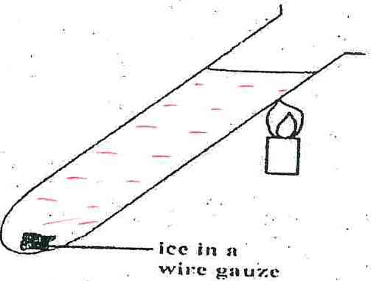
- The figure below shows an ice cube wrapped in a wire gauze and dipped in water in a test tube. The test tube is then heated at the top.Giving reason, explain what is observed.(2mks)

- On the diagram below show how the body can be acted upon by two forces 6N and 7N to give a resultant force of 1N. (2 mks)

- State twofactors that affect rate of heat transfer in solids.(2mks)

- On the graph below show how volume of water varies with temperature as it raises form 0⁰cto 10⁰c(2mks)

Volume(m³)
Temperature (ºc)

- State two effects of anomalous expansion of water (2mks)

- On heating brass-iron bimetallic strip, brass expands more than iron. Use a diagram to illustrate this (2mks)

SECTION B: 55marks
- a)What property of light is manifested by formation of shadows (1mk)

b)State two examples of luminous sources of light (2mks)

c) State two characteristics of image formed by a pinhole camera (2mks)

d)The figure shows a ray of light being reflected from a mirror.Find the angle of reflection? (2mks)
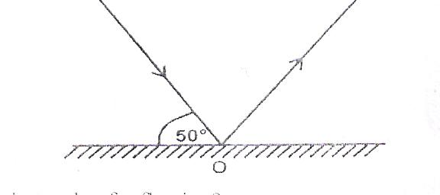

- a) Differentiate between cohesive and adhesive forces (2mks)

- The figure below shows water drops on two surfaces. In a) the glass is smeared with wax and in b) the glass surface is clean. Explain the difference in the shapes of the drops. (2mks)

- a) Differentiate between conduction and convection as modes of heat transfer. (2mks)

b)In the set up below, when the flask is heated, level of water in the tube drops and bubbles are observed from the water in the trough.Explain this observation. (2mks)

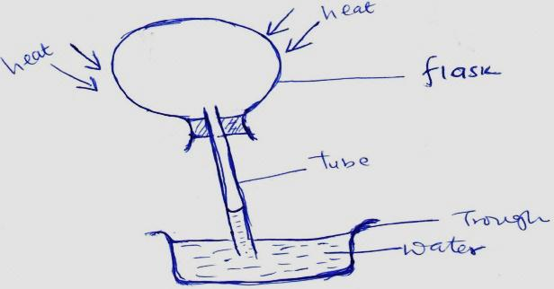

- Explain why houses in Mombasa which experiences hot weathershould be painted in white colors while those in Limuru which experiences cold weather should be painted in dull colors. (2mks)

- The figure below shows a vacuum flask
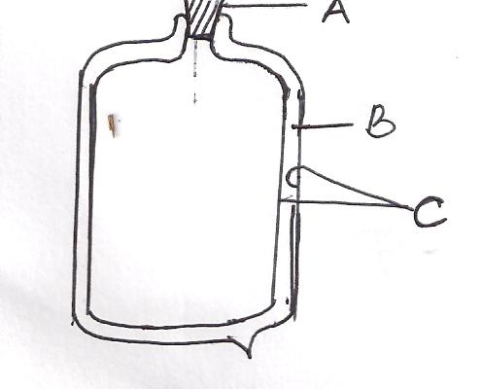

    - Name the parts labeled (3mks)
- _____________________________
- _____________________________
- _____________________________
b) Explain how the parts A, B and C minimize heat loss from the flask. (3mks)

- a)Using kinetic theory of matter, state any three differences between solids and liquids (3mks)

b) A girl weighs 400 N on the surface of the earth and 240N on the surface of the moon. If the gravitational field strength on earth is 10N/kg. Determine:
    - The mass of the girl (2mks)

    - The gravitational field strength on the surface of the moon (2mks)

- a) What is diffusion? (1mk)

b).Figure below shows a smoke cell being used to study Brownian motion. Use the diagram to answer the questions that follow.

State the purpose of the following: (3mks)
- Lamp

- Smoke particles

- Microscope

c).State and explain what is observed in the smoke cell (2mks)

d).State what is observed when temperatures in the smoke cell are raised (1mk)

- a) Define the term atmospheric pressure (1mk)

b) high-heeled shoes make deeper marks on soft ground than flat shoes. Explain. (2mks)

c) The figure below shows the measurements of a solid of mass 40 Kg and dimensions 2.5m by 2.0m by 1.3m as shown below

Determine:
- The weight of the solid. (1mk)

- The greatest pressure it can exert on a flat surface (3mks)

  - Given that the density of sea water is 1.03g/cm³, what is the pressure due to the column of water on a body which is 20m below the surface of sea water? (3mks)

  - Explain why the wall of a dam are thickerat the bottom than at the top. (2mks)

  - A hydraulic lift has a smaller piston of area 0.02m² and a larger piston of area 0.04m². If a force of 40N is applied on the smaller piston, what load can this force support on the larger piston (3mks)

- a) State the basic law of electrostatics (1mk)

b)State how you would manifest electrostatics by use of a plastic ruler and a sheet of paper (2mks)

