MARKING SCHEME
PHYSICS FORM 2

- 4
1000000

= 0.000004km

= 4.0 x 10⁻⁶ km

2. 3.9
+0.07
3.97

Actual diameter = 3.97
+0.02
3.99 cm

3. A vector quantity is a quantity which has both magnitude and direction .e.g. force,
velocity, displacement while a scalar quantity is a quantity which has magnitude only e.g.
mass, area, density, distance .

4. The metal part (blade) is a better heat conductor than wood, thus conducts heat at a faster rate
than wood. This makes it feel colder.

5. Volume of oil drop = volume of parch
9x 10 ⁻¹² = 5x10⁻³ x t
t= 9x10⁻¹²
5x10⁻³
t = 1.8 x 10⁻⁹ m
6. (i) increase /enhance sensitivity of thermometer
(ii) Magnifies the readings (markings on the glass)

7. Heat lowers surface tension. Heat causes water molecules to move fast and move further
apart reducing cohesive force.

8. Repulsion only takes place between two like poles unlike attraction which can occur
between two unlike poles or between a magnetic material.

9. Temperature
Impurities

10. (a) 11.00 (b) 10.5
+0.63 0.12
11.63 mm 10.62.mm

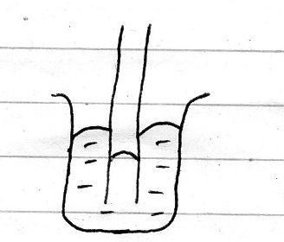
11.

The cohesive force of mercury molecules is greater than the adhesive force between mercury molecules and container molecules.

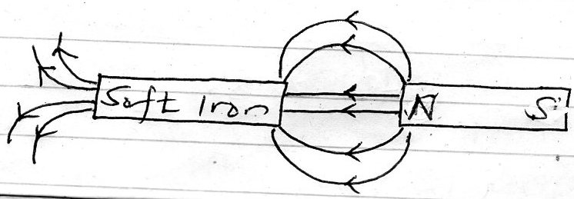
12.

13. Radiation

14 (a) Density is the mass per unit volume
S1 unit Kgm⁻³

(b) Mass of fresh water =1000x0.0001=0.1kg
Mass of sea water =1030 x 0.0001=0.103kg
Mass of mixture = 0.1+0.103=0.203 kg
Volume of mixture =0.0001+0.0001=0.0002m³

There density of mixture = 0.203
0.0002
= 1015kgm ⁻³

(c) Mass of water = 43- 18
25g
Volume of water =25cm³ (density of water =1glcm³)

Mass of alcohol 38 – 18
20g

Density of alcohol = 20
25
= 0.8gcm⁻³
= 800 kgm ⁻³

15 (a) When a body is in equilibrium the sum of clockwise moments about any point is equal to
the sum of anticlockwise moments about the same point.

(b) Sum of clockwise = sum of anticlockwise
Moments . Moments

Let weight of the stone be w.
0.5 x W = 0.1
W = 0.01
0.5
= 0.02 N

(c) (i) Stable equilibrium
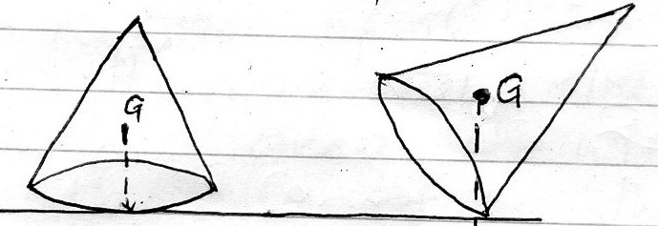

When a force is applied on the cone ,it falls back to its original position when the force is withdrawn . This is because the line of action from COG passes through the base of support of the cone.

(ii) Unstable equilibrium
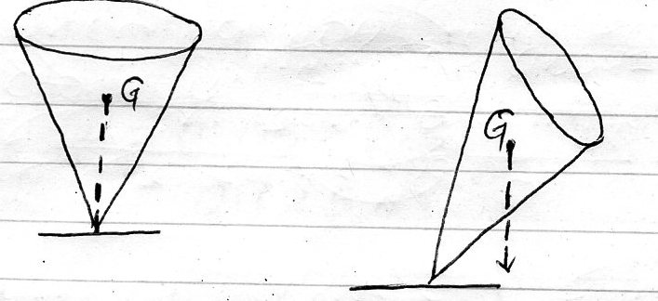

When the c one is given a slight push it topples over .the line of action of COG passes outside the area of support.

(iii) Neutral equilibrium
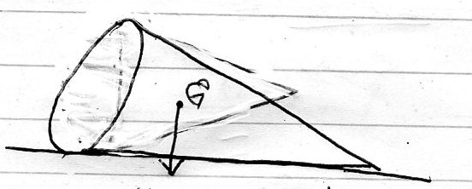

The position of the c one remains unchanged even after a force is applied . the position of the COG does not change.

(d) ( i) Position of COG the lower the C.O.G. the lower the COG the more stable the
body is.
(ii) Base area . the wider the base area , the more stable the the body is.

16 (a) Regular reflection is the reflection on a smooth surface while irregular reflection is
the reflection on a rough surface .
(b) (i) m = hi
ho
hi = 0.05 x 4
= 0.2 m

(ii) M = v
u

V= 0. 05 x2.5
= 0.125m

(c)- - literally inverted
- Same size as the object
- Virtual
- Upright
- Same distance from the mirror as the object infront of the mirror.

(d) n = 360 - 1
0
= 360 -1
20
= 17 images

17 (a)( i) To illuminate the inside of the smoke cell.
(ii) To focus light into smoke cell
(iii) To magnify /enlarge the smoke particles

(b ) Bright specks are seen in constant random motion .
( c) The motion of the smoke particles is due to collision with air molecules which are in
constant random motion
(d) The smoke particles would move faster. This is due to the increased kinetic energy of
the particles.

18 (a) Current is the rate of flow of changes SI unit ,Ampere (A)

(b) I = Q
t
= 180
2x60
= 1.5 A

(c) A primary cell cannot be charged while a secondary cell is rechargeable.

19 (a) Like charges repel unlike charges attract.

(b) The leaf falls .

( c) - To detect charge of a body .
- To test the sign of charge on a charged body
- To test the quantity of charge on a charged body
- To test for insulation properties of a material

