NAME …………………………………………………………………………………
ADM. N0…………………….……………...
DATE ………………………….
PHYSICS
FORM TWO
MARCH/APRIL 2016
MWAKICAN JOINT EXAMINATION TERM (MJET) 2016
2 Hours

INSTRUCTIONS TO CANDIDATES

- Write your name and admission number in the spaces provided above
- Attempt all questions in section A and B
- All your answers must be written in the spaces provided below each question
- All working MUST be clearly shown.
- KNEC Mathematical tables may be used
- Do not use calculators
Take g=10N/Kg.

SECTION A (25 MARKS)

1. Convert 4mm to Km and express your answer in standard form (2mks)

2. The vernier caliper below has a zero error of -0.02. if it used to measure the diameter of a ball, what is the actual diameter of the ball. (2mks)
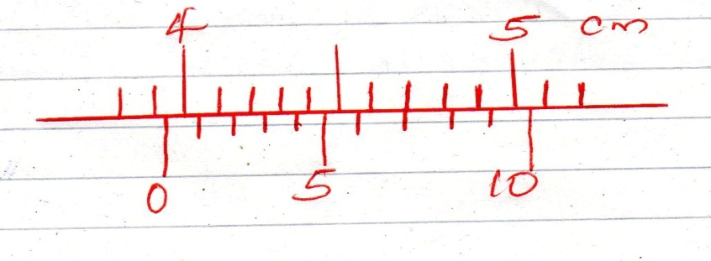

3. Distinguish between a vector quantity and a scalar quantity giving an example for each
(2mks)

4. The blade of a kitchen knife feels colder to the cheek than its wooden handle. Explain .
(2mks)

5. An oil drop forms a circular patch of area 5 x 10⁻³m². If the oil drop has a volume of 9 x 10⁻¹² m³, estimate the diameter of the oil molecule (3mks)

6. State the functions of the following features in a liquid glass thermometer

- Thin walled bulb (1mk)

- Thick walled stem (1mk)

7. Explain why a needle resting on the surface of water sinks when the water is heated
(2mks)

8. Give a reason why repulsion is regarded as the only surest test for polarity in magnetism
(1mk)

9. State two factors that affect surface tension (2mks)

10. State the value of the readings shown by the micrometer screw gauges shown below
(2mks)
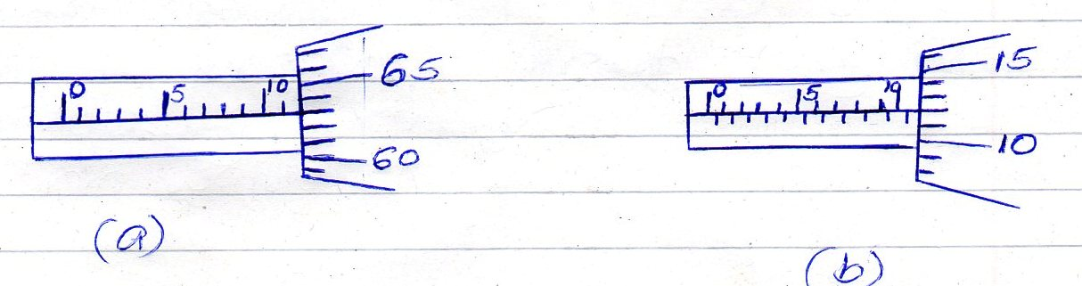

11. The figure below shows mercury placed in a container and a thin capillary tube inserted
in it.
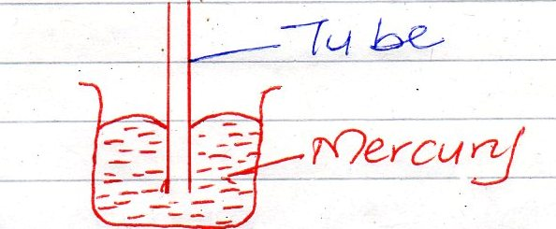

Indicate on the diagram the level of mercury in the tube. Explain your answer (2mk)

12. The figure below shows a bar of soft iron placed near a magnet

Soft Iron S N

On the same diagram, sketch the magnetic field pattern due to the set up (2mks)

13. State one mode by which heat is lost from a black can filled with hot water (1mk)

SECTION B (55MARKS)

14. (a) Define the term density and state its S1 units (2mks)

(b) 100cm³ of fresh water of density 1000Kgm⁻³ is mixed with 100cm³ of sea water of
density 1030Kgm ⁻³. Calculate the density of the mixture. (4mks)

- The mass of an empty density bottle is 18g. its mass when filled with water is 43g and when filled with alcohol its mass is 38g. calculate the density of alcohol (3mks)

15. (a) State the principle of moments (1mk)

(b) A uniform metre rule is pivoted at the 50cm mark and a stone suspended at the 0cm mark. The metre rule is balanced horizontally when a mass of 100g is suspended at the 60cm mark as shown in the diagram below.
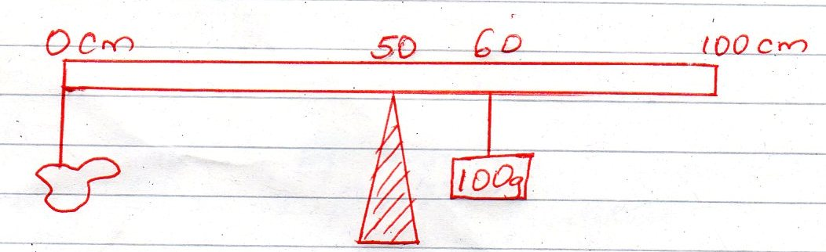

Calculate the weight of the stone (3mks)

(c) Using suitable diagrams, explain the three states of equilibrium (6mks)

(d) Explain two factors that affect the stability of a body (4mks)

16 (a) Distinguish between regular and irregular reflection (2mks)

(b) An object of height 4m is placed 2.5m away from a pinhole camera. If its magnification is 0.05, calculate the:

- Height of the image (2mks)

- Length of the pinhole camera (2mks)

(c) State three characteristics of an image formed by a plane mirror (3mks)

(d) Two mirrors are placed at an angle of 20⁰ to each other. Calculate the number of images that will be seen in the two mirrors (2mks)

17. The diagram below shows a set up used to study Brownian motion in air. Study the set up and answer the questions that follows.
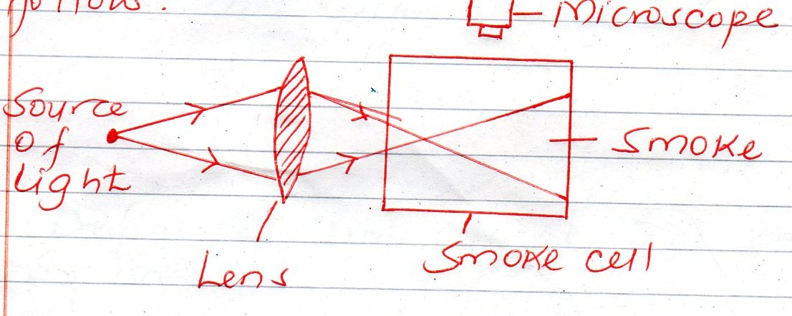

- State the function of each of the following:-

- Source of light (1mk)

- Lens (1mk)

- Microscope (1mk)

- State the observation mark in the smoke cell (2mks)

- Explain the observation made in (b) above (2mks)

- What difference would there be in the observation made in (b) above if the temperature inside the smoke cell were increased. Explain your answer (2mks)

18 (a) Define the term current and state its S1 units (2mks)

(b) A charge of 180C flows through a lamp for 2 minutes. Find the electric current following through the lamp (3mks)

(c) Distinguish between a primary and a secondary cell (2mks)

19 (a) State the basic law of electrostatics (1mk)

(b) The diagram below shows part of a gold leaf electroscope
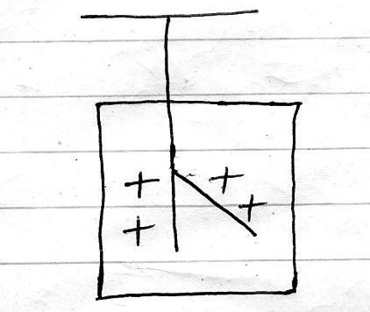

What happens to the leaf if a negatively charged rod is brought near the cap. (1mk)

(c) Stare three sues of a leaf electroscope (3mks)

