Name: ……………………………………………………Adm. No: ………………Class:……………..

232/1
PHYSICS
Paper 1
(THEORY)
NOV.
Time: 2 Hours

MWAKICAN JOINT EXAMINATION (MJET) FORM 3
TERM 3 – 2016
Kenya Certificate of Secondary Education (K.C.S.E)

PHYSICS
Paper 1
Time: 2 Hours

INSTRUCTIONS TO CANDIDATES:-
- Write your name, index number and class in the spaces provided above.
- This paper consists of two sections; A and B
- Answer all the questions in section A and B in the spaces provided
- All working must be clearly shown.
- Mathematical tables and electronic calculators may be used
- This paper consists of 9 printed pages. Candidates should check to ascertain that all pages are
printed as indicated and that no questions are missing.
- Candidates should answer the questions in English.
- Take g=10N/kg

For Examiner’s Use Only:
Section | Question | Maximum  Score | Candidate’s  Score
A | 1 – 13 | 25
 | 14 | 11
 | 15 | 9
B | 16 | 11
 | 17 | 11
 | 18 | 13
Total Score |  | 80

SECTION A: 25mks (Answer all the questions)
- State one assumption made when determining the size of a molecule in an oil drop experiment
(1 Mark)

- Air is blown into the horizontal tube as shown below.
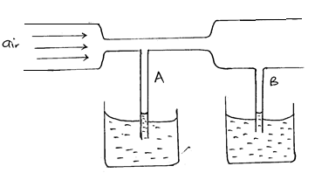
- Indicate the levels of water in tubes A and B when air passes through the horizontal tube at a high velocity. (1 Mark)

- Explain your observation in (a) above (1 Mark)

- Sketch a velocity – time graph of a body moving with uniform velocity. (1 Mark)

- The figure below shows an empty wine glass.
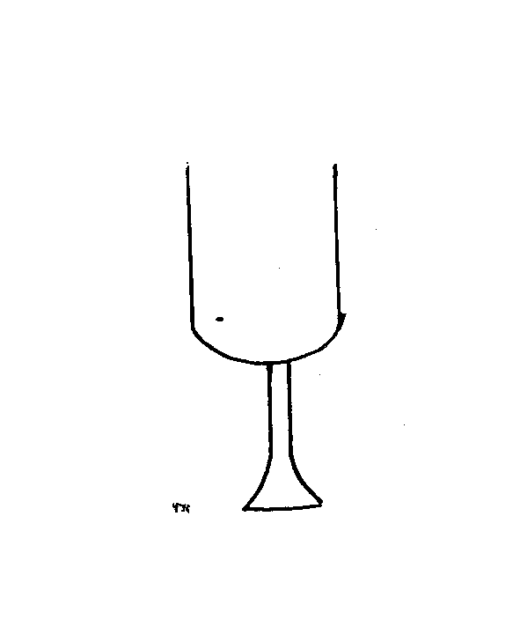
- How is its stability affected when filled with wine? (1 Mark)

- Explain the observation in (a) above (1 Mark)

- State one factor that affects heat transfer in solids. (1 Mark)

- The figure below shows a uniform bar of length 1 metre. Calculate the weight of the bar. (3 Marks)
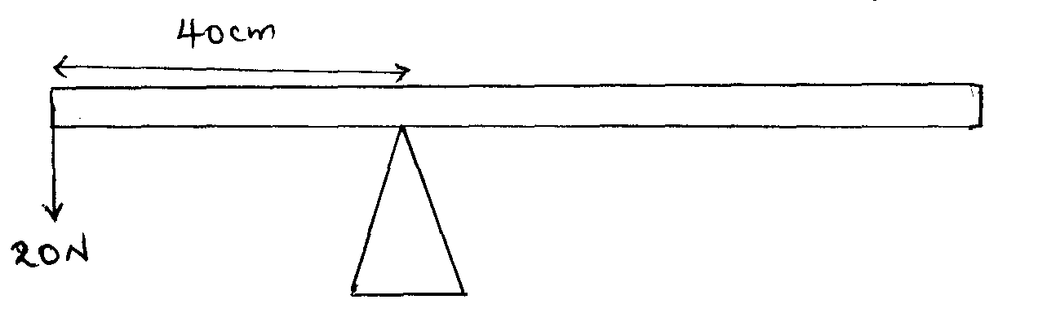

- The figure below shows a u-tube containing the liquids X and Y. Given that the density of liquid X is 1.8g/cm³, calculate the density of liquid Y in g/cm³. (3 Marks)
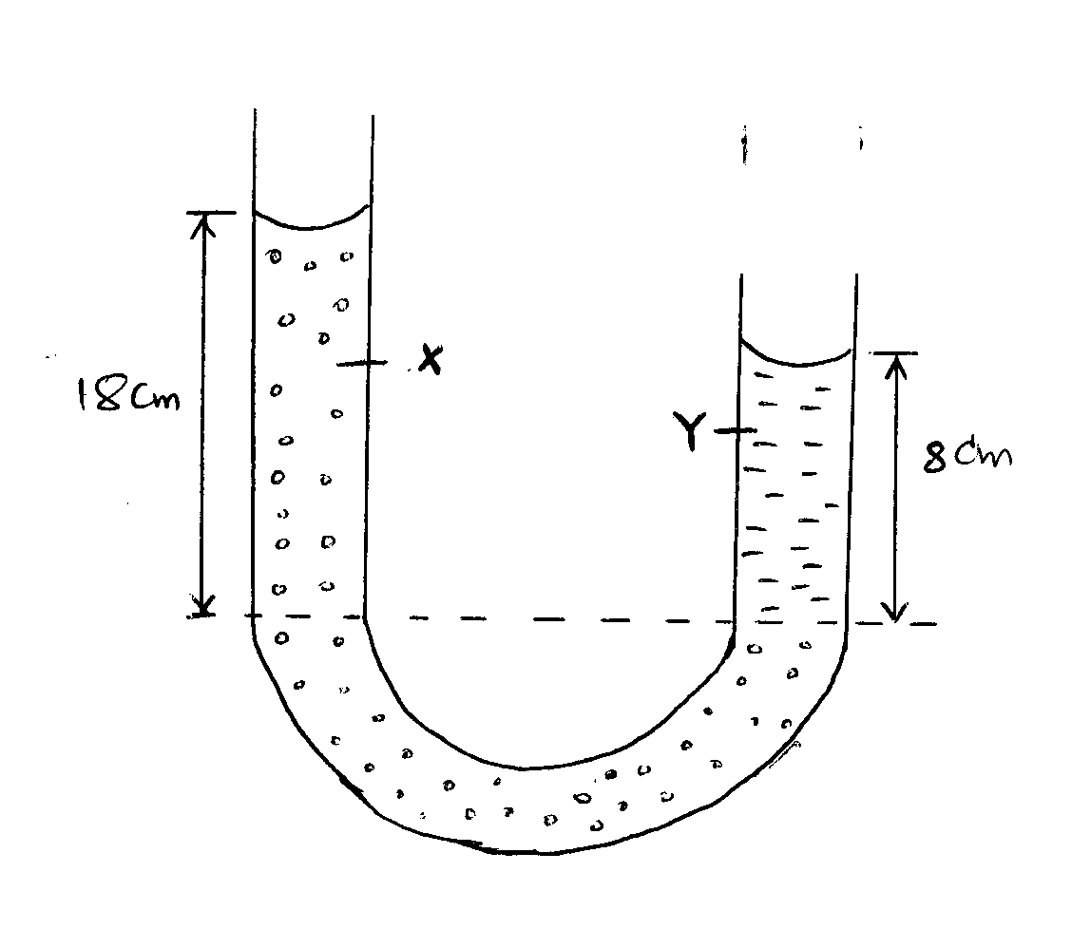

- Name one factor that affects surface tension. (1 Mark)

- When a liquid is heated in a glass flask, its level first falls and then starts rising. Explain this observation.
(2 Marks)

- The figure below shows two identical springs with negligible weight. The extension produced on the system is 10cm.
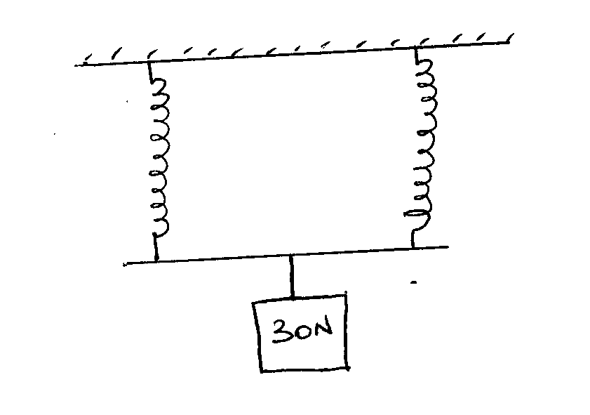
Determine the spring constant of each spring. (3 Marks)

- A body A of mass 2kg moving with a velocity of 5m/s collides with a body B of mass 30kg travelling at 2m/s in the opposite direction. If the collision is perfectly inelastic, find their common velocity after collision. (3 Marks)

- The figure below shows a velocity time graph for a trolley
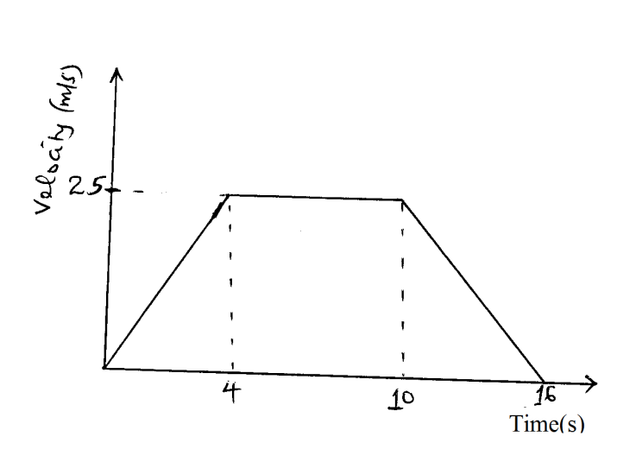
From the graph, calculate the distance covered by the trolley in the first 10 seconds (2 Marks)

- State the reason why gases are easier to compress than solids. (1 Mark)

SECTION B: 55mks
- a. State the Hooke’s law (1 Mark)

b. The table below shows the extension produced in a spring by various forces.
Extension (cm) | 0 | 0.3 | 0.7 | 1.10 | 1.5 | 1.9
Force (N) | 0 | 1.0 | 1.9 | 3.0 | 4.1 | 5.0

- Plot a graph of force against extension. (5 Marks)

- From the graph, determine the spring constant. (3 Marks)

- What force would cause an extension of 1.2cm on the spring? (2 Marks)

- The figure below shows a block and tackle system
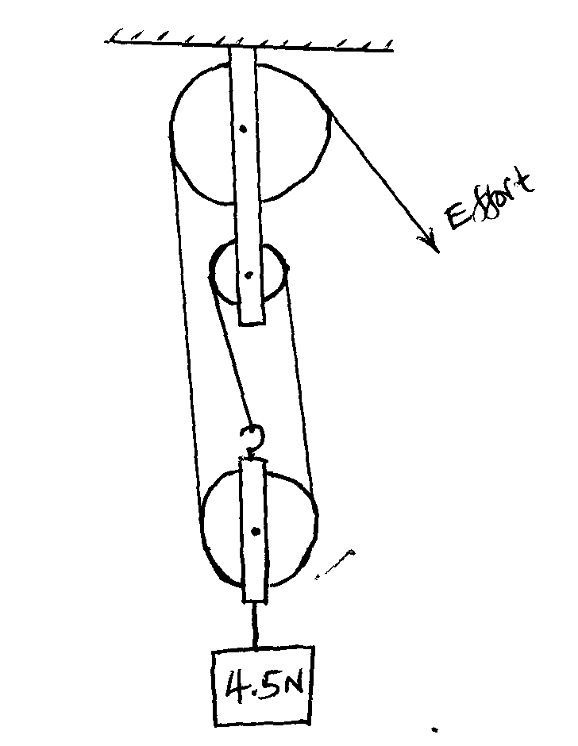
- State the velocity ratio of the system (1 Mark)

- Mark the direction of tension in the strings (1 Mark)

- If an effort of 2N is applied, calculate the mechanical advantage of the system. (3 Marks)

- Calculate the efficiency of the system. (3 Marks)

- State why the efficiency of the system is less than 100%. (1 Mark)

- A body of mass 2kg is thrown vertically upwards with a velocity of 14m/s. Determine;
- The maximum height reached by the body (3 Marks)

- Its velocity after 0.5 seconds. (3 Marks)

- The time taken to reach maximum height. (3 Marks)

- Calculate the net force acting on the ball as it moves upwards if it experiences an air resistance of 8N. (2 Marks)

- a. State the Newton’s 2nd law of motion (1 Mark)

b. A lady of mass 90kg is standing on the floor of a lift. Determine the reading on the weighing machine when
- Lift is at rest (2 Marks)

- Lift is moving upwards with an acceleration of 3m/s² (2 Marks)

c. Two masses of 4kg and 2kg are connected by a light string passing over a frictionless pulley as shown below.
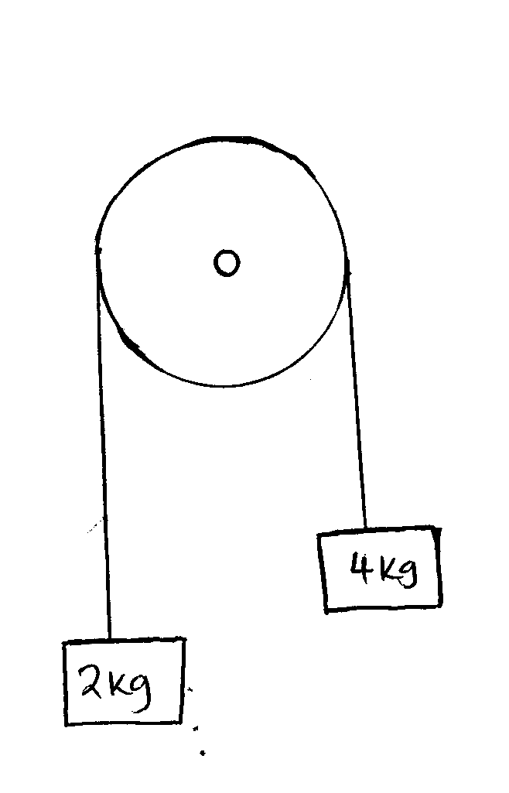
Calculate the acceleration of the masses when left to move freely. (3 Marks)

d. A block of mass 35kg is pushed along a horizontal surface whose frictional force is 20N. If the force moving the block is 100N, calculate the co-efficient of friction between the block and the surface.
(3 Marks)

- The figure below shows a hydraulic brake system.
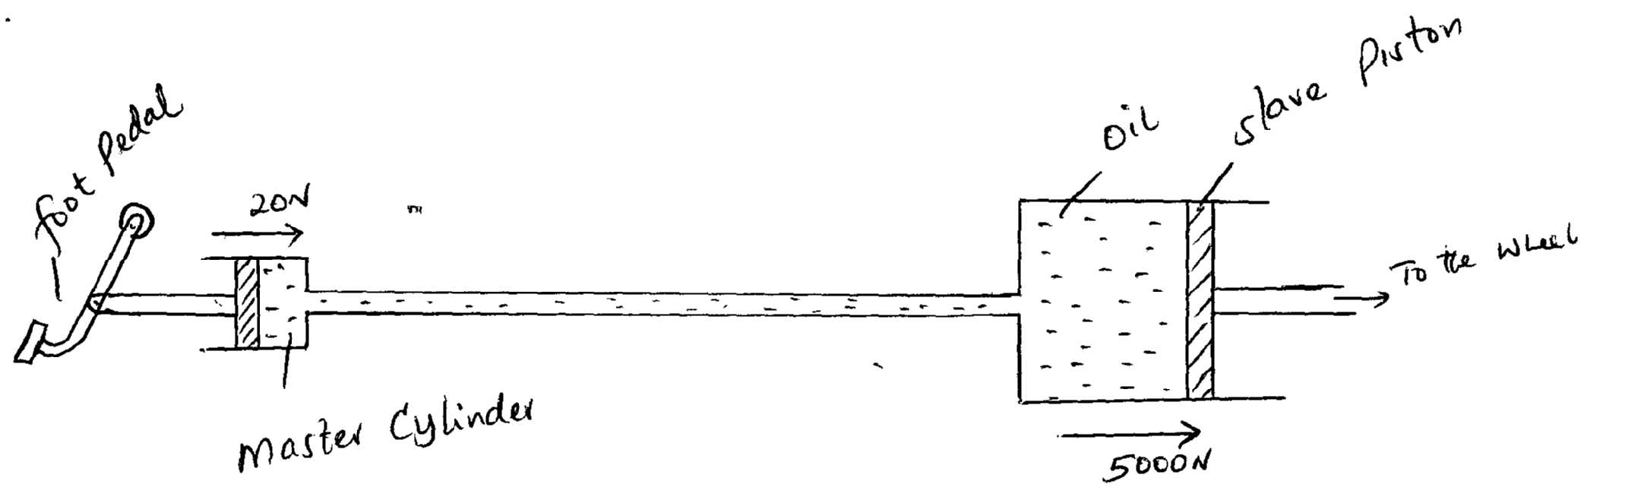
A force of 20 N is applied on the foot pedal connected to a piston of area 0.05m². This causes a stopping force of 5000N on one wheel. Calculate.
- Pressure in the master cylinder (3 Marks)

- Area of the slave piston. (3 Marks)

- Velocity ratio of the system. (3 Marks)

- Give two reasons why oil is used in the hydraulic brake system. (2 Marks)

- State two factors affecting pressure in liquids. (2 Marks)

