Name: ……………………………………………………Adm. No: ………………Class:……………..

232/1
PHYSICS
Paper 1
(THEORY)
NOV.
Time: 2 Hours

MWAKICAN JOINT EXAMINATION (MJET) FORM 3
TERM 3 – 2016
Kenya Certificate of Secondary Education (K.C.S.E)

PHYSICS
Paper 1
Time: 2 Hours

INSTRUCTIONS TO CANDIDATES:-
- Write your name, index number and class in the spaces provided above.
- This paper consists of two sections; A and B
- Answer all the questions in section A and B in the spaces provided
- All working must be clearly shown.
- Mathematical tables and electronic calculators may be used
- This paper consists of 11 printed pages. Candidates should check to ascertain that all pages are
printed as indicated and that no questions are missing.
- Candidates should answer the questions in English.
- Take g = 10N/kg

For Examiner’s Use Only:
Section | Question | Maximum  Score | Candidate’s  Score
A | 1 – 13 | 25
 | 14 | 11
 | 15 | 9
B | 16 | 11
 | 17 | 11
 | 18 | 13
Total Score |  | 80

SECTION A: 25mks (Answer all the questions)
- State one assumption made when determining the size of a molecule in an oil drop experiment
(1 Mark)
- The drop is perfectly spherical any one = 1 Mark
- The layers/ patch is one molecule thick.
- Air is blown into the horizontal tube as shown below.

- Indicate the levels of water in tubes A and B when air passes through the horizontal tube at a high velocity . (1 Mark)
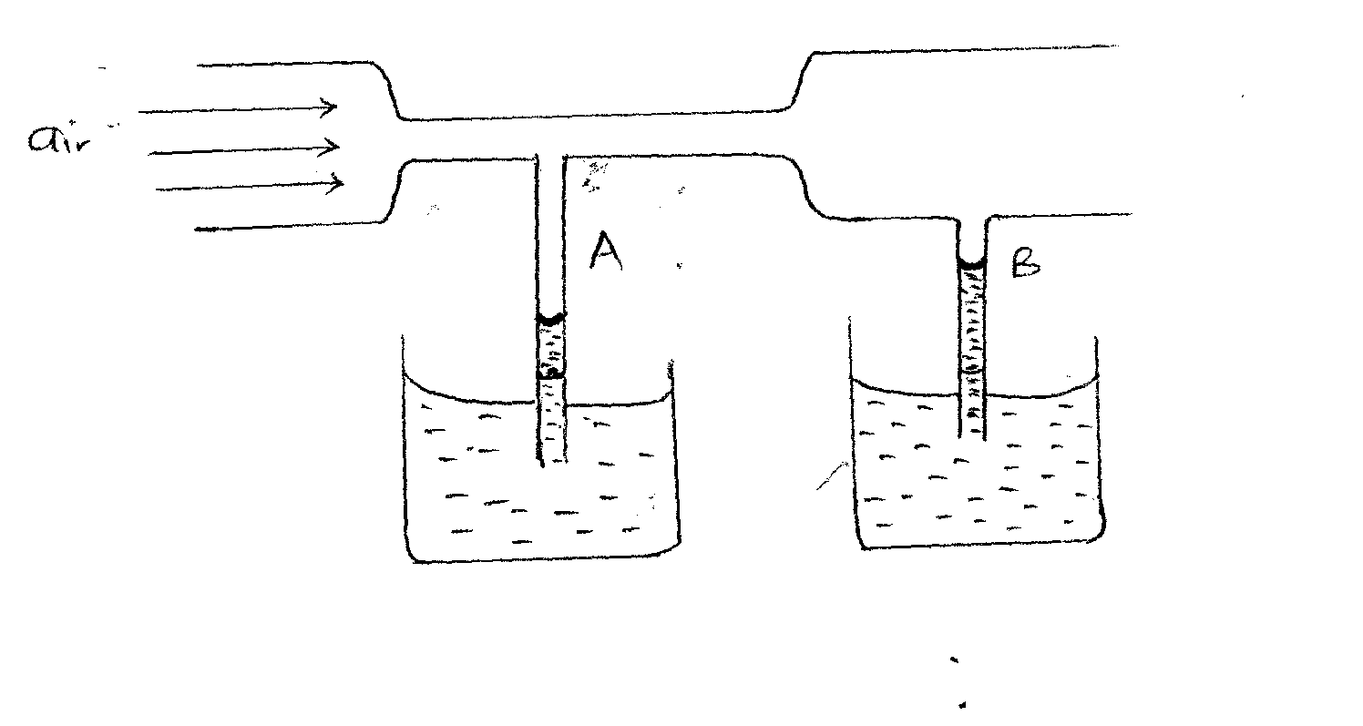
- Explain your observation in (a) above (1 Mark)
- In tube A, velocity of air above it is higher than velocity of air above tube B
- Therefore in table A, pressure is lower than tube B
- Sketch a velocity – time graph of a body moving with uniform velocity. (1 Mark)
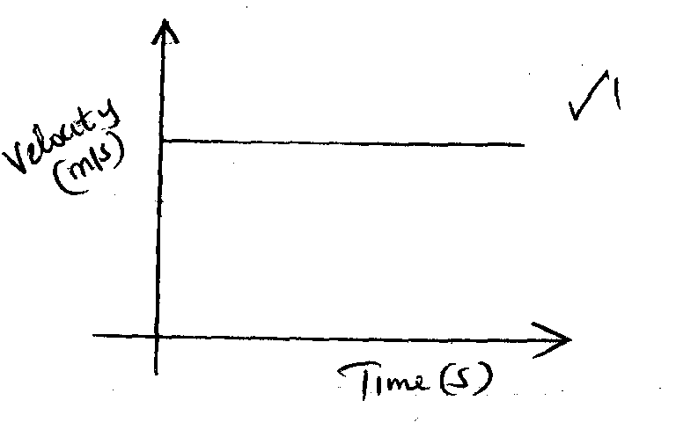

- The figure below shows an empty wire glass.
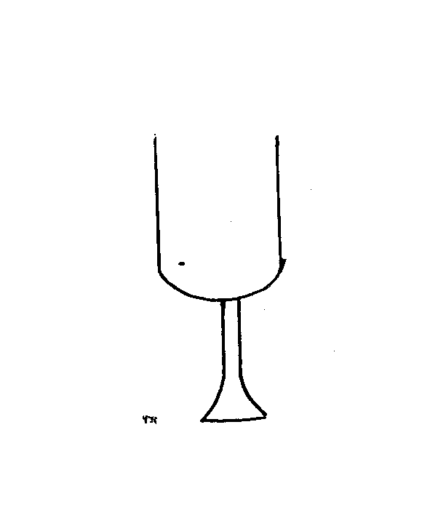
- How is its stability affected when filled with wine? (1 Mark)
- Stability is reduced
- Explain the observation in (a) above (1 Mark)
- The position of the centre of gravity is raised ¹ when more weight is added on the upper side, reducing stability
- State one factor that affects heat transfer in solids. (1 Mark)
- Length of the conductor
- Cross sectional area any one=1
- Temperature difference of the source
- Nature of the material making the conductor.
- The figure below shows a uniform bar of length 1 metre. Calculate the weight of the beam. (3 Marks)
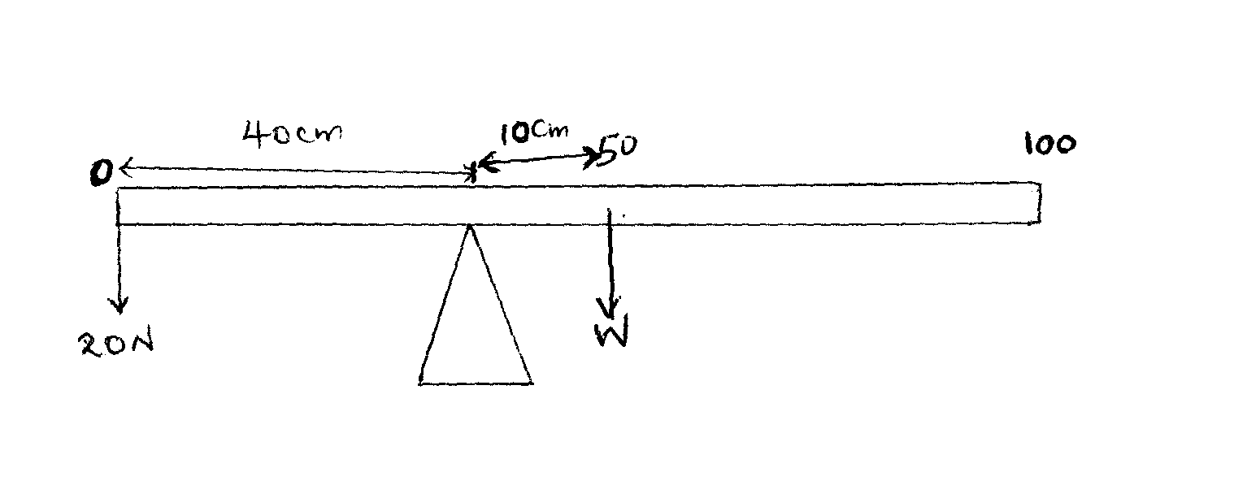
- Clockwise moments = Anti clockwise moments
$0.1×W=0.4m×20N$ $W=\frac{0.4×20}{0.1}$
$W=80N$

- The figure below shows a u-tube containing the liquids X and Y. Given that the density of liquid X is 1.8g/cm³, calculate the density of liquid Y in g/cm³. (3 Marks)
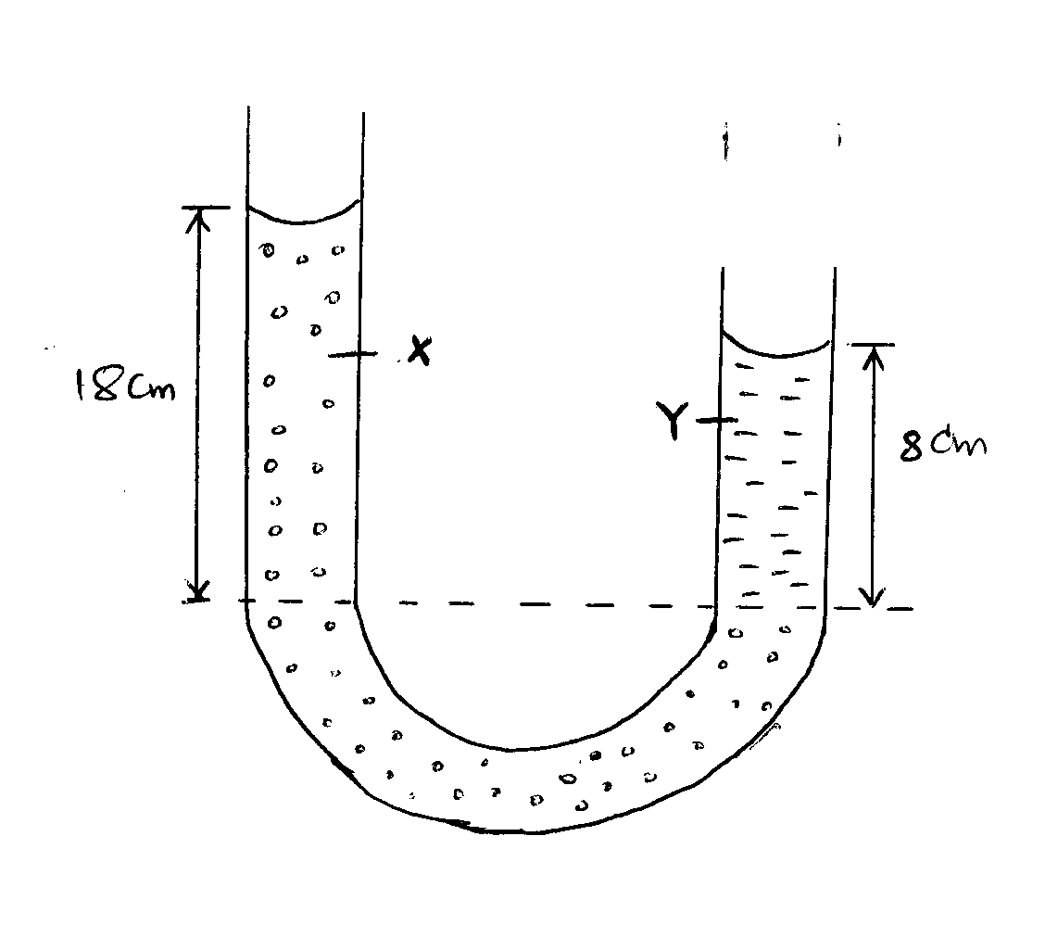

$ρ_{x}h_{x}g=ρ_{x}h_{x}g$
$ρ_{x}h_{x}$ =$ρ_{x}h_{x}$
$1.8g/cm^{3} ×18cm=ρ_{y}×8cm$
$$ρ_{y}=\frac{1.8×18}{8}$$
$ρ_{y}=4.05g/cm^{3 }$
- Name one factor that affects surface tension. (1 Mark)
- Temperature
- Impurities
Any= 1
- When a liquid is heated in a glass flask, its level first falls and then starts rising. Explain this observation.
(2 Marks)
- The level first dropped due to expansion of glass 1
- The level then started rising when the heat reaches the water. 1
- The figure below shows two identical springs with negligible weight. The extension produced on the system is 10cm
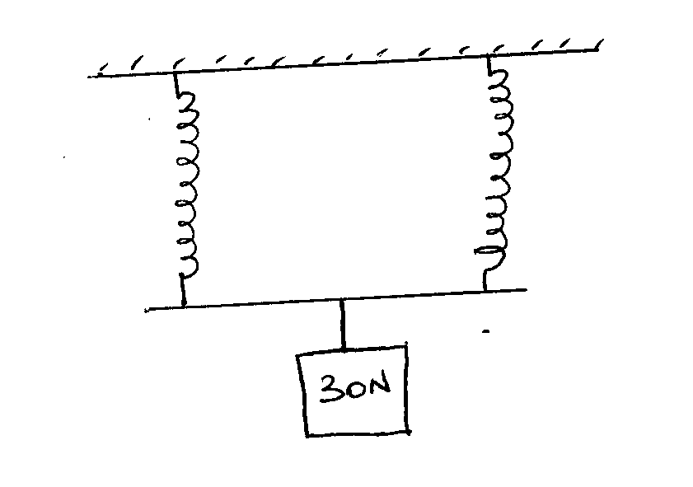

Determine the spring constant of each spring. (3 Marks)
$combined spring constant =k_{1}+k_{2}$
$for identical spring, k_{e}=2k$
$f=2ke$
$30N=2k×0.1m$
$2k=\frac{30N}{0.1m}$
$2k=300N/m$
$k=150N/m$
- A body A of mass 2kg moving with a velocity of 5m/s collides with a body B of mass 30kg travelling at 2m/s in the opposite direction. If the collision is perfectly inelastic, find their common velocity after collision. (3 Marks)
$m_{1}u_{1}+ m_{2}u_{2}= {(m}_{1}+m_{2})$V
$(2kg×5m/s )+(30kg×-2m/s )=(30kg+2kg)V$
$10kgm/s -60kgm/s=32kgV$
$V=-1.56m/s$
$moves in the direction of 30kg body$
- The figure below shows a velocity time graph for a trolley
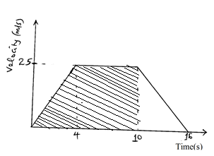
From the graph, calculate the distance covered by the trolley in the first 10 seconds (2 Marks)
Distance = Area under the graph from 0-10seconds
$Area=\left(\frac{6+10}{2}\right)×25$
$8×25=200m$
Distance = 200m
- State the reason why gases are easier to compress than solids. (1 Mark)
- Gas particles have larger intermolecular distances than solids

SECTION B: 55mks
- a. State Hook’s law (1 Mark)
For a helical spring or any other elastic material, the extension is directly proportional to the stretching force, provided that elastic limit is not exceeded.
b. The table below shows the extension produced in a spring by various forces.
Extension (cm) | 0 | 0.3 | 0.7 | 1.10 | 1.5 | 1.9 | 2.4
Force (N) | 0 | 1.0 | 1.9 | 3.0 | 4.1 | 5.0 | 8.0

- Plot a graph of force against extension. (5 Marks)
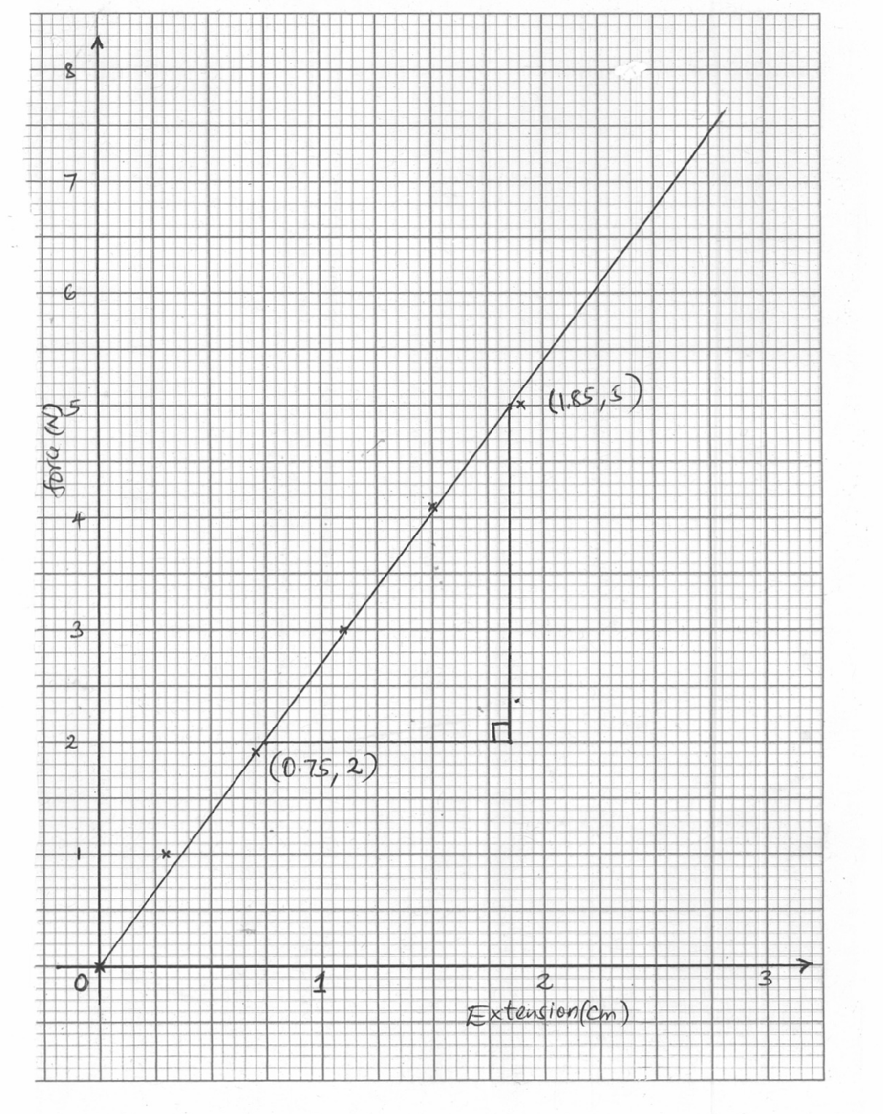
- From the graph, determine the spring constant. (3 Marks)
Gradient = Spring constant
$K=\frac{5-2}{1.85-0.75}$
$K=\frac{3}{1.1}$
$K=2.73 N/cm$
- What force would cause an extension of 1.2cm on the spring? (2 Marks)
Force = Ke
F = 2.73N/cm X 1.2cm
F = 3.276 N
- The figure below shows a block tackle system
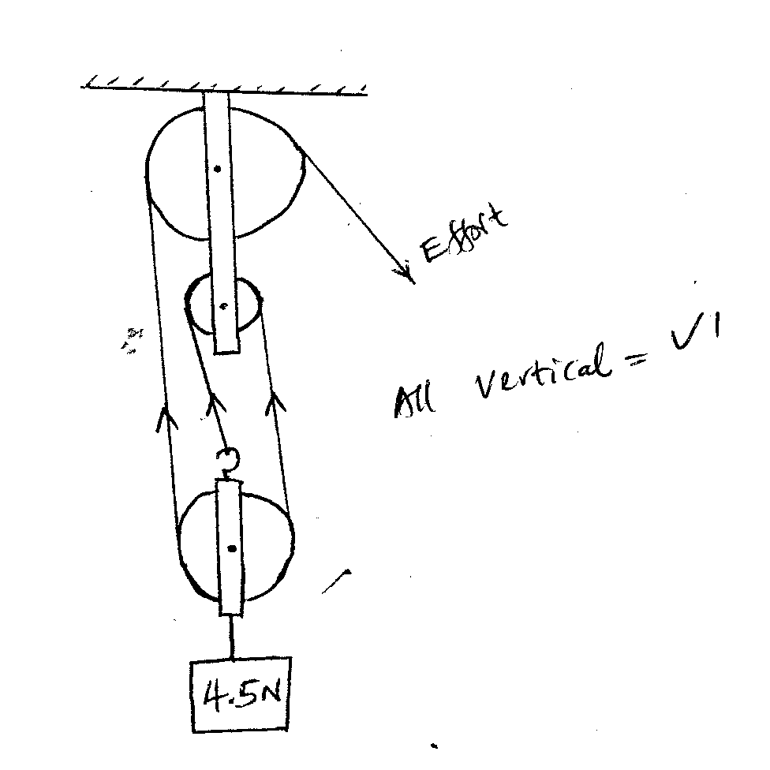
- State the velocity ratio of the system (1 Mark)
3
- Mark the direction of tension in the springs (1 Mark)
All vertical tensions1
- If an effort of 2N is applied, calculate the mechanical advantage of the system. (3 Marks)
$MA=\frac{Load}{Effort}$
$MA=\frac{4.5N}{2N}$
$MA=2.25$

- Calculate the efficiency of the system. (3 Marks)
$Efficiency=\frac{MA}{VR}×100\%$
$\frac{2.25}{3}×100\%$
$Eff=75\%$
- Explain why the efficiency of the system is less than 100%. (1 Mark)
- Weight of the pulley blocks/ dead weight 1
- Friction
- A body of mass 2kg is thrown vertically upwards with a velocity of 14m/s. Determine;
- The maximum height reached by the body (3 Marks)
$V^{2}=U^{2}-2gh$
$V=0$
$U^{2} 2gh$
${14}^{2}=2×10×h$
$h=\frac{196}{20}$
$h=9.8m$
- Its velocity after 0.5 seconds. (3 Marks)
$V=u-gt$
$V=14m/s-(10×0.55)$
$$V=14-5$$
$V=9m/s$
- The time taken to reach maximum height. (3 Marks)
$V=u-gt$
$O=14m/s-10t$
$10t=14$
$T=\frac{14}{10}=1.4 seconds$
- Calculate the net force acting on the ball as it moves upwards if it experiences an air resistance of 8N. (2 Marks)
$Net force =mg-Air resistance$
$= (2kg×10N/kg)-8 N$
$=20N-8N$
$=12N$
- a. State the Newton’s 2nd law of motion (1 Mark)
The rate of change of momentum of a body is directly proportional to the force applied and take place in the direction of the force
b. A lady of mass 90kg is standing on the floor of a lift. Determine the reading on the weighing machine when
- Lift is at rest (2 Marks)
$At rest Reaction =mg$
$=90Kg ×\frac{10N}{kg}$
$= 900N$
- Lift is moving upwards with an acceleration of 3m/s² (2 Marks)
$R=mg+ma$
$=\left(90×10\right)+(90×3)$
$= 900N+270N$
$=1170N$
c. Two masses of 4kg and 2kg are connected by a light string passing over a frictionless pulley as shown below.
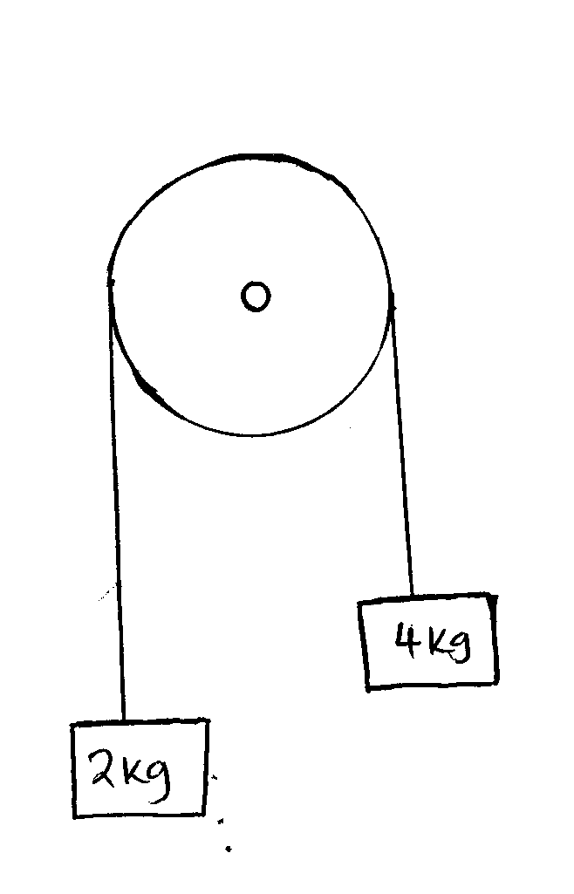
Calculate the acceleration of the masses when left to move freely. (3 Marks)
$Net force=40N-20N=20N$
$Force=Mass×acceleration$
$20N=6kg×a$
$a=\frac{20N}{6kg}=3.33{m/s}^{2 }$

d. A block of mass 35kg is pushed along a horizontal surface whose frictional force is 20N. If the force moving the block is 100N, calculate the co-efficient of friction between the block and the surface.
(3 Marks)

$μ=\frac{F}{R}$
$μ=\frac{20N}{350N}$

$μ=0.06$

- The figure below shows a hydraulic brake system.
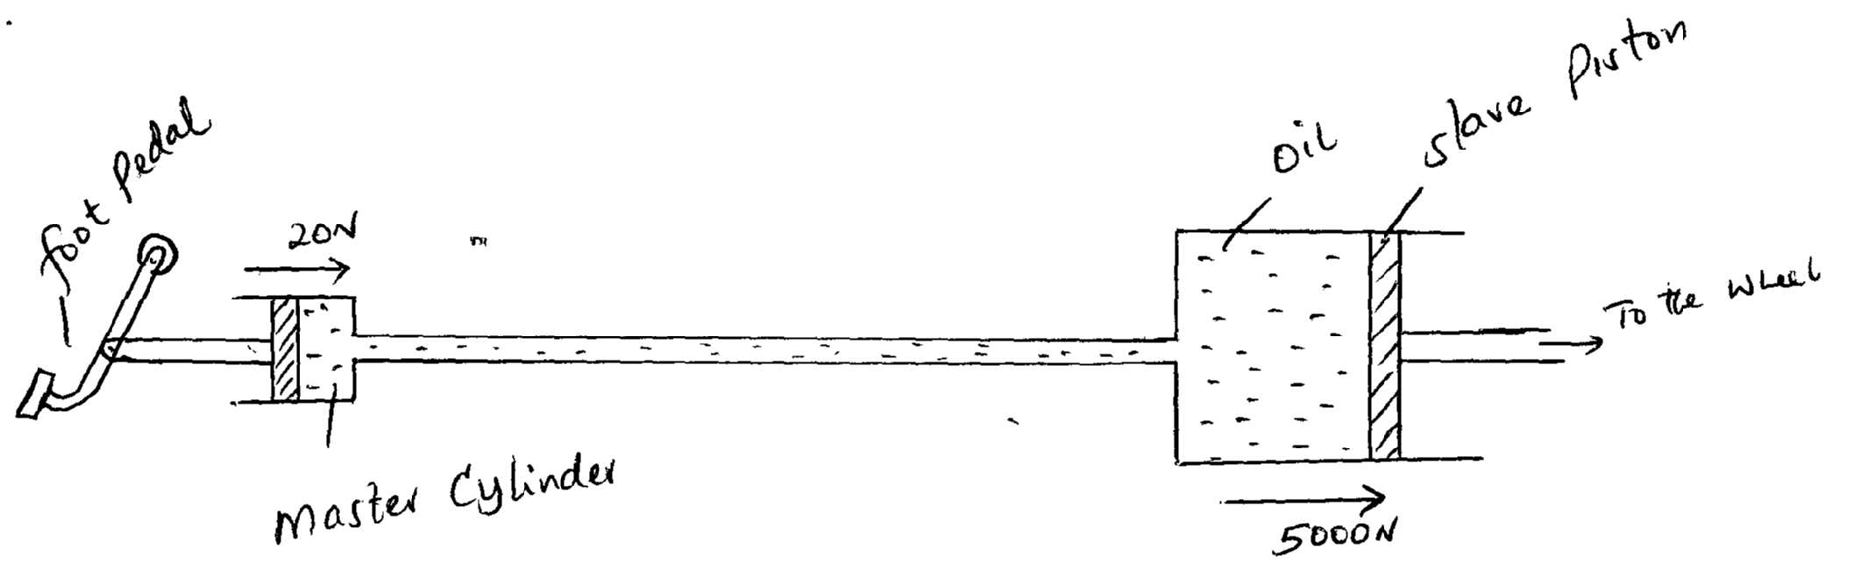
A force of 20 N is applied on the foot pedal connected to a master piston of area 0.05m². This causes a stopping force of 500N on one wheel. Calculate.
- Pressure in the master cylinder (3 Marks)
$Pressure=\frac{force}{area}$
$=\frac{20N}{0.05m^{2 }}$
$Pressure=400N/m^{2 }$
- Area of the slave piston. (3 Marks)
$Pressure is transmitted equally$
$\frac{400N}{m^{2 }}=\frac{5000N}{Area}$
$Area=\frac{5000}{400}$
$Area=12.5m^{2}$
- Velocity ratio of the system. (3 Marks)
$V.R=\frac{Area of the load piston}{Area of effort piston}$
$V=R=\frac{12.5}{0.05}$
$=250$
- Give two reasons why oil is used in the hydraulic brake system. (2 Marks)
- Incompressible 1
- Does not corrode the system 1
- State two factors affecting pressure in liquids. (2 Marks)
- Density
- Depth of the liquid Each = 1

