MWAKICAN MARKING SCHEME PHYSICS FORM 3 TERM 3 2016

- (a) The ammeter reading decreases.

(b) The resistance of the metal increases with increase in temperature.

- 5 + 1 = 360
Ѳ

Ѳ = 360 = 60⁰
6

- (a)

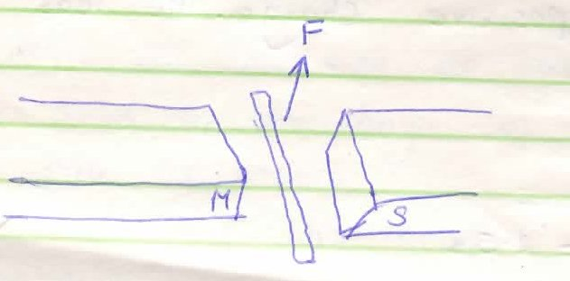

(b) - Direction of magnetic field.

- Direction of current in the conductor.

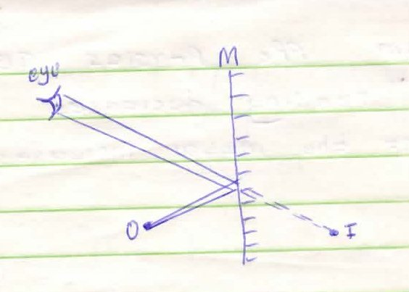

- On earthing negative charges are repelled to the ground. When the rod is withdrawn, the leaf is left with a net positive charge. The leaf rises.

- Speed = 2d
t

t = 500 = 2.5 s
20

Speed = 2 x 400 = 320ms⁻¹
2.5

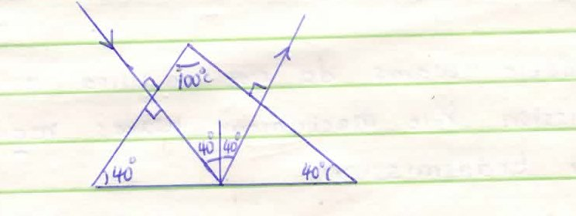

- Hydrogen gas bubbles at the cathode.
- White deposit forms at the plates.
- Relative density of the electrolyte drops.

- (a)(i)

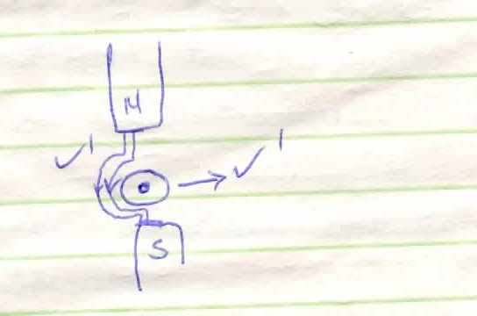

- From N - S ; around conductor

- - Nail is hammered in North – South direction.
- Earth’s magnetic field aligns dipoles of the nail in one direction.

- (i) Focal plane is a plane passing through the focal point and perpendicular to
the principal axis.

(ii) Produces as - Upright image
- Magnified image
- Virtual

SECTION B

- a.
    - Frequency not affected
    - Speed reduces
    - Wavelength reduces
  - $f=\frac{v}{ƛ}=\frac{0.02}{0.08}=1.5Hz$
  - Stationary wave Progressive wave
- No energy is transferred from source - energy is transferred from source
- Wave form does not appear to move - wave form moves away continuously

  - (i) Time taken to make one complete oscillation

10 x 10⁻² seconds

(ii) F = I
T

I
10 x 10⁻² = 10Hz

(iii) V = λf
X = v
f
= 200 = 20m
10

  - Mechanical waves require material medium for transmission but electromagnetic waves do not
- a.
- Rectification smoothing circuits
- Turning circuits
- Camera flash
(any one correct)

b.i. $\frac{2×8}{2+8}=\frac{16}{10}=1.6µF$
1.6+3.2=4.8µF
$C_{T}=\frac{5×4.8}{5+4.8}=\frac{24}{9.8}=2.45×{10}^{-6}F$
ii. Q=CV
$2.45×10^{-6}×12=2.94×10^{-5}C$
Charge on $3.2µF=\frac{2}{3}×2.94×10^{-5}$
=1.96 X $10^{-5}$
iii. P.d on 5µF =$\frac{Q}{C}=\frac{2.94×10^{-5}}{5×10^{-6}}=5.88V$
iv. Energy = ½ CV²
= ½ $×2×10^{-6}×6.12^{2}$
=3.75 X $10^{-5}$
c. - Area (cross sectional area)
- length of a conductor

- (a) A current flowing through a conductor is directly proportional to the potential difference across it provided the temperature and other physical conditions are kept constant.

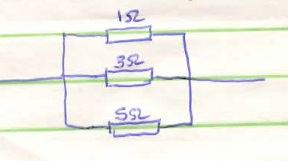
(b) 1 - 1 + 1 + 1 = 5 + 15 + 3 = 23
R_{T} 3 1 5 15 15

RT = 15 = 0.6522 Ω
23

C(i) 3 + 20 x 30 = 3 + 60 = 4.2Ω
20 + 20 50

(ii) I = V = 1.8 = 0.428 A
R 4.2

(iii) V = 1R = 0.428 x 3 = 1.2857 V

- a) The ratio of the sine of angle of incidence to the sine of the angle of refraction is constant.

(b) P = Real depth
Apparent depth
1.56 = 10
X

1.56 x = 10

X = 10 = 6.410
1.56

Vertical displacement = 10 - 6.410 = 3.59cm

(c)(i) n = Velocity of light in vacuum
Velocity of light in medium

n = 3.0 x 10⁸
1.94 x 10⁸

= 1.546

(ii) I = 1.546
Sin C

Sin C = 1
1.546

C = 40.30⁰

(d) - Minimal energy loses due to total internal reflection.
- Large quantity of data can be converted per second or unit time.
- Its flexible.

