PHYSICS FORM 3 PAPER 1
MARKING SCHEME
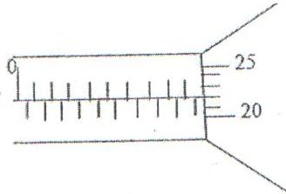
- The micrometer screw gauge represented by figure 1 below has a thimble scale of 50 divisions. What is the reading shown? (1 mk)

Reading 9.75mm
- Figure 2 shows a uniform bar of length 1.0m pivoted near one end. The bar is kept in equilibrium by a spring balance.

Given that the reading of the spring balance 0.6N, determine the reaction on the pivot. (3 mks)
At equilibrium, clockwise moments = anticlockwise moments
Taking moments about the pivot,
0.6N x 0.8 = W x 0.4
W = $\frac{0.48}{0.4}$
W = 1.2N
The sum of parallel forces always equals zero, hence
Reaction = (1.2 – 0.6) N.
= 0.6N

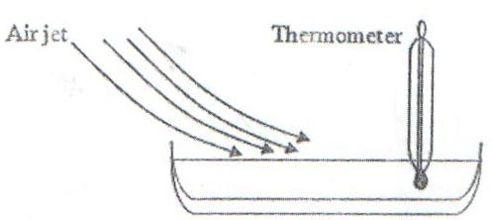
- Figure 3 shows a shallow dish containing a volatile liquid. The bulb of a thermometer is held inside the liquid. A jet of air is blown over the surface of the liquid, so that the liquid evaporates rapidly.

State and explain what happens to the reading shown on the thermometer. (3 mks)
The reading indicated by the thermometer drops instantly. This is because the jet of air blown over the surface causes a rapid increase in evaporation which causes cooling of the liquid.

- Figure 4(a) shows a glass ornament standing on a shelf. Figure 4(b) shows an identical ornament filled with colored glass beads.

State which ornament is more stable and why. (2 mks)
A is more stable the base is broad and it is lighter. B is unstable because the heavy weight placed on top raises its C.O.G.

- 100g of water of density 1g/cm³ is mixed with 60g of a liquid of relative density 1.2. Assuming no change in volume, find the density of the mixture. (2 mks)
Density = $\frac{Total mass}{Total volume}$
Volume of water = $\frac{Mass}{Density}$
= $\frac{100g}{1 g{cm}^{3}}$
= 100cm³
Volume of liquid = $\frac{60}{1.2}$ = 50cm³
Density = $\frac{100+60}{100+50}= \frac{160}{150}$
= 1.067g/cm³

- An object of mass ‘m’ has a weight ‘w₁’ in air and ‘w₂’ in water. Suggest a reason why w₁ is greater than w₂. (1 mk)
The upthrust in water is much grater than the upthrust in air.

- State the significance of the closeness of streamlines in fluids. (1 mk)
The speed of streamlines is much higher where the streamlines are close and slower where the streamlines are apart.

- A thin metal disc has a hole passing through its center. What would happen to the size of the hole if the disc were heated? (1 mk)
The size of the hole would become bigger due to the expansion of the disc.

- State two factors, which can cause the temperature at which water boils to rise. (2 mks)
Pressure
Impurities

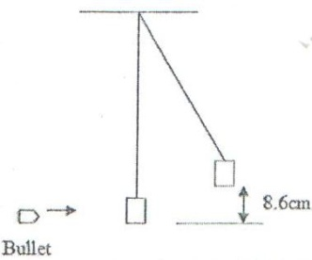
- A bullet of mass 2.0g is fired horizontally into a block of wood of mass 600g. The block is suspended from strings so that it is free to move in a vertical plane. The bullet and the block rise together through a vertical distance of 8.6cm as shown in figure 5.

Determine the speed of the bullet before the impact with the block. (3 mks)
If the velocity of both after impact is V, then K.E = P.E
½ mV² = mgh
½ V² = gh
V² = 2gh, = 2 x 10 x 0.086
V = 1.31m/s
Let the velocity of the bullet be v.
Momentum before impact is = momentum after impact
0.002 kg x v + 0 = 0.602 kg x 1.31 v=394.3 m/s

- The figure below shows a uniform plank of wood of length 1.2m pivoted near one end. The plank is kept in equilibrium by a string as shown S.
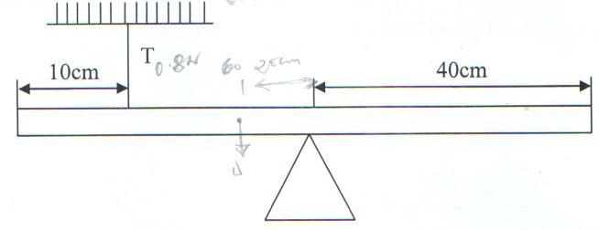
20 cm

W

Given that the tension T in the string is 0.8N, determine the reaction force at the pivot.(3 mks)
At balance
CMM = Anti CMM
50x0.8 = 20 x W
W = $\frac{50×0.8}{20}$
= 2.0N (1)
Also Algebraic sum of forces = 0 at balance (1)
$∴$ 0.8 + R = 2.0N
R = 1.2N (1)

- Give a reason why heat transfer by radiation is faster than heat transfer by conduction.(1 mk)
Heat transfer by radiation travels at the speed of light while by conduction it is through molecule to molecule.

- In the diagram in figure 6, water flows through a section of a pipe whose diameter changes.
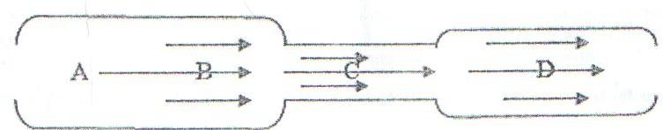

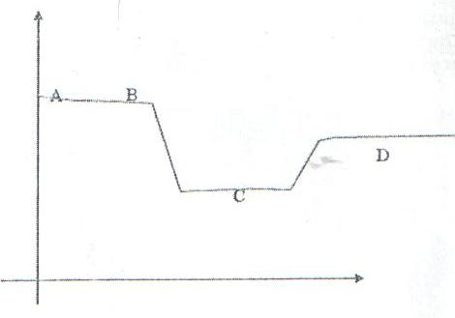
Sketch a graph of the variation of pressure along the line ABCD. (2 mks)

SECTION B:
- (a) The figure below shows a section of a ticker tape. The dots were made at a frequency of 50Hz.

Determine the acceleration of the trolley pulling the tape. (3 mks)
t = $\frac{1}{50}$
= 0.02S
VA = $\frac{2}{0.02}$
= 100cms⁻¹
VB = $\frac{3}{0.02}$
= 150cms⁻¹
A = $\frac{VB-VA}{T}$
= $\frac{150-100}{7×0.02}$
= $\frac{50}{0.14}$
= 357.14cms⁻²
(b) A body starts from rest and accelerates at 2 m/s² for a time of 5 seconds, calculate:
- Its final velocity. (2 mks)
U=0ms-1
a= 2ms⁻²
t=5s
v=?
v=u+at (1mk)
= 0+2x5
= 10ms⁻¹ (1 mk)

- The distance travelled. (2 mks)
S = ut+ ¹/₂at² (1 mk)
= 0x5+¹/₂x2x5²
= 25m (1 mk)

(c) State Newton’s 2nd Law of motion. (1 mk)
The rate of charge of momentum is directly proportional to the applied force and take place in the direction of force.

(d) A hammer of mass 2 kg strikes a nail with a velocity of 9m/s and is stopped by the force of reaction in 0.025s. find the force of the acting on the nail. (2 mks)
M=2 kg
u = gms⁻¹
v=0ms⁻¹
t=0.025s
f = ?
F = $\frac{m(v-m)}{t}$ (1 mk)
= $\frac{2(0-9)}{0.025}$
= 720N (1 mk)

(e) A body is released from a height, h. if the acceleration due to gravity is g, derive an expression of the velocity of the stone just before hitting the ground. (3 mks)
s = h
a = g
v = ?
u = o
s = avevelo x time
= $\left(\frac{u+v}{2}\right)\left(\frac{v-u}{a}\right)$
S =$\frac{v^{2}-u^{2}}{2g}$
2gs = v² – u²
V² = u² + 2gs
V² = u² + 2gs
But u = 0
$∴$ V² = 2gs
$v= \sqrt{2gs}$

(f) The figure below shows a velocity – time graph of a body in motion – sketch on space provided a displacement – time graph of the motion. (2 mks)
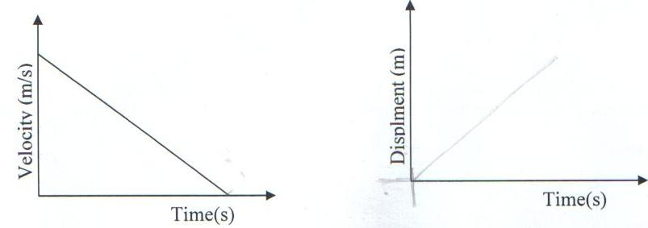

- A burette is filled with oleic acid drop upto the 15.5cm³ ark. After 50 drops of the oil were let out of the burette the level of the oil dropped to 22.5cm³.
- Determine the volume of one drop of the oleic oil. (3 mks)
50 drops = 22.5
15.5 (1 mk)
7.0
1 drop = $\frac{7.0}{50}$ (1 mk)
= 0.14cm³ (1 mk)

- One drop of the oleic oil is carefully introduced onto a clean surface of a trough. It spread to a patch. Determine the thickness of each oleic oil molecules in metres. (Assuming the radius of drop = radius of patch). (5 mks)
Vol of the drop = vol of the patch
$∴$ $\frac{4}{3}{πr}^{3}$ = ${πr}^{2}×t$ (1 mk)
But $\frac{4}{3}{πr}^{3}=0.14$ (1 mk)
$r^{3}$ = $\frac{0.14×3}{4π}$
r = $\sqrt[3]{\frac{0.14×3}{4π}}$
= 0.322 cm (1 mk)
Hence 0.14 = πx0.322²xt (1 mk)
t = $\frac{0.14}{πx{0.322}^{2}}$
= 0.4298 cm (1 mk)
- State two assumptions made in part (b) above. (2 mks)
- Oil spread to one molecule thick. (1 mk)
- No evaporation took place. (1 mk)

- The table below shows the values of extensions of a spiral spring when various forces are applied to it.
Force F, (N) | 0 | 1.2 | 2.0 | 3.0 | 4.0 | 5.0 | 6.0
Extension R, (cm) | 0 | 0.8 | 1.5 | 2.3 | 3.1 | 3.8 | 4.6
- On the grid provided, plot a graph against the extension. (5 mks)
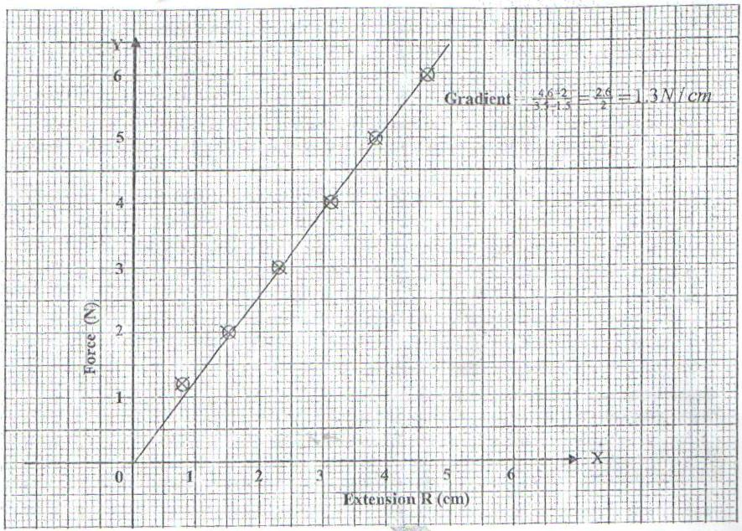

- From the graph, determine the work done in stretching the spring by 4cm. (3 mks)
Work done = ½ ke² (where k is the spring constant)
K = F/e = gradient = 130N/m (from the graph) (1 mk)
= ½ x 130 x 0.04² (1 mk)
W = 0.104J (1 mk)
- Differentiate between mechanical advantage and velocity ratio. (2 mks)
M.A is the ratio of load to effort
V.R is the ratio of distance moved by the effort to that moved by the load.

- An effort of 125N is used to lift a load of 500N through a vertical height of 2.5 m using a pulley system. If the distance moved by the effort is 1.5 m, calculate the;
- Work done on the load. (2 mks)
W = Fs (1 mk)
= 500x2.5
= 1250 J (1 mk)

- Work done by the effort. (2 mks)
W = Fs (1 mk)
= 125 x 15
= 1875 N (1 mk)

- Efficiency of the system. (2 mks)
R = $\frac{work output}{work imput} ×100$
= $\frac{1250}{1875}×100$
= 66.67%
- Draw a well labeled diagram of the pulley used in (b) above. (3 mks)
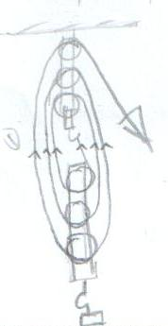
V.R = $\frac{distance moved by effort}{distance moved by load}$ or No of roaps supporting load (1 mk)
= $\frac{15}{25}$
= 6 (1 mk)

- Suggest one method of improving the efficiency of the system. (1 mk)
- Reducing friction between the pulleys (1 mk)
- Lifting more weights as M.A increases with weight being lifted. (1 mk)

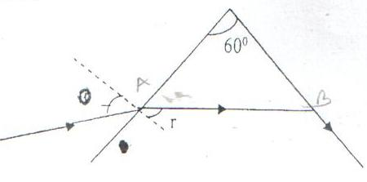
- The figure below shows path of ray of yellow light through a glass prism. The speed of yellow light in the prism is 1.88x10⁸m/s.

- Determine the refractive index of the prism material for the light (speed of light in vacuum=3.0 x 10⁸m/s). (3 mks)
n = $\frac{c}{v}$ (1 mk)
= $\frac{3×{10}^{8}}{1.88×{10}^{8}}$ (1 mk)
= 1.596
= 1.6 (1 mk)

- (i) Show on the diagram the critical angle. (1 mk)

- Given that r=21.20, determine angle Ɵ. (3 mks)
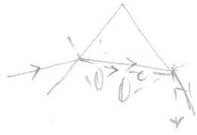
n = $\frac{\sin{i}}{\sin{r}}$ (1 mk)
1.59 = $\frac{\sin{Ɵ}}{\sin{21.2}}$
$\sin{θ}$ = 1.5 Sin 21.2 (1 mk)
Ɵ = 35.25 (1 mk)

- On the same diagram sketch the path of the light after striking the prism if the prism was replaced by another of similar shape but lower refractive index (use dotted line for your answer). (2 mks)
- State 2 conditions that must be satisfied at B for total internal reflection to occur. (2 mks)
- Critical angle must be exceeded. (1 mk)
- By must be moving from the denser medium to raver medium. (1 mk)

