MWAKICAN JOINT EXAMINATION (MJET)
FORM 3 TERM 1 YEAR 2016
232/3 PHYSICS PRACTICAL PAPER 3
TIME: 2 ¼ HOURS
NAME:………………………………………………………………..ADM NO:…………………

INSTRUCTIONS TO CANDIDATES
- Write your name and index number in the spaces provided above.
- Answer all questions in the spaces provided in the question paper.
- You are supposed to spend the first 15minutes of the 2 ¼ hours allowed for the paper reading the whole paper carefully.
- Marks are awarded for clear record of the observations actually made, their suitability and accuracy.
- Candidates are advised to record their observations as soon as are made.
- Mathematical tables and calculators may be used.

 | QUESTION 1 | QUESTION 2 | TOTAL
SCORES
OUT OF | 20 | 20 | 40

QUESTION 1
You are provided with the following apparatus
- A metre rule
- A cotton or a silk thread
- A stop watch or stop clock
- A 50g mass
- Four pieces of wood
Proceed as follows:
a)Measure accurately 1 metre of thread and cut it leaving an allowance of 50cm on either end. Mark the centre of the thread
b)Clamp the thread between two retort stands and suspend a 50g mass at the same level 55cm above the bench, as shown below. 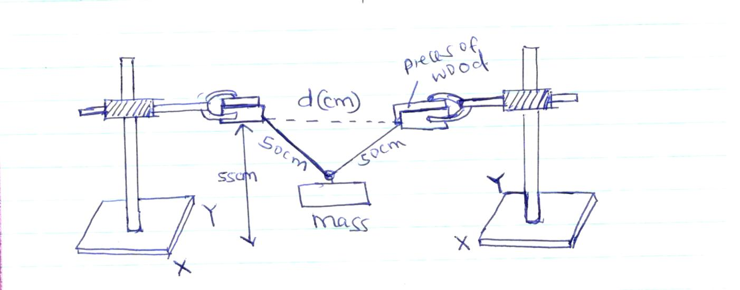

c)By moving one end of the retort stands, adjust d to value of 40cm.
d)pull the mass slightly in a direction parallel to xy then release it to oscillate. Record the time t,for 20 oscillations.
e)Repeat the procedure (c) and (d) with other values of d, increasing at intervals of 5cm and complete the table below. Where T is the periodic time.

d(cm) | 40 | 45 | 50 | 55 | 60 | 65 | 70 | 75 | 85
t(s)
T(s)
T ²(s²)
d²(cm²)
(7mrks)
f)plot a graph of T² against d² (5mrks)
g)Determine the slope of your graph.(3mrks)

T² = 3d² + C
m
h)Given that using your graph determine the values.
- M (3mrks)

- C (2mrks)

QUESTION TWO
PART A
You are provided with the following :
- Vernier calipers
- Micrometer screw gauge
- Masses;two 10g,20g,50g and 100g
- A helical spring
- Metre rule or half metre rule
Proceed as follows
a) Determine the number of complete turns of the helical spring.
N=……………………………………………….(1mrk)
b) Measure the external diameter of the spring using the vernier calipers
D=……………………………………m (1mrk)
c) Use the micrometer screw gauge to determine the diameter of the wire of the spring.
D=……………………………………m (1mrk
N= 0.4D
dM
d) Determine the value of M
(2mrk)

e)Suspend the helical spring vertically alongside the clamped half metre rule as shown in figure 1below.Determine the length L_{o},of the spring before loading it.
L_{o}=………………………cm

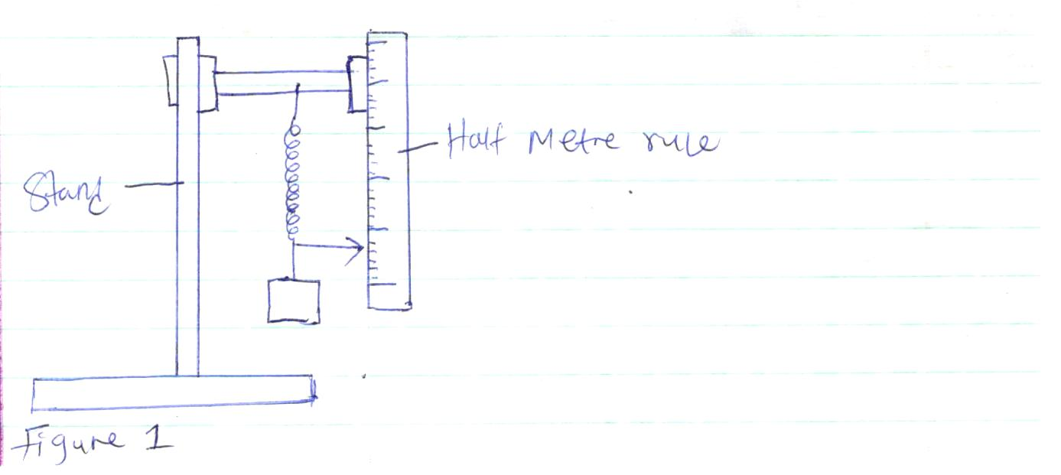
f)load the spring with a mass of 20g and determine the new reading on the metre.(L) record this in the table below. Calculate the extension e=L-L_{o} due to the mass of 20g and record the value in the table given below. Repeat step f for other masses and complete the table.
Mass(g) | 0 | 10 | 20 | 30 | 40 | 50 | 60 | 70 | 80 | 90 | 100
Weight(N)
Reading(L)cm
Extension e(cm)
Ye (cm⁻¹)

g)Plot a graph of weight (N) against 1/e (cm⁻¹) (5mrks)
h)Determine the slope (s) of the graph at a mass of 45g (3mrks)

i)Given that
M= -255T
(S+60)²

Determine the value of T where S is the slope at 45g (3mrks)

