MWAKICAN JOINT EXAMINATION
PHYSICS 232/2
MARKING SCHEME

SECTION A: 25 MARKS

1. Volume = 30cm³ (1 mk)
P = m/v
= 540/30 (1 mk)
= 18 g/cm³ (1 mk)

2. Soap lowers the surface tension of water, hence the pin sinks. (1 mk)
3. Total momentum before collision = total momentum after collision
(2 x 0.2) – (1.5 x 0.35) = (2.0 + 1.5) x v (1 mk)
0.4 – 0.525 = 3.5V
V = 0.0357 m/s (1 mk)

4. Black surface is as good absorber of radiation than shiny surface.
5. Main scale = 3.50
Thimble = $\frac{0.01}{3.51 mm}$ (1 mk)

6. Sum of clockwise moment = sum of anti clockwise moment.
5x40 = W x 2 + 3.3 x 24 (1 mk)
200 = 2W + 79.2
W = 60.4N or 6.04 kg (1 mk)
7. Constant collision between smoke and air particles. (1 mk)
8. In (a) cohesive forces between water molecules are stronger (1 mk) than adhesive forces between water and waxed surface. In (b) adhesive forces between water and glass are stronger than cohesive. (1 mk)

9. mass weight
- Its constant - varies from place to place (1 mk)
- Its quantity of matter in an object - its force of gravity on an object (1 mk)
- Measured using beam balance - measured using spring balance. (1 mk)
Accept any other correct answer.

10. Unstable equilibrium (1 mk) cog very high, slight displacement makes it to topple over (1 mk)
11. the papers move towards each other (1 mk)

12. size = volume of drop (1 mk)
Area of patch
= $\frac{1.5 x {10}^{-9}}{125680}$ (1 mk)
= 1.194 x 10⁻¹⁴ mm (1 mk)
13. h1p1g = h1p1g
30 x 1= 25xp1 (1 mk)
= 1.2 g/cm³ (1 mk)

SECTION B:
14 (a)

B

A

Evaporation causes cooling. Rate of cooling faster in A due to large surface area.
(b) A – vacuum (1 mk) minimize heat loss by conduction and convection
B = shiny surface (1 mk) minimize heat loss by radiation

(c) wood is a poor conductor of heat, helps minimize heat loss through conduction. (1 mk)

(d) – opaque
- expands and contracts uniformly and over a wide range of temperature. (1 mk)
- does not wet the glass (1 mk)
- has a low freezing point and high B.p. (1 mk)

(ii) This because impurities lowers the boiling point of water but that of steam remains 100⁰C. (1 mk)
Accurate | Faulty
100⁰C | 90⁰C
20⁰C | ?x
0⁰C | 10⁰C

(90 – 10) (100 – 0) (1 mk)
(x – 10) (20 – 0)

80 100
? 20

²⁰/₁₀₀ x 80

= 6⁰C (1 mk)
X – 10 = 6
X = 16⁰C (1 mk)

15. (i) 3kg 0.6ms⁻¹ -0.8ms⁻¹ 4kg

Momentum before collision = momentum after collision (1 mk)
3 x $0.6$ + A x -0.8 = 7v (1 mk)
1.8 – 3.2 = 7v
-1.4 = 7v
V = 0.2 Ms⁻¹ (1 mk)

(ii) Moves to the left. (1 mk)

(iii) The collision not elastic since the bodies fuse and move with a common velocity. (1 mk)
The kinetic before collusion is not to kinetic energy after collision.

(b) At balance the sum of clockwise moment; equal to the sum of anticlockwise moment. (1 mk)
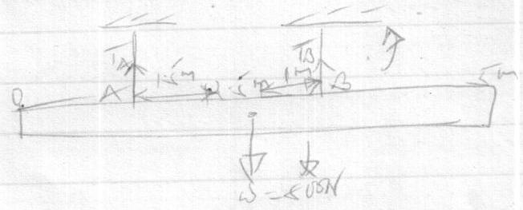

At balance
Clockwise moment = anticlockwise moment
Taking moments about A (1 mk)
$\frac{800}{T_{B}}x1.5=2.5xT_{B}$ (1 mk)
$T_{B}$= $\frac{800x1.5}{2.5}$

= 480N (1 mk)
Also sum of upward forces = sum of downward forces
$∴TA+480=800N$
TA = 800 – 480
= 320N (1 mk)
Hence force at A = 320N & at B = 480N

16. (a) total area under the graph
= $\frac{1}{2}\left(100+70\right)×30$
= 170X15 (1 mk)
= 2550M

(b) (i) 5/0.02 (1 mk)
= 250cm/s² (1 mk)

(ii) 15/0.02 (1 mk)
= 750cm/s² (1 mk)

(iii) $\frac{750-250}{3x0.02}$ (1 mk)

= 8333.3cm/s² (1 mk)

(c) P = mxv
= 3000x20 (1 mk)
= 60000kgm/s (1 mk)

17. (i) V.R = 1/sin$θ$
= 1/sin30 (1 mk)
= 2 (1 mk)

(ii) eff = M.A x 100
V.R (1 mk)
80 = M.A (1 mk)
100 2
M.A = 160/100
= 1.6 (1 mk)

(iii) M.A = $\frac{L}{E}$
E (1 mk)
1.6 = $\frac{1000}{E}$
E = 625N (1 mk)
(iv) w.d = mgh
= 100x10x8
= 8000J (output) (1 mk)
80% = 8000
w.input
work input = 10000J (1 mk)
lost = 10000-8000
= 2000J (1 mk)

18.For a herical spring or any other elastic material extension is directly proportion to the force applied/provided extension limit is not exceeded.

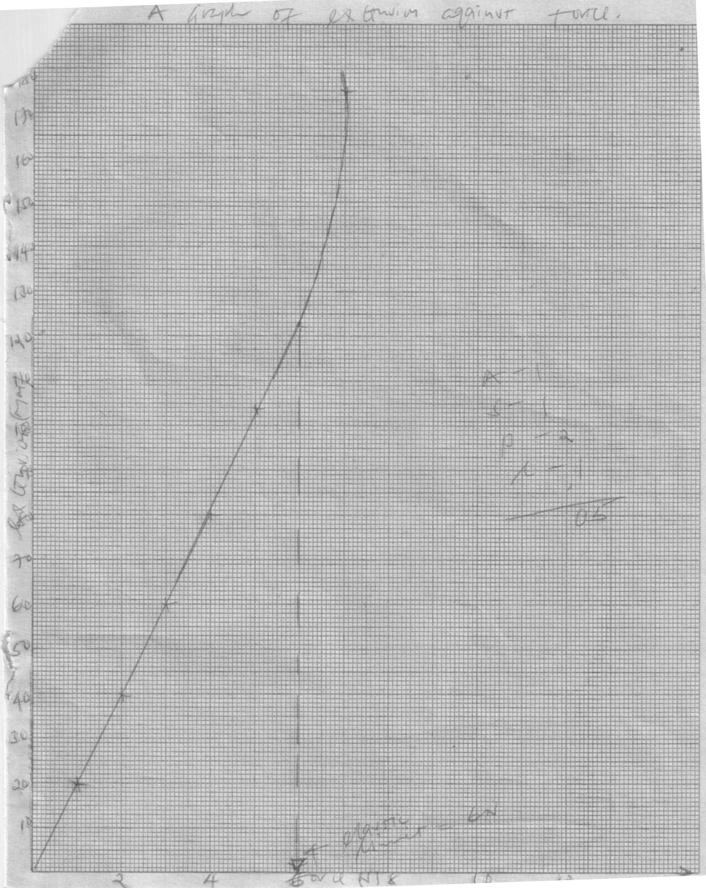
(b) (i)

A – 1
S – 1
P – 2
C – 1
=05

Extension (cm)

Elastic limit
Force (N)

(c) f = ke
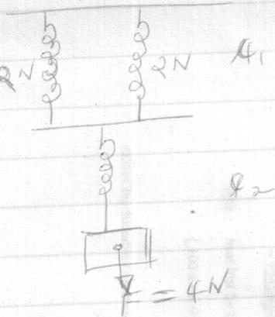
e= $\frac{f}{k}$ (1 mk)

e₁ = $\frac{2}{50}$

= 0.04m (1 mk)

e₂ = $\frac{4}{50}$

= 0.08m (1 mk)
Total = e₁ + e₂
= 0.04 + 0.08
= 0.12m (1 mk)

