NAME………………………………………….ADM. NO…………CLASS:……………………..
MWAKICAN FORM 4 JOINT EXAMINATION 2016
KENYA CERTIFICATE OF SECONDARY EDUCATION

232/1
PHYSICS PAPER 1
TIME: 2 HOURS

INSTRUCTIONS TO CANDIDATES
- Write your name and admission number and class in the spaces provided above
- This paper consists of two sections A and B
- Answer all the questions in sections A and B in the spaces provided
- All working must be clearly shown
- Candidates should answer the questions in English.

SECTION A (25 marks)
Answer all the questions in this section in the spaces provided
- Figure 1 below shows a part of Vernier calipers used to determine the length of a metallic cube. If the cube has a mass of 1533g.
Determine the density of the cubein g/cm³ (3marks)

- Figure 2 below shows a mercury manometer. Some dry gas is trapped in one of the limbs.
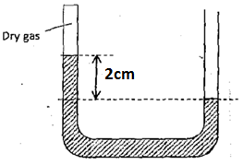
Given that the atmospheric pressure is 76cm of mercury. Determine the pressure of the gas in mmHg (3 marks)

- When it is raining, it is advisable not to touch a canvas tent from inside. Explain. (1 mark)

- State the reason why it is easier to separate water into drop than to separate a piece of solid into smaller pieces. (1 mark)

- Figure 3 below shows a simple fire alarm.
Explain how it works (2marks)

- It feels hotter to sit on a metallic chair that has been left in the sun for a long time than wooden bench at the same temperature. Explain(2 marks)

- State the principle of moments. (1 Mark)

- A uniform meter rule of mass 10g is balanced by masses 24 g and 16g suspended at 0 cm mark and 100cm mark respectively. Determine the position of the pivot. (2 marks)

- The figure below shows a compression spring, before and after a mass of 5kg was placed on it. Use it to answer questions 9, 10, and 11.
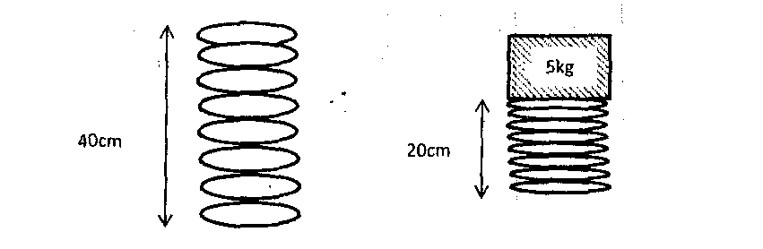
Find the spring constant of the spring. (3marks)

- Sketch a graph of force against length if different masses were used in the above set up. (1 mark)

force

length

- Explain the shape of the graph above (1 mark)

- State Bernoulli’s effect (1 mark)

- a) Water flows through a pipe of different cross-section areas as shown in the diagram below. Indicate in the diagram the levels of water in tubes A, B and C. (1 mark)

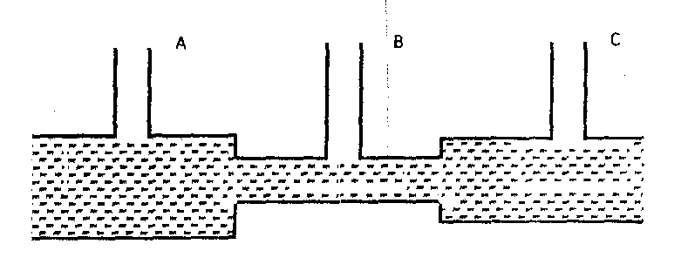
b) Give a reason for your answer in 13(a) above. (1 mark)

- i) An electric heater is placed at equal distances from two similar metal cans A and B filled with water at room temperature. The outer surface of can A is shiny while that of can B is dull black. State with reasons which can will be at a higher temperature after the heater is switched on for some time. (2marks)

ii) Sketch a graph of temperature against time for can A and B after the heater is switched off. (1 mark)

SECTION B: (55 marks)
- a) State Charles’ law. (1 mark)

b) The Set up below was used to verify Charles’ law. Use it to answer the following questions.

- State two measurements taken from the above set up. (2marks)

- Describe briefly how the set up above can be used to verify Charles’s law. (3marks)

- State the function of sulphuric acid index. (1 mark)

- Pressure of the trapped air remains unchanged throughout the experiment. Explain how this is possible. (2marks)

- A mass of 1200 cm³ of oxygen at 27⁰ C and a pressure 1.2 atmosphere is compressed until its volume is 600 cm³ and its pressure is 3.0 atmospheres. Find the temperature of the gas after compression (2 marks)

- (a) Define the term heat capacity. (1 mark).

(b) In experiment to determine the specific latent heat of vaporization Lv of water, steam was passed into cold water in a copper calorimeter. The following data was obtained:
Mass of calorimeter 105.2g
Mass of calorimeter + water =228.8 g
Mass of calorimeter + water + steam= 231.2g
Temperature of the cold water = 18⁰C
Final temperature of the water=29⁰ C

- Determine the amount of steam that condensed. (1 mark)

- Calculate the amount of heat lost by the condensed steam. (specific heat capacity of water=4200J/Kg/K) (3 marks)

- Calculate the amount of heat absorbed by water and the calorimeter (specific heat capacity of copper = 390J/kg/K) (3marks)

- Calculate the specific latent heat of vaporization Lv of water. (2 marks)

- Explain why cooling the water used in the calorimeter to below room temperature could have led to more accurate result. (1 mark)

- a) Distinguish between elastic collision and inelastic collision. (1 mark)

b) A van of mass 1500 kg travelling at a constant velocity of 72 km/h collides with a stationary car of mass 900kg. The impact takes 2 seconds before they move together at a constant velocity for 20 seconds. Calculate:
- Their common velocity (3marks)

- The distance moved after the impact.(2marks)

- The impulsive force (3marks)

- The change in kinetic energy (3marks)

- Why is the kinetic energy not conserved in this collision (1 mark)

- a) Define angular velocity. (1 mark).

b) Figure 4 below shows a mass 500g moving in vertical circle having a radius of 35cm at a constant velocity. It makes 2 revolutions in one second.
- Indicate on the diagram the direction of centripetal force. (1 mark)

- Calculate the linear velocity of the mass. (3marks)

- Calculate the centripetal acceleration of the object. (2marks)

- Determine the centripetal force. (3marks)

- Giving a reason, state the point at which the string is likely to snap. (2mark)

- a) State the law of conservation of energy. (1 mark)

b) Figures4 below shows a ball of mass of 5kg rolling along a frictionless path as shown.

- Calculate the potential energy of the ball at point O. (2 marks)

- Determine the velocity of the ball at point A (2 marks)

- If the ball rolls back when it reaches point B, state the energy changes that takes place O to B. (1 mark)

- It is observed that the efficiency of the machine increases when it is used to lift large loads. Give a reason for this (1 mark)

