**NAME………………………………………. INDEX NO……………………........................**

**232/3 CANDIDATE’S SIGN………….….….….…...**

**FORM 4 PHYSICS PAPER 3 DATE…………………………………………**

**(PRACTICAL)**

**TIME: 2½ HOURS**

**MWAKICAN MJET JOINT EXAMINATION**

**Kenya Certificate of Secondary Education**

**FORM 4 PHYSICS**

**PAPER 3**

**(PRACTICAL)**

**INSTRUCTIONS TO CANDIDATES:**

1. Write your **name** and **index number** in spaces provided **above**.

2. **Sign** and write the date of examination in spaces provided **above**.

3. Answer **all** the questions in spaces provided in the question paper.

4. You are supposed to spend the first 15 minutes of 2½ hours allowed for

this paper reading the whole paper carefully before commencing the work.

5. Marks are given for clear record of the observations actually made, their

suitability, accuracy and the use made of them.

6. Candidates are advised to record their observations as soon as they are made.

7. Non-programmable silent electronic calculators and KNEC Mathematical table

may be used.

**FOR EXAMINER’S USE ONLY**

|  |  |  |  |  |  |  |  |  |  |  |  |  |
| --- | --- | --- | --- | --- | --- | --- | --- | --- | --- | --- | --- | --- |
| Question 1 | d | f | h | i | j | K |  | Question 2 | c | d | e | f |
| Maximum Score | 6 | 5 | 4 | 4 | 3 | 2 |  | Maximum Score | 5 | 5 | 3 | 3 |
| Candidate’s Score |  |  |  |  |  |  |  | Candidate’s Score |  |  |  |  |

|  |  |
| --- | --- |
| **GRAND TOTAL** |  |

*Physics Paper 3*

*Turnover*

1. You are provided with the following:

* A rectangular glass block.
* 4 optical pins.
* A softboard.
* A plain paper.

Proceed as follows:

1. Place the glass block on the plain paper with one of the largest face upper most. Trace round the glass block using a pencil as shown below.

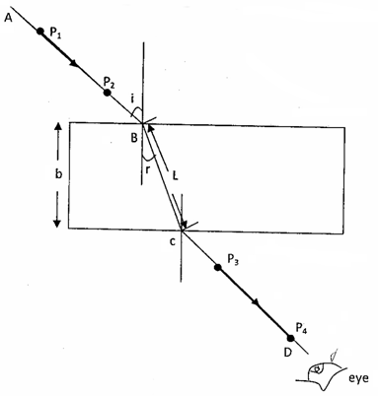

1. Remove the glass block and draw a normal at B. Draw an incident ray AB of angle of incidence, i = 20°.
2. Replace the glass block and trace the ray ABCD using the optical pins.

(d) Remove the glass block and draw the path of the ray ABCD using a pencil. Measure length L and record it in the table below.

|  |  |  |  |  |  |
| --- | --- | --- | --- | --- | --- |
| Angle i° | L(cm) | L²(cm²) |  | Sin² i |  |
| 20 |  |  |  | 0.1170 |  |
| 30 |  |  |  | 0.2500 |  |
| 40 |  |  |  | 0.4132 |  |
| 50 |  |  |  | 0.5868 |  |
| 60 |  |  |  | 0.8830 |  |
| 70 |  |  |  |  | 1. marks) |

e) Repeat the procedure above for the angles of incidence given.

Calculate the value of L² and; Record in the table.

1. Plot a graph of (y-axis) against Sin² i (χ-axis). (5 marks)

(F) Calculate the gradient, S. (4 marks)

(i) Given that the equation of that graph: 

Determine the intercept C and the (Sin² i) intercept B. (4marks)

(j) Calculate the value of Q given by: (3 marks)



1. Hand in your constructions on the plain paper together with the answer script. (2marks)

2. You are provided with the following apparatus:

* 2 size D dry cells.
* 100cm nichrome wire on a mm scale.
* A bulb (2.5v) and a bulb holder.
* 8 conductivity wires (at least 4 with crocodile clips).
* Cell holder.
* A switch.
* A voltimeter (0 – 5v).
* An ammeter (0 – 1A).
* A jockey.

1. Connect the apparatus provided as show in the diagram below.

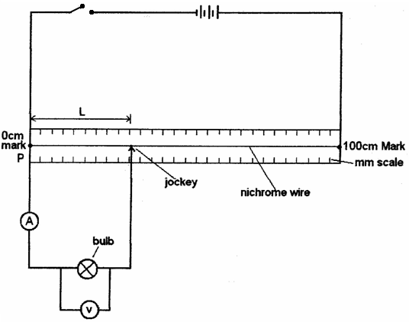

**Procedure**

1. Place the jockey at χ = 20cm from P, then close the switch.

Record the ammeter reading and the voltmeter reading in the table below.

1. Repeat the experiment by placing the jockey at χ = 40, 60, 70 and 80cm from P.

Record your readings and complete the table below. 5marks

|  |  |  |  |  |  |  |
| --- | --- | --- | --- | --- | --- | --- |
| Length L(cm) | 1(A) | Pd V(v) | 1(mA) | Pd V(mv) | Log 1 | Log V |
| 20 |  |  |  |  |  |  |
| 30 |  |  |  |  |  |  |
| 40 |  |  |  |  |  |  |
| 50 |  |  |  |  |  |  |
| 60 |  |  |  |  |  |  |
| 80 |  |  |  |  |  |  |

d)Plot a graph of log I (y-axis) against log V. (5 marks)

(e) Determine the slope of the graph. (3 marks)

1. Given that Log I = n log v + log k where k and n are constants of the lamp.

(i) Determine using your graph the value of

K _______________________________________________(2 marks)

N _______________________________________________(1 mark)