**Name: ................................................................................Index No. ............................... Class: ..........**

**MOMALICHE 2 CYCLE 6**

232/1

Physics Paper 1 (Theory)

March/April 2019

2 Hours

**Kenya Certificate of Secondary Education**

**Physics Examination 2019**

**Instructions to candidates**

* Write your name and class in the spaces provided above.
* This paper consists of **TWO** sections; **A** and **B**.
* Answer **ALL** the questions in section A and B in the spaces provided after each question.
* **ALL** working **MUST** be clearly shown.
* Non-programmable silent electronic calculators and KNEC mathematical tables may be used.

**Take**: Acceleration due to gravity g = 10 ms-2 Density of water = 1000 Kg/m3

**FOR EXAMINERS USE ONLY**

|  |  |  |  |
| --- | --- | --- | --- |
| Section | Questions | Maximum score | Candidates score |
| **A** | 1 – 13 | 25 |  |
| **B** | 14 | 12 |  |
|  | 15 | 12 |  |
| 16 | 11 |  |
| 17 | 09 |  |
| 18 | 8 |  |
|  | **TOTAL** | **80** |  |

**This paper consists of 9 printed.**

**Candidates should check the question paper to ascertain that all the pages are printed as indicated and that no questions are missing.**

**SECTION A (25MKS)**

1. Figure 1 shows a micrometer with a negative error of 0.02 mm, used to measure the diameter of a ball bearing.



Fig. 1

Record the diameter of the ball. (2 marks)

1. Explain the washing effects of detergents of soap and why detergents in warm water wash greasy clothes even better. (2 marks)
2. State the reasons why concrete beam reinforced with steel does not crack when subjected to changes in temperature. (1mark)
3. A uniform metallic bar of length 100cm and mass 40kg is supported horizontally by two vertical spring balances A and B as shown below.

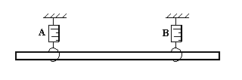 Fig. 2

Balance A is 20cm from one end while balance B is 30cm from the other end. Find the reading of each individual balance AB. (3 marks)

1. The figure 3 below shows a fire alarm circuit. Explain how the alarm functions. (2 marks)

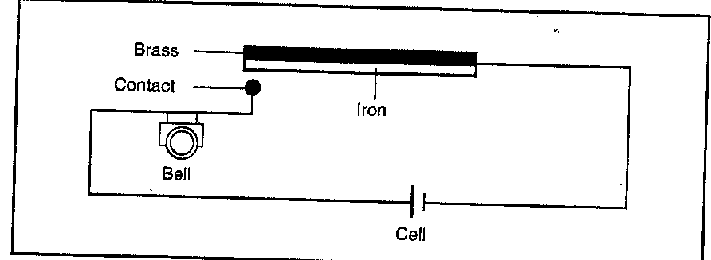 Fig. 3

1. The mass M was suspended from a tight copper wire using a rider as shown in figure 4.

The copper wire was then heated.

heat Fig. 4

M

State and explain what was observed on the position of M as the wire was heated for some time. (2 marks)

1. A car of mass 1600kg traveling at 56km/h is brought to rest over a distance of 50m. Find

(i) The acceleration. (2 marks)

(ii) The breaking force in newtons. (1 mark)

1. A carbon dioxide cylinder contains 6600cm3 of gas at a pressure of 2.40x105 Pa. Atmosphere pressure is 1.0x105 Pa. Calculate the volume of the gas at atmospheric pressure. (2 marks)
2. Why are wire shelves used rather than solid shelves in the center of a refrigerator? (1mark)
3. When a Bunsen burner is lit below a wire gauze, it is noted that the flame initially burns below the gauze as shown in the figure below. After sometime the flame burns below as well as above the gauze.

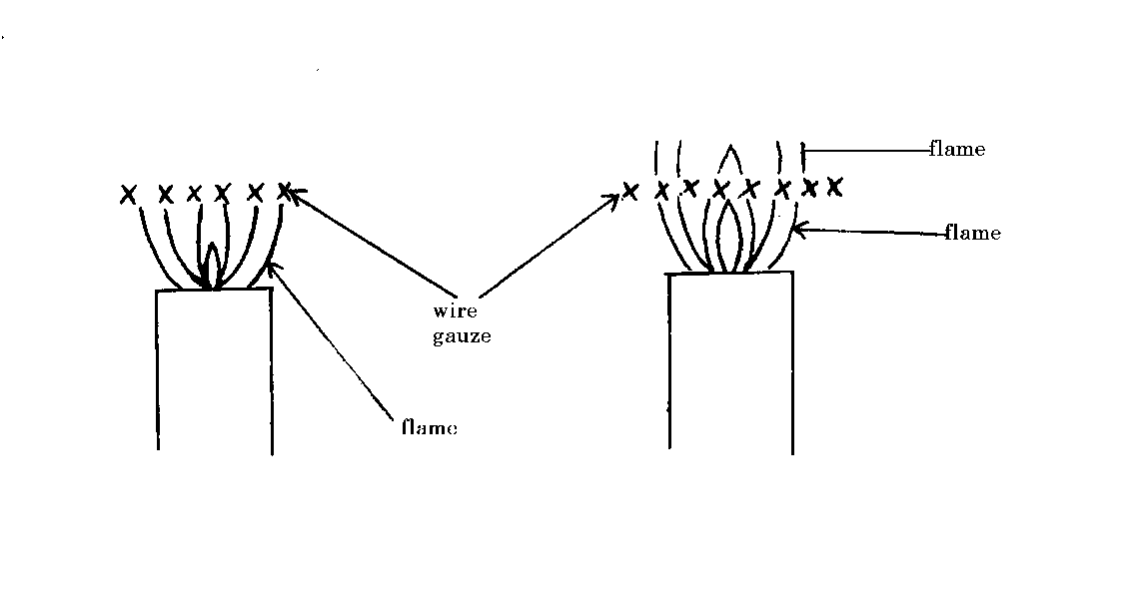 Fig. 5

Explain this observation. (2 marks)

1. A clinical thermometer has a constriction in the bore just above the bulb. State the use of this constriction and the thin walled bulb. (2 marks)



Fig. 6

1. State Hooke’s law. (1 mark)

1. The figure below shows a burning candle standing on a bench. State and explain how the stability of the candle will be affected. (2 marks)

Fig. 7

**SECTION B (55 MARKS)**

# Answer all questions in this section

1. (a) An object is released to fall vertically from height of 98m. At the same time another object is projected vertically upward with velocity of 42m/s.

(i) Calculate the time taken before the objects meet. (3 marks)

(ii) At what height do the objects meet? (2 marks)

(b) A stone is projected horizontally at a speed of 35m/s from a cliff 160m high. After how long will it strike the ground? (2 marks)

(c) You are going to investigate the motion of an object down a slope. A length of track *s*  = 1.20 m has been marked out for you.

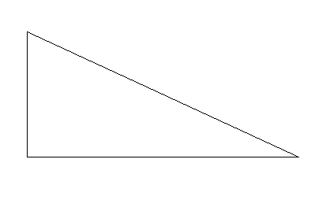Fig .8

If the ball starts from rest (*u* = 0) it can be shown that the acceleration, *a*, is given by:

where *t* is the time taken for the marble to roll a distance *s*.



(i) Setting the height h to 0.10m and if the time t taken for the marble to roll down the slope is 1.70s. [2 marks]

(ii) Use the above equation to calculate the acceleration, *a*, of the marble. [2 marks]

By resolving forces acting on the ball a student suggests that

*ma* = *mg* sin φ

and hence that *a* = *g*sinφ

Use your solution to (i) to find a value for the acceleration due to gravity, *g*. [2 marks]

1. (a) i) Define Archimedes’ Principle. (1 mark)
   * + 1. An object weighs 1.04N in air, 0.64N when fully immersed in water and 0.72N when fully immersed in a liquid. If the density of water is 1000 kg m-3, find :

I. The density of the liquid. (3 marks)

II. Calculate the density of the metal block. (2 marks)

(ii) Calculate the up thrust on the metal and the apparent weight of the metal when completely submerged in salt solution of density 1.2g/cm3. (3 marks)

1. A block of metal of volume 80cm3 weighs 3.80N in air. Determine its weight when fully sub merged in a liquid of density 1200kgm-3. (3 marks)
2. a) Define Pressure Law (1 mark)

b) State **one** basic assumption of the kinetic theory of gases. (1 marks)

c) Figure **8** shows a set up that may be used to verify Pressure law.



Fig. 8

i) State the measurements that may be taken in the experiment. (2 marks)

ii) Explain how the measurement in (i) above may be used to verify Pressure law

(4 marks)

iii) A car tyre is at an air pressure of 4.0 x 105 Pa. at a temperature of 27 0C. While it is running, the temperature rises to 75 0C. What is the new pressure in the tyre?

(Assume the tyre does not expand) (3 marks)

1. (a) (i) Describe the experiment to determine the specific heat capacity C, of a block of aluminium with two holes drilled in it, to accommodate a thermometer and an electric immersion heater. ( 2 marks)

(ii)State two precaution that should be taken in this experiment. ( 2 marks)

(b) A copper calorimeter of mass 60g is filed with 100g of water at 250C. Steam at a normal temperature and pressure ( N.T.P) is passed thought the water until a temperature 450C is attained. The final mass of calorimeter and the contents was found to be 163.5g. Calculate the specific latent heat of vaporization ‘l’ of water. ( 5 marks)

(Specific heat capacity for water is 4200JKg-1 and for copper is 378Kg-1K­1)

1. A machine with a wheel of diameter 1.2m and an axle of diameter 0.4m lifts a load of mass 9kg with an effort of 100N. Given that the acceleration due to gravity is 10m/s2 calculate.
2. The velocity ratios of the machine. (2 marks)

(ii) The mechanical advantage of the machine . (2 marks)

(iii) The efficiency. (2 marks)

(c) Draw a well labeled diagram of a pulley system with a velocity ratio of 3 showing application of load and effort. (2 marks)