**SCHOOL BASED EXAMINATION 2019**

**PHYSICS 232/2**

**MARKING SCHEME**

**JULY/AUGUST 2019**

**Section A**

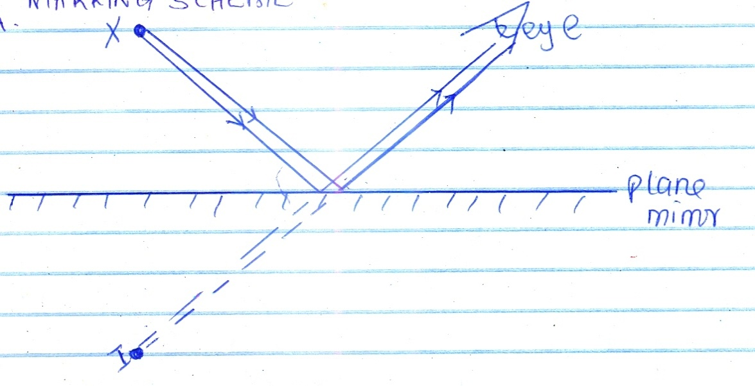

* Real rays with arrows ✓ 1/2 mk
* Virtual rays with no arrows✓ 1/2 mk
* Image position – equidistant as the object from the mirror ✓ 1mk

1. When the strip get nearer the water, the water gets positively( ✓ 1/2 mk) through induction hence it gets attracted. ( ✓ 1/2 mk)
2. a) X – rays

b) Infra – red radiation detected by:

- heating effect produced on the skin.

- thermopile

- barometer

- thermometer with blackened bulb

(Any one correct give) 1mk

1. Keeper get magnetized ( ✓ 1mk) by induction acquiring opposite poles that makes them get attracted to the magnets hence retains magnetism. ( ✓ 1mk)
2. a) i) C and R will be much closer. ( ✓ 1mk)

ii) No change on the position of compressions and rarefractions. ( ✓ 1mk)

b)

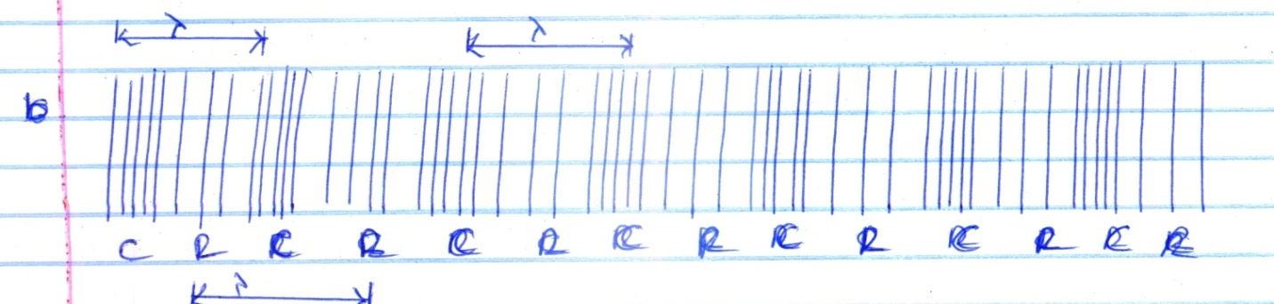

Any show that is correct, give ( ✓ 1mk)



**7.** P = VI

100 = 240 I ✓ 1mk

I = 100

240

I = 0.417A ✓ 1mk

~ 0.42A

**8.** Less current is transmitted ( ✓ 1mk) hence less power loss. ( ✓ 1mk)

**9.** Polarisation ( ✓ 1mk)

Local action ( ✓ 1mk)

**10.** a) A = Beta particle

B = Gamma particle

C = Alpha particle

b) They have different charges ( ✓ 1/2 mk) and different masses. ( ✓ 1/2 mk)

**11.** Q – the diode is forward biased.

**12.** Cp = C1 + C2

Cp= 50μF + 50μF

Cp = 100μF



**Section B**

1. a) The current flowing through a conductor is directly proportional to the potential difference across it,

provided the temperature and other physical conditions are kept constant. ( ✓ 1mk)

b) i) The device is non ohmic, the graph of P.d against current is not a straight line ( ✓ 1mk)

ii) Show on the graph ( ✓ 1mk)

Correct reading – 7.6V ✓ 1mk

c) i)



ii)



d) i) Air is removed to prevent oxidation of the filament.

ii) So that when current exceeds its rating it melts and breaks.

1. a) Sound waves,

b)



c) i) Because of construction interference.

ii) No loud sound or soft sound is heard because there is no interference.

d) Two progressive waves travelling in the opposite direction must have:-

- Equal speed ✓ 1 or

- Same frequency ✓ 1 or

- Same or nearly equal amplitudes✓ 1

e) i)

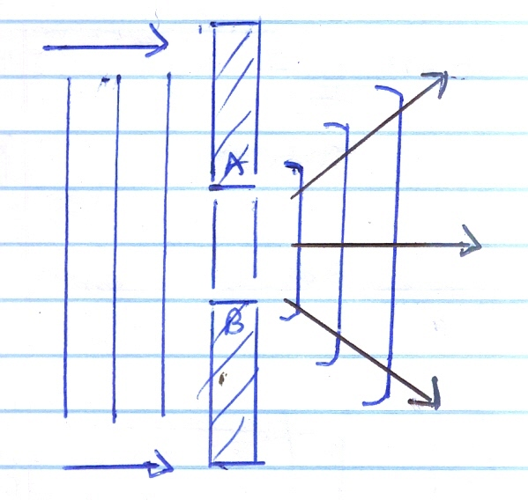

ii) The wavefront emerge as circular and spreads in all directions.

1. a) - The eye has a crystalline convex lens while ✓ 1 the camera has a convex lens. or

* The Choroid layer of the eye is black ✓ 1 while the camera box is painted black inside or
* The eye has the retina, where images ✓ 1 are formed but the camera has a light-sensitive film,

where images are formed or

* The Iris controls the amount of light ✓ 1 entering the eye while in the camera the diaphragm controls the amount of light entering the camera.

b) i) Convex lens / Converging lens ✓ 1

ii) The object must be placed between the principal focus, F and the optical centre,

O of the lens. ✓ 1

c) i) Short sightendness

ii) – The eye ball is too long ✓ 1 or

* The lens has a short focal length ✓ 1

iii)

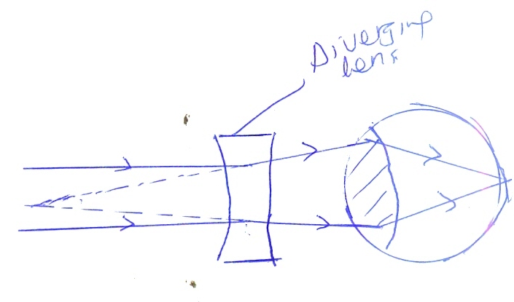

**Diverging lens**

d) i) Object distance, u, using a metre rule.

Image distance, V, using a metre rule.

ii) Obtain a set of value sof u and v, use the formular  to determine the values of f for each set, get the average value of f.

or

* Obtain a set of values of u and v, determine the reciprocals of u and v, plot the graph of  against  . At  intercept  or

At  intercept  .

or

* Get a set of values of u and v.

Draw a graph of magnification against v then get graphical reciprocal of the gradients as focal length.

1. a) i) I – So that electrons do not lose some kinetic energy through collision with air molecules.

II – Tungsten has a high melting point.

III – To accelerate electrons from cathode to anode

To give electrons enough kinetic energy.

ii) Reduce E.H.T voltage / Reduce the high P.d./ Reduce the accelerating voltage.

iii) – Detecting flaws in casting and welding

* Sterilise surgical equipment before packaging
* In security purposes in high security areas such as airports to inspect luggages for weapons.
* In crystallography.

b) i) Emmission of electrons on a metal surface when the metal surfaces is irradiated with electro-magnetic waves of sufficient frequency.

ii)



1. a) The direction of the induced e.m.f is such that the induced current which it causes to flow produces a magnetic effect that opposes the change producing it.

b) i) The galvanometer deflects to the right hand side.

ii) I – No deflection is observed

II – The galvanometer deflects to the right hand side.

c) The secondary coil is wound over the primary coil / or the primary coils is wound next to the secondary coils.

d) i) Step down transformer. The primary coils has a higher number of turns compared to the secondary coils.

ii)



iii)



η =

1. a) An electron beam is charged / Electrons are charged.

b) i) I - V = 7.5 x 2

= 15V

II - 2.0 ms = 0.002s

T 🡪 2cm

T = 2 x 0.002

= 0.004S



ii)

