**SCHOOL BASED EXAMINATION 2019**

**PHYSICS 232/3**

**MARKING SCHEME**

**JULY/AUGUST 2019**

**Question I**

1. ii)

|  |  |  |  |  |  |  |  |  |
| --- | --- | --- | --- | --- | --- | --- | --- | --- |
| Length, l(cm) | 100 | 80 | 60 | 40 | 20 | 0 |  |  |
| Voltage, V (v) | 0.25 | 0.45 | 0.55 | 0.75 | 1.10 | 1.60 | + 0.3V | 1d.p |
| Current, I (A) | 0.13 | 0.14 | 0.15 | 0.16 | 0.18 | 0.21 | + 0.02A | 2 d.p |

Voltage (V) @ ½ to max of 2mks

Current (A) @ ½ to max of 2 mks

iii) Brightness increases (1mk)

iv)

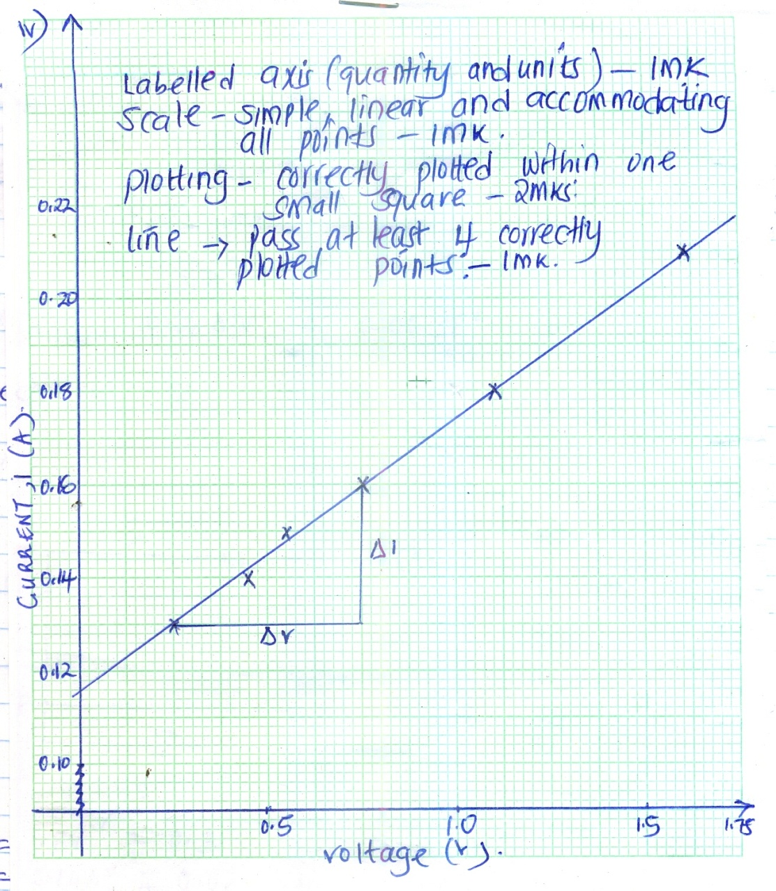

v)



vi) Reciprocal of resistance or conductance

b) i)

A

2mks

V

P

Q

P

ii) V = 1.8 V + 0.3 to at least 1 dp

I = 0.14A + 0.02 to at least 2 dp

iii) d = 0.00036m (5 dp or 1 dp in standard form)

iv)



✓ 1 [Correct evaluation and units]

To at least 4 s.f or exact

✓ 1 [Substitution of V, I, L and d2]

**Questions 2 A**

n)

|  |  |  |  |  |  |  |
| --- | --- | --- | --- | --- | --- | --- |
| Angle of incidence i0 | 10 | 20 | 30 | 40 | 50 | 60 |
| Distance d (cm) | 2.0 | 4.0 | 5.5 | 7.5 | 10.0 | 13.5 |
| Sin i | 0.1736 | 0.3420 | 0.5000 | 0.6429 | 0.7660 | 0.8660 |
| Sin2i | 0.0301 | 0.1170 | 0.2500 | 0.4133 | 0.5868 | 0.750 |

Distance d (cm + 0.5 @ ½ marks max 3 marks

* distance to at least 1 d.p

Sin I 4 s.f. or exact - 1 mark

Sin2i 4 s.f or exact - 1 mark

1. I

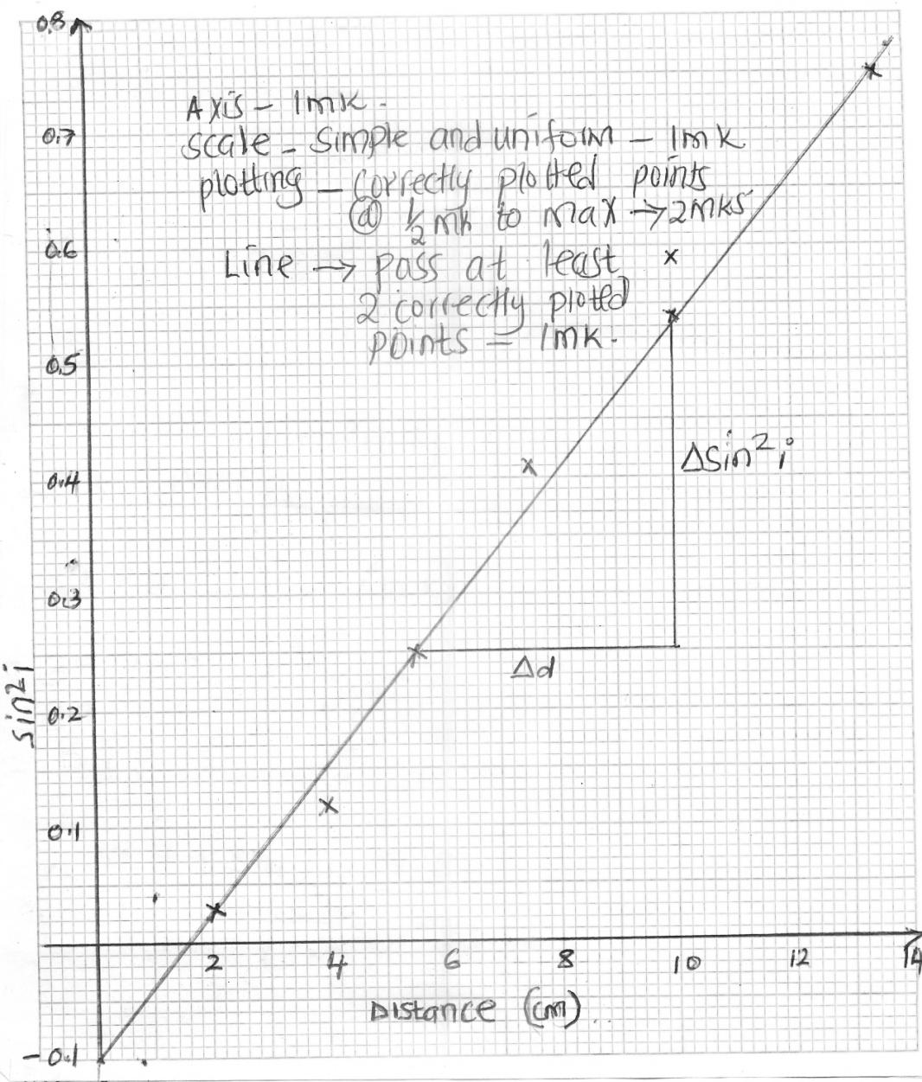

II



✓ 1

✓ 1

✓ 1/2

4 s.f.

Mark units independently

ii) X = 39.8cm + 2.5 ✓ 1 (1mk) 1 d.p. a must

iii) X1 = 39.7cm ✓ 1/2 + 2.5 1 d.p. a must

X2 = 39.7cm ✓ 1/2 + 2.5 1 d.p. a must

X3 = 39.8cm ✓ 1/2 + 2.5 1 d.p. a must



✓ 1/2 2 d.p. or exact +2.5

iv) W = 0.5 x Xav

= 0.5 x 39.77 ✓ 1

= 19.885cm ✓ 1 to at least 3 s.f.

v) W is half the value of X ✓ 1

vi) The focal length of the concave mirror✓ 1