END OF TERM 2 2019
FORM 4 PHYSICS
PAPER 1
NAME:………………………………………………ADM NO:…………………..CLASS:……………
SECTION A: (25 MARKS)
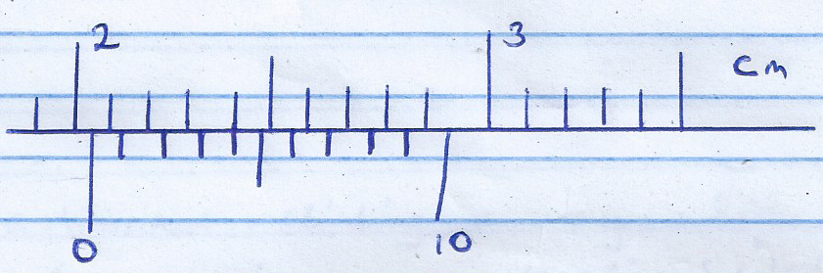
- A spherical ball bearing is held between the jaws of vernier calipers. The reading on the vernier calipers when the jaws are closed without anything in between is 0.11 cm

What is the diameter of the ball bearing? (2mks)
..........................................................................................................................................................................................................................................................
- Figure 2 shows a sheet of paper rolled into a tube
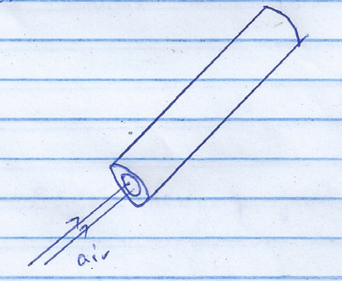

When a stream of air at high speed is blown into the tube, the tube collapses. Explain this observation. (2mks)
......................................................................................................................................................................................................................................................................................................................................................................................................
- The bulb of a thermometer is dipped in ether at room temperature. When the thermometer is removed, its reading drops below room temperature. Explain (2mks)
......................................................................................................................................................................................................................................................................................................................................................................................................
- An astronaut climbing a very high mountain is likely to experience nose bleeding. Explain why this (1mk)
......................................................................................................................................................................................................................................................................................................................................................................................................
- An external force applied to a ball of mass 160 g increases its velocity from 2 cm/s t 275 cm/s in 10 seconds. Calculate the force applied. (3mks)
............................................................................................................................................................................................................................................................................................................................................................................................................................................................................................................................................................................................................................................................................................................................................................................................................
- (a) State Boyle’s law of gases. (1mk)
......................................................................................................................................................................................................................................................................................................................................................................................................
(b) Explain in terms of kinetic theory why the pressure of a gas increases when its temperature rises. Assume that the volume remains constant. (2mks)
......................................................................................................................................................................................................................................................................................................................................................................................................

- Explain why swimmers are advised to wear wet clothes before diving into a cold swimming pool. (1mk)
......................................................................................................................................................................................................................................................................................................................................................................................................
- Figure 3 shows two thermometers A and B placed at the same distance from a very hot copper plate.
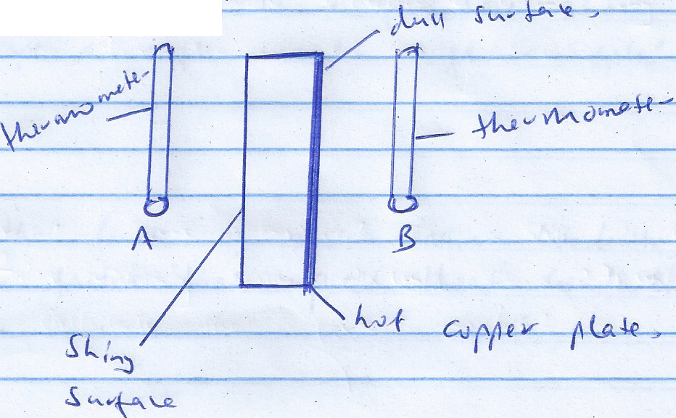

What adjustment should be made so that the thermometers read the same temperature after 10 minutes (1mk)
......................................................................................................................................................................................................................................................................................................................................................................................................
- Water of mass 500g flows through a tube of uniform cross-section in 10s. Calculate the rate of flow of water in m³/s, if density of water is 1000 kg/m³. (3mks)
......................................................................................................................................................................................................................................................................................................................................................................................................

......................................................................................................................................................................................................................................................................................................................................................................................................

- Distinguish between a liquid and a gas in terms of:
(a) Movement of particles. (1mk)
......................................................................................................................................................................................................................................................................................................................................................................................................
(b) Intermolecular distance. (1mk)
......................................................................................................................................................................................................................................................................................................................................................................................................
- A student wearing sharp pointed shoes is likely to damage a soft wooden floor. Explain. (2mks)
......................................................................................................................................................................................................................................................................................................................................................................................................
- Besides the length of a metallic conductor, state two other factors that affect heat conduction. (2mks)
......................................................................................................................................................................................................................................................................................................................................................................................................
- State the reason why the speed of water at the narrow section of a river is brighter than at the wider section. (1mk)
......................................................................................................................................................................................................................................................................................................................................................................................................

SECTION B: (55 MARKS)
- (a) (i) Define velocity ratio of a machine (1mk)
......................................................................................................................................................................................................................................................................................................................................................................................................
(ii) Draw a labeled diagram of a pulley system with a velocity ratio of 5. (2mks)
............................................................................................................................................................................................................................................................................................................................................................................................................................................................................................................................................................................................................................................................................................................................................................................................................
(iii) Give any two possible reasons why the efficiency is less than 100% (2mks)
............................................................................................................................................................................................................................................................................................................................................................................................................................................................................................................................................................................................................................................................................................................................................................................................................

(b) The effort piston of a hydraulic machine is of radius 2.8 cm, while that of the load piston is of radius 14 cm. The machine raises a load of 120 kg at a constant velocity through 2.5 m. If the machine has an efficiency of 80%, find:
(i) The velocity ratio of the hydraulic machine. (3mks)
............................................................................................................................................................................................................................................................................................................................................................................................................................................................................................................................................................................................................................................................................................................................................................................................................

(ii) The mechanical advantage of the hydraulic machine (2mks)
............................................................................................................................................................................................................................................................................................................................................................................................................................................................................................................................................................................................................................................................................................................................................................................................................
(iii) The effort needed to raise the load. (2mks)
............................................................................................................................................................................................................................................................................................................................................................................................................................................................................................................................................................................................................................................................................................................................................................................................................
- (a) State Archimedes principle. (1mk)
......................................................................................................................................................................................................................................................................................................................................................................................................
(b) A block of wood of weight 200N measuring 0.8 m by 0.5 m by 2m floats in water; 1.2 m of the block is submerged.
(i) Determine the weight of the water displaced (2mks)
(Density of water =1000 kg/m³)
........................................................................................................................................................................................................................................................................................................................................................................................................................................................................................................................................................................................................................................................................................................................................................................................................................................................................................................... (ii) Find the force required to just make the block fully submerged. (3mks)
..............................................................................................................................................................................................................................................................................................................................................................................................................................................................................................................................................................................................................................................................................................................................................................................
(c) A glass block of mass 250g floats in mercury. What volume of glass lies under the surface of mercury?
(Density of mercury=13600 kg/m³) (3mks)
..............................................................................................................................................................................................................................................................................................................................................................................................................................................................................................................................................................................................................................................................................................................................................................................
..............................................................................................................................................................................................................................................................................................................................................................................................................................................................................................................................................................................................................................................................................................................................................................................
(d) A piece of sealing wax weighs 3N in air and 0.22N when immersed in water. Calculate the density of the wax. (3mks)
...........................................................................................................................................................................................................................................................................................................................................................................................................................................................................................................................................................................................................................................................................................................................................................................................................................................................................................................
- (a) State two ways by which the rate of evaporation of a liquid may be increased. (2mks)
............................................................................................................................................................................................................................................................................................................................................................................................................................................................................................................................................................................................................................................................................................................................................................................................................
(b) Define the term ‘specific latent heat of fusion’. State its S.I units. (2mks)
............................................................................................................................................................................................................................................................................................................................................................................................................................................................................................................................................................................................................................................................................................................................................................................................................
(c) A copper calorimeter of mass 0.4 kg contains 0.5 kg of water at 10⁰c. Electric water heats the water and calorimeter to 90⁰c in 3 minutes. Given that specific heat capacity of water = 4200J/kgk and specific heat capacity of copper = 400 J/Kgk, Calculate:
(i) Heat absorbed by water (2mks)
.............................................................................................................................................................................................................................................................................................................................................................................................................................................................................................................................................................................................................................................................................................................................................................................. (ii) Head absorbs by calorimeter (2mks)
..............................................................................................................................................................................................................................................................................................................................................................................................................................................................................................................................................................................................................................................................................................................................................................................
(iii) The power rating of the heating coil given that the coil is 85% efficient. (3mks)
..........................................................................................................................................................................................................................................................................................................................................................................................................................................................................................................................................................................................................................................................................................................................................................................................................................................................................................................
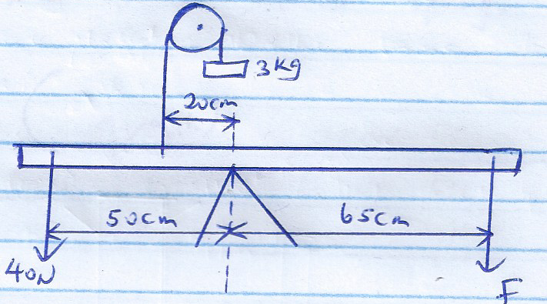
- (a) Figure 4 shows a system in equilibrium.

Determine the force, F needed to maintain the equilibrium. (Ignore the weight of the beam) (3mks)
..................................................................................................................................................................................................................................................................................................................................................................................................................................................................................................................................................................................................................................................................................................................................................................................................................................................................................................................................................................................................................................................................................................................................................................................................................................................................................................................................................

(b) Explain why it is dangerous for a bus to carry standing passengers. (2mks)
............................................................................................................................................................................................................................................................................................................................................................................................................................................................................................................................................................................................................................................................................................................................................................................................................
(c) Figure below shows a beaker containing molten candle wax.
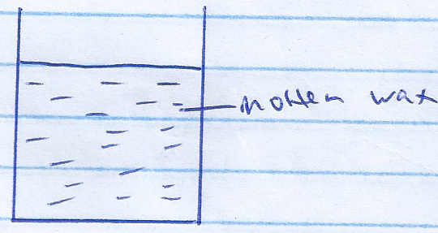

Indicate on the same diagram the position of the centre of gravity when the candle wax solidifies. (2mks)
............................................................................................................................................................................................................................................................................................................................................................................................................................................................................................................................................................................................................................................................................................................................................................................................................
(d) State Hooke’s law.
............................................................................................................................................................................................................................................................................................................................................................................................................................................................................................................................................................................................................................................................................................................................................................................................................

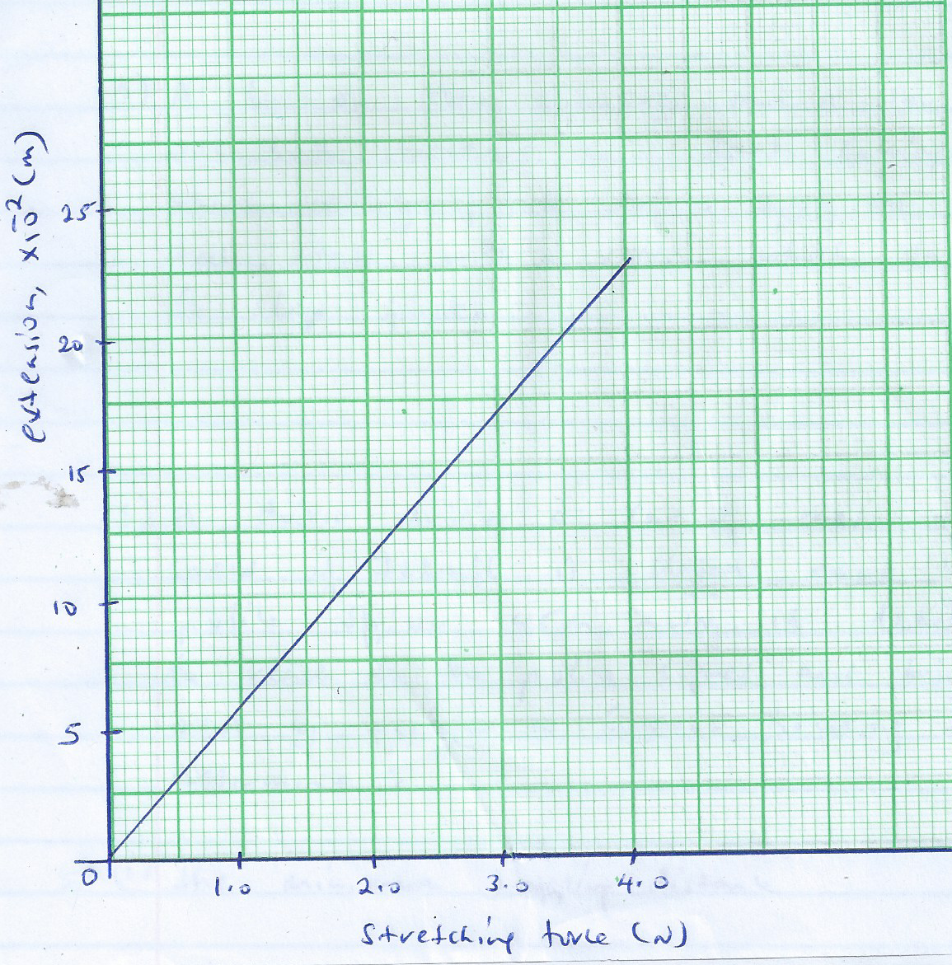
(e) Figure 5 shows a graph of extension against stretching force for helical spring

Use the graph to determine the spring constant of the spring (2mks)
......................................................................................................................................................................................................................................................................................................................................................................................................
- (a) State Newton’s first law of motion (1mk)
......................................................................................................................................................................................................................................................................................................................................................................................................
(b)A bus of mass 5,000 kg and a car of mass 1200 kg are both travelling on a dual carriage way at the same velocity. If both drives apply the same braking force, state with a reason which one will come to stop first. (2mks)
.................................................................................................................................................................................................................................................................................................................................................................................................................................................................................................................................................................................................................................................
(c) A driver driving a car of mass 1200 kg at a constant speed of 72 km/h is flagged down by a traffic public officer 145 m way. It takes him 2 seconds to react to the public signal and brings the car to rest by applying a constant breaking force in 10 seconds. Determine:
(i) The minimum stopping distance (3mks)
..............................................................................................................................................................................................................................................................................................................................................................................................................................................................................................................................................................................................................................................................................................................................................................................
(ii) State whether it will hit the traffic police officer or not. (1mk)
.......................................................................................................................................................................................................................................................................................................................................................................................
(d) What provides centripetal force for an electron moving round the nucleus. (1mk)
.......................................................................................................................................................................................................................................................................................................................................................................................
(e) A model car moves round a circular track of radius 0.4 m at 2 revolutions per second. Determine the linear speed of the car (2mks)
....................................................................................................................................................................................................................................................................................................................................................................................................................................................................................................................

