END OF TERM 2 2019

FORM 4 PHYSICS

**PAPER 1**

marking schem

**SECTION A: (25 MARKS)**

1. A spherical ball bearing is held between the jaws of vernier calipers. The reading on the vernier calipers when the jaws are closed without anything in between is 0.11 cm

What is the diameter of the ball bearing? (2mks)

**2.04 – 0.11 = 1.93 cm**

1. Figure 2 shows a sheet of paper rolled into a tube

When a stream of air at high speed is blown into the tube, the tube collapses. Explain this observation. (2mks)

* **blowing air into the tube reduces pressure inside**
* **pressure from outside is greater than inside**
* **Pressure difference cause tube to collapse.**

1. The bulb of a thermometer is dipped in ether at room temperature. When the thermometer is removed, its reading drops below room temperature. Explain (2mks)

**On removing, the bulb provides latent heat to ether and it evaporates reducing the temperature**

1. An astronaut climbing a very high mountain is likely to experience nose bleeding. Explain why this (1mk)

* **Atmospheric pressure is less than pressure of blood**
* **due to pressure difference the blood flows out.**

1. An external force applied to a ball of mass 160 g increases its velocity from 2 cm/s t 275 cm/s in 10 seconds. Calculate the force applied. (3mks)



1. (a) State Boyle’s law of gases. (1mk)

**The volume of a fixed mass of an ideal gas in inversely proportional to pressure at constant temperature**

(b) Explain in terms of kinetic theory why the pressure of a gas increases when its temperature rises. Assume that the volume remains constant. (2mks)

* **When temperature rises gas particles gain kinetic energy**
* **the collisions per unit time increase which causes increase in pressure.**

1. Explain why swimmers are advised to wear wet clothes before diving into a cold swimming pool. (1mk)

**Wet clothes make the person lose heat slowly preventing sudden heat loss which may cause pain.**

1. Figure 3 shows two thermometers A and B placed at the same distance from a very hot copper plate.

What adjustment should be made so that the thermometers read the same temperature after 10 minutes (1mk)

**Move thermometer B further from the block or move A closer to the block**

1. Water of mass 500g flows through a tube of uniform cross-section in 10s. Calculate the rate of flow of water in m3/s, if density of water is 1000 kg/m3. (3mks

1. Distinguish between a liquid and a gas in terms of:

(a) Movement of particles. (1mk)

**Random motion in gases is higher than in liquids**

(b) Intermolecular distance. (1mk)

**Intermolecular distance is more in gases than in liquids**

1. A student weaving sharp pointed shoes is likely to damage a soft wooden floor. Explain. (2mks)

**Due to small area of contact, more pressure is exerted on the floor**

1. Besides the length of a metallic conductor, state two other factors that affect heat conduction. (2mks)

**Cross sectional area**

**Temperature difference between the ends**

1. State the reason why the speed of water at the narrow section of a river is brighter than at the wider section. (1mk)

**Since the rate of flow is constant, when the area increases, velocity reduces.**

**SECTION B: (55 MARKS)**

1. (a) (i) Define velocity ratio of a machine (1mk)

**Ratio of effort distance to load distance**

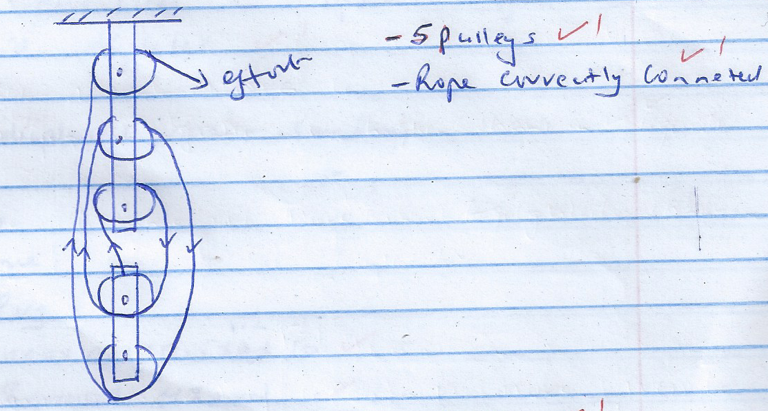 (ii) Draw a labeled diagram of a pulley system with a velocity ratio of 5. (2mks)

(iii) Give any two possible reasons why the efficiency is less than 100% (2mks)

* **Some energy is lost in overcoming friction**
* **Some energy is used to lift parts of the machine**

(b) The effort piston of a hydraulic machine is of radius 2.8 cm, while that of the load piston is of radius 14 cm. The machine raises a load of 120 kg at a constant velocity through 2.5 m. If the machine has an efficiency of 80%, find:

(i) The velocity ratio of the hydraulic machine. (3mks)



(ii) The mechanical advantage of the hydraulic machine (2mks)



(iii) The effort needed to raise the load. (2mks)



1. (a) State Archimedes principle. (1mk)

**When an object is wholly or partially immersed in a fluid it experiences an up thrust equal to the weight of fluid displaced.**

(b) A block of wood of weight 200N measuring 0.8 m by 0.5 m by 2m floats in water; 1.2 m of the block is submerged.

(i) Determine the weight of the water displaced (2mks)



. (ii) Find the force required to just make the block fully submerged. (3mks)

**Weight of block + extra weight = weight of water displaced.**

**200 + m = 800**

**m = 600N**

(c) A glass block of mass 250g floats in mercury. What volume of glass lies under the surface of mercury?

(Density of mercury=13600 kg/m3) (3mks)

**Weight of glass = weight of displaced mercury**

**2.5 = v x 13600 x 10**

**v = 1.838 x 10-5 m3**

(d) A piece of sealing wax weighs 3N in air and 0.22N when immersed in water. Calculate the density of the wax. (3mks)



1. (a) State two ways by which the rate of evaporation of a liquid may be increased. (2mks)

**Increasing the area of evaporation**

**Blowing cold air over the liquid**

**Increase temperature**

(b) Define the term ‘specific latent heat of fusion’. State its S.I units. (2mks)

**Amount of heat needed to convert a unit mass of a solid to liquid without change in temperature**

(c) A copper calorimeter of mass 0.4 kg contains 0.5 kg of water at 100c. Electric water heats the water and calorimeter to 900c in 3 minutes. Given that specific heat capacity of water = 4200J/kgk and specific heat capacity of copper = 400 J/Kgk, Calculate:

(i) Heat absorbed by water (2mks)

**Q = 0.5 X 4200 X 80 = 168000J**

(ii) Head absorbs by calorimeter (2mks)

**Q = 0.4 X 400X80 = 12800 J**

(iii) The power rating of the heating coil given that the coil is 85% efficient. (3mks)



1. (a) Figure 4 shows a system in equilibrium.

Determine the force, F needed to maintain the equilibrium. (Ignore the weight of the beam) (3mks)

**(30 x 0.2) + (F x 0.65) = (40 x 0.5)**

**6+ 0.65 F = 20**

**F = 21.54N**

(b) Explain why it is dangerous for a bus to carry standing passengers. (2mks)

**Standing passengers raise the centre of gravity of the bus which lowers its stability**

(c) Figure below shows a beaker containing molten candle wax.

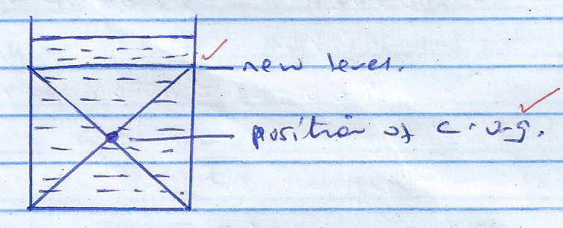Indicate on the same diagram the position of the centre of gravity when the candle wax solidifies. (2mks)

(d) State Hooke’s law.

**For a helical spring or any other elastic material, the stretching force is directly proportional to extension produced provided the elastic limit is not exceeded.**

(e) Figure 5 shows a graph of extension against stretching force for helical spring

Use the graph to determine the spring constant of the spring (2mks)



1. (a) State Newton’s first law of motion (1mk)

**A body remains in a state of rest or uniform motion in a straight line enters acted upon by an external** **force.**

(b)A bus of mass 5,000 kg and a car of mass 1200 kg are both travelling on a dual carriage way at the same velocity. If both drives apply the same braking force, state with a reason which one will come to stop first. (2mks)

**The car stops first. Since it has a lower momentum compared to the bus**

(c) A driver driving a car of mass 1200 kg at a constant speed of 72 km/h is flagged down by a traffic public officer 145 m way. It takes him 2 seconds to react to the public signal and brings the car to rest by applying a constant breaking force in 10 seconds. Determine:

(i) The minimum stopping distance (3mks)

Distance travelled before applying brakes

= 20 x 2 = 40 m

On applying brakes



(ii) State whether it will hit the traffic police officer or not. (1mk)

**The policemen will not be hit**

(d) What provides centripetal force for an electron moving round the nucleus. (1mk)

**Electrostatic force of attraction between the electrons and the nucleus.**

(e) A model car moves round a circular track of radius 0.4 m at 2 revolutions per second. Determine the linear speed of the car (2mks)

