Name…………………………………………………………………………….. Index Number………………………..……………
SCHOOL: ……………………………………………………………………….. Candidate’s Signature.............……………….
232/1 Date…………….………………………………..…………
PHYSICS
Paper 1
2018
2hours
JULY/AUGUST
FORM FOUR EVALUATION TEST
PHYSICS PAPER 1
2 hours

Instructions to candidates
(a) Write your name and index number in the spaces provided above.
(b) Write the name of your school in the space provided above.
(c) Sign and write the date of examination in the spaces provided above.
(d) This paper consists of two sections: A and B.
(e) Answer all the questions in sections A and B in the spaces provided in this booklet.
(f) All working must be clearly shown in the spaces provided in this booklet.
(g) Non programmable silent electronic calculators may be used.
(h) Mathematical tables must not be used.
(i) This paper consists of 14 printed pages.
(j) Candidates should check the question paper to ascertain that all the pages are printed as indicated and that no questions are missing.
(k) Candidates should answer the questions in English.

For Examiner’s Use Only
Section | Question | Maximum Score | Candidate’s Score
A | 1-11 | 25
B | 12 | 10
 | 13 | 15
 | 14 | 13
 | 15 | 08
 | 16 | 09
Total Score |  | 80

SECTION A:(25 marks)
Answer all the questions in this section in the spaces provided.
1. Figure 1 shows a vernier callipers’ scale.
4
3

10
5
0

Figure 1
Determine the reading. (1 mark)
………………………………………………………………………………………………………………………………………………………………………………………………………………………………………………………………………………………………………………
2. Water of density 1g/cm³ and volume 2cm³ is mixed with milk of density 2.4g/cm³. If the resulting mixture has density 1.9g/cm³, determine the mass, m and volume, v of milk in the mixture. Give your answer in g and cm³. (3 marks)
…………………………………………………………………………………………………………………………………………………………………………………………………………………………………………………………………………………………………………………………………………………………………………………………………………………………………………………………………………………………………………………………
3. Figure 2 shows parallel forces F₁ and F₂ acting oppositely on a body M.
M
4 CM
3 CM
F2
F1
Figure 2

(a) Show diagrammatically the direction of the resultant force, F, acting on the body. (1 mark)

(b) Write down an expression of F in terms of F₁ only. (1 mark)
…………………………………………………………………………………………
4. Suggest a possible reason why brownian motion is more evident in gas particles than in liquid molecules. (1 mark)
…………………………………………………………………………………………………………………………………………………………………………………………………………
5. Figure 3 shows the variation of temperature of a certain liquid A in different layers.
Figure 3
4⁰ C
3⁰C
2⁰ C
1⁰ C
Solid of liquid A (0⁰ C)

(a) State the name of liquid A. (1 mark)
…………………………………………………………………………………………
(b) Explain why the temperature of the liquid increases downwards. (2 marks)
…………………………………………………………………………………………
…………………………………………………………………………………………
…………………………………………………………………………………………
6. A student heated water in two round bottomed flasks to a boiling point. He then stopped boiling, clipped and turned them upside down. He ran cold water over them as shown in figure 4.
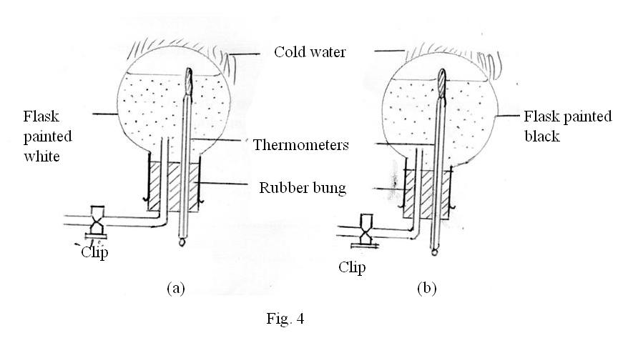

(a) State the observation that was made in the set up. (2 marks)
…………………………………………………………………………………………
…………………………………………………………………………………………
(b) Explain the difference in the observations in figure (4 a) and (4b). (2 marks)
…………………………………………………………………………………………
…………………………………………………………………………………………
…………………………………………………………………………………………
…………………………………………………………………………………………
7. In order to determine the speed of a liquid in the wider section of a tube of flow, a student was given the area of the wider section, A₁ = 30cm², the area of the narrower section, A₂ = 5cm² and the speed of the liquid in the narrower section, v₂ = 6m/s. State two assumptions made by the student for the calculations to be exact. (2 marks)
……………………………………………………………………………………………………
……………………………………………………………………………………………………

8. Figure 5 shows a velocity-time graph for a moving object.
A
B
Velocity (m/s)
Time (s)
Figure 5

Sketch two other graphs on figure 5 for displacement (y axis) against time and label them A and B respectively. (2 marks)
9. The initial velocity of a body of mass 2kg is 4ms⁻¹. Determine how long a constant force of 5.0N would act on the body in order to double its kinetic energy. (3 marks)
……………………………………………………………………………………………………
……………………………………………………………………………………………………
……………………………………………………………………………………………………
……………………………………………………………………………………………………
10. State what happens to an air bubble released at the bottom of a tank as it moves to the surface. (1 mark)
………………………………………………………………………………………………………………………………………………………………………………………………………………………………………………………………………………………………………………

11. When floating in a liquid of relative density 0.8, a hydrometer displaces 90cm³, determine the volume it will displace when it is transferred to a liquid of relative density 1.2. (3 marks)
………………………………………………………………………………………………………………………………………………………………………………………………………………………………………………………………………………………………………………………………………………………………………………………………………………………………………………………………………………………………………………………………………………………………………………………………………………………………
SECTION B: (55 marks)
Answer all the questions in this section in the spaces provided.
12. (a) State the principle of conservation of momentum. (1 mark)
…………………………………………………………………………………………
…………………………………………………………………………………………
…………………………………………………………………………………………
…………………………………………………………………………………………
(b) Figure 6 shows two wheeled trolleys X (mass 3kg) and Y (mass 4kg) which can run on a horizontal rail held together at rest against a compressed spring.
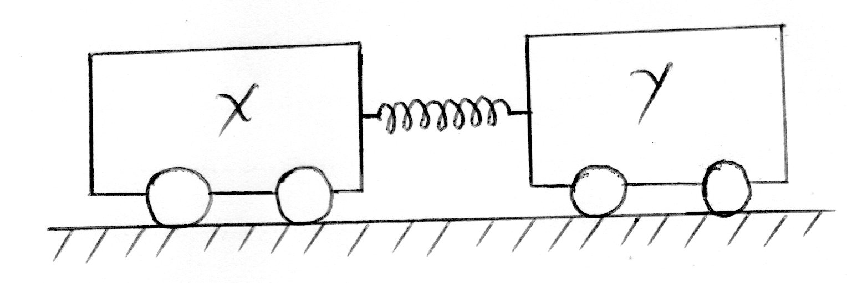

Figure 6
When they are released at the same instant, X moves to the left at 0.8m/s.
Determine the:
(i) momentum of X immediately after release. (2 marks)
…………………………………………………………………………………...
…………………………………………………………………………………...
…………………………………………………………………………………...
(ii) momentum of Yimmediately after release. (1 mark)
…………………………………………………………………………………...
…………………………………………………………………………………...
(iii) velocity of Yimmediately after release. (2 marks)
…………………………………………………………………………………...
…………………………………………………………………………………...
…………………………………………………………………………………...
(iv) kinetic energy of Y and X immediately after release. (2 marks)
…………………………………………………………………………………...
…………………………………………………………………………………...
…………………………………………………………………………………...
…………………………………………………………………………………...
…………………………………………………………………………………...
…………………………………………………………………………………...
(v) potential energy that was stored in the spring. (2 marks)
…………………………………………………………………………………...
…………………………………………………………………………………...
…………………………………………………………………………………...
…………………………………………………………………………………...
13. (a) State the energy changes that take place when a woman addresses a crowd using a microphone. (1 mark)
…………………………………………………………………………………………
…………………………………………………………………………………………
(b) A man uses a steel bar of length 1.5m to lift a load of weight 900N on one end of the bar. If the distance of the pivot from the load is 30cm, determine the:
(i) effort applied (2 marks)
…………………………………………………………………………………...
…………………………………………………………………………………...
…………………………………………………………………………………...
…………………………………………………………………………………...
…………………………………………………………………………………...
(ii) energy transferred from the man to the lever. (2 marks)
…………………………………………………………………………………...
…………………………………………………………………………………...
…………………………………………………………………………………...
…………………………………………………………………………………...
…………………………………………………………………………………...
(c) Figure 7 shows a wheel and axle being used to raise a load W by applying an effort F. The radius of the larger wheel is R and of smaller r as shown.
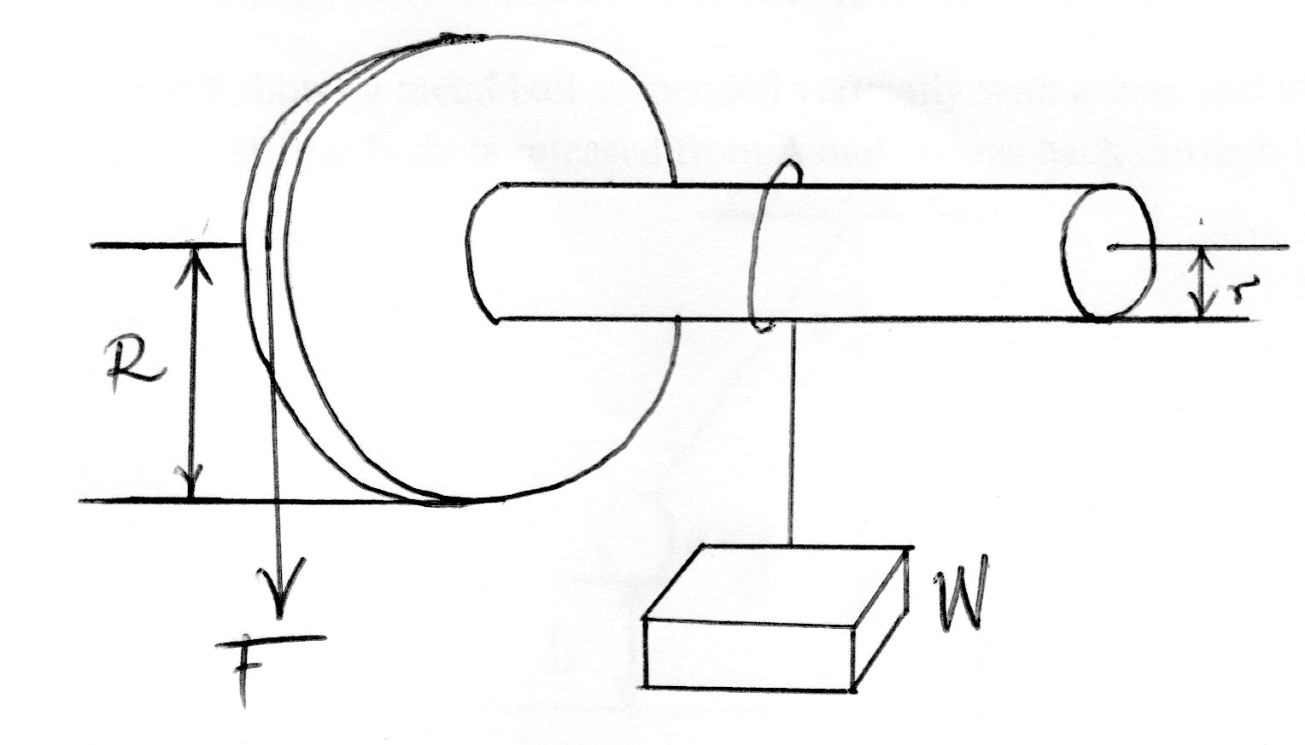

Figure 7

(i) Show that the velocity ratio (V.R.) of this machine is given by R/r. (3 marks)
…………………………………………………………………………………...
…………………………………………………………………………………...
…………………………………………………………………………………...
…………………………………………………………………………………...
…………………………………………………………………………………...
…………………………………………………………………………………...
(ii) Given that r = 5cm, R = 8cm, determine the effort required to raise a load of 20N if the efficiency of the machine is 80%. (4 marks)
…………………………………………………………………………………...
…………………………………………………………………………………...
…………………………………………………………………………………...
…………………………………………………………………………………...
…………………………………………………………………………………...
…………………………………………………………………………………...
…………………………………………………………………………………...
(iii) It is observed that the efficiency of the machine increases when it is used to lift larger loads. State the reason for this. (1 mark)
…………………………………………………………………………………...
…………………………………………………………………………………...

(d) Figure 8 shows a metal ball suspended vertically with a wire and then displaced through an angle Θ. The body is released from A and swings back through B.
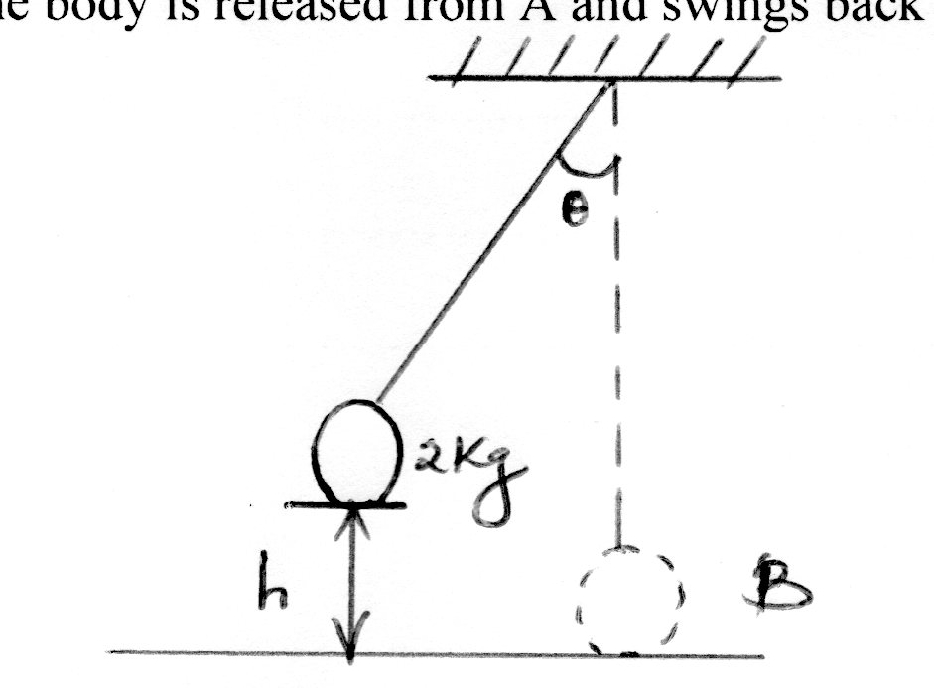

Figure 8
Given that the maximum velocity at the lowest point is 2.5m/s, determine the height h from which the ball was released. (2 marks)
…………………………………………………………………………………………
…………………………………………………………………………………………
…………………………………………………………………………………………
…………………………………………………………………………………………
…………………………………………………………………………………………
14. (a) Distinguish between latent heat of fusion and latent heat of vaporization. (1 mark)
…………………………………………………………………………………………
…………………………………………………………………………………………
…………………………………………………………………………………………
…………………………………………………………………………………………
…………………………………………………………………………………………
(b) An aluminium tray of mass 400g containing 300g of water is placed in a refrigerator. After 80 minutes, the tray is removed and it is found that 60g of water remain unfrozen at 0°C. If the initial temperature of tray and its contents was 20°C, determine the average amount of heat removed per minute by the fridge. (Specific heat capacity of aluminium c_{al} is 900Jkg⁻¹K⁻¹, specific heat capacity of water is 4200Jkg⁻¹K⁻¹and specific latent heat of fusion of ice is 3.4 x 10⁵Jkg⁻¹). (3 marks)
…………………………………………………………………………………………
…………………………………………………………………………………………
…………………………………………………………………………………………
…………………………………………………………………………………………
…………………………………………………………………………………………
…………………………………………………………………………………………
…………………………………………………………………………………………
(c) An electric kettle rated 1.5kW is used in an experiment to convert 200g of ice at -5°C, to steam at 100°C under standard pressure. Determine the time for which the kettle has to be used. (Specific heat capacity of ice c is 2100Jkg⁻¹K⁻¹,specific heat capacity ofwater is 4200Jkg⁻¹K⁻¹, specific latent heat of fusion of ice is 3.4 x 10⁵Jkg⁻¹and specific latent heat of vaporization of steam is 2.26 x 10⁶Jkg⁻¹.) (3 marks)
…………………………………………………………………………………………
…………………………………………………………………………………………
…………………………………………………………………………………………
…………………………………………………………………………………………
…………………………………………………………………………………………
…………………………………………………………………………………………
…………………………………………………………………………………………
…………………………………………………………………………………………
…………………………………………………………………………………………
…………………………………………………………………………………………
…………………………………………………………………………………………
(d) You are provided with a round bottomed flask filled with water, thermometer, and rubber tubing with a clip. Describe with the aid of diagram how you would use the apparatus to show the effect of pressure on boiling points. (3 marks)

(e) State three conditions necessary for a siphon to work. (3 marks)
…………………………………………………………………………………………
…………………………………………………………………………………………
…………………………………………………………………………………………
…………………………………………………………………………………………
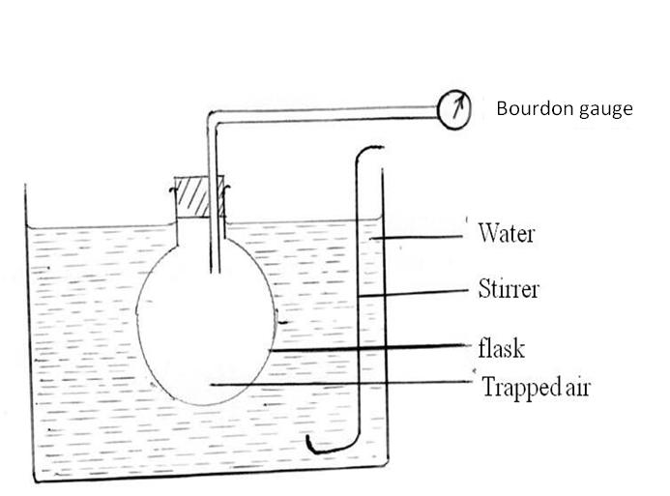
15. Figure 9 shows the diagram drawn by a student who was asked to draw a diagram of the apparatus used to investigate how the pressure of some strange gas varies with temperature.

Figure 9
(a) Complete the diagram showing and labeling the essential items the student has omitted. (2 marks)
(b) State the purpose of the:
(i) stirrer (1 mark)
…………………………………………………………………………………...
…………………………………………………………………………………...
(ii) bourdon gauge. (1 mark)
…………………………………………………………………………………...
…………………………………………………………………………………...
(c) State the temperature at which the pressure of the air will theoretically be zero. (1 mark)
…………………………………………………………………………………………
(d) State the name of the temperature in (c). (1 mark)
…………………………………………………………………………………………
(e) Using the kinetic theory of gases, explain how the rise in temperature of a gas causes a rise in the pressure of the gas if the volume is kept constant. (2 marks)
…………………………………………………………………………………………
…………………………………………………………………………………………
…………………………………………………………………………………………
…………………………………………………………………………………………
16. (a) Figure 10 shows a centrifuge containing muddy water and being whirled at high speed.
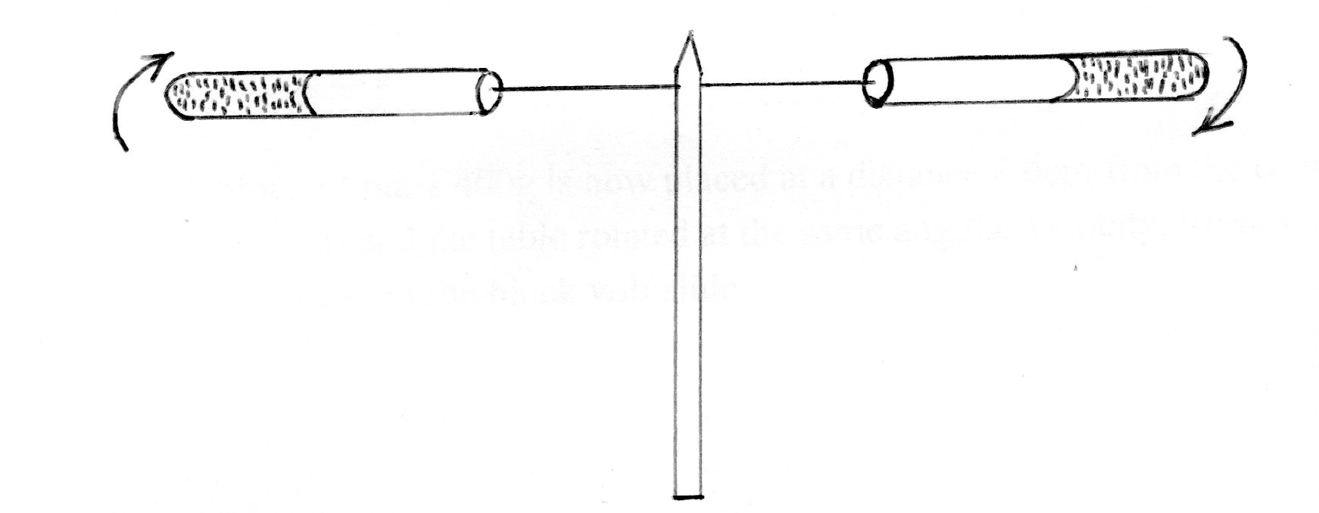

Figure 10
Explain how the high speed rotation causes the separation of mud from water. (3 marks)
…………………………………………………………………………………………
…………………………………………………………………………………………
…………………………………………………………………………………………
…………………………………………………………………………………………
(b) A wooden block of mass 200g is placed in turn at various distances from the centre of a turntable which is rotating at constant angular velocity. It is found that at a distance 8.0cm from the centre, the block just starts to slide off the table. If the force of friction between the block and the table is 0.4N, determine the:
(i) angular velocity of the table. (2 marks)
…………………………………………………………………………………...
…………………………………………………………………………………...
…………………………………………………………………………………...
…………………………………………………………………………………...
(ii) force required to hold the block at a distance 12cm from the centre of the table. (2 marks)
…………………………………………………………………………………...
…………………………………………………………………………………...
…………………………………………………………………………………...
…………………………………………………………………………………...
(iii) A block of mass 400g is now placed at a distance 8.0cm from the centre of the table in (i) and the table rotated at the same angular velocity. State with a reason whether or not the block will slide. (2 marks)

…………………………………………………………………………………...
…………………………………………………………………………………...
…………………………………………………………………………………...
…………………………………………………………………………………...
…………………………………………………………………………………...

THIS IS THE LAST PRINTED PAGE

JULY/AUGUST EXAM
PHYSICS PAPER 1 MARKING SCHEME
SECTION A
- 3.50cm 1

Substance | Mass(g) | Volume (cm³ ) | Density (g/cm³)
Water | 2 | 2 | 1
Milk | m | V | 2.4
Mixture | (2+m) | (2+v) | 1.9

$\frac{m}{v}=2.4$ i)

m = 2.4v 1

= $\frac{2+m}{2+v}=1.9$ ii) Allow ALT working

$$\frac{2+2.4v}{2+v}=1.9$$
2+2.4v = 1.9 (2+v)

2+2.4v = 3.8 + 1.9v
0.5v = 1.8
v = 3.6cm³ 1 v in cm³
m= 2.4x3.6
= 8.64 g 1 m in g
M
- (a) F
1cm 1 For both magnitude and direction
(b) F = F₁ – F₂
But F₂ = ¾ F₁
F = F₁ – ¾ F₁ = $\frac{F1}{4}$ 1
- Gas particles have larger inter molecular spaces than liquid molecules 1/
Gases have higher kinetic energy/lower density /lower cohesive forces/lower intermolecular forces than liquids (Any one)

- (a) Water 1
(b) Water expands when cooled 1 from 4ºC to 0ºC. 1

- (a) Water in (b) boils at a temperature below its boiling point 1 faster than in (a) 1
(b) White surfaces are good reflectors of radiant heat than black surfaces1. Steam condenses faster in (b) reducing vapour pressure hence lowering the boiling point of water. 1

- (i) Fluid is flowing steadily. 1
(ii) Fluid is incompressible 1 (Any two)
(iii) Fluid is non-viscous.
1
A

B
1
Displacement
(m)

Time (s)
- 2( ½ mu²) = 1/2 mv²
V² = 2u²
= 2x4²
V = $\sqrt{2x4^{2}}$
= 5.657m/s 1
F = ma
5 = 2a
a = 2.5 m/s² 1
v = u+at
5.657 = 4+2.5t
2.5t = 1.657
t = 0.6628 s 1
- Its volume increases 1
- W=ρvg = 0.8x90x10⁻⁶x10 1
= 7.2x10⁻⁴N 1
7.2x10⁻⁴ = 1.2xvx10
V = 6x10⁻⁵m³ 1
= 60 cm³

SECTION B
- (a) For a system of colliding bodies, the total linear momentum remains constant, provided no external forces act. 1
(b) (i) P_{x}= mv_{X}
= 3 X 0.8 1
= 2.4kgms⁻¹ 1
(ii) – 2.4kgms⁻¹ 1 Allow TE
(iii) – 2.4 = 4xv_{y} 1 Allow TE
v_{y}= $\frac{-2.4}{4}$
= - 0.6ms⁻¹ 1

(iv) K.E_{x} = ½ mv_{x}²
= ½ x3x0.8²
= 0.96J 1

K.E_{y} = ½ mv_{y}²
= ½ x4x-(0.6²) Allow TE
= -0.72J 1

(v) P.E = 0.96 – 0.72 1 Allow TE
= 0.24J 1

- (a) Sound Kinetic electrical Sound 1

(b)(i)
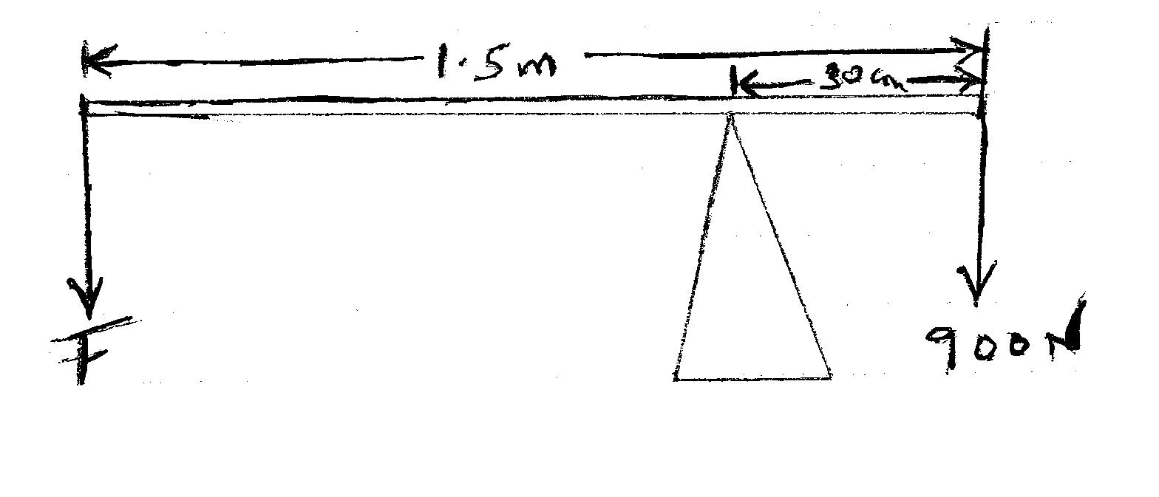

Fx 1.2 = 900x0.3 1

F = $\frac{900x0.3}{1.2}$

= 225N 1

(ii) Energy = Wd = Fd
= 225x1.5 1
= 337.5J 1

(c)(i) V.R = $\frac{distance moved by effort}{distance moved by load}$

= $\frac{circumference of wheel}{circumference of axle}$ 1

= $\frac{2πR}{2πr}$ 1
= $\frac{R}{r}$ 1
(ii) V.R = $\frac{8}{5}=1.6$ 1

$\frac{M.A}{V.R} X 100\%=$ƞ

$\frac{M.A}{1.6} X100\%=80\%$ 1

M.A = $\frac{80X1.6}{100}$

= 1.28 1

$\frac{L}{E}=M.A$
$\frac{20}{E}=1.28$

E =$\frac{20}{1.28}$

= 15.625N 1
(iii) Increase in load increases the mechanical advantage of the machine, 1 hence increase in efficiency.

(d) P.E before release = K.E at B
mgh = ½ mv²
gh = ½ v²
10xh = ½ x2.5² 1
h = ½ x $\frac{2.5^{2}}{10}$
h = 0.3125m 1
= 31.25cm
- (a) Latent heat of fusion is the quantity of heat energy required to change a given mass of a substance from solid to liquid without change in temperature while latent heat of vaporization is the quantity of heat required to change a given mass of a substance from liquid to vapour, without change of temperature. 1
(b) Heat removed by fridge = Heat lost by tray and contents.
Q = Heat lost by tray (20ºC to 0ºC) + Heat lost by cooling water (20ºC to 0ºC) + Heat lost by frozen water (ice) (0ºC to 0ºC)
= m_{al} c_{al}θ + m_{w} c_{w}θ+ m_{i}L_{f}
= $\left(\frac{400}{1000}x 900x20\right)+ \left(\frac{300}{1000}x 4200x20\right)+ \left(\frac{240}{1000}x 3.4x10^{5}\right)$ 1

= 7,200 + 25,200 + 81,600
= 114,000J 1
Pt = Q
P = $\frac{Q}{t}$
= $\frac{114,000J}{80 min}$
= 1,425J min⁻¹ 1
(c) Heat lost by kettle = Heat gained by ice (-5ºC to 0ºC) + Heat gained by melting ice(0ºC to 0ºC)+
Heat gained by melted ice (water) (0ºC to 100ºC)+ Heat gained by boiling water (100ºC to 100ºC)
1
Pt = m_{i} c_{i}θ + m_{i}L_{f}+ m_{w} c_{w}θ+ m_{w}L_{v}
1.5x10³xt = $\left(\frac{200}{1000}x2100x5\right)+ \left(\frac{200}{1000}x3.4x10^{5}\right)+ \left(\frac{200}{1000}x4200x100\right)+ \left(\frac{200}{1000}x2.26x10^{6}\right)$ 1
1.5x10³t = 2100 + 68,000 + 84,000 + 452,000J
1.5x10³t = 606,100J
t = 404.1s 1
= 6.734 min

(d)
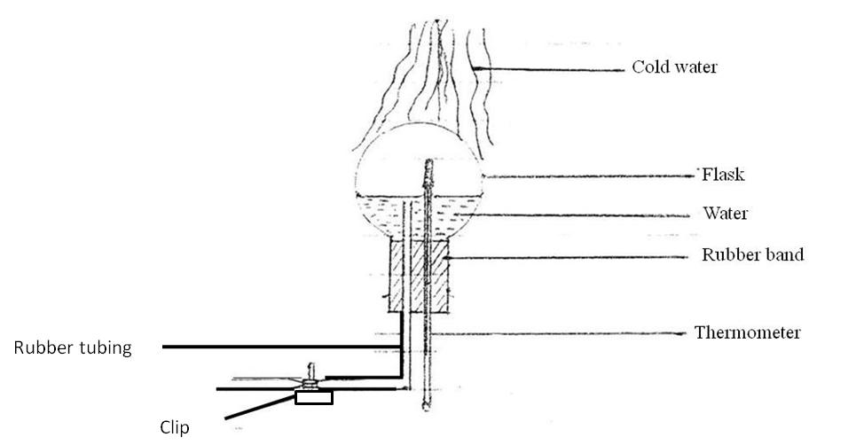

1
Procedure
- Heat water in a round-bottomedflask fitted with a thermometer and a tube.
- Stop heating, close the clip and turn the flask upside down.
- Run cold water over the flask
- Note observations. 1
Observation
The water stops boiling when the heating is stopped. When cold water is run over the flask, the water inside begins boiling again, even though the temperature is below boiling point. 1
Explanation
The cold water condenses the steam reducing vapour pressure. This lowers the boiling point of the liquid.
(e) (i) The end of the tube to eject the liquid is lower than the surface of the liquid to be emptied. 1
(ii) The tube is first filled with the liquid, without any bubbles in it. 1
(iii) The tube above the liquid surface does not rise above the barometric height of the liquid. 1
(iv) One end of the tube must be inside the liquid to be emptied.
Any three.
- (a) Fit a thermometer in flask 1
Introduce source of heat. 1
(b)
- To make the temperature of the gas equal to that of the bath. 1
- Record pressure readings 1
(c) -273ºC 1 / 0K
(d) Absolute zero. 1
(e) when a gas is heated, its molecules gain kinetic energy and move faster. The molecules bombard the walls of the container many more times per unit time, 1 with greater momenta. The total rate of change of momentum per unit area increases. 1 Thus pressure increases.
- (a) The closed ends of the tubes provide the centripetal force on the mixture which is highest at the closed end than at the open end. 1 Thus a pressure gradient is created along the radius of the circle of rotation.
This pressure gradient acts on every section of the mixture producing centripetal force at that section. 1 Action of centripetal force moves particles up the tube depending on their masses. Thus water particles will settle at the bottom since they are lighter as mud moves up the tube. 1

(b) (i) F=mrω²
0.4 = $\frac{200}{1000} x \frac{8}{100} x ω^{2}$ 1

$ω$ ² = $\frac{1000 x 100 x 0.4}{200 x 8}$

$ω$ ² = 25
$ω$ = 5 rad s⁻¹ 1

(ii)F = mrω²
= $\frac{200}{1000}$ x $\frac{12}{100 }x 5^{2}$ 1
= 0.6N 1

- F = $\frac{400}{1000} x \frac{8}{100} x 5^{2}$

= 0.8N 1
0.8N>0.4N
The block will slide. A greater centripetal force is required to keep the block in a circular path. 1
Increase in mass increases the centripetal force required to keep the block in a circular path.
Any one

