Kenya Certificate of Secondary Education 2019
231/ 1 PHYSICS -Paper 1
(Theory )
END TERM 2019 - Time :2 hours

Name …………………………………………….……… Index Number…………………………..
Candidate’s Signature ………………….…...……….. Date ……………………………………

INSTRUCTIONS TO CANDIDATES
- Write your name, admission number and class in the spaces provided above.
- Sign and write the dateof examination in the spaces provided above.
- This paper consists of TWO sections: A and B.
- Answer ALL the questions in sections A and B in the spaces provided.
- ALL working MUST be clearly shown.
- Non-programmable silent electronic calculators and KNEC mathematical tables may be used.
- Candidates should check the question paper to ascertain that all the pages are printed as indicated and that no questions are missing.

For Examiner’s Use Only
Section | Question | Maximum Score | Candidate’s Score
A | 1 – 13 | 25
B | 14 | 09
 | 15 | 12
 | 16 | 10
 | 17 | 10
 | 18 | 07
 | Total Score | 80

Physics Paper 1 2019

Turn over

2019

SECTION A (25 MARKS )
- A piece of cotton is used to measured between two points on a ruler as shown

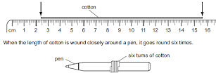
Calculate the circumference of pen (3 marks)

- Koome heats 5kg of water to a temperature of 80ºC. When she adds m kg of water at 15ºC the mixture attains a temperature of 40ºC. Determine the value of m (3mks)
………………………………………………………………………………………………………………………………………………………………………………………………………………………………………………………………………………………………

- 100 drops of oil, of density 800kg/m³ are found to have a total mass of 2 x 10-⁴ kg. One of the drops is placed on a large clean water surface and it spreads to form a uniform film of diameter 50 cm². Determine; the diameter of the oil molecule. (3 mks)
………………………………………………………………………………………………………………………………………………………………………………………………………………………………………………………………………………………………
- The figure below shows a uniform plank AB of length 10m weighing 500N. Two masses measuring 25kg and 60kg are loaded on its ends.
25kg
60kg
A
B

Determine the distance from point A where a support should be placed for the plank to balance horizontally. (3mks)
………………………………………………………………………………………………………………………………………………………………………………………………………………………………………………………………………………………………

- An aircraft 300m from the ground, travelling horizontally at 400 m/s releases a parcel. Calculate the horizontal distance covered by the parcel from the point of release. (Ignore air resistance) (2mks)
………………………………………………………………………………………………………………………………………………………………………………………………………………………………………………………………………………………………

- The figure below the figure below shows two experiments to investigate energy transfer in water.

ice
water

water
gentle
heating
gentle
heating

ice trapped by
small piece of
wire gauze

gentle
heating

Name the process by which thermal (heat) energy travels through the glass. (1 mk)
…………………………………………………………………………..
- In the above experiment give a reason who the ice had to be wrapped on metal (1 mark)
………………………………………………………………………………………………………………………………………………………………………………………………………………………………………………………………………………………………

- Distinguish between speed and velocity. (1mark)
………………………………………………………………………………………………………………………………………………………………………………………………………………………………………………………………………………………………
- In the study of free fall, it is assumed that the force F acting on a given body of mass, m, is gravitational, given by F = mg. State two other forces that act on the same body. (2marks)
………………………………………………………………………………………………………………………………………………………………………………………………………………………………………………………………………………………………

- In the set up shown below, it is observed that the level of the water initially drops before starting to rise. Explain this observation. (2marks)

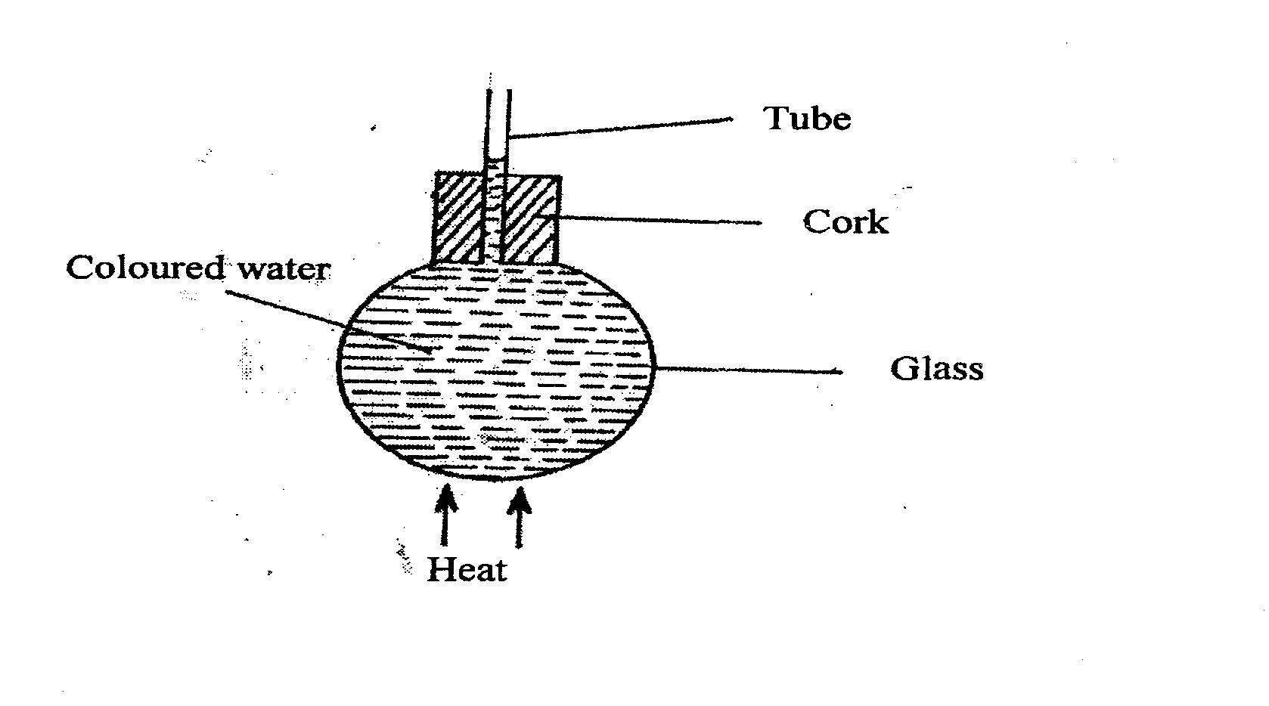
………………………………………………………………………………………………………………………………………………………………………………………………………………………………………………………………………………………………
- A wise cyclist will carry a load on the bicycle’s carrier and not in a rack sack on his
back. Explain (2mks)
………………………………………………………………………………………………………………………………………………………………………………………………………………………………………………………………………………………………

Section B (55 Marks)
- . (a) The figure below shows a circuit diagram for a device for controlling the temperature in a room.
Brass
Iron
Contact
Copper strip
Heater element
S

(i) State the purpose of the bimetallic strip. (2mks)
………………………………………………………………………………………………………………………………………………………………………………………………………………………………………………………………………………………………

(ii) Describe how the circuit controls the temperature when the switch S is closed. (3 Marks)
………………………………………………………………………………………………………………………………………………………………………………………………………………………………………………………………………………………………

(b) (i) Differentiate between the term heat capacity and specific heat capacity of a substance (2mks)
………………………………………………………………………………………………………………………………………………………………………………………………………………………………………………………………………………………………

(ii) An electric kettle rated 2.5kW is used to raise the temperature of 3.0kg of water through 50⁰C. Calculate the time required to effect this (Specific heat capacity of water is 4200j/kgK) (3 Marks)
………………………………………………………………………………………………………………………………………………………………………………………………………………………………………………………………………………………………
- (a) A glass capillary contains enclosed air by a thread of mercury 15cm long when the tube is horizontal, the length of the enclosed air column 24cm as shown.
24cm
15cm

- What is the length of the enclosed air column when the tube is vertical with the open end uppermost if the atmosphere pressure is 750mmHg? (2mks)
………………………………………………………………………………………………………………………………………………………………………………………………………………………………………………………………………
- Explain why the mercury does not run out when the tube is vertical with the closed end uppermost. (1mk)
………………………………………………………………………………………………………………………………………………………………………………………………………………………………………………………………………

b) Explain why an air bubble increase in volume as it rises from the bottom of a lake to the surface. (1mk)
………………………………………………………………………………………………………………………………………………………………………………………………………………………………………………………………………………………………
c) When an inflated balloon is placed in a refrigerator it is noted that its volume reduces, use the kinetic theory of gases to explain this observation. (2mks)
………………………………………………………………………………………………………………………………………………………………………………………………………………………………………………………………………………………………
d) A certain mass of hydrogen gas occupies a volume of 1.6$m^{3}$ at a pressure of 1.5 × ${10}^{5}$ Pa and a temperature of 22⁰c. Determine the volume when the temperature is 0⁰c at a pressure of 0.8×10⁵ Pa. (3mks)
………………………………………………………………………………………………………………………………………………………………………………………………………………………………………………………………………………………………
e) i)State the pressure law (1mk)
………………………………………………………………………………………………………………………………………………………………………………………………………………………………………………………………………
ii)On the axis provided, sketch a graph of pressure against temperature on the celcius scale. On the same axis sketch another graph for a gas of a larger volume. (2mks)
Pressure (Pa)
Temperature (ºc)

- a) A machine is a device that enables work to be done more easily and conveniently.
State two ways in which a machine ensures this. (2 marks)
………………………………………………………………………………………………………………………………………………………………………………………………………………………………………………………………………………………………
b) The figure below shows a simple machine being used to raise a load W by applying an effort E.
- Name the machine. (1 mark)
……………………………………………………..
- Show that the velocity ratio (V.R) of the machine is given by $R/r$. (2marks)

- Given that r =11cm and R = 99cm, determine the effort E required to raise a load of 2800N if the efficiency () of the machine is 95%. (4 marks)

c) Explain why as the load increases the value of mechanical advantage of a machine approaches the value of the velocity of the machine. (1 mark)
………………………………………………………………………………………………………………………………………………………………………………………………

- (a) The figure below shows a stone of mass 450g rotated in a vertical circle at 3 revolutions per second. If the string has a length of 1.5m, determine:

B
A
O

(i) The linear velocity (3mks)
………………………………………………………………………………………………………………………………………………………………………………………………………………………………………………………………………………………………………………………………………………………………………………………………………………………………………………………………………………………………………………………………………………

(ii) The tension of the string at position A (3mks)
……………………………………………………………………………………………………………………………………………………………………………………………………………………………………………………………………………………………………………………………………………………..

b) On the same diagram indicate the path that the stone will follow if the string snaps at point B (1 Mk)

(c) A stone is whirled with uniform speed in horizontal circle having radius of 10cm. It takes the stone 10 seconds to describe an arc of length 4cm. Determine:
(i) The angular velocity ω (3mks)
………………………………………………………………………………………………………………………………………………………………………………………………………………………………………………………………………
(ii) The period T (3mks)
………………………………………………………………………………………………………………………………………………………………………………………………………………………………………………………………………………………………
.
- The diagram below shows a pendulum bob swinging freely to and fro.
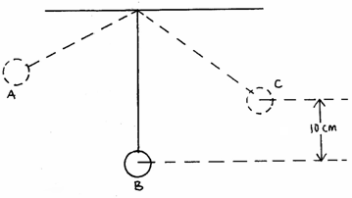

(a) (i) State the position where the pendulum bob has maximum kinetic energy. (1mk)
………………………………………………………………………………………………………………………………………………………………………………

- Determine the velocity of the bob at the position identified in (a)i above if the maximum vertical displacement of the bob is 10cm. (3mks)
………………………………………………………………………………………………………………………………………………………………………………………………………………………………………

- A bullet of mass 20g moving with a velocity of 1000m/s hits a stationery wooden block of mass 12kg. The bullet imbeds and the two move in one direction. Calculate its final velocity. (3mks)

………………………………………………………………………………………………………………………………………………………………………………………………………………………………………………………………………

- A block of mass 200g rests on a rough horizontal table. A force of 0.6N pulls the block so that it moves with a constant acceleration of 1m/s². Calculate
(i) the time it takes to travel a distance of 200m. (2mks)

………………………………………………………………………………………………………………………………………………………………………………………………………………………………………………………………………

(ii) the friction force between the block and the table. (2mks)

………………………………………………………………………………………………………………………………………………………………………………………………………………………………………………………………………

