END OF TERM 2 2019

FORM 4 PHYSICS

**PAPER 2**

**Marking scheme**

**SECTION A: (25 MARKS)**

1. Figure 1 below shows a ray of light incident on a plane mirror

The mirror is then rotated 100 clockwise about point o, with the path of incident ray remaining unchanged, what is the new angle of reflection. (2mks)

**600 + 100 = 700** ...

1. A house has two 100 w bulbs, three 60w bulbs and one 30w bulb. Determine the cost of having all bulbs switched on for 10 hours, given that the cost of electricity is 95 cents per kilowatt hour. (3mks)

**No of units = ( 0.2 x 10) + 0.18 x 10) + 0.03 x10)**

**= 2 + 1.8 + 0.3**

**= 4.1**

1. Figure 2 shows a charged rod which is close to a metal sphere.

Identify the charge on rod A. (1mk)

**Negative**

1. Figure 3 shows part of electromagnetic spectrum.

|  |  |  |  |  |
| --- | --- | --- | --- | --- |
| Gamma rays | P | Ultra-violet | Q | Intra red |

(a) Identify radiation p (1mk)

**x- rays** .

(b) State two applications of radiation Q. (2mks)

**enables animals to see**

**helps plants to manufacture their food**

**ordinary photography**

**(any 1 mark)**..

(c) Compare the frequency of P to that of Q (1mk)

**P has a frequency than Q**

1. The half life of a certain radioactive element is 15 hours, if at time, t =0 the mass of the element is 640 g, what mass is left after 5 days? (3mks)

**Total time = 5 x 12 = 60 hors**

**No of half lites = **

**640 g → 320 g→160g→80g→40g**

1. A pendulum bob takes 0.5 seconds to move from its main position to a maximum displacement positions. What is the periodic time of the pendulum? (2mks)

**T= 0.5 x 4 = 2 seconds**

1. Distinguish between real and virtual images. (1mk)

**Real can be focused on a screen while virtual cannot.**

**Real images are inverted while virtual are upright**

1. Explain using domain theory of magnetism how hammering demagnetizes a magnet. (2mks)

**Mechanical vibrations disorient the dipoles.**

1. A transformer connected to 240V a.c supply is used to supply power to three identical bulbs each rated 24w, 12v in a lighting circuit.

Calculate:

(a) The turns ratio (2mks)



(b) The efficiency of the transformer, if the current from the power supply is 0.75A. (2mks)

**Efficiency = **

**= 40%**

1. What is meant by “doping” as used in the process of making semiconductors (1mk)

**Process of adding small quantities of impurities to an intrinsic semiconductor to enhance its conductivity**

1. Figure 4 shows a conductor carrying current in a magnetic field.

(a) If the conductor experiences a force in the direction shown, identify pole A of the magnet. (1mk)

**North pole**

(b) State one way of increasing the force experienced by the conductor (1mk)

* **Using a stronger magnet**
* **Increasing the current**
* **Placing the conductor at right angles with the magnetic field**
* **Increasing the length of the conductor subjected to magnetic field**

**SECTION B:**

1. (a) What is meant by the term electrical resistance? (1mk)

**Opposition to flow of electric charges.**

(b) State two factors that affect electrical resistance of a metallic conductor. (2mks)

**Length of conductor**

**Cross sectional area of the conductor**

**Temperature**

**(Any 2 each 1 mark)**

(c) The circuit diagram shown in figure 5 shows four resistors connected to a cell of emf 3.0 v and internal resistance 0.1Ω

Calculate

(i) The effective resistance in the circuit. (3mks)



**R = 3Ω**

**Total R = 3 + 3+ 0.1 = 6.1Ω**

(ii) The current flowing in the circuit. (2mks)



(iii) The potential difference (p.d) across points A and B (2mks)

**V= IR**

**= 0.4918 X 3**

**= 1.475 V**

(iv) Current through the 6Ω resistor. (2mks)



1. (a) Distinguish between photoelectric effect and thermionic emission. (1mk)

.**Photo electric effect – emission of electrons from a metal surface by use of suitable em. radiation**

**Thermionic emission – emission of electrons due to heat energy.**

**( 1 mark for defining both)**.

(b) State one property of x-ray which is:

(i) Similar to that of cathode rays (1mk)

**They travel in straight lines**

(ii) Different to that of cathode rays. (1mk)

**Cathode rays are negatively charged while x rays are not charged**

**x – Rays travel at the speed of light while cathode rays travel at different speed.**

(c) The graph below shows the variation of stopping potential with frequency of radiation on a certain metal surface.

From the graph, determine:

(i) The threshold frequency (1mk)

**2.5 x 1014 Hz**

(ii) Planck’s constant, h given that the equation of the graph is hf=hf0+evs where f is the frequency of radiation, f0 is the threshold frequency,  (4mks)



(d) Figure 6 shows the pattern produced by an arch voltage on a cathode ray oscilloscope (CRO) screen.

Given that time base setting is 50ms/cm and y- gain celibration is 5 v/cm, determine;

( i) Peak – to – peak voltage of the y- input (1mk)

**1 x 5= 5V**

(ii) Frequency of the a.c signal (3mks)

**T = 0.05 X 4** **=** 0**.2 Seconds**

**f = **

1. (a) Classify the following waves either as longitudinal or transverse waves; sound waves, light waves, water waves.

(i) Longitudinal waves

**Longitudinal – sound**

(ii) Transverse waves. (3mks)

**Transverse – light, water waves.**

(b) Figure 7 shows waves formed on a slinky spring.

Indicate in the diagram, the distance equal to one wavelength, () (1mk)

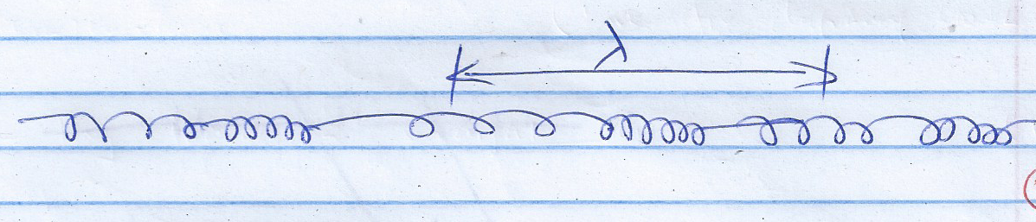

(c) A certain radio station broadcasts at a frequency of 100MHz. Determine the wavelength of the waves if the speed of the waves is 3.0 x108m/s. (3mks)



(d) Figure 8 shows straight waves in deep water approaching a shallow region

(d) Sketch the appearance of the waves in the shallow region. (2mks)

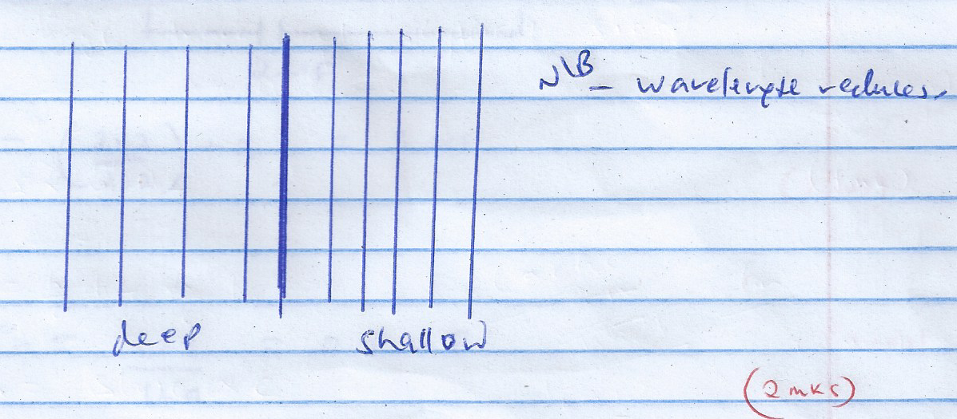

1. (a) Figure 9 shows a parallel plate capacitor.

State two ways of increasing the capacitance of the capacitor. (2mks)

**Reducing the distance, d**

**Increase area of overlap**

**Using a dielectric with a higher permittivity**

(b) You are provided with three capacitors each of capacitance 2. Draw a diagram to show how you would connect all the three capacitors to give a combined capacitance of 3. (Show your working) (2mks)

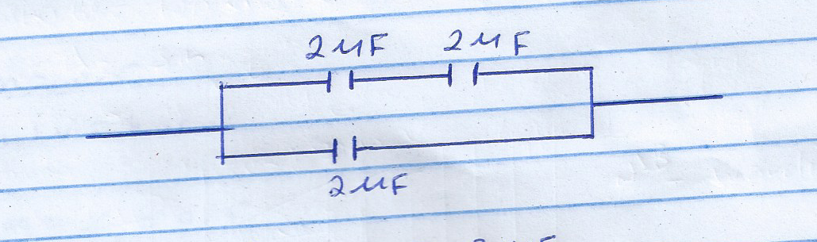



(c) Figure 10 shows three capacitors connected to a cell of emf 1.5v.

Calculate

(i) The effective capacitance. (3mks)



(ii) The total charge in the circuit. (2mks)



(iii) The charge across the 6 capacitor (2mks)

1. (a) What is meant by the term refraction of light. (1mk)

**bending of light as it travels from one medium to another**

(b) Figure 11 shows a ray of light travelling from the air

Given that the refractive index of glass is -1.5, determine angle, i. (3mks)



(c) The figure below shows a ray of white light incident on a glass prism.

What difference will be observed if monochromatic light (one colour) is used instead of white light? (1mk)

**Only deviation occurs (No dispersion)**

(d) A convex lens produces a real image of an object which is half the size of the object, the distance between the object and the image is 60 cm. Calculate:

(i) The object distance (4mks)



(ii) The focal length of the lens. (2mk

