Name…………………………………………………………………………….. Index Number………………………..……………
SCHOOL: ………………………………………………………………………. Candidate’s Signature.............……………….
232/2 Date…………….………………………………..……………
PHYSICS
Paper 2
2018
2hours
JULY/AUGUST EXAM
PHYSICS PAPER 2
2 hours

Instructions to candidates
(a) Write your name and index number in the spaces provided above.
(b) Write the name of your school in the space provided above.
(c) Sign and write the date of examination in the spaces provided above.
(d) This paper consists of two sections: A and B.
(e) Answer all the questions in sections A and B in the spaces provided in this booklet.
(f) All working must be clearly shown in the spaces provided in this booklet.
(g) Non programmable silent electronic calculators may be used.
(h) Mathematical tables must not be used.
(i) This paper consists of 12 printed pages.
(j) Candidates should check the question paper to ascertain that all the pages are printed as indicated and that no questions are missing.
(k) Candidates should answer the questions in English.

For Examiner’s Use Only
Section | Question | Maximum Score | Candidate’s Score
A | 1-14 | 25
B | 15 | 11
 | 16 | 07
 | 17 | 11
 | 18 | 15
 | 19 | 11
Total Score |  | 80
SECTION A:(25 marks)
Answer all the questions in this section in the spaces provided.
1. State the effect on the image formed by a pin-hole camera of increasing the size of the pin hole and keeping the distance between the pin-hole and object constant. (1 mark)
……………………………………………………………………………………………………
2. Figure 1 shows a plastic rod rubbed with a dry cloth.
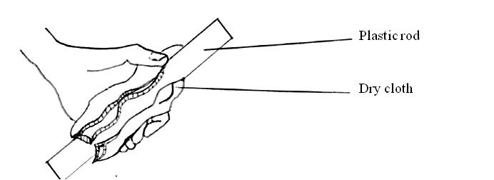

Figure 1

After this, the rod is held close to a girl’s long hair. The hair is attracted to the rod. Suggest why this happens. (1 mark)
…………………………………………………………………………………………………...

…………………………………………………………………………………………………...
3. Figure 2 shows an iron bar placed close to the S-pole of a bar magnet.
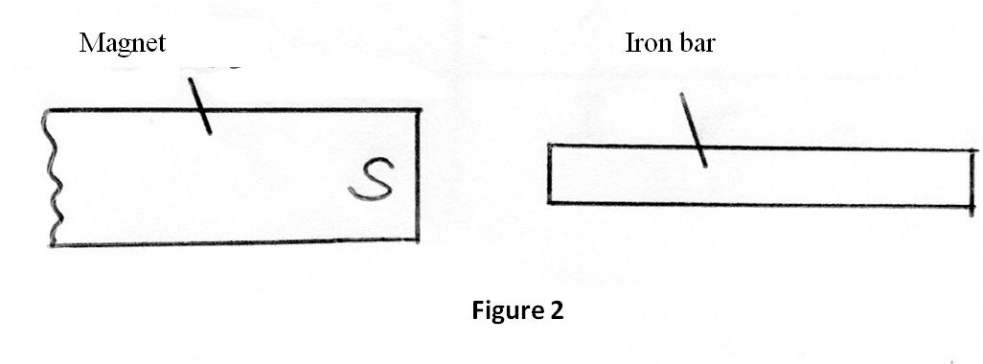

Sketch the magnetic field pattern around the arrangement. (1 mark)
4. A ship in an ocean sends out ultrasound whose echo is received after 5 seconds. If the wavelength of the ultrasound in water is 7.5cm and the frequency 20kHz, determine the depth of the ocean. (3 marks)

…………………………………………………………………………………………………...
…………………………………………………………………………………………………...
…………………………………………………………………………………………………...
…………………………………………………………………………………………………...
…………………………………………………………………………………………………...
…………………………………………………………………………………………………...
5. State the reason why it is not advisable to arrange cells in parallel unless they have identical e.m.f.s. (1 mark)
…………………………………………………………………………………………………...
…………………………………………………………………………………………………...

6. Figure 3 shows the image I of an object placed in front of a convex mirror. C is the centre of curvature of the mirror.

On the diagram, draw appropriate rays to locate the position of the object. (3 marks)
7. Figure4 shows a soft iron core with current carrying coils wound around its arms. Two nails attached to the poles when the soft iron core is magnetized behave as shown.
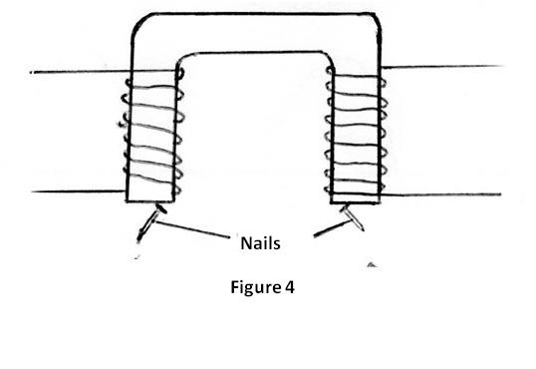

Indicate the possible direction of current in the coils. (2 marks)
8. A small object lies at the bottom of a water pond of depth 1.2m. Given that the refractive index of water is 1.3, determine the apparent depth of the object. (3 marks)

……………………………………………………………………………………………………
……………………………………………………………………………………………………
……………………………………………………………………………………………………
9. (a) Arrange the following waves in order of decreasing wavelength; X-rays, infrared, microwaves, U.V radiation and visible light. (1 mark)
…………………………………………………………………………………………
…………………………………………………………………………………………
(b) State one application of visible light. (1 mark)

…………………………………………………………………………………………
10. In a practical motor, the coil is usually wound on a laminated soft iron core. State one problem which arises as the coil rotates in the magnetic field. (1 mark)
…………………………………………………………………………………………………...
…………………………………………………………………………………………………...
11. Light of frequency 5.50 x 10¹⁴ Hz is incident on a surface whose work function is 2.5eV. Determine the energy of a photon of the light in e V. (Planck’s constant h is 6.63 x 10⁻³⁴Js and 1eV = 1.6 x 10⁻¹⁹J) (3 marks)
…………………………………………………………………………………………………...
…………………………………………………………………………………………………...
…………………………………………………………………………………………………...
12. Figure 5 shows a graph of the output voltage (y axis) against time for a rectifier circuit with only one diode.
Voltage
Time (s)
Figure 5

Sketch output voltage (y axis) against time graph for a rectifier circuit with two diodes in the space provided below. (2 marks)

13. A radioactive carbon-14 decays to nitrogen by releasing a beta particle as shown below.
$\begin{matrix}14 \\ 6\end{matrix}C= \begin{matrix}x \\ 7\end{matrix}N+\begin{matrix}0 \\ y\end{matrix}e$

Determine the value of: (1 mark)
(a) x
……………………………………………………………………………………………………
(b) y
……………………………………………………………………………………………………
14. It is observed that when a charged body is brought near the cap of a negatively charged electroscope, the divergence of the leaf increases. State the type of charge on the body. (1 mark)
……………………………………………………………………………………………………
SECTION B:(55 marks)
Answer all the questions in this section in the spaces provided.
15. (a) In an experiment to determine the focal length of a convex lens, a group of form four students from The Sacred Heart girls – Mukumu collected some data and used the results to plot the graph shown below.
0
1
2
3
4
5
6
10
20
30
40
50
60
70
80
x
x
x
x x
Image Distance, v (cm)
Magnification, m

Determine the:
(i) object position when the image position is 45cm (2 marks)
…………………………………………………………………………………...
…………………………………………………………………………………...

(ii) slope of the graph (1 mark)
…………………………………………………………………………………...
…………………………………………………………………………………...
…………………………………………………………………………………...
(iii) focal length f of the lens given that f = 1/ slope. (1 mark)
…………………………………………………………………………………...
(b) An object is placed at 2F in front of a converging lens and its image is observed. State how the image changes as the object is moved from 2F towards F. (1 mark)
…………………………………………………………………………………………
(c) Name the two defects of vision. (2 marks)
…………………………………………………………………………………………
…………………………………………………………………………………………
(d) Sketch a ray diagram to show the image formed when a convex lens is used as a simple microscope. (2 marks)

(e) An object is placed 12cm from a converging lens of focal length 18cm. Determine the position of the image. (2 marks)
…………………………………………………………………………………………
…………………………………………………………………………………………
…………………………………………………………………………………………

16. (a) Figure 6 shows two loudspeakers S₁ and S₂ connected to a signal generator.
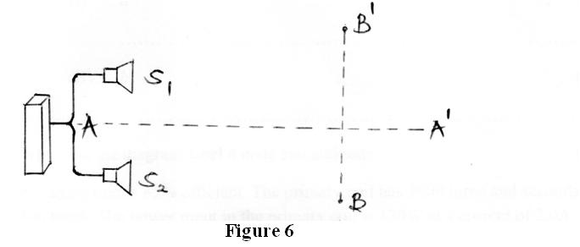

(i) An observer walks along BB¹. State what is observed. (1 mark)
…………………………………………………………………………………...
(ii) State the reason for the observation in (i). (1 mark)
…………………………………………………………………………………...
…………………………………………………………………………………...
(iii) Another observer walks along AA¹. State what she observes. (1 mark)
…………………………………………………………………………………...
(iv) State the effect on the observation in (i) if the frequency of the signal is increased. (1 mark)
…………………………………………………………………………………...
…………………………………………………………………………………...
(b) Figure 7 shows a stretched string vibrating between 2 fixed ends.
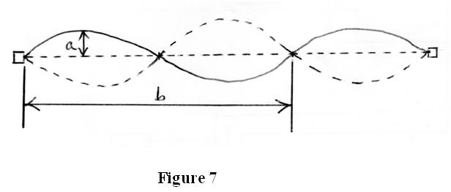

(i) State the name of distance:
(I) a (1 mark)
……………………………………………………………………………
(II) b (1 mark)
……………………………………………………………………………
(ii) On the diagram label a node and antinode. (1 mark)
17. (a) A transformer is 85% efficient. The primary coil has 3000 turns and secondary coil has 400 turns. The power input in the primary coil is 120W at a current of 2.0A. Determine the:
(i) p.d. in secondary coil (2 marks)
…………………………………………………………………………………...
…………………………………………………………………………………...
…………………………………………………………………………………...
…………………………………………………………………………………...
(ii) current in the secondary coil. (2 marks)
…………………………………………………………………………………...
…………………………………………………………………………………...
…………………………………………………………………………………...
…………………………………………………………………………………...
(b) Figure 8 shows a section of a house wiring.
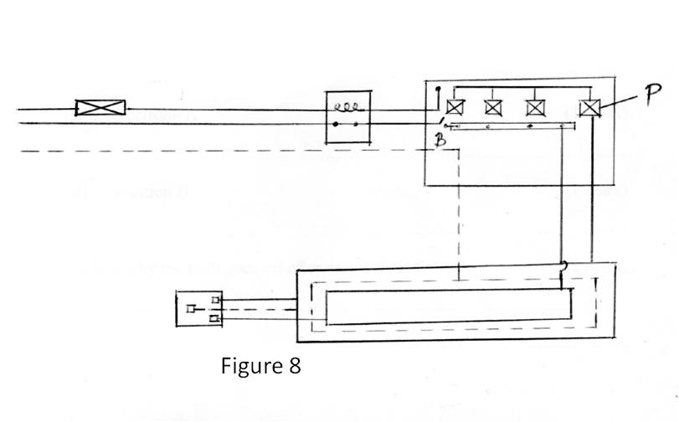

(i) State the function of P in the circuit. (1 mark)
…………………………………………………………………………………...

(ii) Explain why earthing is necessary in such a circuit. (2 marks)
…………………………………………………………………………………...
…………………………………………………………………………………...
(c) An electric cooker rated 3kW is used every day for 2 hours. Determine the electricity bill for 31 days if the rate of electricity cost is Ksh.10.00 per kilowatt-hour. (3 marks)
…………………………………………………………………………………………
…………………………………………………………………………………………
(d) State one property of tungsten which makes it suitable for use in electric bulbs. (1 mark)
…………………………………………………………………………………………
18. (a) Figure 9 shows a simple circuit in which a simple cell connected to a bulb.
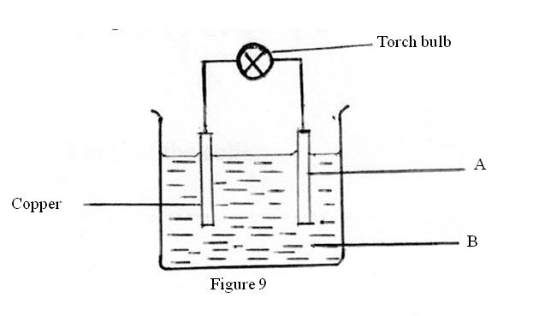

(i) State the name of the:
(I) electrode A (1 mark)
……………………………………………………………………………
(II) solution B (1 mark)
……………………………………………………………………………
(ii) Explain why the bulb goes off after only a short time. (2 marks)
…………………………………………………………………………………...
…………………………………………………………………………………...
(iii) State what can be done to restore the brightness of the bulb in the circuit.
(1 mark)
…………………………………………………………………………………...
…………………………………………………………………………………...

(b) Figure 10 shows three cells each with e.m.f. 1.5V connected in series.
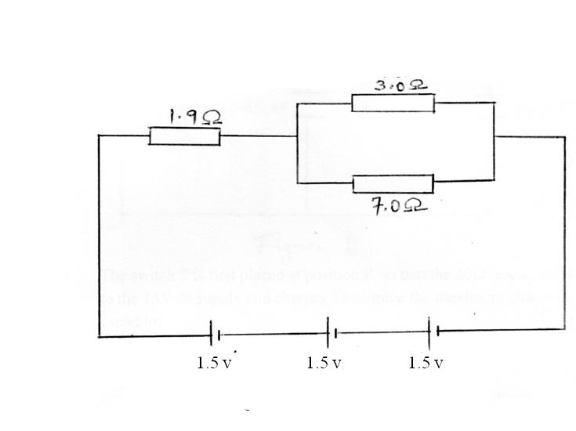

Figure 10
Determine the:
(i) combined e.m.f. of the cells. (1 mark)
…………………………………………………………………………………...
…………………………………………………………………………………...
(ii) combined resistance of the three resistors shown. (2 marks)
…………………………………………………………………………………...
…………………………………………………………………………………...
…………………………………………………………………………………...
(iii) current flowing through the 3.0Ω resistor. (2 marks)
…………………………………………………………………………………...
…………………………………………………………………………………...

…………………………………………………………………………………...

…………………………………………………………………………………...

(c) Figure 11 shows a circuit which may be used to charge a 20µF capacitor by connecting it to a 15V battery. Later the capacitor is connected across an uncharged 10µF capacitor.
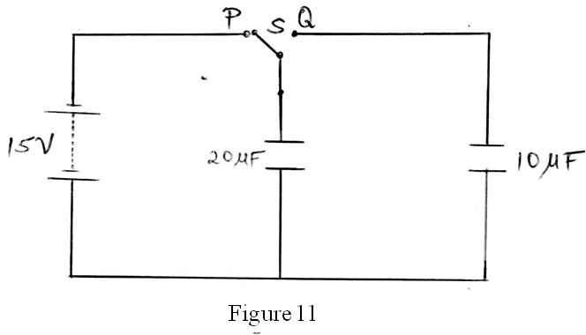

(i) The switch S is first placed at position P, so that the 20µF capacitor is connected to the 15V dc supply and charges. Determine the maximum charge stored in the capacitor. (2 marks)
…………………………………………………………………………………...
…………………………………………………………………………………...
…………………………………………………………………………………...
(ii) The switch S is then moved to position Q. Determine the final potential difference, V across the capacitors. (3 marks)
…………………………………………………………………………………...
…………………………………………………………………………………...
…………………………………………………………………………………...
19. (a) State two properties common to both X-rays and gamma rays. (2 marks)
…………………………………………………………………………………………
…………………………………………………………………………………………
(b) Figure 12 shows an X-ray tube.
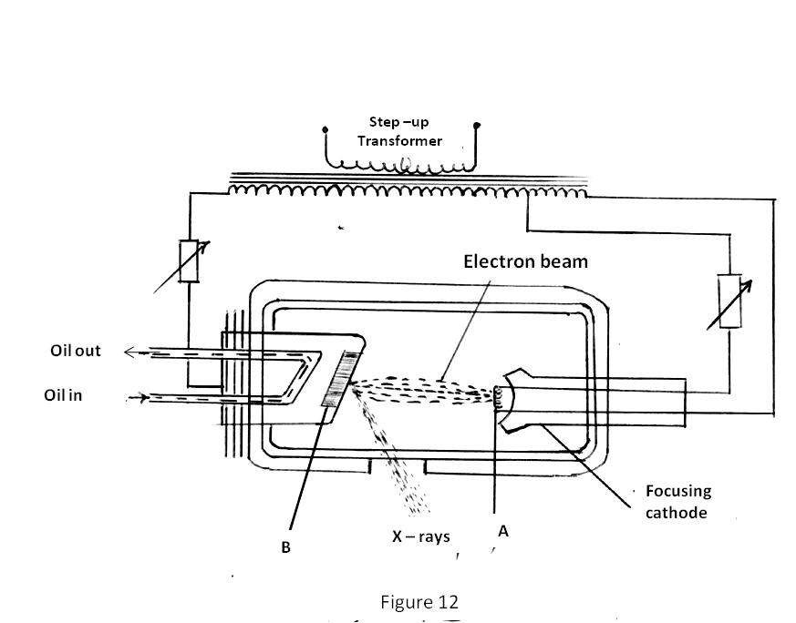

Figure 12
(i) State the name of the part labeled:
(I) A (1 mark)
……………………………………………………………………………

(II) B (1 mark)
……………………………………………………………………………
(ii) State the function of the part labeled:
(I) A (1 mark)
……………………………………………………………………………
(II) B (1 mark)
……………………………………………………………………………
(iii) In the X-ray tube, the voltage between the cathode and anode is more than 50000V. State the reason for this. (1 mark)
…………………………………………………………………………………...
…………………………………………………………………………………...
(c) An X-ray tube operates with a potential difference of 100kV between the cathode and the anode. The tube current is 10mA.Determine the:
(i) rate at which energy is transferred in the target of the X-ray tube (2 marks)
…………………………………………………………………………………...
…………………………………………………………………………………...
…………………………………………………………………………………...
(ii) Maximum energy of the X-rays. (2 marks)

…………………………………………………………………………………...
…………………………………………………………………………………...
…………………………………………………………………………………...

JULY/AUGUST EXAM
PHYSICS PAPER 2 MARKING SCHEME
SECTION A
- Image becomes blurred but brighter. 1
- This is due to formation of static charges. 1
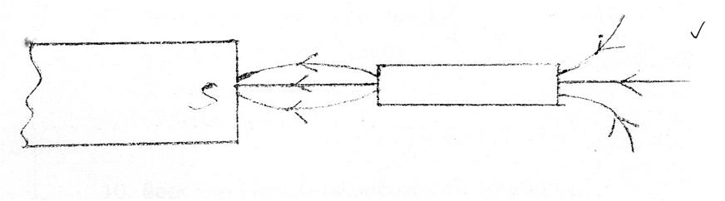
For correct pattern and direction

- v = f$λ$
=20x10³x7.5x10⁻²
=1,500m/s 1
Depth = $\frac{speed x time}{2}$
= $\frac{1,500x5}{2}$ 1
= 3,750m 1
- To prevent one cell from draining the others. 1
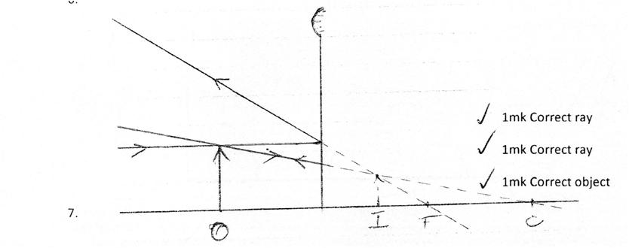

2mk for same direction on both coils
- Apparent depth = $\frac{Realdepth}{RefractiveIndex}$ 1
= $\frac{1.2m}{1.3}$ 1

= 0.9231m 1

- (a) Microwaves, infrared, visible light, uv radiation, X-rays. 1

(b) – Enables the eye to see 1 (Any one)
-Ordinary photography
-Optical fibres
-laser beams

- Back e.m.f resists or opposes the rotation; 1
Eddy currents also opposes the rotation; Any one.

- E = hf
= 6.63x10⁻³⁴ x 5.50x10¹⁴ J 1
= 3.6465 x 10⁻¹⁹ J 1

1.6x10⁻¹⁹ J = 1 eV

1.6x10⁻¹⁹ J = $\frac{3.6465x10^{-19}x1}{1.6x10^{-19}}$eV

= 2.279 eV 1
A1
1 for full wave rectification
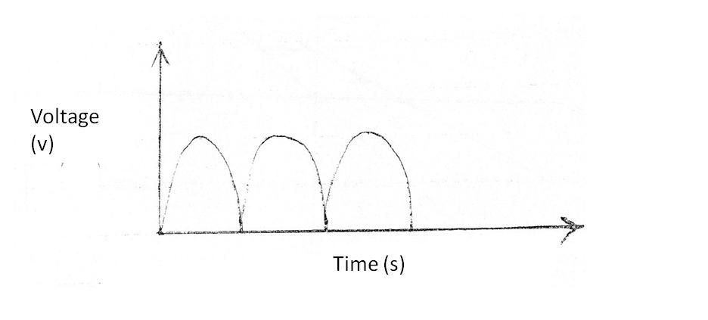
- .

- (a) x=14
(b) y = -1 1

- Negative 1

SECTION B
- (a) (i) m=3.5 ± 0.2 1
u = $\frac{v}{m}$
= $\frac{45}{3.5} cm$
= 12.86cm 1

(ii) slope = $\frac{5-2}{60-30}$

= $\frac{3}{30}$

= 0.1cm⁻¹ 1 Award ½ mk if no units
Award 0mk if wrong units

(iii) f = $\frac{1}{0.1}$ Allow ET
= 10cm 1
(b) Size of image increases/1 magnified
(c) short sight1 / Myopia
Long sight1/ Hypermetropia
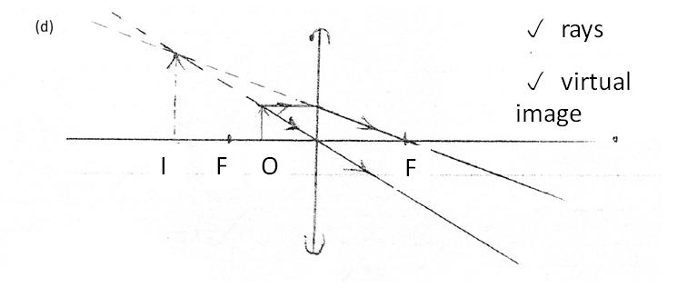
(d)

(e)$\frac{1}{v}$ = $\frac{1}{f}- \frac{1}{u}$

$\frac{1 }{v}= \frac{1}{18}- \frac{1}{12}$ 1

$\frac{1}{v}$ = - $\frac{1}{36}$

V = -36cm
Position : 36cm from the lens, on the same side as the object 1
- (a) (i) Alternate loud and soft sound 1
(ii) Loud sound in due to constructive interference while soft sound is due to destructive interference. 1
(iii) Loud sound 1 all through.
(iv) Points of loud and soft sound will become more closely spaced. 1
(b)(i) (I) Amplitude 1
(II) Wavelength 1

(ii)
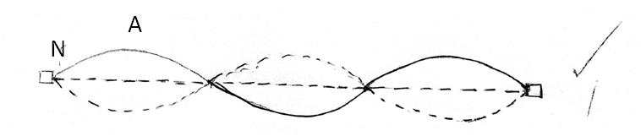

- (a)(i) V_{p}I_{p} = Power input
V_{p}x2 = 120
V_{p}= 60V 1

$\frac{Vs}{Vp}= \frac{Ns}{Np}$

$\frac{Vs}{60}= \frac{400}{3000}$

V_{s}= $\frac{60x400}{3000}$

= 8V 1

(ii) Power output = $\frac{85}{100} x120$

= 102W 1

I_{s} = $\frac{P_{s}}{Vs}=\frac{102}{8}=12.75 A$ 1

(b) (i) Safeguard against excess currents. 1
(ii) To prevent electric shock . If the live wire accidentally touches the casing of an appliance, a large current flows through the earth wire and the fuse will blow, thereby cutting off the current. 1
(c)Total units = 3x2x31kWh = 186kWh 1
Total cost = 186x10 1
= Kshs. 1860 1
(d) High melting point 1
- (a) (i) (I) Zinc 1
(II) Dilute sulphuric acid 1
(ii) – Polarization. 1 Accumulation of bubbles around the copper plate. 1
(iii) Add a depolarizer 1 e.g. Potassium dichromate

(b)(i) 1.5 + 1.5 + 1.5 = 4.5V 1

(ii) Rp = $\frac{7x3}{7+3}$ = $\frac{21}{10}$ = 2.1Ω 1

R_{E} = 1.9+2.1 = 4.0Ω 1
(iii)I_{T} = $\frac{V}{RE}$ Allow ALT working

= $\frac{4.5}{4.0}$ Allow ET

= 1.125 A 1

I = $\frac{7}{10}$ x1.125 A

= 0.7875 A 1

(c)(i) Q₁ = C₁ V₁
= 20x10⁻⁶x15 1
= 3x10⁻⁴ C 1
(ii) Q₁+Q₂ = Q
C₁ V₁ + C₂ V₂= Q
But V₁= V₂=V
C₁ V+ C₂ V= Q 1

(20x10⁻⁶V)+ (10x10⁻⁶xV) = 3x10⁻⁴C Allow ET
(20+10)x 10⁻⁶ V = 3x10⁻⁴ C
30x10⁻⁶ V = 3x10⁻⁴ C
V = $\frac{3x10^{-4}}{30x10^{-6}}$
= 10V 1

- (a) - They are not charged1, and therefore cannot be affected by magnetic or electric fields.
- They can be plane-polarized and diffracted. 1
- They travel at the speed of light (3x10⁸ms⁻¹) ; any two
(b) (i) (I) Filament 1
(II) Tungsten target 1
(ii) (I) Heat the cathode to produce electrons 1 by thermionic emission
(II) Suddenly stop fast moving electrons to produce x-rays. 1
(iii) Accelerate electrons towards the metal target. 1
(c) (i) Rate of energy = Power = IV
= 10x10⁻³x100x10³ 1
= 1000W 1
(ii) Energy = QV
= 10x10⁻³x100x10³ 1
= 1000 J 1

