PHYSICS
232/2
MARKING SCHEME
TERM 1 2019

SECTION A (25 MARKS)

Rays and all angles shown 3 marks

$$\sin{42.5=}\frac{1}{n}$$
$$n=\frac{1}{42.5}=1.48$$

- Soft iron became induced magnet and attracts back the razor
Wood is non-magnetic material hence does not attract the blad
- The charges that accumulates on the body of the car by rubbing with the air leak to the earth through the man while he stept out
- A Tv tube use magnetic coils for deflection of an electron beam instead of electric field .Magnetic field gives a wider deflection
- i) Diffraction1
ii) Interference.1
The two opening acts as two source1 hence the two waves interfere producing soft and loud sound along the way1
- The leaf diverges
Negative charges from electroscope flows to the sphere leaving +ve charges on the electroscope thus there is divergence.

- E = IR + Ir
3.0 = I $×$3.5 $×$I $×$0.51
$∴$ I = 0.75A;

- A thick sheet of plastic, n = 1.5, is used as the side of an aquarium tank. Light reflected from a fish in the water has an angle of incidence of 35⁰. At what angle does the light enter the air. (3 mks)
n; sin ө; = n_{r} sin ө_{r}
1.3 sin 35⁰ = 1.5 sin ө_{r}
ө_{r} = 29.8⁰
sin r = sin i
n
= sin 29.8
1.5

= 0.3313
r = 19.39
- When the object distance from the pinhole is equal to the image distance.
- When the screen is as large as the object1(any 1) Give 1 mk
11. Period = $\frac{0.03}{3}$ = 0.011
f = $\frac{1}{T}$ = $\frac{1}{0.01}$1
f = 100Hz

12.The figurebelow shows a laclanche cell.

A Manganese Iv Chloride
B Ammonium IV chloride
Section b
13. (a) (4 Marks)
- Correct diagrams.
- It occurs when the earth is between the sun and moon and all lie on a straight line.
- The earth casts a shadow on the moon.
(b) For security reasons since they cover a wide field of view.
(c) $\frac{hi}{ho}$ = $\frac{v}{u}$ (3 Marks)
$\frac{hi}{2.5}$ = $\frac{0.16}{8}$
hi = $\frac{0.16 x 2.5}{8}$ = 0.05 or 5cm
(d) (i)
(ii) n₁sinθ₁ = n₁sinθ₂ (3 Marks)
$\frac{3}{2}$SinC = $\frac{4}{3}$Sin90
C = Sin⁻¹0.8889
= 62.720
14. (a) Capacitance is charge per unit volt
(b) (i) 2μ₣ + 6μ₣ = 8 μ₣
Effective capacitance =Product
sum
= 8 x 3
8 + 3
= 24
11
= 2.182 μ₣

    - Total charge Q = CV = 2.18 x 10⁻⁶ x 12
= 26.16 x 10⁻⁶C
(iii) p.d across the 2 μ₣ = 26.16 x 10⁻⁶√1
8 x 10⁻⁶
= 3.27V
- Ohm’s law – The amount of current flowing through a metallic conductor is directly proportional to the p.d across its ends so long as temperature and other physical conditions remain constant.
(ii) Effective resistance

RE = 4 + 6 x 3
3 + 6
= 4 + 18
9
= 6Ω
V =IR
I =12 = 2A
6
. V = 2 x 4 = 8V
(ii) V = 12 – 8 = 4V√
. V = 1R
I = 4 = 2 = 0.667 A√
6 3
15. (a) (i) Frequency not affected. ✓1
(ii) Speed reduces. ✓1
(iii) Wavelength reduces. ✓1
(b) f = v = 0.12 = 1.5 Hz ✓1
λ✓ 0.08
(c) Gamma ray, x-rays, ultraviolent, visible light, infra red, microwaves.
(d) Stationary wave Progressive ways
1. No energy is transferred Energy is transferred from
from source. source. ✓1
2.Wave form does not Wave form moves away
appear to move. continuously. ✓1
(e) Wave length = 9/6 = 1.5 cm ✓1
16. (a) (i) At A light undergoes refraction / dispersion✓1/2
At B light undergoes total internal reflection✓1/2
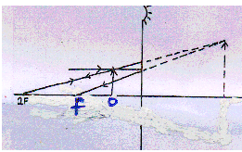
(ii) C - Violet
D - Red

17. . a) - Axes labeled with units; 1
- Consistent scale ; 1
- 5 points2 ( 3 – 4 points ) 1
- Line ; 1

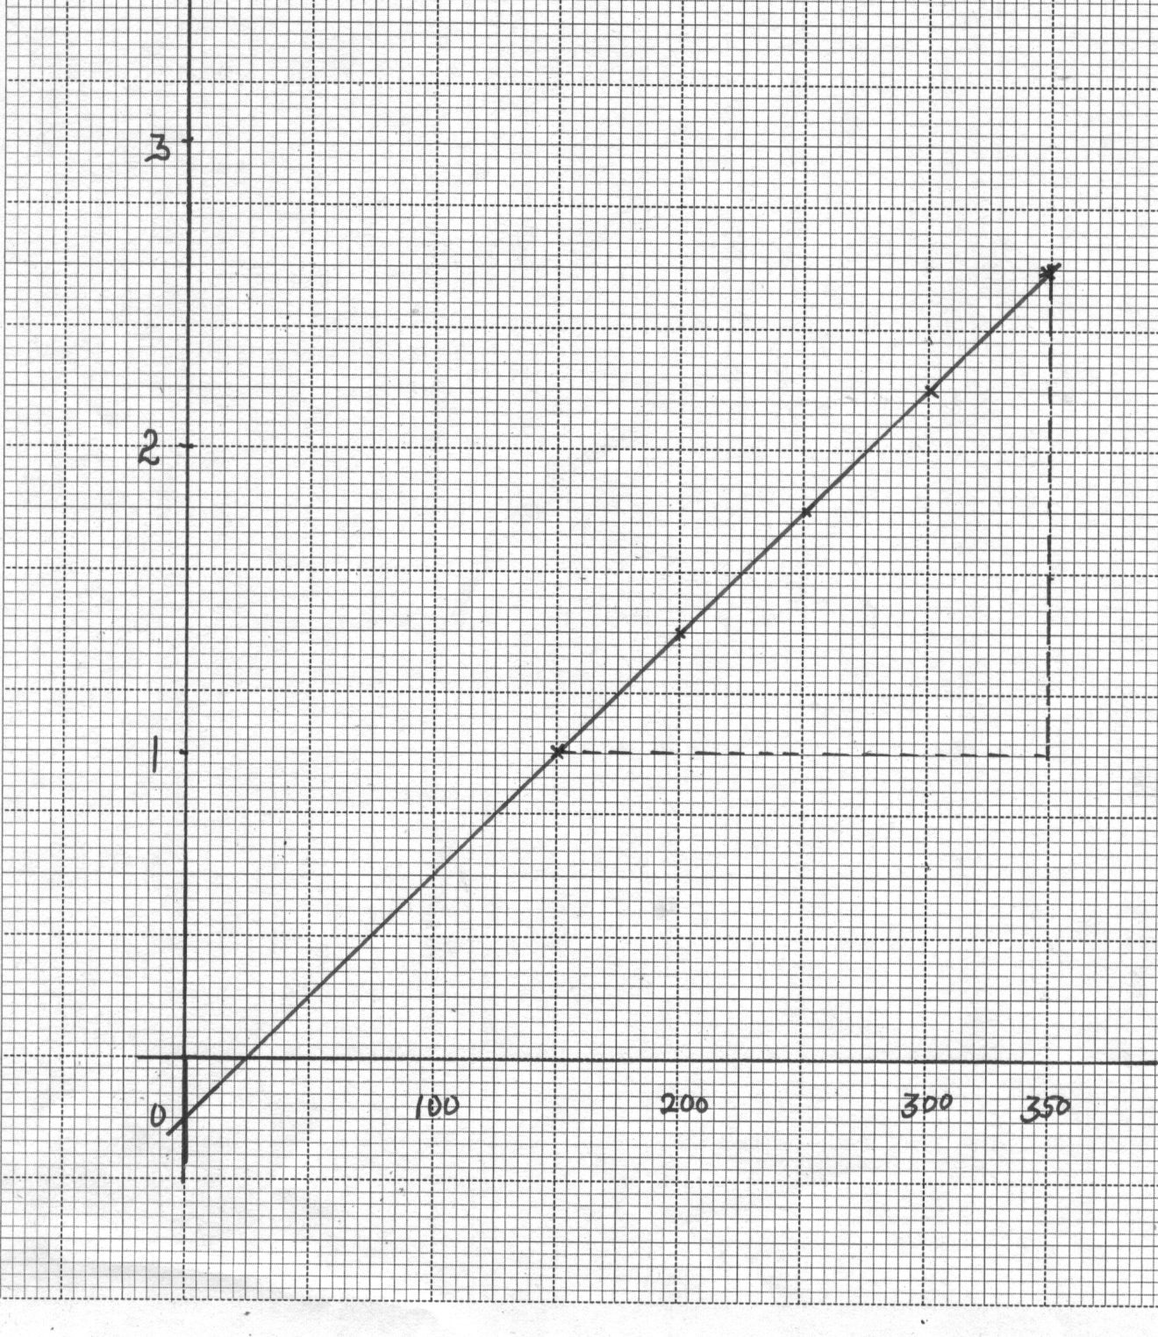
Voltage(V)
Resistance = gradient
= 2.60 – 1.00
(350 – 150) x 10⁻³
= 8.0 ± 0.2 Ω
Current(mA)

- Resistance = slope of Graph ;
= 2.2 – 1.4
0.3 – 0.2
= 80hrs;

