**Kenya Certificate of Secondary Education 2019**

**232/ 2 PHYSICS -Paper 2**

**(Theory)**

**END TERM 1 2019**

**Name …………………………………………….……………… Index Number…………………………...**

**Candidate’s Signature ………………….…………...………... Date ……………………………………**

**INSTRUCTIONS TO CANDIDATES:**

(a) Write your **Name** and**Index Number** in the spaces provided **above**.

(b) **Sign** and write the **date** of examination in the spaces provided **above**.

(c) This paper consists of **two** Sections; **A** and **B**.

(d) Answer **ALL** the questions in Sections **A**and**B** in the spaces provided.

(e) All workings must be clearly shown.

(f) Non-programmable silent electronic calculators and KNEC Mathematical tables and **may be** used.

**FOR EXAMINER’S USE ONLY:**

|  |  |  |  |
| --- | --- | --- | --- |
| **Section** | **Question** | **Maximum**  **Score** | **Candidate’s**  **Score** |
| **A** | **1 – 11** | **25** |  |
|  | **11** | **13** |  |
|  | **12** | **10** |  |
| **B** | **13** | **12** |  |
|  | **14** | **8** |  |
|  | **15** | **12** |  |
| **Total Score** | | **80** |  |

Turn over

**SECTION A (25 MARKS)**

1. A ray immerges from a mirror S at an angle of 300 to the mirror as shown in the figure below. On the same diagram complete the ray path to show its incident path to mirror Q and state the angle of incidence. (2 marks)

Ray

300

Q S

800

R

1. A X-ray tube has an accelerating potential of 60kv. **What** is the shortest wavelength of the X-ray beam? Take planck constant -6.63 x 10-34JS (3mks)

The electronic charge to be -1.6 x 10-19C

………………………………………………………………………………………………………………………………………………………………………………………………………………………………………………………………………………………………………………………………………………

1. **State one**use and **one**source of gamma rays. (2mks)

Use: ________________________

Source:_______________________

1. A man driving a car in rain discovers that the moment he alights from it, while touching its body he gets an electrical shock. Why was he not getting the shock while inside even if he touches metallic parts?

(1 mk)

………………………………………………………………………………………………………………………………………………………………………………………………………………………………………………………………………………………………………………………………………………

1. State and explain why TV tube has a wider screen than cathode Rays oscilloscope (C.R.O) tube (2mks)

………………………………………………………………………………………………………………………………………………………………………………………………………………………………………………………………………………………………………………………………………………

1. 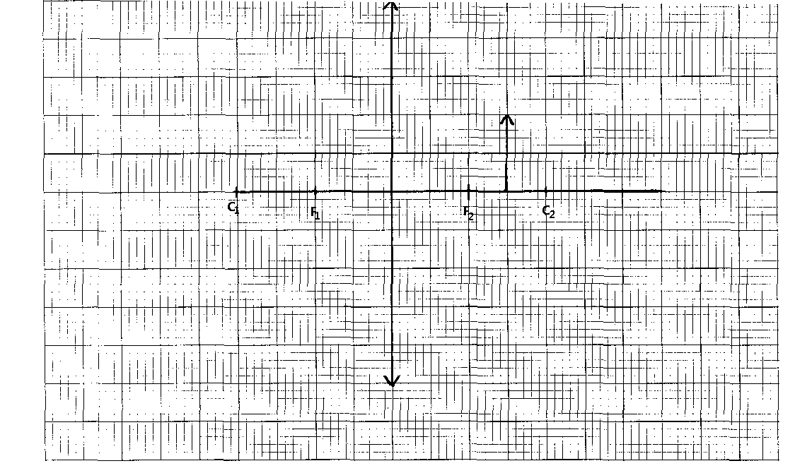The diagram below shows an image formed by a convex lens. By construction show the position of the object. (3mks)
2. A charged metal sphere is connected to an uncharged electroscope as shown in the figure below. **State and explain** the observations made (2mks)

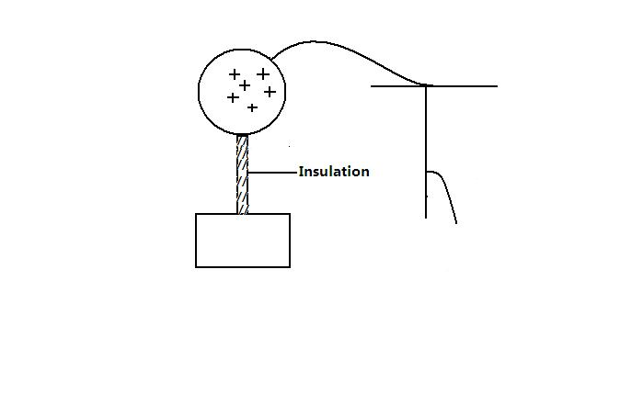

………………………………………………………………………………………………………………………………………………………………………………………………………………………………………………………………………………………………………………………………………………

1. Using the circuit diagram below write formula relating E, I, R and r. (2 mks)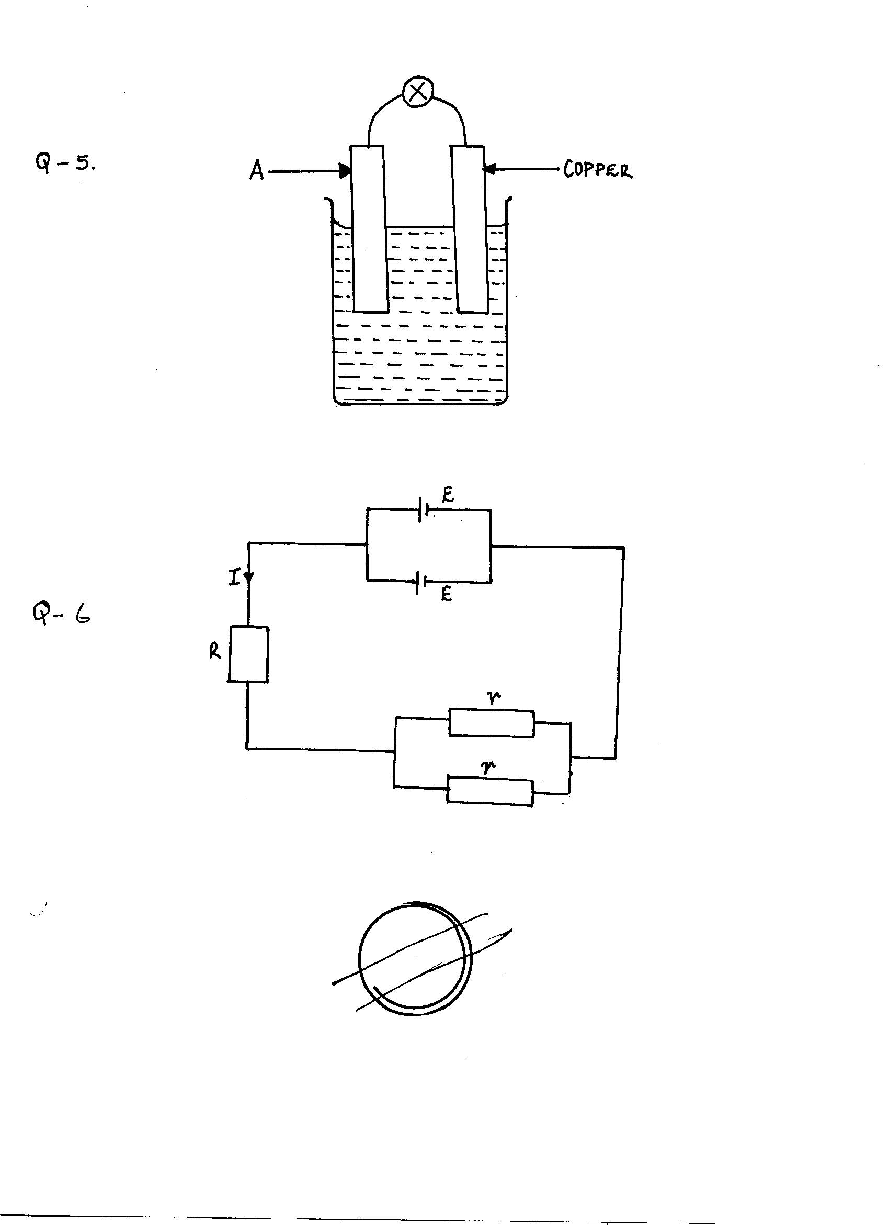

1. . A thick sheet of plastic, n = 1.5, is used as the side of an aquarium tank. Light reflected from a fish in the water has an angle of incidence of 350. At what angle does the light enter the air. (3 mks)

………………………………………………………………………………………………………………………………………………………………………………………………………………………………………………………………………………………………………………………………………………

1. Explain why an x-ray tube is evacuated. (1mk)

........................................................................................................................................................................................................................................................................................................................................................................................................................................................................................................................

1. Distinguish between ‘hard and soft’ x – rays (1mk)

………………………………………………………………………………………………………………………………………………………………………………………………………………………………………………………………………………………………………………………………………………

1. The figurebelow shows a laclanche cell.

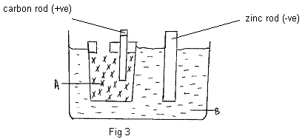

Name the chemical substances in the parts labeled.(2mks)

A............................................................

B.............................................................

**SECTION B(55 MARKS)**

1. (a) The fig 8 represents cathode ray oscilloscope (CRO)

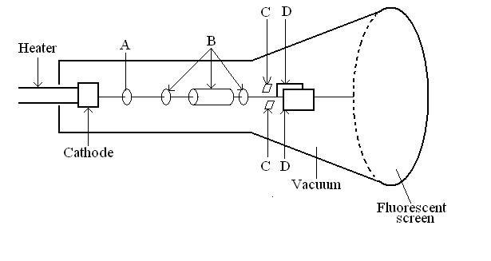

* + - 1. **Name** the parts labelled A and B (2 marks)

A_________________________

B_________________________

* + - 1. **What** are the functions of the parts labelled C and D? (2 marks)

C:__________________________

D:__________________________

* + - 1. **Explain how** the electrons are produced (2 marks)

………………………………………………………………………………………………………………………………………………………………………………………………

………………………………………………………………………………………………………………………………………………………………………………………………

(iv) **Give a reason** why the tube is evacuated (1 mark)

…………………………………………………………………………………………………………………………………………………………………………………………………………

(b) The work function of a tungsten is 7.2x 10-19J. **Calculate** the wavelength of the light photon that is capable of first removing an electron from the tungsten surface. (3 marks)

1. The current in a wire varied with voltage as shown in the following table.

|  |  |  |  |  |  |
| --- | --- | --- | --- | --- | --- |
| **Voltages(V)** | 1.05 | 1.40 | 1.80 | 2.20 | 2.60 |
| **Current (mA)** | 150 | 200 | 250 | 300 | 350 |

(a) Plot a graph of V against current. (5mks)

Hhhhhh



(b) From your graph, determine the resistance of the wire. (3mks)

………………………………………………………………………………………………………………………………………………………………………………………………………………………………………………………………………………………………………………………………………………

1. i) **State three** properties of electric field lines. (3mks)

……………………………………………………………………………………………………

……………………………………………………………………………………………………

……………………………………………………………………………………………………

(ii) With the help of a diagram **explain** how a lighting arrestor works. (5mks)

(b) (i) **Define** the term capacitance of a capacitor. (1mk)

……………………………………………………………………………………………………

……………………………………………………………………………………………………

(ii) Other than area of overlap of plates and the separation distance between plates. **State** any other factor that affect the capacitance of a capacitor. (1mk)

……………………………………………………………………………………………………

……………………………………………………………………………………………………

……………………………………………………………………………………………………

(iii) **Write down** an equation relating three factors in b(ii) above to the capacitance of a capacitor. (1mk)

………………………………………………………………………………………………………………………………………………………………………………………………………………………………

(c) 2f capacitor is charged to a potential of 200v, then the supply is disconnected. The capacitor is then connected to another uncharged capacitor. The potential difference across the parallel arrangement is 80v. **Find** the capacitance of the second capacitor. (4mks)

………………………………………………………………………………………………………………………………………………………………………………………………………………………………………………………………………………………………………………………………………………

………………………………………………………………………………………………………………………………………………………………………………………………………………………………………………………………………………………………………………………………………………

. 17. (a) A car battery is used to light a 12V lamp A constant current of 3 A passes round the circuit.

1. **Explain** what happens to the energy of the electron as they flow through the lamp wire. (3mks)

……………………………………………………………………………………………………

……………………………………………………………………………………………………

……………………………………………………………………………………………………

……………………………………………………………………………………………………

1. **How** much energy is transferred by the lamp in 20 seconds? (2mks)

……………………………………………………………………………………………………

……………………………………………………………………………………………………

……………………………………………………………………………………………………

1. For a particular specimen of wire, a series of readings of the current through the wire for different potential differences across it is taken and plotted as shown.

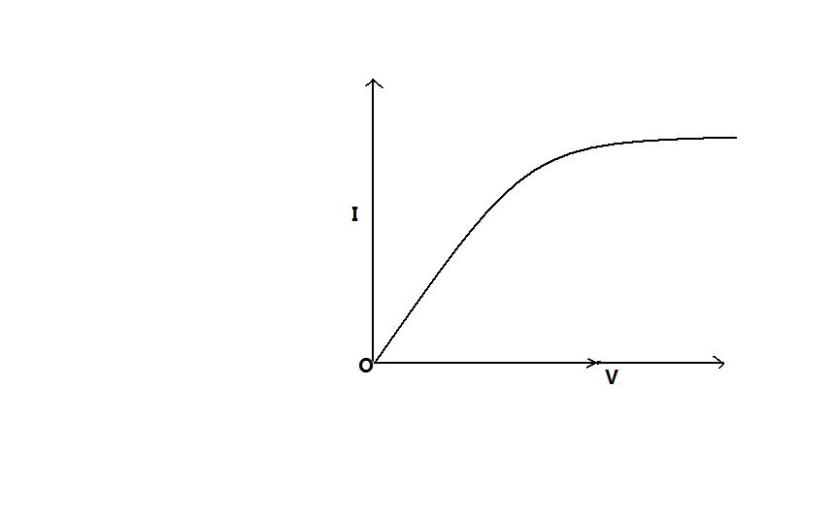

(i) **Explain** how the resistance of the wire changes (3mks)

……………………………………………………………………………………………………

……………………………………………………………………………………………………

……………………………………………………………………………………………………

1. **How** would the resistance of a piece of wire change if

(I) the length were doubled (1mks)

……………………………………………………………………………………………………

……………………………………………………………………………………………………

……………………………………………………………………………………………………

(II) the diameter were doubled (1mks)

……………………………………………………………………………………………………

……………………………………………………………………………………………………

……………………………………………………………………………………………………

**18.**Define the terms ;

(i) Work function: (1mk)

…………………………………………………………………………..………………

…………………………………………………………………………..………………

(ii) Threshold frequency (1 mk)

…………………………………………………………………………..………………

…………………………………………………………………………..………………

(b) In an experiment of photoelectric emission from a clean metal surface,

the following readings were obtained as shown below.

|  |  |  |  |  |
| --- | --- | --- | --- | --- |
| Frequency f ( 1015 H2) | 0.6 | 0.7 | 0.8 | 1.0 |
| Maximum kinetic energy EK (10-19J) | 0.58 | 1.25 | 2.56 | 3.26 |

1. The metal surface used normally should be cleaned. 2maks**Explain**………………………………………………………………………………………………………………………………………………………………………………

(2mks)

1. Plot a graph of kinetic energy, ER against frequency f and use the graph to determine (4mks)

**Inert graph**

* 1. The planks constant (2mk)

…………………………………………………………………………..………………

…………………………………………………………………………..………………

* 1. The work function of the metal in electron volts (eV) (2mks)

…………………………………………………………………………..………………

…………………………………………………………………………..………………

…………………………………………………………………………..………………