**NAME……………..…………………………Class…………… Adm No……………**

**232/1**

**PHYSICS PAPER 1**

**TIME: 2 HOURS**

**X X X X X X NAME OF THE SCHOOL X X X X X**

**INSTRUCTIONS TO THE CANDIDATE:**

(a) Write your **name** and **index number** in the spaces provided above.

(b) **Sign** and write the **date** of examination in the spaces provided above.

(c) This paper consists of **two** Sections **A** and **B**.

(d) Answer **all** the questions in sections **A** and **B** in the spaces provided.

(e) All working **must** be clearly shown in the spaces provided.

(f) Non-programmable silent electronic calculators and KNEC Mathematical tables **may be** used.

**FOR EXAMINER’S USE ONLY:**

|  |  |  |  |
| --- | --- | --- | --- |
| **Section** | **Question** | **Maximum**  **Score** | **Candidate’s**  **Score** |
| **A** | **1-8** | **25** |  |
|  | **9** | **9** |  |
|  | **10** | **7** |  |
| **B** | **11** | **9** |  |
|  | **12** | **12** |  |
|  | **13** | **8** |  |
| **14** | **10** |  |
| **Total Score** | | **80** |  |

**SECTION 25 MARKS**

1. What you understand by the term SI unit. (1 mark)
2. 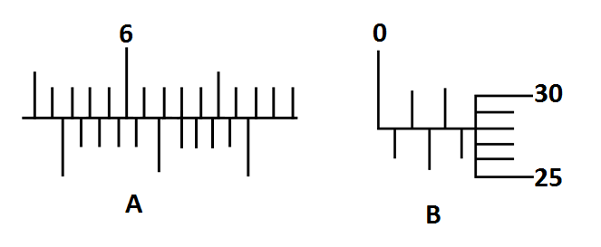Form four students used two measuring instruments to measure two quantities A and B as shown below

Given that **A - 2B = K** calculate the value of K. Express your answer SI unit and in standard form. (4 mark)

1. With a help of a diagram show how 15N force and 9N force can have a resultant force of
2. 24N (1 mark)
3. 6N (1 mark)
4. State how a thermometer can better
5. Quick action (1 mark)
6. Accuracy (sensitive to small changes in temperature) (1 mark)
7. 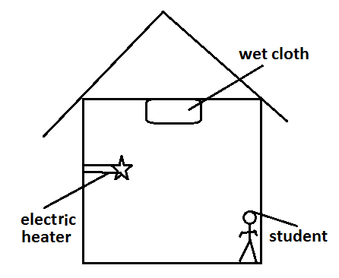The diagram below shows a cross-section of a house. Electric heater is on, wet cloth is hanged on the roof and a student is standing near one wall of the house.

State the mode of heat transfer through which

1. Wet cloth is getting heat (2 mark)
2. Student is not getting heat (2 mark)
3. The figure below shows a cylinder of radius 17cm being pulled by horizontal force against a step 2cm high. If a force of 11.2 N is just sufficient to turn the drawn so that it rises over the step, calculate its weight (3 mark)



1. 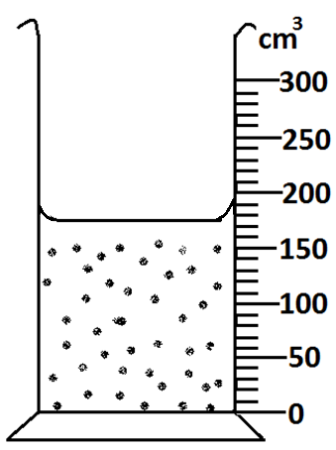The diagram below shows a measuring cylinder with water.

15 metal balls are gently lowered. Show on the diagram the final volume of water if the metal balls have a density of 1200kg/m3 and the mass of each ball is 7.2g. (4 mark)

1. .
2. Define pressure and state its SI unit (2 mark)

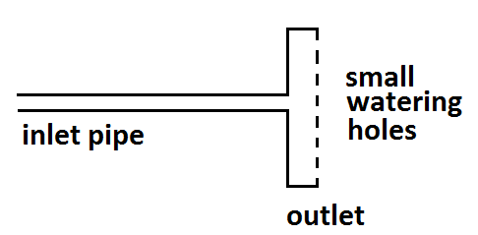

1. The diagram below shows a device used for watering crops out let has **N** number of holes. Inlet has a cross-section area of 2.4cm2 and water flows at 15m/s. calculate the number of small holes if each hole has a cross-section area of 3mm2 and water come out at 25m/s. (3 mark)

**SECTION 55 MARKS**

1. A trailer of mass 30000kg travelling at a velocity of 20m/s collide with a bus of mass 10000kg travelling at 10m/s in the opposite direction. The impact takes 0.5 seconds before the two vehicles move off together at a constant velocity for 15 seconds. Determine.
2. The common velocity. (3 mark)
3. The impulsive force on the trailer on impact. (3 mark)
4. An wooden block of mass 600g is pulled along a horizontal bench with a constant force as shown below

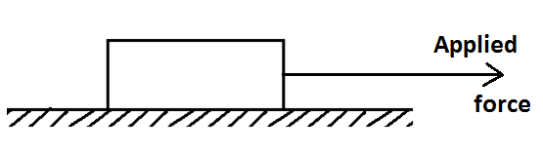

If the block accelerate at 2m/s2 and coefficient of friction between the block and the table is 2.5 calculate applied force. (3 mark)

1. The diagram below shows a block and tackle. Show on the diagram the path string passes through the pulleys and state velocity ratio (2 mark)

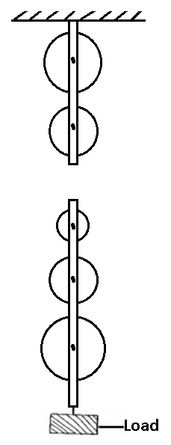

1. Define a transducer, give one example that illustrate how it work (2 mark)
2. A block of weight 120N is pulled along an inclined plane using a steady force as shown below

If distance AB is 25m and work done against friction is 240J calculate the value of applied force (3 mark)

1. State pressure law (1marks)
2. In an experiment to verify Charles laws state two quantities that are kept constant. (2marks)
3. A balloon seller has a cylinder containing hydrogen of volume 3.0m3 at a pressure of 2.6× 105 N/m2 at 270C he sells a balloons of volume 1250cm3 at a pressure of 1.04× 105 N/m2 at 270C. Calculate the number of balloons he can sell. (3marks)
4. Calculate the maximum pressure of a glass block of density 2500kg/m3 would exert on a horizontal surface, if the block measured 30 x 12 x 20cm. (3marks)
5. .
6. A rectangular block is held at the bottom of a container by a string as shown below

On the diagram show the forces acting on the bock (3marks)

1. If density of water is 1000kg/m3 and the block has a volume of 750cm3 and a density of 0.8g/cm3 calculate the value of each force. (3marks)
2. An object weighs 1040g in air, 640g when fully immersed in water and 720g when fully immersed in a liquid. If the density of water is 1000kg/m3, find the density of the liquid. (3marks)

1. In a hydrometer what is the purpose of
2. Lead shots. (1marks)
3. Narrow stem (1marks)
4. Wide bulb (1marks)
5. A copper of heat capacity 600J/K contains 200g of water at 200C. Dry steam at 1000C is passed through the water while stirring until it reaches a final temperature of 600C. Given that specific heat of capacity of water as 4200J/Kgk and specific latent heat of steam as 2260,000 J/kg
6. Heat absorbed by water ( 2 marks)
7. Heat absorbed by calorimeter (2 marks)
8. Write an expression on heat lost by steam heat lost by steam (2 marks)
9. Calculate the mass of the steam condensed (2 marks)
10. Explain why a body moving in a circular path at constant velocity is said to be accelerating. (1 marks)
11. A stone is projected horizontally from top of a cliff with initial horizontal velocity of 20m/s if the stone land s 100m from the bottom of the cliff, calculate height of the cliff. (3 marks)
12. A string of negligible mass has a bucket tied at the end. The string is 70cm long and the bucket has a mass of 450g. The bucket is swung horizontally making 8.4 revolutions per second. Calculate
13. The linear velocity. (3 marks)
14. The tension on the string. (3 marks)