NAME …………………………………… INDEX NUMBER ……………

CANDIDATE SIGNATURE………………

DATE …………………………………..
232/1/
PHYSICS
PAPER 1
JULY/AUGUST 2019
2 HOURS

BUURI EAST STANDARDS
Kenya Certificate of Secondary Education
PHYSICS PAPER 1

INSTRUCTIONS TO CANDIDATES.
- Write your name and index number in the spaces provided above.
- Answer all questions in section A and B in the spaces provided.
- All working must be shown clearly.
- Scientific calculators and mathematical tables may be used.
- Instructions and constants are given per question.

FOR EXAMINERS’ USE ONLY

Section | Questions | Maximum score | Candidate ‘s score
A | 1-12 | 25
B | 13 | 11
 | 14 | 11
 | 15 | 11
 | 16 | 11
 | 17 | 11
Total score 80

SECTION A (25MKS)
1. In an experiment to determine the density of liquid X, a student obtained the following date:
- Mass an empty density bottle = 55.0g.
- Mass of the density bottle + water = 80.0g.
- Mass of the density bottle + liquid x = 70g.
Determine the density of liquid x (density of water is 1000kg/m3) (3mks)

2. A stick of legible weight is kept in a horintal position by the force shown in the diagram below.
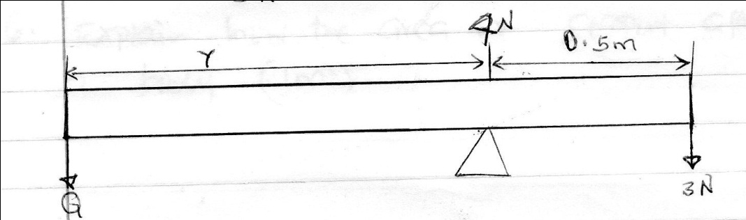
Calculate the value of y and the magnitude of force Q. (3mks)

3. State one way of increasing surface tension. (1mk)

4. Distinguish between Brownian motion and diffusion. (1mk)

5. i) Table below shows results of an experiment carried out to study properties of a spring.

Force (n) | 0 | 10 | 20 | 30 | 40
Extension(cm) | 0 | 2.0 | 4.0 | 6.0 | 8.0
State with a reason whether the experiment was done within the elastic limit of the spring. (1mk)

ii) An object of weight 20N is attached at the end of spring causes an extension of 0.05cm on the spring. Determine the spring constant. (2mks)

6. Explain how the area of support affect the stability of a body. (1mk)

7. Figure 2 below shoes a Bunsen Burner.
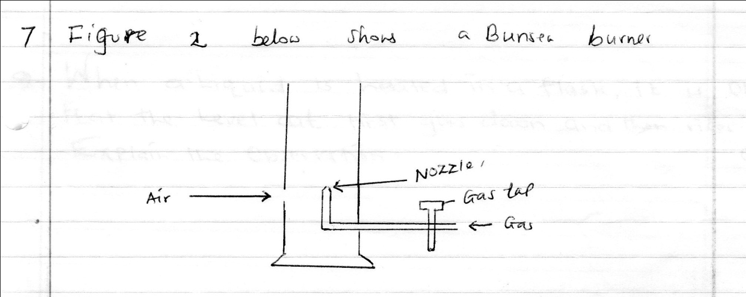
Explain how air is drawn into the burner when the gas tap is opened. (3mks)

8. A vacuum pump was used to pump out air from the glass immersed in liquids as shown below
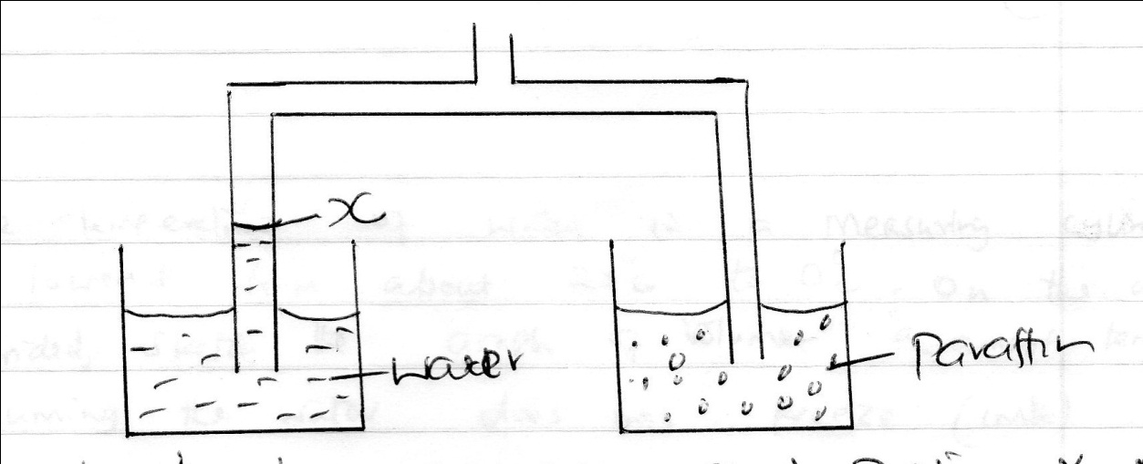

After sometime the level of water rose to position X. Mark Y the corresponding position for the paraffin level. Give a reason for your answer. (2mks)

9. When a liquid is heated in a glass flask, it is observed that the level at first goes and then rises. Explain the observation. (2mks)

10. a) Give two ways of increasing sensitivity of a clinical thermometer. (2mks)

b) The temperature of water in a measuring cylinder is lowered from about 20⁰c to 0⁰. On the axes provided sketch the graph of volume against temperature assuming the water does not freeze. (1mk)
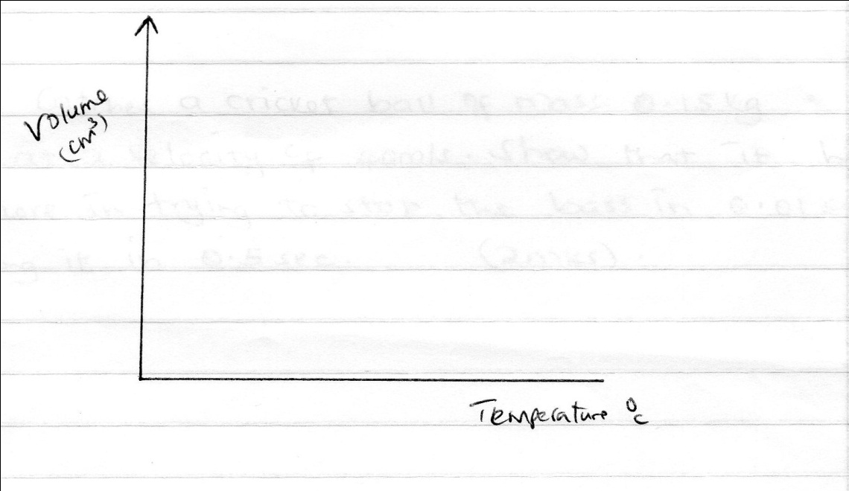

11. State one way in which the centripetal force on a body of mass (m) can be increased. (1mk)

12. A boy catches a cricket’s ball of mass 0.15kg moving at a velocity of 40m/s. Show that it hurts the boy more in trying to stop the bass in 0.01sec than stopping it in 0.5 sec. (2mks)

SECTION B (55MARKS)

13. a) State what is meant by an ideal gas. (1mk)

b) The pressure acting on a gas in a container was changed steadily while the temperature of the gas was maintained constant. The value of volume (v) of gas was measured for various value of pressure (p). The graph in the figure below shows the relationship between the pressure (p) and the reciprocal of volume (v).
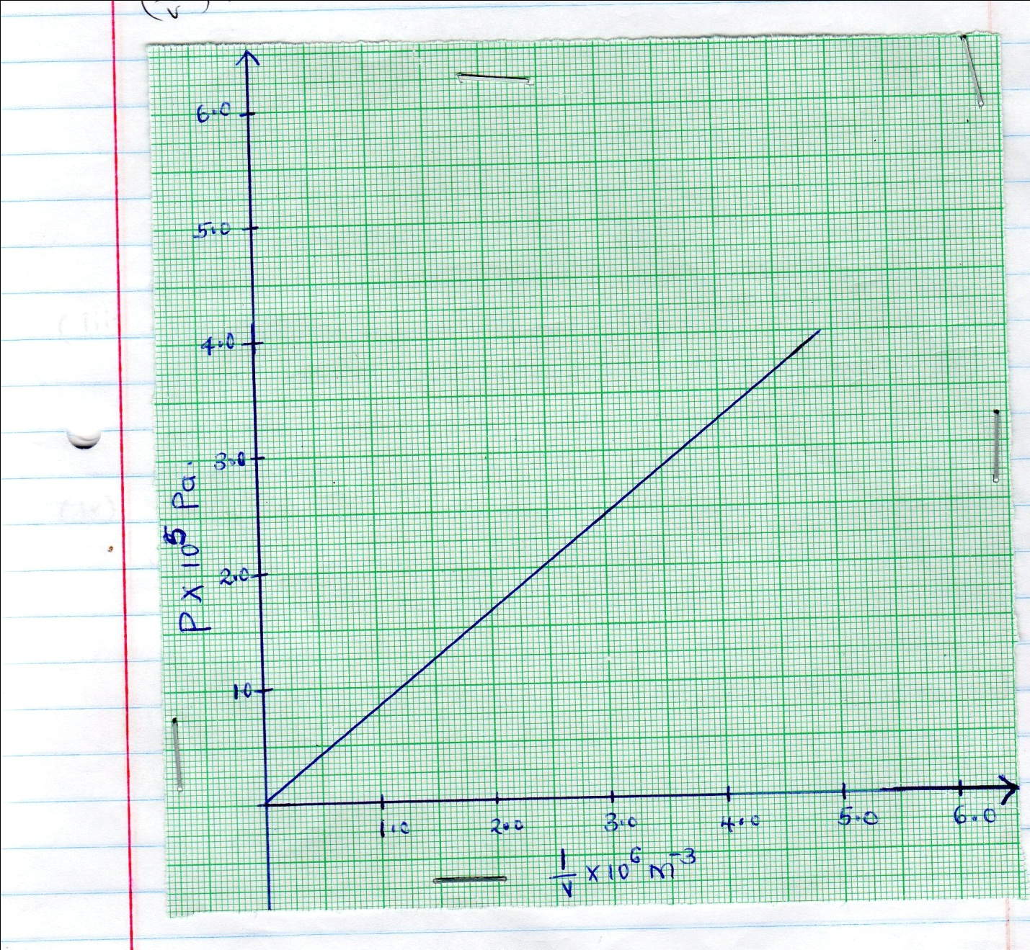
i) Suggest how the temperature of the gas could be kept constant. (1mk)

ii) Given that the relationship between pressure (p) and volume (v) of the gas is given by pv= k whereby k is a constant, use the graph to determine the value of k. (3mks)

iii) What physical quantity does k represent? (1mk)

iv) State one precautions you would take when performing such an experiment. (1mk)

c) A gas occupies a volume of 4000 litres at a temperature of 37⁰c and normal atmospheric pressure. Determine the new volume of the gas if it is heated at a constant pressure to a temperature of 67⁰c. (Normal atmospheric pressure = 1.01 x105pa) (4mks)

14. a) State the principle of conservation of linear momentum. (1mk)

b) Distinguish between elastic and inelastic collision. (1mk)

c) A sticker kicks a ball of mass 200 g initially at rest with a force of 78N. Given that the foot was in contact with the ball for 0.30s, determine the take – off velocity of the ball. (3mks)

d) A high jumper usually lands on a thick soft mattress. Explain how the mattress helps in reducing the force of impact. (2mks)

e) A ball is throne horizontally from the top of a vertical tower of height 75m and strikes the ground at a point of 80m from the bottom of the tower.
Determine the:
- Time taken by the ball to hit the ground (acceleration due to gravity= 10m/s)

- Initial horizontal velocity of the ball. (2mks)

15. a) Show that V2 = u+2as (3mks)

b) The figure below shows a graph of velocity against time for a moving body.
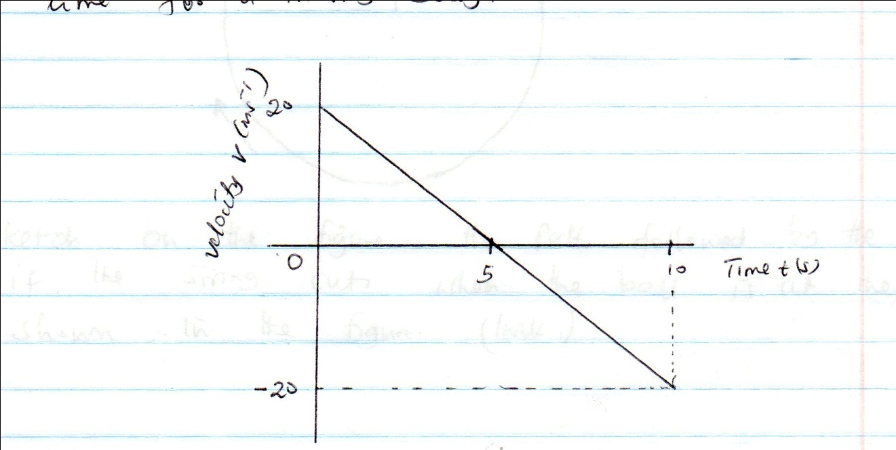
Describe the motion of the body during the 10 seconds. (2mks)

c) i) Explain why a pail of water can be swing in a vertical circle without the water pouring out. (2mks)

ii) A body of mass 5.0kg is attached to the end of a string of length 50cm and whirled in a horizontal circle. If the tension of the string is 81N, determine the velocity of the body. (3mks)

- The figure below shows a ball being whirled in a vertical plane.
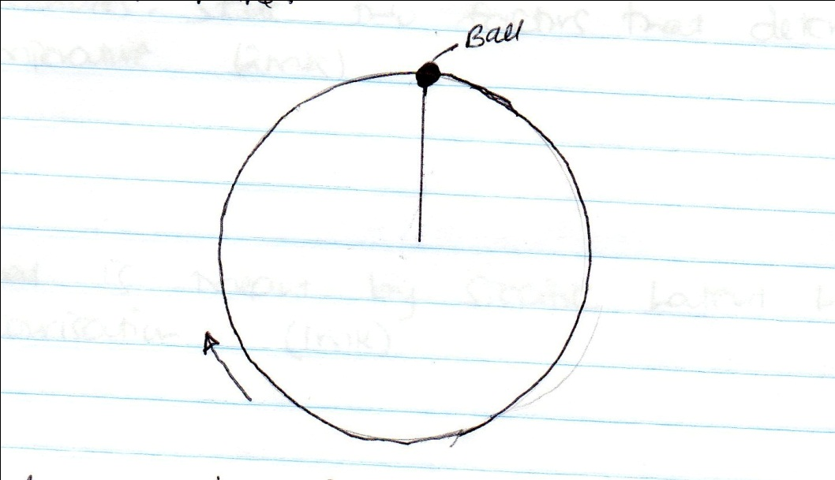

Sketch on the figure the path followed by the ball if the string cut when the ball is at the position shown in the figure. (1mk)

16. a) A liquid at 80⁰C in a cup was allowed to cool for 20 minutes. State two factors that determine the final temperature. (2mks)

b) What is meant by specific latent heat if vaporization. (1mk)

c) In an experiment to determine the specific latent heat of vaporization of water, steam at 100⁰c was passed into water contained in a well logged copper calorimeter. The following measurements were made:
Mass of calorimeter=80g
Initial mass of water = 70g
Initial temperature of water =5⁰c
Final mass of calorimeter + water + condensed steam=156g.
Final temperature of mixture = 30⁰c.
Specific heat capacity of water = 4200j/kg/k and specific heat capacity for copper = 390j/kg/k.
Determine:
- Mass of condensed steam. 2mks

- Heat gained by the calorimeter and water. (2mks)

- Given heat L is the specific latent heat of vaporization of steam.
- Write an expression for the heat given out by steam. (2mks)

- Determine the value of L. (2mks)

17. The figure below shows a metallic red rod length 10cm and uniform cross-sectional area 4 cm² suspended from a spring balance with 7.5cm of its length immersed in water. (The density of the material is 1.5g/cm³ while density of water 1.05/cm³).

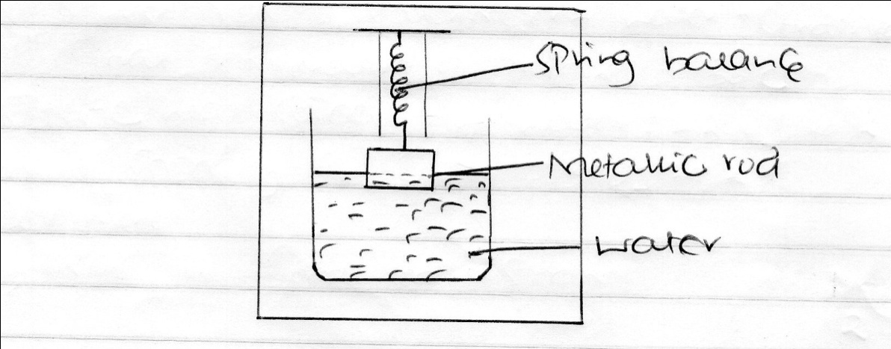

Determine:
- The mass of the rod. (2mks)

- The up thrust acting on the rod. (2mks)

- The reading of the spring balance. (2mks)

- The reading of the spring balance when the rod is wholly immersed in water. (3mks)

- Explain why ice cubs float on water and solid benzene sinks in liquid benzene. (2mks)

