Name: ………………………..……………………Index Number: …..……..CLASS:….. Candidate’s signature: …………....
Date: ……………………
232/2
PHYSICS
Paper 2
(Theory)
July / August 2019
TIME: 2 HRS

Kenya Certificate of Secondary Education

232/2
PHYSICS
Paper 2
(Theory)
2 HRS

INSTRUCTIONS
- Write your name and your Index number in the spaces provided.
- This paper consists of two sections, Section A and B.
- Answer ALL the questions in both section in the spaces provided in this paper.
- ALL working must be clearly shown.
- Mathematical tables and electronic calculators may be used.
Take: Planck’s constant =6.6x10⁻³⁴ Js
FOR EXAMINER’S USE ONLY:
SECTION | QUESTION | MAXIMUM SCORE | STUDENTS SCORE
A | 1-12 | 25
B | 13 | 11
 | 14 | 09
 | 15 | 15
 | 16 | 10
 | 17 | 10
 | TOTAL | 80
This paper consists of 12 printed pages
Candidates should check to ensure that all pages are printed as indicated and no questions are missing

1. State any 2 ways of in increasing the size of an image formed by a fixed pinhole camera.(2 mks)

2.State 2 advantages of alkaline battery over a lead acid battery. (2 mks)

3. The diagrams below show a soft iron plate in a solenoid and a permanent magnet suspended by a spring.
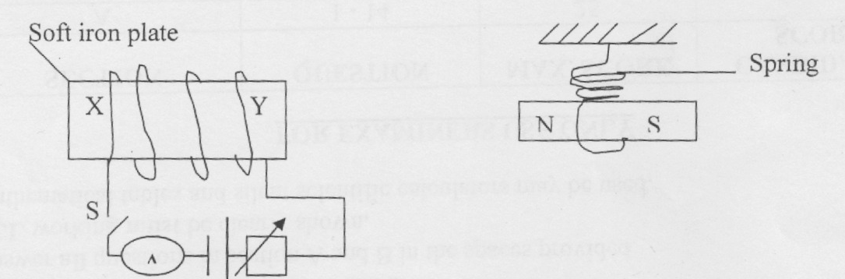
State with reason the behaviour of the magnet when the switch S is closed. (2 mks)

4. A man, standing between 2 parallel vertical walls, claps his hands. He hears the first echo 0.3 seconds later and the next echo after a further 0.2 seconds. If the velocity of sound in air is 300m/h. Calculate the distance between the walls. (3 mks)

5. The table below shows an electromagnetic spectrum. Complete the table in the order of increasing wavelength from A- B. (2 marks)
A |  |  | Visible  Light |  |  | B
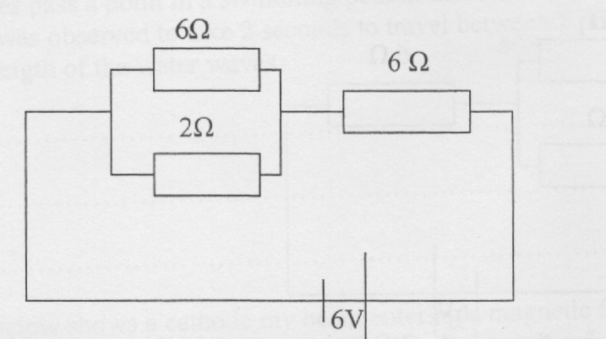
6.The figure below shows a 6V battery connected to an arrangement of resistors.

Determine the current flowing through 2 Ω resistor. (4 marks)

7.State difference between semi conductors and metallic conductors. (1 mark)

8. A radioactive sample has a mass of 16g and a half-life of 10 days. How much of the original sample remains after 40 days. (2 marks)

9. Negatively charged rod is brought near the cap of a lightly charged electroscope. The leaf divergence first reduces but as the rod comes nearer, it diverges more.
i) State the charge of the electroscope. (1 mark)

(ii) Explain the behaviour of the leaf above. (1 mark)

10. Water waves pass a point in a swimming pool at the rate of 30 crests per 60 seconds. One of the crests was observed to take 2 seconds to travel between 2 points, 6m apart. Determine
the wavelength of the water waves. (2 marks)

b. The figure below shows a cathode ray beam entering a magnetic field, perpendicular to the plane of the paper complete the diagram to show the path of the beam in the field. (1 mark)
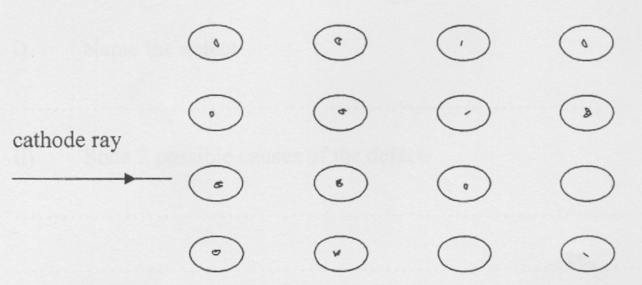

11.The diagram below shows a junction diode.

p | n
Complete the diagram to show how the diode can be connected in a reverse bias mode. (1 mark)
12.An Uranium 236 isotope has a symbol $\begin{matrix}2361 \\ 92\end{matrix} U$ when bombarded by a neutron, it splits to give
Substances K and L and 2 neutrons. Calculate the values of a and b in the equation below. (1 mark)
$\begin{matrix}236 \\ 92\end{matrix} U + \begin{matrix}1 \\ 1 \end{matrix}n \begin{matrix}95 \\ 56 \end{matrix} K + \begin{matrix}a \\ b \end{matrix}L \begin{matrix}+2 \\ 0\end{matrix}$n

SECTION B 55MKS
13a) Explain why a cathode ray tube is evacuated (1 mark)

b) State four properties of cathode rays (2 marks)

c) The figure shows the waveform displayed on the cathode ray oscilloscope screen when an alternating voltage is applied on the Y-input. The time- base is set at 1ms/cm and the Y-gain at 10v/cm
1cm
1cm

Calculate;
- The amplitude of the ac input voltage (2marks)

- The frequency of the ac input voltage signal (2 marks)

d) The threshold frequency of sodium is 5.6x10¹⁴Hz .Find
- Work function of sodium (2marks)

- The kinetic energy of the ejected electrons when sodium is shone with light of frequency 8.6x10¹⁴ Hz (2 marks)

14.State the meaning of the term critical angle as applied in refraction of light.(1 mark)

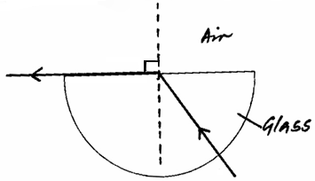
ii)The figure shows a ray of light incident on a glass-air interface.

(i) Show on the diagram the critical angle, c. (1 mark)
ii)Given that the refractive index of the glass is _{a}η_{g}, and that the critical angle c = 42º, determine the value of is _{a}η_{g}. (3 marks)

- The figure shows an experimental set up consisting of a mounted convex lens L, cardboard screen with cross-wires at the centre, a plane mirror, a metre rule and
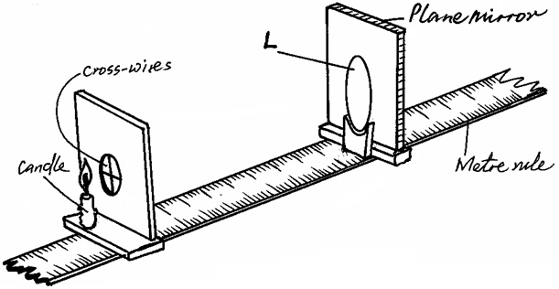
a candle.

Describe how the set-up may be used to determine the focal length, f, of the lens. (4 marks)

15.a) State one advantage of high voltage transmission. (1mark)

(b) A generator produces 150kw at a voltage of 5kv. The voltage is stepped up to 60kv and transmitted through cables of resistance 15Ω to a step down transformer in a substation. If both transformers are 80% efficient, calculate the:
(i) Current through the transmission cables. (3marks)

(ii) Power lost during transmission. (3marks)

(c) The figure below shows the features of an x ray tube
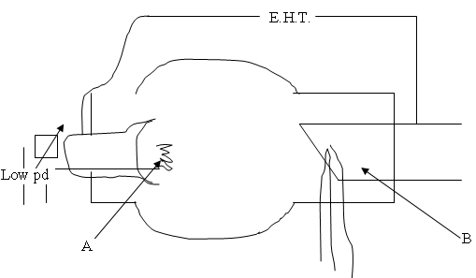
i)Name the parts labelled A and B. (2marks)

(ii) Explain how change in the potential across PQ change the intensity of the x-rays produced in the tube. (1marks)

(iii) During the operation of the tube, the target becomes very hot. Explain how the heat is caused. (1mark)

(iv) What property of lead makes it suitable for use as shielding material? (1mark)

(b) In a certain X ray tube, the electrons are accelerated by a p.d of 12000v. assuming that all the energy goes to produce x rays, determine the frequency of the x rays produced(take planks constant h=6.62x10⁻³⁴Js, and the charge of an electron e=1.6x10⁻¹⁹ (3marks)

16.Figure 8 shows an electromagnetic relay being used to switch an electric motor on and off. The electromagnet consists of a coil of wire wrapped around a core. The motor in figure is switched off.
Motor
Springy metal strips
Contacts
Soft iron armature
Core
S
A
B
Pivot
Insulator
Figure 8

- Suggest suitable material for the core. (1mark)

- What happens to the core when switch S is closed? (2marks)

c)Why do the contacts A and B close when the switch S is closed. (2marks)

- When the switch S is opened, what will happen to;
- The core (1mark)

- Soft iron armature. (1mark)

- Give one other application of an electromagnet. (1mark)

- State two ways in which an electromagnet could be made more powerful. (2marks)

17.Explain why carbon-14 (${}_{6}^{14}C)$ is radioactive while carbon ${}_{6}^{12}C$ is not. (1 mark)

(b) The figure below shows features of a diffusion cloud chamber used for detecting
radiations from a radioactive source.

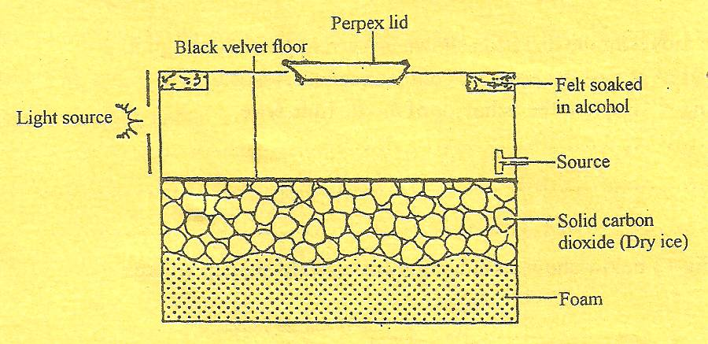

Explain how the chamber works when a radioactive particle is introduced at the source. (2 marks)

(c) (i) What is the purpose of solid carbon (iv) oxide. (1 mark)

- (i) Using a diagram explain how doping produces a p-type semi-conductor. (3 marks)

(ii) What is biasing? (1 mk)

(iii) The diagram below shows a circuit with a p-n junction and a very low power
bulb.

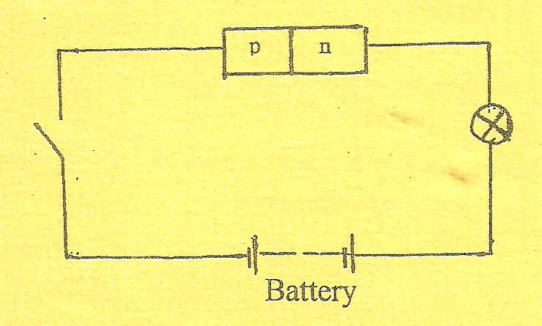
State with reason the observations made on the bulb when the switch is closed.
(2 marks)

