232/2
NAME…………………………………………….……. INDEX NO………..…………………..
SIGNATURE……………………………….………………DATE……………………………..
ASUMBI GIRLS HIGH SCHOOL
POST -MOCK 1
AUGUST/SEPTEMBER
2022
AUGUST / SEPTEMBER - 2022

PHYSICS
PHYSICS PAPER 2
TIME: 2 HOURS

INSTRUCTIONS TO CANDIDATES
- This paper consists of two sections A and B
- Answer ALL the questions in sections A and B in the spaces provided.
- All workings must be clearly shown. Mathematical tables and silent electronic calculators may be used.
Take h= 6.63 x 10⁻³⁴ Js

FOR EXAMINERS USE ONLY

SECTION | Questions | Maximum Score | Candidate’s Score
A | 1-11 | 25
B | 12 | 09
 | 13 | 05
 | 14 | 15
 | 15 | 14
 | 16 | 12
 | TOTAL SCORES | 80

This paper consists of 12 printed pages. Students should check the paper to ascertain that all the pages are printed as indicated.
SECTION A: 25 MARKS
Answer all questions in this section
- Figure 1 shows two mirrors inclined at an angle of 30º to each other. A ray of light is incident on one mirror as shown
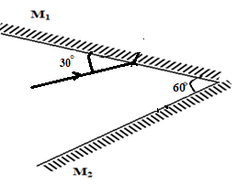
Fig. 1
Sketch the path of the ray to show its reflection on the two mirrors (2mks)
- Figure 2 below shows two pith balls A and B hanging from nylon threads and brought close to negatively charged rod. Pith ball A is uncharged while B is charged.
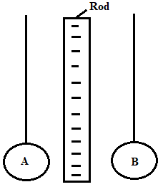
Fig. 2
It is observed that both pith balls A and B are attracted to the charged rod.
- State the charge on B (1mk)
………………………………………………………………………………………………………………
- Explain the reason why pith ball A is attracted (1mk)
…………………………………………………………………………………………………………………
…………………………………………………………………………………………………………………
- Show the charge distribution on the pith balls (1mk)
…………………………………………………………………………………………………………………
- Figure 3 shows the path of a ray of light CB passing from glass to air.
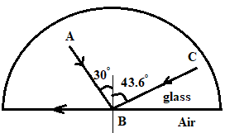
Fig. 3
Complete the diagram to show the path of the ray of light AB after it emerges from the glass showing the angle calculated. (3mks)
…………………………………………………………………………………………………………………
…………………………………………………………………………………………………………………
…………………………………………………………………………………………………………………
- Figure 4 shows water waves moving towards barrier.
Fig. 4
- State the property of wave under investigation. (1mk)

……………………………………………………………………………………………………
- Show the emergence of the reflected wave after passing the opening (1mk)

- State why passing of light through narrow opening is a very rare phenomenon (1mk)

……………………………………………………………………………………………………

- Figure 5 shows an object in front of a concave mirror and its image.
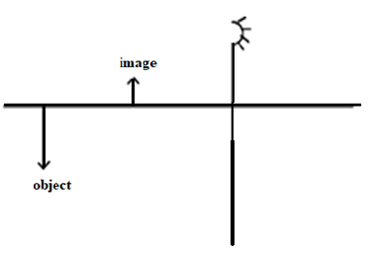
Fig. 5
Locate position of its principal focus and label it as F (2mks)

- Figure 6 shows a trace obtained from a CRO with the time base switched on.
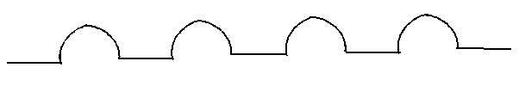
Fig. 6
Draw a circuit diagram that can be used to produce the wave above (2mks)
…………………………………………………………………………………………………………………
……………………………………………………………………………………………………………………………………………………………………………………………………………………………………
- A boy opened up a used-up dry cell and found the following:
i) The zinc casing was ‘eaten away’
ii) The cell was watery
Name the cell defect (1 mk)
…………………………………………………………………………………………………………
- State two uses of microwaves (2mks)
………………………………………………………………………………………………………………
………………………………………………………………………………………………………………

- Figure 7 shows a wave profile.
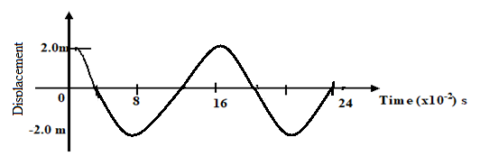
Fig. 7
Determine the frequency of the wave (3mks)
………………………………………………………………………………………………………………………………………………………………………………………………………………………………………………………………………………………………………………………………………………………
- Below is a nuclear reaction.
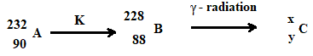
i) Identify radiation K (1mk)
…………………………………………………………………………………………………….......
ii) Determine the value of X and Y (1mk)
… ……………………………………………………………………………………………………………
- Figure 8 shows a bar of soft iron placed near a magnet.

SOFT IRON
N S

Fig. 8

On the same diagram, sketch the magnetic field pattern due to the set up (2mks)

SECTION B. (55 MARKS)
Answer all questions in this section
- a) Figure 9 shows an object, a screen and light sources X, Y and Z.
Fig. 9
- Complete the diagram to show the formation of a shadow (2mks)
- State one property of the object that makes it possible for its shadow to be formed
(1mk)
- Explain why it is impossible to obtain a sharp edged shadow of the object (1mk)
.......................................................................................................................................................................................................................................................................................................................................................
b) (i) The length of a pinhole camera is 20cm. Determine the height of a sloppy building 300m away from a pinhole camera which forms an image 2.5cm high on the screen of the camera. (3mks)
................................................................................................................................................................................................................................................................................................................................................................................................................................................................................................................................................................................................................................................................................................................
(ii) A student decided to use a nail to make the hole of the camera mentioned above. State two possible characteristics of the image formed (2mks)
...................................................................................................................................................................................................................................................................................................................................................................................................................................................................................................................................

- Figure 10 shows an X-ray tube.
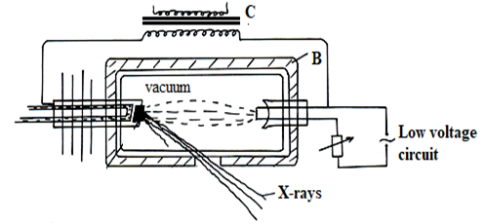

Fig. 10
- Explain the use of part labelled B and C (2mks)
B: ……………………………………………………………………………………………………...
C:………………………………………………………………………………………………………
- Explain how the X-rays are produced. (2mks)
………………………………………………………………………………………………………………………………………………………………………………………………………………………………………………………………………………………………………………………………
- Why is it necessary to maintain a vacuum inside the tube? (1mk) ………………………………………………………………………………………………………………………………………………………………………………………………………………………………………………………………………………………………………………………
- a) What is meant by the term electromotive force of a cell? (1mk)

........................................................................................................................................................................................................................................................................................................................................................
............................................................................................................................................................................
b) Battery of e.m.f. 12 V supplies a current of 10 A flows through it for 5 minutes. Determine the amount of electrical energy produced. (2mks)
....................................................................................................................................................................................................................................................................................................................................................................................................................................................................................................................................

c) Figure 11 shows a graph of resistance against reciprocal of current. Use it to answer the questions that follow.
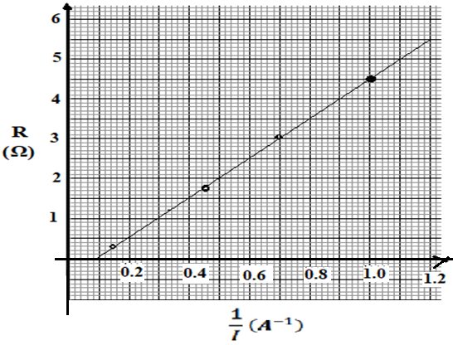
Fig. 11
- Find the internal resistance, r. (2mks)
........................................................................................................................................................................................................................................................................................................................................................
............................................................................................................................................................................
- Determine the e.m.f, E of the cell. (2mks)
........................................................................................................................................................................................................................................................................................................................................................
............................................................................................................................................................................
- Draw a circuit diagram to show the set-up used to generate the above graph (2mks)
............................................................................................................................................................................
....................................................................................................................................................................................................................................................................................................................................................................................................................................................................................................................................
- i) Draw a circuit diagram to show how a 12V battery may be used to operate efficiently 3 headlamp bulbs each marked 6V, 24W. (2mks)
............................................................................................................................................................................................................................................................................................................................................................................................................................................................................................................................................................................................................................................................................................................................................................................................................................................................................................
ii) Calculate the current supplied by the battery in (d) above. (2mks)
...................................................................................................................................................................................................................................................................................................................................................................................................................................................................................................................................
iii) Calculate the total effective resistance of the bulbs in (i) above. (2mks)
...................................................................................................................................................................................................................................................................................................................................................................................................................................................................................................................................
- ​a) State what is meant by the term electromagnetic induction. (1mk)
...................................................................................................................................................................................................................................................................................................................................................................................................................................................................................................................................
(b) Figure 12 shows a simple electric generator
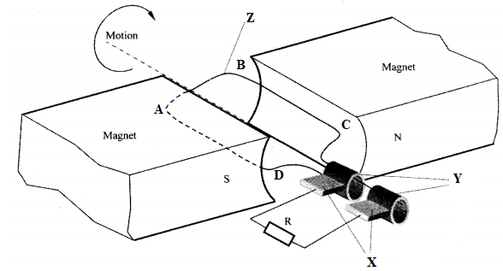
Fig. 12

- ​Name the parts labelled X, Y and Z. (3mks)
X:……………………………………………………………………………………………….
Y:………………………………………………………………………………………………..
Z:…………………………………………………………………………………………………
- Show the direction of induced current along BC (1mk)
- Sketch on the axes provided, a graph to show how the magnitude of the potential difference across R, changes with the time t for one rotation of the coil when it starts from horizontal position (1mk)
- ​State the effect of using a magnet with curved poles as shown in the diagram (2mks)
……………………………………………………………………………………………………………………………………………………………………………………………………………………………………
(c) In a transformer, the ratio of primary turns to the secondary turns is 2:20. A current of 500 mA flows through a 400 ohms resistor in the secondary circuit. Assuming that the transformer is 100% efficient, determine:
i) the secondary voltage (2mks)
………………………………………………………………………………………………………………………………………………………………………………………………………………………………………………………………………………………………………………………………………
- the primary voltage (2mk)
………………………………………………………………………………………………………………………………………………………………………………………………………………………………………………………………………………………………………………………………………

- the primary current. (2mks)
………………………………………………………………………………………………………………………………………………………………………………………………………………………………………………………………………………………………………………………………………………………
- I. Figure 13 shows a graph of photoelectric current against frequency. Use it to answer questions that follow.
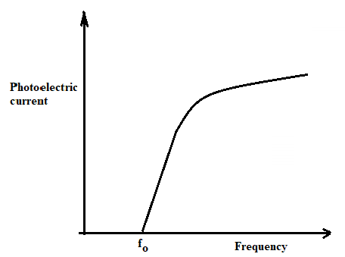
Fig. 13
- What does the term fo stand for in the graph above? (2mks)

…………………………………………………………………………………………………………………………………………………………………………………………………………………………

- Explain what the graph shows in terms of photoelectric emission. (2mks)
…………………………………………………………………………………………………………………………………………………………………………………………………………………………
- The work function of a metal is 6.4 x 10⁻¹⁹ J.
- Explain what is meant by the term work function (1mk)
…………………………………………………………………………………………………………………………………………………………………………………………………………………………

- Light with a frequency of 1.2 x 10¹⁵ Hz is shone onto the metal surface. Find out whether or not the photons of this light will cause the photoelectric effect to take place. (3mks)
………………………………………………………………………………………………………………………………………………………………………………………………………………………………………………………………………………………………………………………………………..
- The light source is now replaced with a light source which produces light with a frequency of 1.5 x 10¹⁵ Hz. The photons from this source contain more energy than is required to release electrons.
- Determine the extra energy available after the electron has been released. (3mks)
………………………………………………………………………………………………………………………………………………………………………………………………………………………………………………………………………………………………………………………………………
- What is the extra energy calculated above converted to? (1mk)
……………………………………………………………………………………………………………

END

