ASUMBI GIRLS HIGH SCHOOL
POST -MOCK 1
AUGUST/SEPTEMBER
2022

233/2

PHYSICS PAPER 2 MS

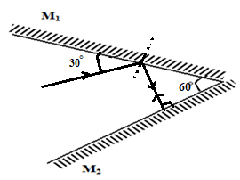
- (i) Positive
(ii) Positive charges are induce on the surface/negative charges are repelled hence the attraction.
(iii)
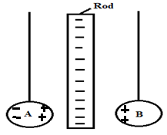

3.
$$n= \frac{1}{\sin{C}}$$
$$n= \frac{1}{\sin{43.6}}$$
n = 1.581
$$1.581=\frac{\sin{30}}{\sin{r}}$$
r = 18.54°
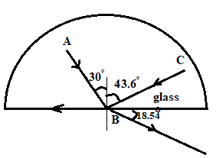
- (i) Diffraction
ii)
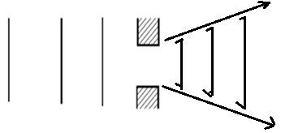
iii) Light waves have much shorter wavelength

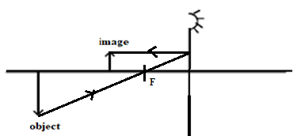

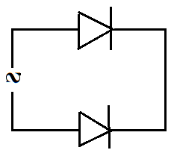
- Local action
- – in telecommunication /radar system
- Used for cooking
- $f= \frac{1}{T}$
$\frac{1}{0.16}$
= 6.25 Hz
- (i) Alpha radiation
(ii) X= 228 Y= 88

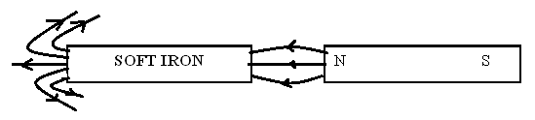
- a) (i)
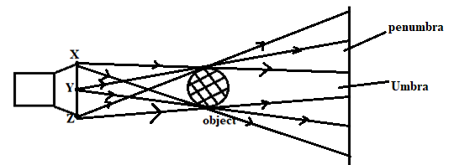
(ii) It is opaque/does not allow light to pass through
(iii) it acts as an extended source
b (i) $\frac{h_{i}}{h_{o}}=\frac{V}{U}$
h_{o} = $\frac{0.025 x 300}{0.2}$
= 37.5 m
(iii) – Blurred
- Brighter
- i) B: Lead shield: to absorb stray X-rays
C: step-up transformer- to supply power
ii) Filament is heated and then heats the cathode with sufficient energy. Electrons are then emitted from the cathode by process of thermionic emission. The fast moving electrons are accelerated and focused to a target where they are stopped with only about 2 % of the energy converted to X-rays.
iii) To ensure that the electrons emitted do not lose energy by colliding with foreign materials e.g. air molecules.

- a) the voltage across the terminals of a cell in an open circuit
b) H = 12 x 10 x 5 x60
= 36000 J.
c) (i) internal resistance r = y-intercept
= 0.5 Ω
(ii) R= $\frac{E}{I}-r$
E = gradient
$$\frac{3-1.5}{0.7-0.4}$$
= 5 V
iii)
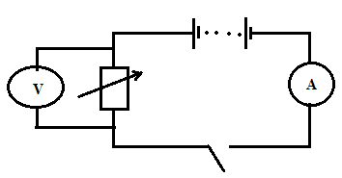
d) (i)
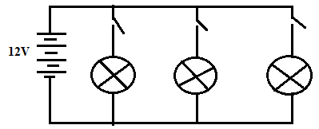
ii) $I= \frac{P}{V}$
$$= \frac{6V}{4A}$$
= 1.5 Ω
R_{T} = R/3
R_{T} = 1.5/3
= 0.5 Ω
- a) the production of induced emf which causes induced current to flow by changing magnetic flux linkage in a coil.
b) (i)
X: Brushes
Y: Slip rings
Z: Turns of the coil
(ii)
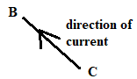
iii)
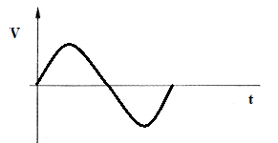

iv) it creates concentric loops which concentrate magnetic fields/flux
c) (i) $\frac{500 x 400}{1000}$
= 200V
(ii) $\frac{200 x 2}{20}$
= 20 V
(iii) I_{p} =$\frac{0.5 x 20}{2}$
V= 5 A
- I. a) threshold frequency- the minimum frequency of an electromagnetic radiation required to dislodge an electron from the metal surface.
b) at threshold frequency photoelectric emission takes place. The magnitude of photo current depends on the frequency. As the frequency increases the magnitude of photocurrent increases upto some point.
II. a) minimum energy require to dislodge an electron from a metal surface.
b) hf=hf_{o} + ½ mv_{max} ²
hf = 6.63 x 10⁻³⁴ x 1.2 x 10¹⁵
= 7.956 x 10⁻¹⁹
hf is greater than the work function hence photoemission occurs.
c)(i) K.E.
(1.5 x 10¹⁵ x 6.63 x 10⁻³⁴) -6.4x10⁻¹⁹
3.545 x 10⁻¹⁹ J
(ii) Maximum kinetic energy.

