NAME …………………………… INDEX NUMBER ……………

CANDIDATE SIGNATURE………………

DATE …………………………………..
232/2/
PHYSICS
PAPER 2
JULY/AUGUST 2019
2 HOURS

BUURI EAST STANDARDS
Kenya Certificate of Secondary Education
PHYSICS PAPER 2

INSTRUCTIONS TO CANDIDATES.
- Write your name and index number in the spaces provided above.
- This paper consists of two sections A and B.
- Answer all questions in sections A and B in the spaces provided.
- All the working MUST be shown clearly.
- Scientific calculators and mathematical tables may be used.

FOR EXAMINERS’ USE ONLY

Section | Questions | Maximum score | Candidate ‘s score
A | 1-14 | 25
B | 15. | 10
 | 16. | 13
 | 17. | 11
 | 18. | 10
 | 19. | 11
Total score 80

SECTION A (25MARKS)

1. The figure below shows two mirrors M1 and M2 are inclined at right angles to each other.
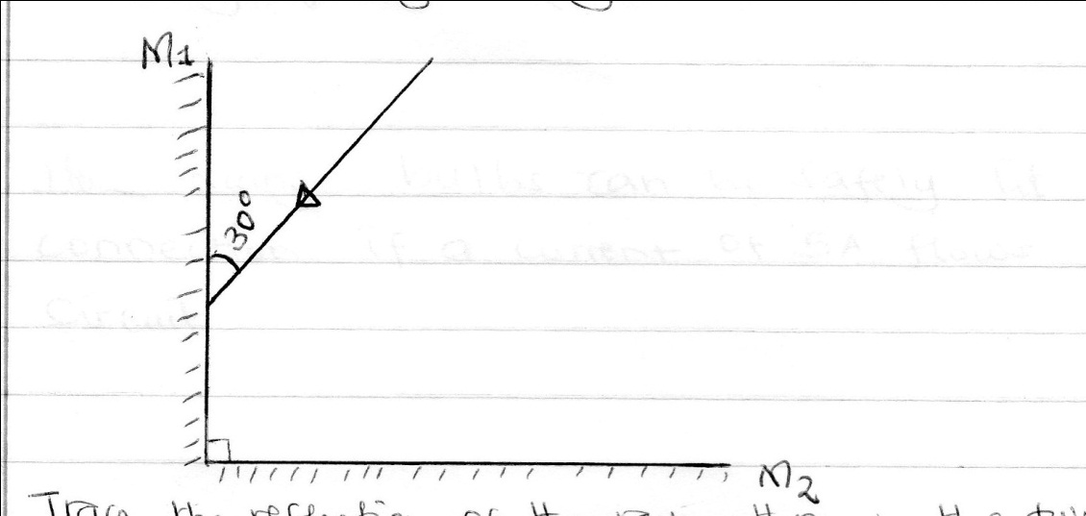
Trace the reflection of the ray through the two mirrors and find the angle between the incident ray and reflected ray of mirror M₂. 2mks
2. State the reasons why a convex mirror is preferred over a plane mirror for use as a driving mirror. (1mk)

3. A current of 0.5A flows in a circuit. Determine the quantity of charge that crosses a point in 4 minutes through the circuit. (2mks)

4. State the reasons why the magnetic field strength is greatest at the poles. (1mk)

5. It is observed that when a ultra violet radiation falls on a zinc plate placed on the negatively charged electroscope the leaf falls. Explain this observation. (1mk)

6. a) An electrical bulb is rated 24V,100W. Explain the meaning of the rating. (1mk)

b) How many bulbs can be safely lit in the above connection if a current of 5A flows through the circuit? (1mk)

7. A radio station broadcasts on a wavelength of 150m at a frequency of 200 kHz. Calculate the velocity of the radio waves. (2mks)

8. Voltage in mains supply is always in alternate current. Explain. (1mk)

9. A microscope is focused on a mark on a horizontal surface. A rectangular glass block 30mm truck is placed on the mark. The microscope is then adjusted 10mm upwards to bring the mark back to focus .Determine the refractive index n of the glass. (3mks)

10. State two properties of cathode rays. (2mks)

11. In an experiment to observe interference of light waves, a double slit placed close to the source.
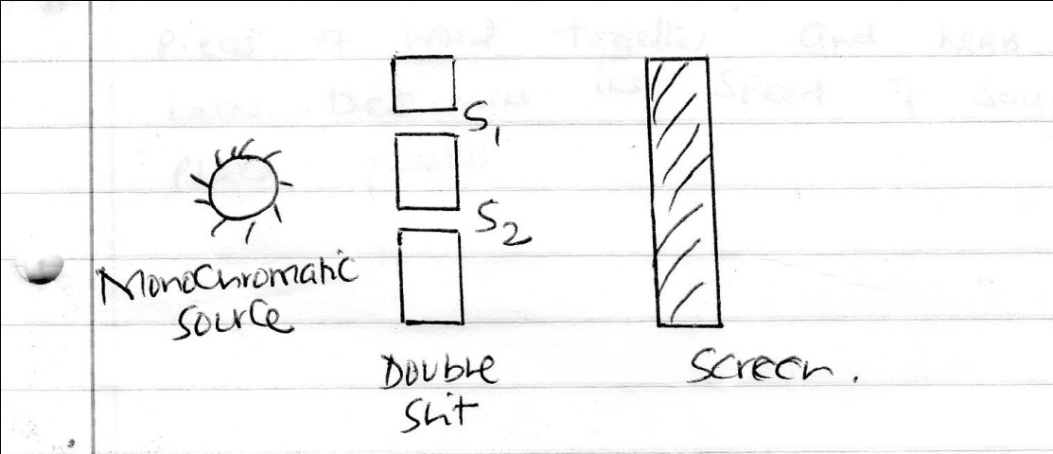
- State the function of the double slit. (1mk)

- State what is observed on the screen when the slit separation S₁ S₂ is reduced. (1mk)

12. The internal resistance of the cell in the figure below is 0.5 Ω.

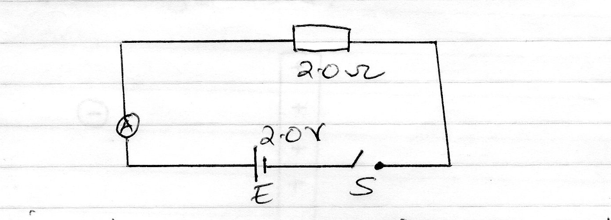

Determine the ammeter reading when the switch S is closed. (2mks)

13. State two sources of background radiation. (2mks)

14. A man standing 600 away from a wall bangs two pieces of wood together and hears an echo 2.5 seconds later. Determine the speed of sound in air at that place. (2mks)

SECTION B ( 55MARKS)
15. a) What is meant by the term capacitance. (1mk)

b) The figure below shows a point placed near a positively charged rod.
Draw on the diagram the resulting electrons field patterns. (1mk)

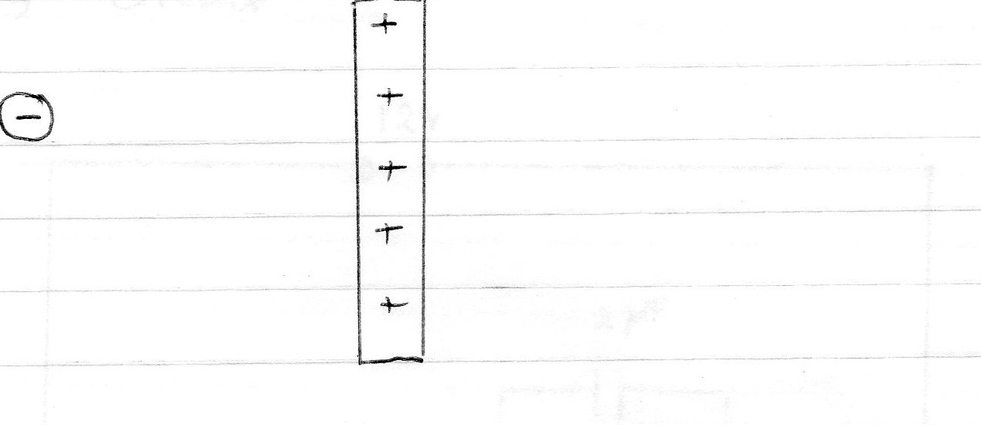

c) When a positively charged conductor is brought close to a candle, the flame is diverted as shown in the figure below. Explain thus observation. (2mks)
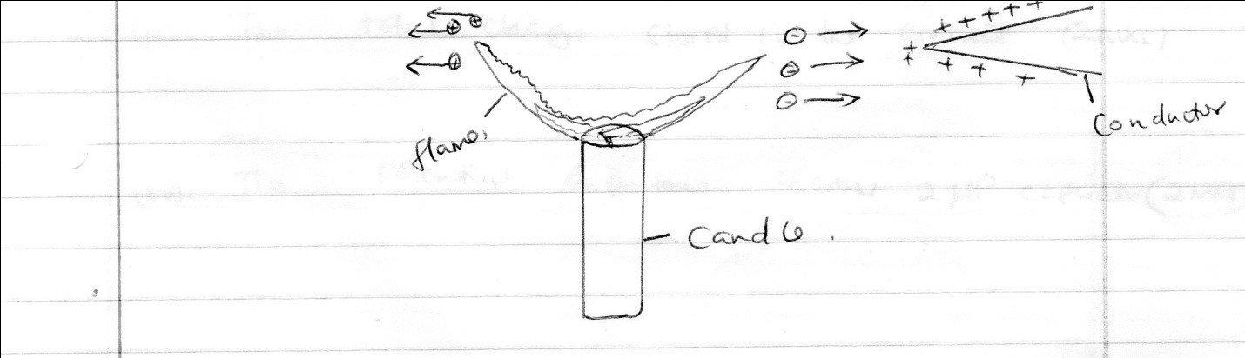

d) The figure below shows three capacitors of capacitance 34µf, 2µf, and 6µf. Connected to a 12v supply circuit.
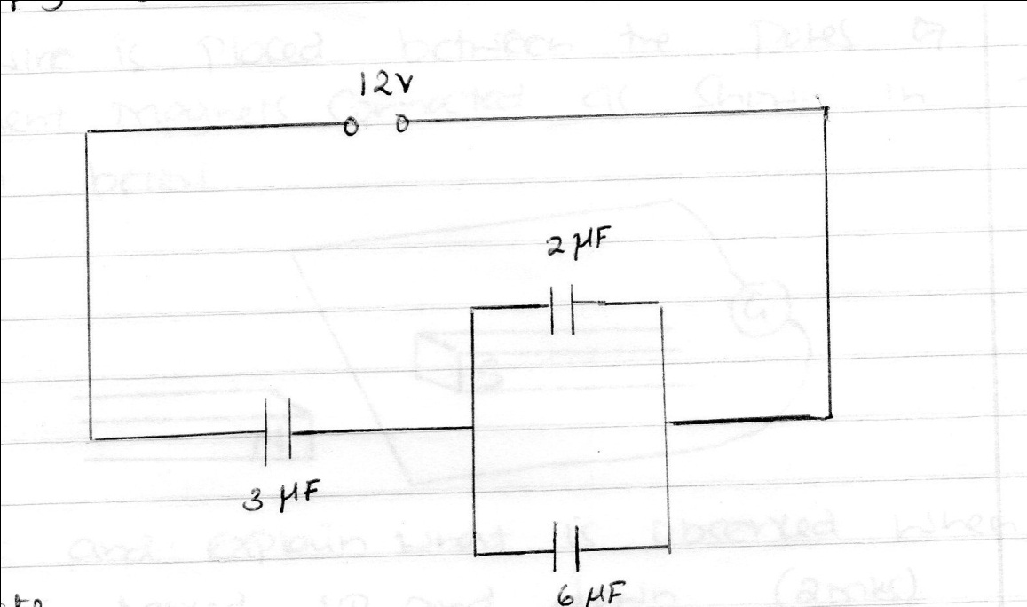

Calculate:
- The total capacitance of the circuit. (2mks)

- The total change stored in the circuit. (2mks)

- The potential differences across 2µf capacitor. (2mks)

16. a) State Lenz’s law of electromagnetic induction. (1mk)

b) A wire is placed between the poles of two permanent magnets connected as shown in the diagram below.
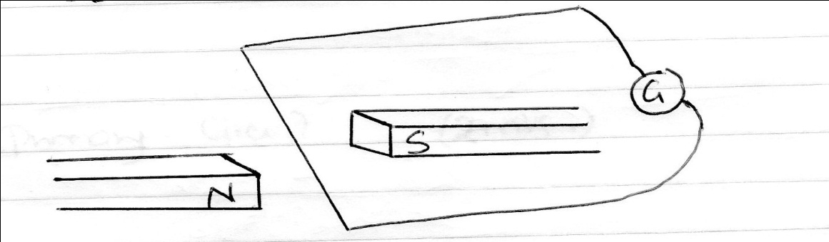

- State and explain what is observed when the wire is moved up and down. (2mks)

- Suggest two ways of altering the magnitude of the effect stated in(i) above (2mks)

c) Explain why the core of a transformer is:
i) Laminated (1mk)

ii) Made of soft iron (1mk)

d) An ideal transformer has 2000 turns in the primary circuits and 200 turns in the secondary circuit. When the primary circuit is connected to a 400V a.c source, the power delivered to a resister is found to be 800W. Determine the current in:
i) The secondary circuit. (4mks)

- The primary circuit. (2mks)

17. The figure below shows an x-ray tube.
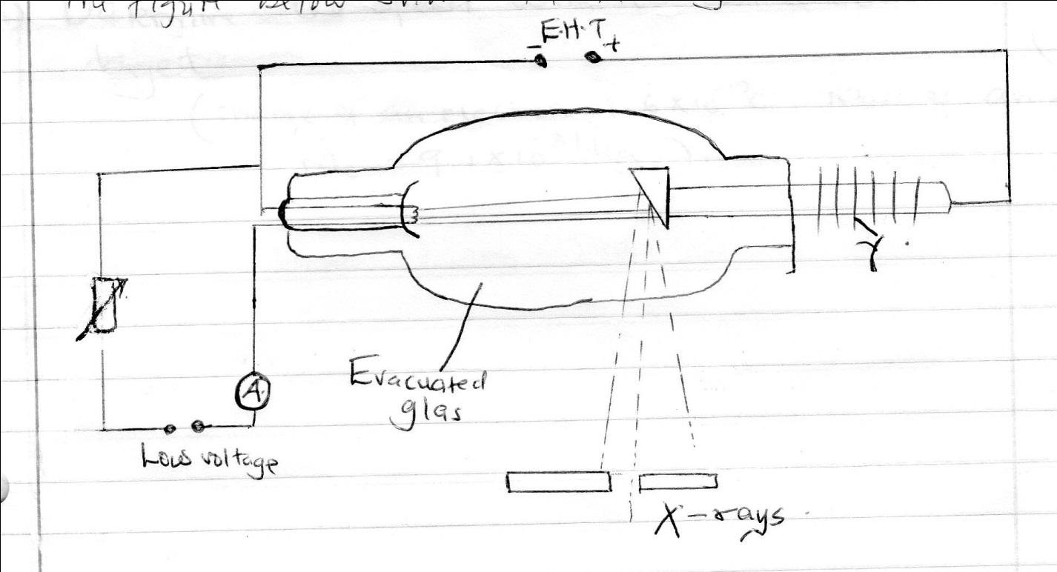
- Name the part labeled Y. (1mk)

- How would one increase:
- The intensity of the x-rays. (1mk)

- Penetrating powers of x-rays. (1mk)

- Explain why the tube is highly evaluated. (2mks)

- An x- ray tube is operating with an anode of potential of 10 kV and current of 15mA.
- Calculate the number of electrons hitting the target per second 3mks

- Determine the speed with which electrons hit the target 3mks
Given are the:
Charge of an electron =1.6x10⁻¹⁹c,
Mass of an electron =9.1x 10⁻³¹kg

18. a) Extrinsic semiconductors are made through the process known as doping.
i) Define doping. (1mk)

ii) Describe how doping produces an n-type conductor. (3mks)

b) The diagram below shows a rectifier circuit for an alternating current (AC) input.
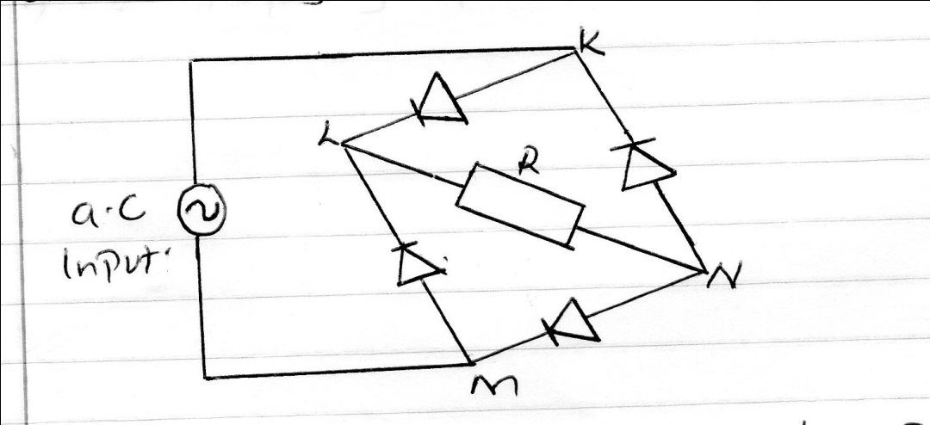

Sketch a graph to show how the p.d across R varies with time. (2mks)

c) In a CRO, a waveform given below was displayed on the screen when the Y-gain of the CRO was set at 5V/cm and time base calibration is 20 milliseconds per cm.
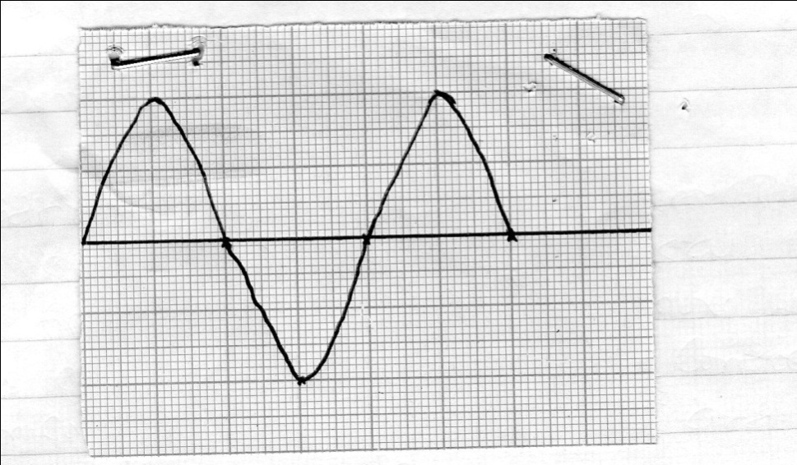
Determine:
- The peak voltage. (2mks)

- The frequency of the voltage. (2mks)

19. The graph in the figure below shows the relationship between 1/u and 1/u for a converging lens where u and v are the object and image distances respectively

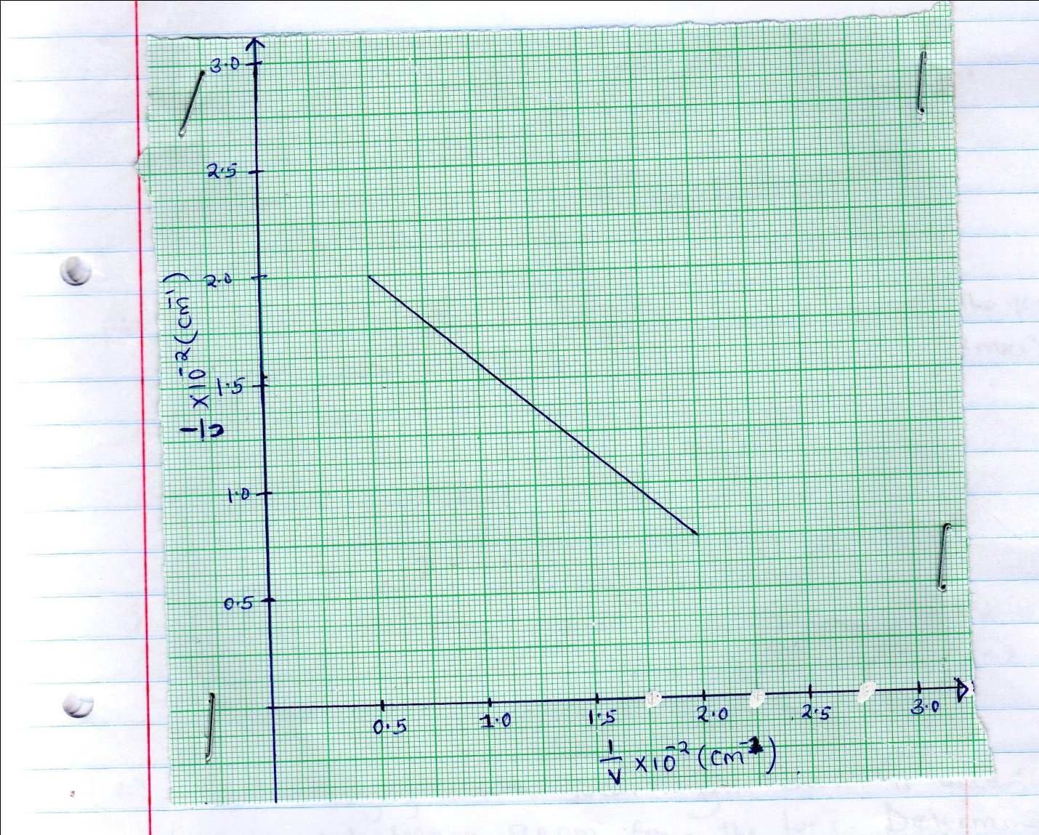

- From the graph determine the focal length f of the lens. (3mks)

- Figure below shows an experimental set up consisting of a counted lens L a screen, a meter rule and a candle.
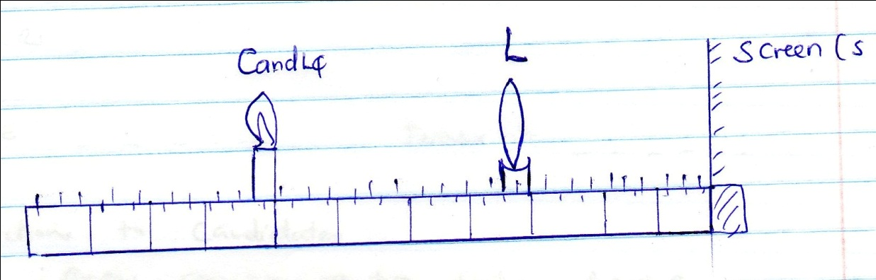
- Describe how the set up may be used to determine the focal length f, of the lens. (3mks)

- State why the set up would not worse if the lens was replaced with a diverging lens. (1mk)

- A thin converging lens of focal length 30cm is used to form a real image 90 cm from the lens. Determine :
- The objects distance from the lens. (2mks)

- The magnification of the lens. (2mks)

